Slide 1

* Fully managed service to access FMs via a single API (Anthropic, Meta, Mistral, Amazon Nova, etc.)
* Key capabilities:
  + Serverless
  + Guardrails (safety/content filters)
  + Provisioned & on‑demand throughput
  + Easy integration with other AWS services

Slide 2

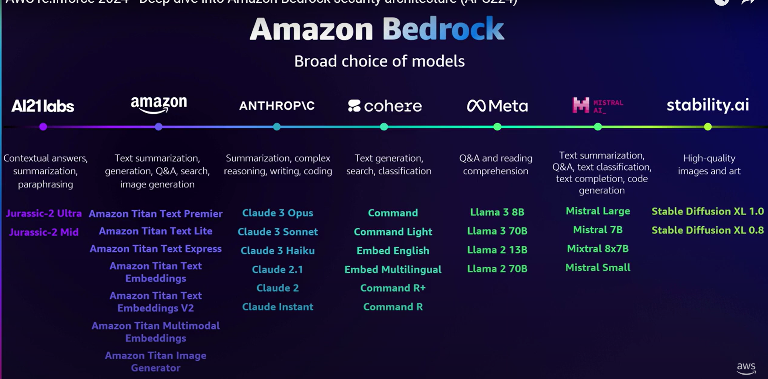

Slide 3

import boto3

client = boto3.client("bedrock-runtime", region_name="us-east-1")

response = client.invoke_model(

modelId="meta.llama2-13b-chat-v1", # Bedrock’s managed LLaMA

body='{"prompt": “Give me the capital of India"}',

contentType="application/json",

accept="application/json"

)

print(response['body'].read().decode("utf-8"))

Slide 4

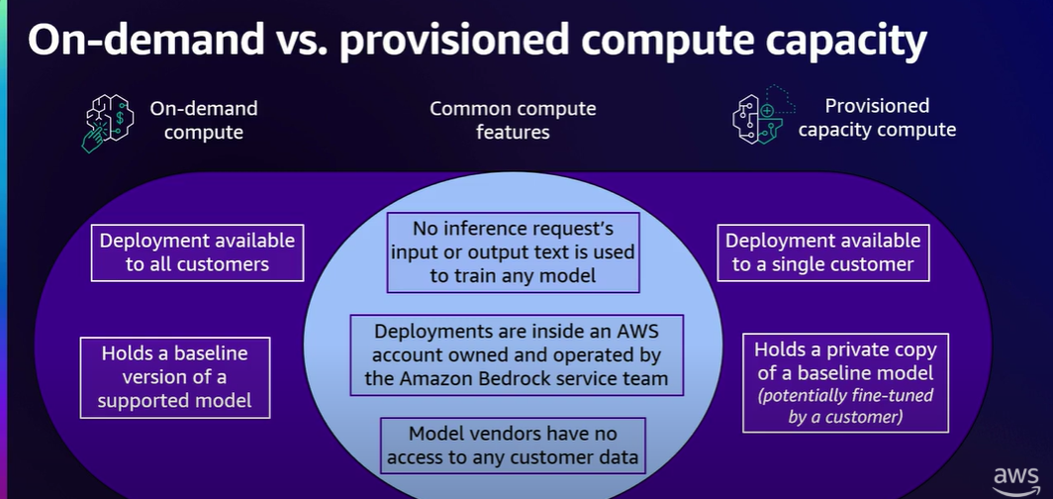

Slide 5

* None of the customer's data is used to train the underlying foundation models
* All data is encrypted at rest using AWS KMS and encrypted in transit with TLS 1.2 (minimum);
* Support for data privacy standards, including GDPR, HIPAA, and PCI

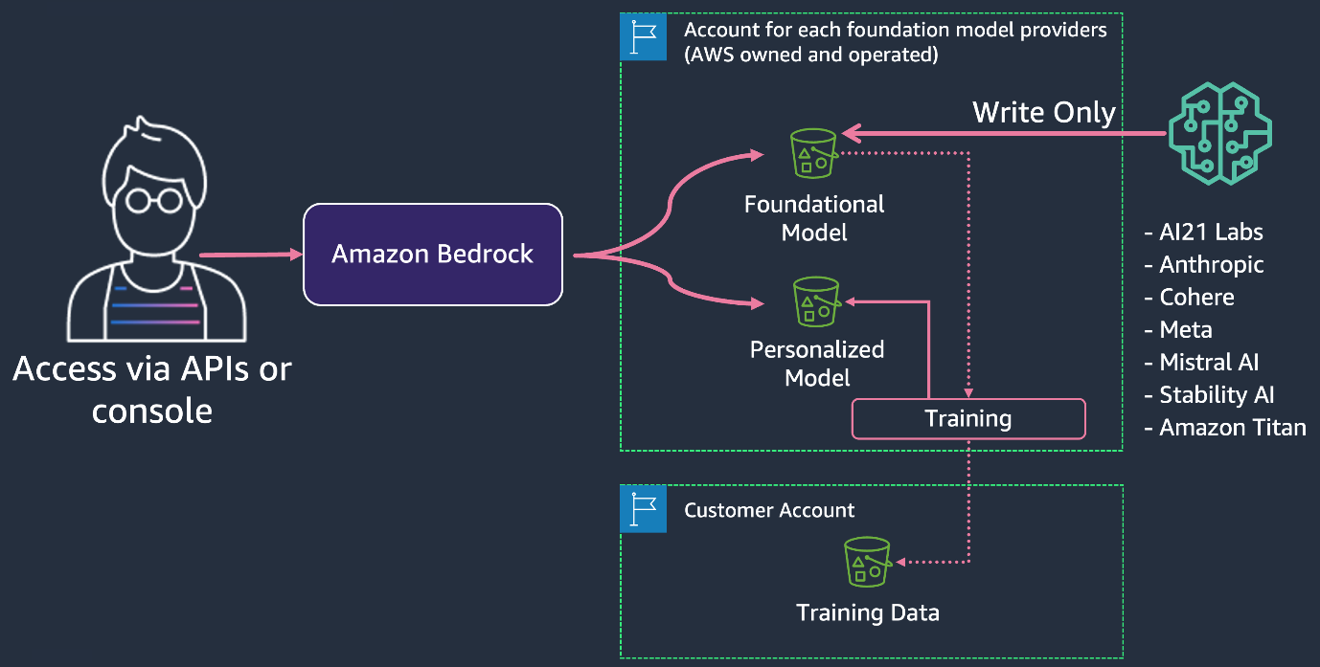

Slide 6

AWS guardrails

* Denied topics
* Content filters
* Sensitive info
* Word filter

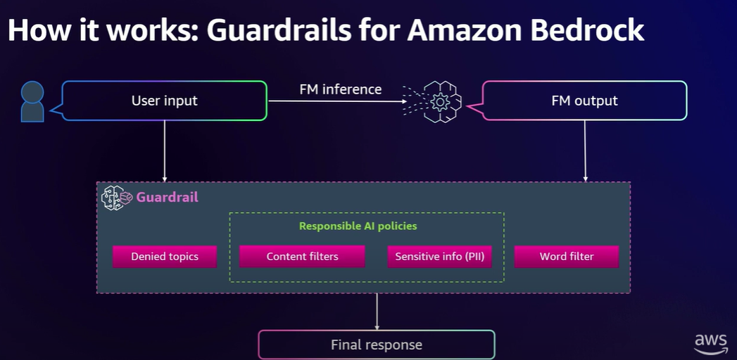

Slide 7

* Fully managed ML platform for building, training, and deploying custom models
* DevOps-relevant features:
  + Pay as you use, scalable infrastructure
  + Model Registry, CI/CD with CodePipeline
  + CloudWatch metrics/logs; Model Monitor

Slide 8

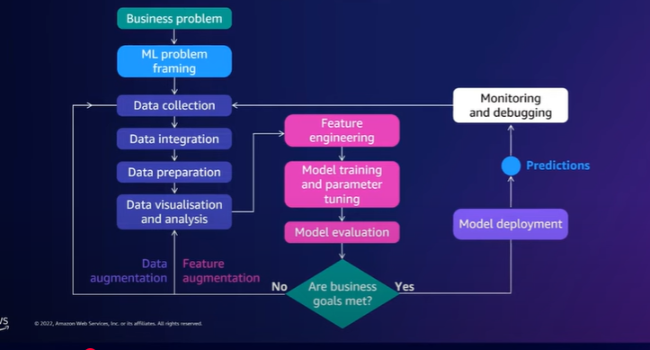

Slide 9

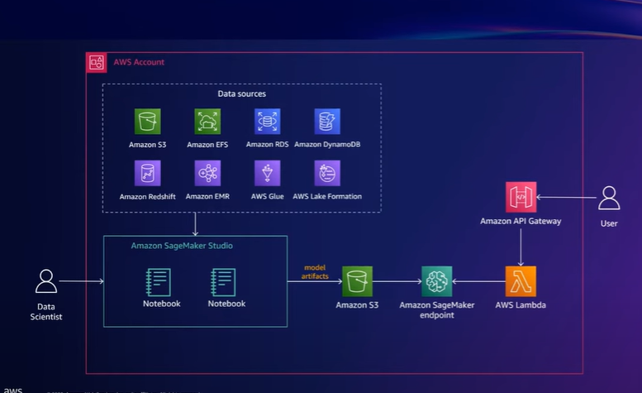

Slide 10

* Bedrock:
  + Fastest path to GenAI, managed safety, RAG, agents, and multi‑FM access
  + Great for app teams that don’t want to host/operate models
* SageMaker:
  + Own training/fine‑tuning stack or host OSS/proprietary models
  + Tight MLOps integration, custom inference graphs, data network locality