 | SIMATS ENGINEERING  Department of Computer Science and Engineering

Guided Project 1
Word Frequency Analytics using Hadoop MapReduce
Course Code | CSA1512
Course Title | Cloud Computing and Big Data Analytics
Slot | B
Faculty | Dr. C. Rajesh Babu
Employee ID | SSETSCS-415
Department | Computer Science and Engineering
Institution | SIMATS Engineering
Delivery Mode | Guided lab project — individual Windows/WSL2 Hadoop installation and MapReduce execution
Estimated Duration | 1 installation session (60-90 min) + 1 guided project session (45-60 min) + evidence preparation
Course Outcome | CO5 - Apply big data storage, integration, Hadoop, HDFS, and MapReduce concepts for distributed data processing.

1. Neatly Organized Notes: Understanding Hadoop and MapReduce
Core Hadoop Characteristics
• Large files are split into fixed-size blocks (128 MB by default) and spread across storage nodes.
• HDFS (Hadoop Distributed File System) stores data reliably by keeping multiple copies (replicas) of every block.
• MapReduce processes data on the node where it is already stored, instead of moving data to one central processor.
• YARN manages cluster resources and decides which node runs which Map or Reduce task.
• The system is designed to scale out across many ordinary machines rather than scale up on one powerful machine.
Real-World Examples of This Processing Pattern
Example | Why It Represents MapReduce-Style Processing
Search engine indexing | Counting and ranking word occurrences across billions of pages — the same map-then-reduce pattern used in this project, at massive scale.
Web server log analysis | Counting page hits, errors, or visits per hour by mapping each log line and reducing by key.
Social media trending topics | Counting hashtag or keyword occurrences within a time window across huge volumes of posts.
Retail transaction analysis | Aggregating purchase counts per product or region across millions of daily transactions.
Where This Fits in Big Data Processing
Layer | Component | Responsibility
Storage | HDFS | Splits and replicates data blocks across the cluster.
Resource Management | YARN | Allocates CPU/memory and schedules Map and Reduce tasks.
Processing | MapReduce | Runs the Mapper, Shuffle/Sort, and Reducer logic to produce the final output.

2. Guided Project Notes: Introduction to Word Frequency Analytics
Why Word Frequency Counting Is Used to Learn MapReduce
Word frequency counting is treated as the "hello world" of distributed computing: the logic is simple enough to trace by hand on a small paragraph, yet it exercises every core MapReduce concept — splitting input, mapping, shuffling/sorting by key, and reducing — that also powers log analysis, search indexing, and trend detection at real-world scale.
Core Components of This MapReduce Job
• Mapper: reads each line of text, splits it into words, and emits <word, 1> for every occurrence found.
• Shuffle & Sort: Hadoop automatically groups all <word, 1> pairs with the same word and routes them to a Reducer.
• Reducer: adds up all the 1s received for each word and emits the final <word, total count>.
• Driver: the small program that tells Hadoop which Mapper, Reducer, input path, and output path this job should use.

PART A — Install Hadoop and Allied Tools on Windows
Hadoop is built for Linux. Installing it directly on Windows requires extra compatibility files (winutils.exe) and frequently breaks. The reliable path below instead installs a real Ubuntu Linux environment inside Windows using WSL2 (Windows Subsystem for Linux), and installs Hadoop inside that Ubuntu environment exactly as it would run on a real Linux server. Every command below is typed into the Ubuntu terminal window unless stated otherwise.
Version Note
This guide installs Hadoop 3.3.6 with Java 11 — a widely used, thoroughly tested combination for a first-time single-node Hadoop cluster. The current Apache Hadoop stable release is 3.5.0, but it requires Java 17 and is newer/less field-tested for classroom rollouts. Faculty may substitute the latest version if preferred; the steps and structure below stay the same.

Step 1: Check Your Windows Version
Purpose: Confirm the laptop can run WSL2 before starting.
• Press the Windows key + R, type winver, and press Enter.
• Confirm Windows 10 version 2004 (Build 19041) or higher, or any edition of Windows 11.
• If the laptop shows an older Windows 10 build, run Windows Update and restart before continuing.
Student Note
WSL2 will not install correctly on Windows versions older than this.

Step 2: Install WSL2 and Ubuntu 22.04
Purpose: Install a real Linux environment inside Windows — Hadoop needs Linux, not Windows, to run reliably.
• Click Start, type "PowerShell", right-click Windows PowerShell, and choose "Run as administrator".
• In the blue PowerShell window, type the command below and press Enter.
• Wait for the download to finish (10-20 minutes depending on internet speed).
• Restart the laptop when prompted.

wsl --install -d Ubuntu-22.04
Student Note
If a message says WSL is already installed, run the same command again — it will just add the Ubuntu-22.04 distribution.

Step 3: Create Your Linux Username and Password
Purpose: Set up your personal Linux account inside Ubuntu.
• After the restart, click Start and open the "Ubuntu 22.04" app (it may also open automatically).
• Wait for "Installing, this may take a few minutes..." to finish.
• When asked "Enter new UNIX username:", type a simple username (for example, your register number in lowercase) and press Enter.
• When asked for a password, type one (it will not show on screen) and press Enter, then re-type to confirm.
Student Note
Remember this username and password — the password will be needed every time a command asks for it (this is normal Linux behaviour, not an error).

Step 4: Update Ubuntu and Install Java 11
Purpose: Update the system and install the Java runtime that Hadoop depends on.
• Type the update command below and press Enter. Enter your password if asked.
• Once it finishes, install Java with the second command.
• Verify the install with the third command — it should print a version starting with 11.

sudo apt update && sudo apt upgrade -y
sudo apt install openjdk-11-jdk -y
java -version
Student Note
As long as the output clearly shows version 11, the exact build number does not matter.

Step 5: Create the Hadoop User (hduser) and Enable SSH
Purpose: Create a dedicated Linux account for running Hadoop and enable the passwordless login Hadoop uses internally to manage its own processes.
• Create the user and set a password when prompted (press Enter through the optional name/phone fields).
• Give this user admin rights.
• Switch into the new user account.
• Install the SSH server.
• Generate a login key (press Enter if asked to overwrite).
• Authorize the key for passwordless login.
• Start the SSH service.
• Test it — this should log in directly without asking for a password; type exit afterwards to return.

sudo adduser hduser
sudo usermod -aG sudo hduser
su - hduser
sudo apt install openssh-server -y
ssh-keygen -t rsa -P "" -f ~/.ssh/id_rsa
cat ~/.ssh/id_rsa.pub >> ~/.ssh/authorized_keys && chmod 600 ~/.ssh/authorized_keys
sudo service ssh start
ssh localhost
exit
Student Note
If ssh localhost still asks for a password, repeat the "authorize the key" command carefully — this is the most common setup mistake.

Step 6: Download and Install Hadoop
Purpose: Download the Hadoop software and place it where the hduser account can use it.
• Make sure the prompt shows hduser@... — if not, type su - hduser first.
• Go to the home folder.
• Download Hadoop 3.3.6.
• Extract the downloaded archive.
• Move it into a system folder.
• Give hduser ownership of that folder.

cd ~
wget https://archive.apache.org/dist/hadoop/common/hadoop-3.3.6/hadoop-3.3.6.tar.gz
tar -xzvf hadoop-3.3.6.tar.gz
sudo mv hadoop-3.3.6 /opt/hadoop
sudo chown -R hduser:hduser /opt/hadoop
Student Note
This download is about 700 MB — use a stable Wi-Fi connection.

Step 7: Set Environment Variables
Purpose: Tell Ubuntu where Hadoop and Java are installed so the hadoop command works from any folder.
• Open the settings file.
• Use the arrow keys to reach the very bottom of the file.
• Type or paste the six lines shown below, exactly as written.
• Save with Ctrl+O, then Enter, then exit with Ctrl+X.
• Reload the settings file.
• Confirm Hadoop is recognised.

nano ~/.bashrc

# --- paste at the bottom of the file ---
export JAVA_HOME=/usr/lib/jvm/java-11-openjdk-amd64
export HADOOP_HOME=/opt/hadoop
export HADOOP_MAPRED_HOME=$HADOOP_HOME
export HADOOP_COMMON_HOME=$HADOOP_HOME
export HADOOP_HDFS_HOME=$HADOOP_HOME
export YARN_HOME=$HADOOP_HOME
export PATH=$PATH:$HADOOP_HOME/bin:$HADOOP_HOME/sbin
# --- save (Ctrl+O, Enter) and exit (Ctrl+X), then run: ---
source ~/.bashrc
hadoop version
Student Note
If hadoop version says "command not found", re-check this step for a typo in HADOOP_HOME.

Step 8: Configure Hadoop (four XML files)
Purpose: Tell Hadoop where to store data and how its internal parts should talk to each other.
• Go to the configuration folder.
• Open hadoop-env.sh, find the line starting with #export JAVA_HOME, and below it add the JAVA_HOME line shown, then save and exit.
• Create the data folders Hadoop will use.
• Open core-site.xml and add the property below between the existing <configuration> and </configuration> tags.
• Open hdfs-site.xml and add its three properties the same way.
• Open mapred-site.xml and add its property the same way.
• Open yarn-site.xml and add its property the same way.

cd $HADOOP_HOME/etc/hadoop
nano hadoop-env.sh
export JAVA_HOME=/usr/lib/jvm/java-11-openjdk-amd64

mkdir -p ~/hdfsdata/namenode ~/hdfsdata/datanode

nano core-site.xml
<property>
<name>fs.defaultFS</name>
<value>hdfs://localhost:9000</value>
</property>

nano hdfs-site.xml
<property><name>dfs.replication</name><value>1</value></property>
<property><name>dfs.namenode.name.dir</name><value>/home/hduser/hdfsdata/namenode</value></property>
<property><name>dfs.datanode.data.dir</name><value>/home/hduser/hdfsdata/datanode</value></property>

nano mapred-site.xml
<property><name>mapreduce.framework.name</name><value>yarn</value></property>

nano yarn-site.xml
<property><name>yarn.nodemanager.aux-services</name><value>mapreduce_shuffle</value></property>
Student Note
Every new property must sit between the <configuration> and </configuration> tags already present in the file — do not delete those tags.

Step 9: Format HDFS and Start the Cluster
Purpose: Prepare the storage system once, then switch the cluster on.
• Format the NameNode — do this only once, ever, for this installation.
• Start HDFS.
• Start YARN.
• Check that everything is running.

hdfs namenode -format
start-dfs.sh
start-yarn.sh
jps

# expected output (order may vary):
NameNode
DataNode
SecondaryNameNode
ResourceManager
NodeManager
Student Note
If any of these five names is missing, check the matching log file inside $HADOOP_HOME/logs before asking for help.

Step 10: Confirm the Cluster from the Browser
Purpose: See the cluster running visually, not just in the terminal.
• Open any Windows browser (Edge or Chrome).
• Go to http://localhost:9870 to see the HDFS NameNode dashboard.
• Go to http://localhost:8088 to see the YARN ResourceManager dashboard.
• Take a screenshot of both pages for your evidence folder.
Student Note
WSL2 automatically makes localhost work between Ubuntu and Windows, so no extra network setup is needed.

Important — Every Time You Reopen Ubuntu
Hadoop's daemons stop whenever the Ubuntu window is closed or the laptop restarts. Before doing any work, always re-run: sudo service ssh start, then start-dfs.sh, then start-yarn.sh. Confirm with jps before continuing.

PART B — Guided Project: Word Frequency Analytics using Hadoop MapReduce
With the cluster running, this project uploads a text file into HDFS and runs a MapReduce word-count job against it to find the most frequently used words.
Step A: Prepare the Input Text File
Purpose: Get a real body of text ready for MapReduce to analyze.
• Choose text of at least 500-1000 words — a book chapter, a set of news articles, or a paragraph you write yourself.
• Create the file in Ubuntu.
• Paste or type the text, save with Ctrl+O then Enter, and exit with Ctrl+X.

nano input.txt
Student Note
Longer, more varied text produces more interesting word-frequency results.

Step B: Upload the File into HDFS
Purpose: MapReduce jobs read only from HDFS, not directly from the Ubuntu or Windows file system.
• Create a folder inside HDFS.
• Upload the file.
• Confirm the upload.

hdfs dfs -mkdir -p /user/hduser/wordcount/input
hdfs dfs -put input.txt /user/hduser/wordcount/input
hdfs dfs -ls /user/hduser/wordcount/input

Step C: Run the Word Count MapReduce Job
Purpose: Execute the distributed Map -> Shuffle/Sort -> Reduce job using the example program that ships with Hadoop.
• Locate the ready-made example program.
• Run the job against the uploaded file.
• Watch the terminal — progress climbs from map 0% reduce 0% to map 100% reduce 100%.

ls $HADOOP_HOME/share/hadoop/mapreduce/
hadoop jar $HADOOP_HOME/share/hadoop/mapreduce/hadoop-mapreduce-examples-3.3.6.jar wordcount /user/hduser/wordcount/input /user/hduser/wordcount/output
Student Note
If the job fails immediately, run jps again — most failures happen because start-dfs.sh or start-yarn.sh was not re-run after reopening Ubuntu.

Step D: View and Interpret the Results
Purpose: Read the word counts MapReduce produced and identify patterns.
• Print the result to the screen.
• Save a copy to the home folder.
• Sort it to see the 20 most frequent words.
• Record the top 10 words and their counts in your submission.

hdfs dfs -cat /user/hduser/wordcount/output/part-r-00000
hdfs dfs -get /user/hduser/wordcount/output/part-r-00000 ~/wordcount_result.txt
sort -k2 -n -r ~/wordcount_result.txt | head -20
Student Note
Common words such as "the", "and", and "a" will usually dominate — note this and explain why in your reflection.

Step E (Bonus): Write Your Own Mapper and Reducer
Purpose: Understand exactly what the built-in example does, by writing the same logic yourself in Java.
• On the Windows side, or using nano in Ubuntu, create the three files below inside a new folder ~/wordcount_src.

// WordCountMapper.java
import java.io.IOException;
import org.apache.hadoop.io.IntWritable;
import org.apache.hadoop.io.Text;
import org.apache.hadoop.mapreduce.Mapper;

public class WordCountMapper extends Mapper<Object, Text, Text, IntWritable> {
private final static IntWritable one = new IntWritable(1);
private Text word = new Text();
public void map(Object key, Text value, Context context)
throws IOException, InterruptedException {
String[] tokens = value.toString().toLowerCase().split("\\W+");
for (String token : tokens) {
if (token.length() > 0) {
word.set(token);
context.write(word, one);
}
}
}
}

// WordCountReducer.java
import java.io.IOException;
import org.apache.hadoop.io.IntWritable;
import org.apache.hadoop.io.Text;
import org.apache.hadoop.mapreduce.Reducer;

public class WordCountReducer extends Reducer<Text, IntWritable, Text, IntWritable> {
public void reduce(Text key, Iterable<IntWritable> values, Context context)
throws IOException, InterruptedException {
int sum = 0;
for (IntWritable val : values) sum += val.get();
context.write(key, new IntWritable(sum));
}
}
// WordCountDriver.java
import org.apache.hadoop.conf.Configuration;
import org.apache.hadoop.fs.Path;
import org.apache.hadoop.io.IntWritable;
import org.apache.hadoop.io.Text;
import org.apache.hadoop.mapreduce.Job;
import org.apache.hadoop.mapreduce.lib.input.FileInputFormat;
import org.apache.hadoop.mapreduce.lib.output.FileOutputFormat;

public class WordCountDriver {
public static void main(String[] args) throws Exception {
Configuration conf = new Configuration();
Job job = Job.getInstance(conf, "word frequency analytics");
job.setJarByClass(WordCountDriver.class);
job.setMapperClass(WordCountMapper.class);
job.setReducerClass(WordCountReducer.class);
job.setOutputKeyClass(Text.class);
job.setOutputValueClass(IntWritable.class);
FileInputFormat.addInputPath(job, new Path(args[0]));
FileOutputFormat.setOutputPath(job, new Path(args[1]));
System.exit(job.waitForCompletion(true) ? 0 : 1);
}
}
Compile, Package, and Run the Custom Job
Purpose: Turn the three Java files into a runnable jar and execute it exactly like the built-in example.
• Compile the three files against the Hadoop classpath.
• Package the compiled classes into a jar.
• Remove any previous output folder (MapReduce refuses to overwrite an existing output directory).
• Run the custom jar against the same input.
• View the result the same way as Step D.

mkdir -p ~/wordcount_src/classes
javac -classpath $(hadoop classpath) -d ~/wordcount_src/classes ~/wordcount_src/*.java
cd ~/wordcount_src/classes && jar -cvf ~/wordcount_src/wordcount.jar *.class && cd ~
hdfs dfs -rm -r /user/hduser/wordcount/output_custom
hadoop jar ~/wordcount_src/wordcount.jar WordCountDriver /user/hduser/wordcount/input /user/hduser/wordcount/output_custom
hdfs dfs -cat /user/hduser/wordcount/output_custom/part-r-00000
Student Note
This bonus step is optional but strongly recommended — it is the clearest way to understand what Map, Shuffle/Sort, and Reduce are each actually doing.

Step F: Prepare Evidence for Submission
Purpose: Package proof of the completed work for grading.
• Screenshot: jps output showing all five daemons.
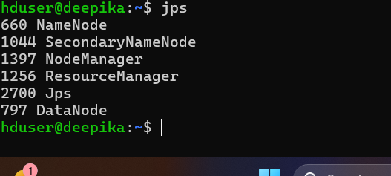
• Screenshot: the HDFS web UI (localhost:9870).
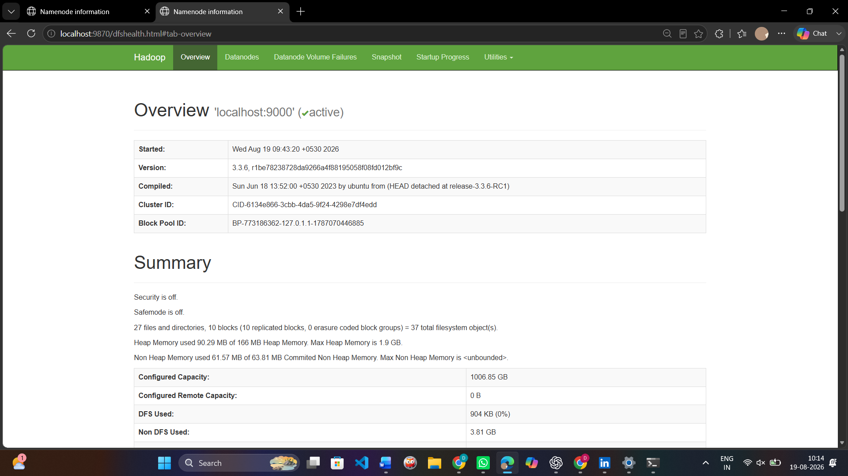
• Screenshot: the YARN web UI (localhost:8088) showing the completed job.
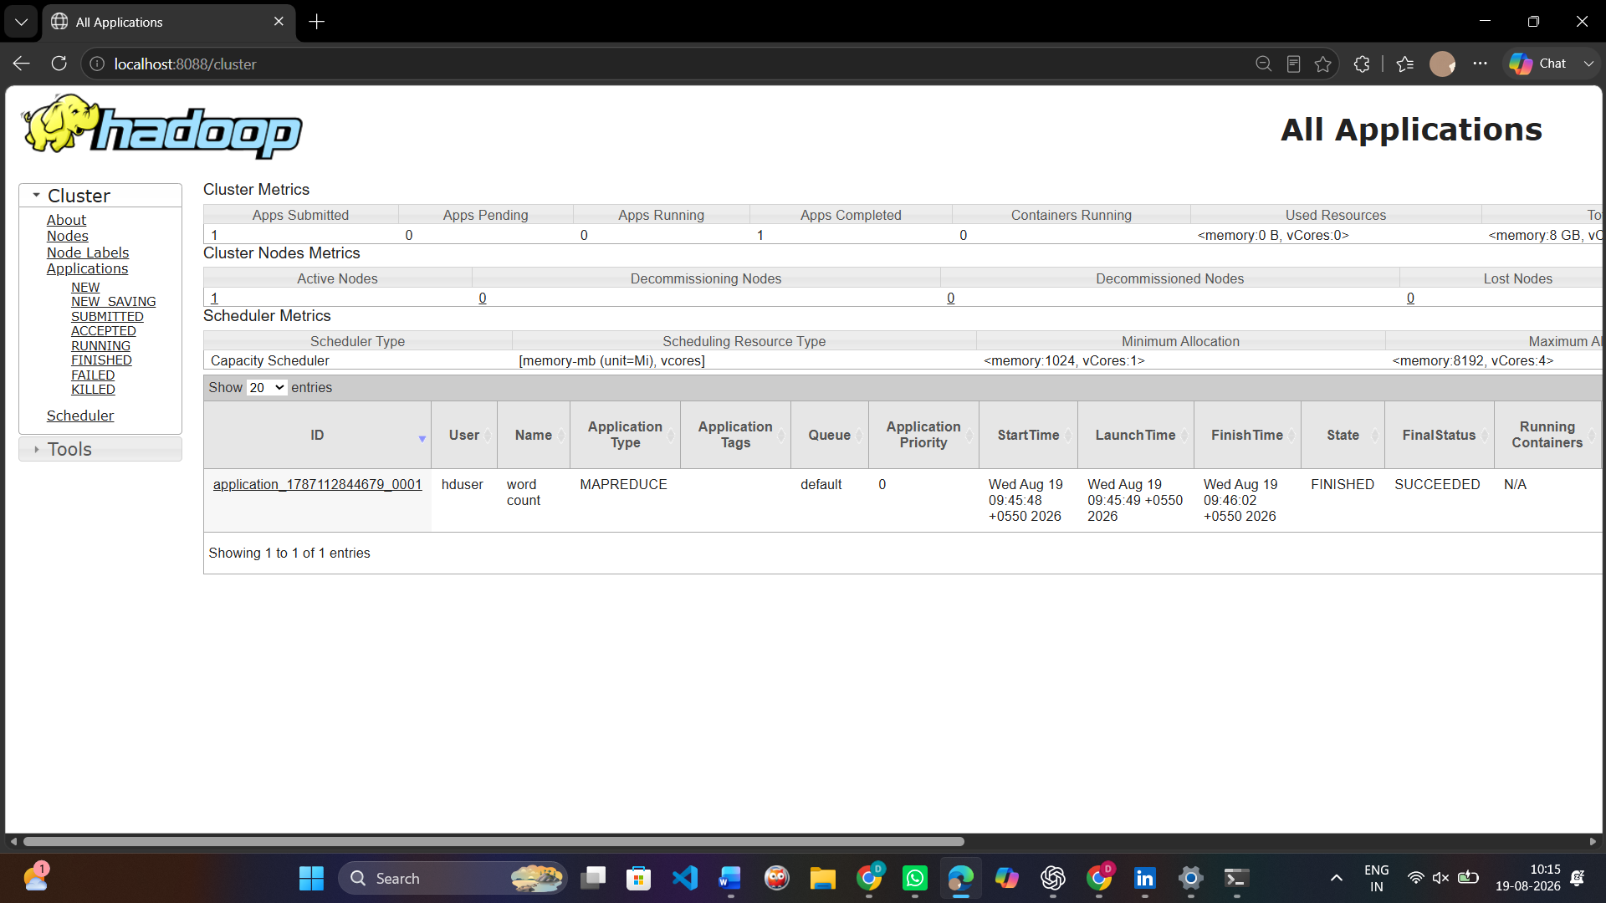
• Screenshot: the terminal showing the job reaching map 100% / reduce 100%.
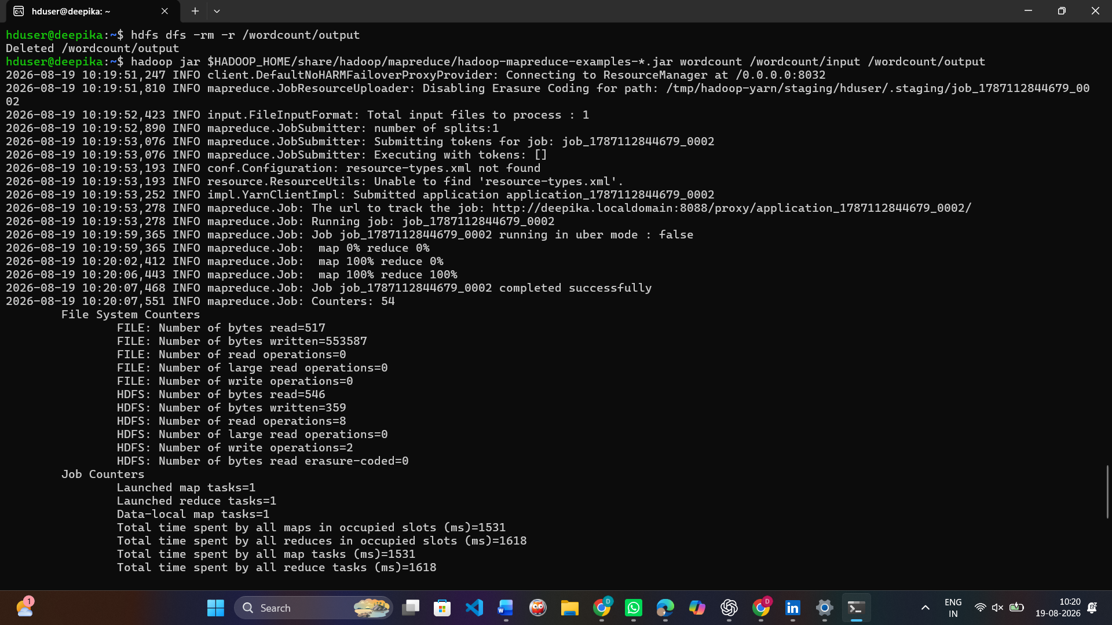
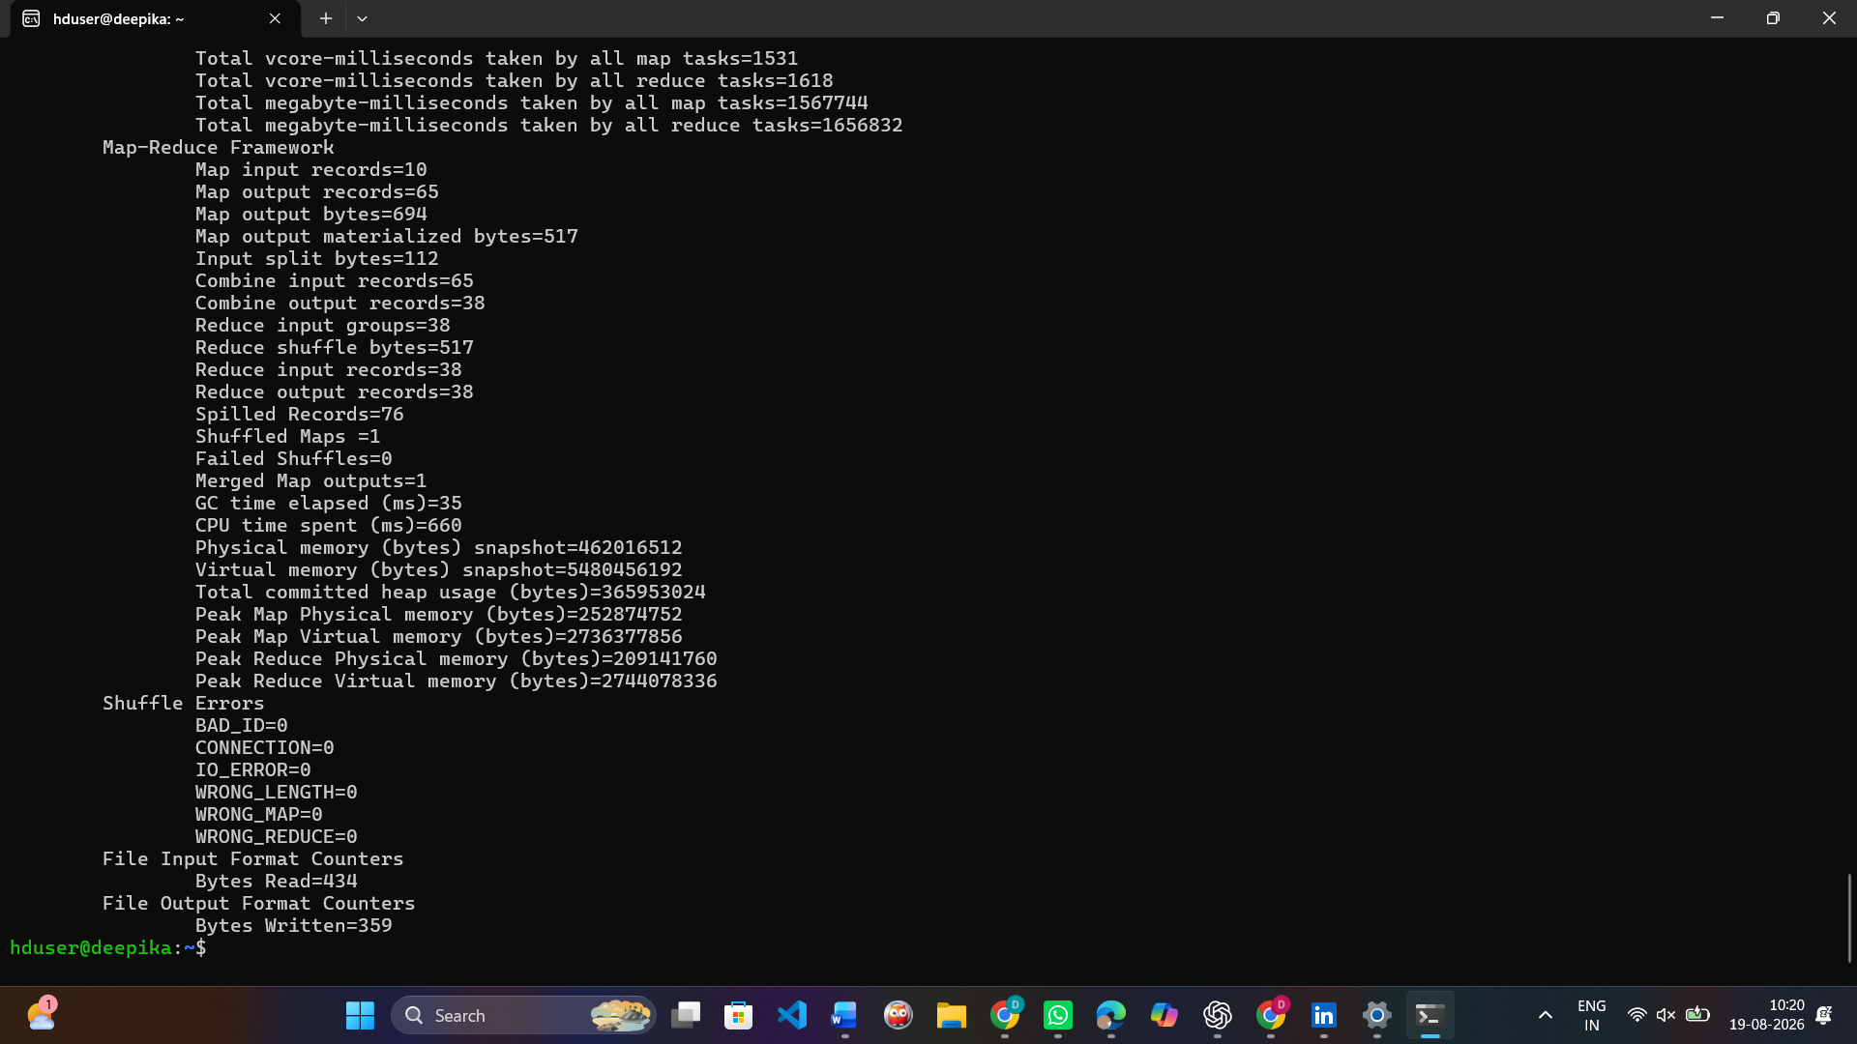
• Save or screenshot: the top-10 word frequency table.
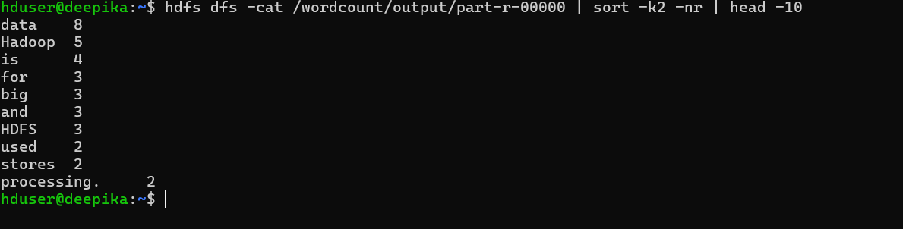

• Upload input.txt, wordcount_result.txt, and all screenshots to a GitHub repository, and submit the repository link through Google Classroom.

https://github.com/mdeepika2006/CCBD1512-Cloud-Computing-LAB

Evidence to Be Submitted
• Screenshot of jps showing NameNode, DataNode, SecondaryNameNode, ResourceManager, and NodeManager.
• Screenshot of the HDFS NameNode web UI (localhost:9870).
• Screenshot of the YARN ResourceManager web UI (localhost:8088) with the completed job visible.
• Screenshot of the terminal showing the MapReduce job reaching map 100% / reduce 100%.
• A table of the top 10 most frequent words with their counts.
• A short written reflection (5-6 lines) on what the Mapper, Shuffle/Sort, and Reducer phases each did in this job.
• GitHub repository link (containing the input file, output file, and screenshots) submitted through Google Classroom.
Learning Outcomes
• Install and configure a working single-node Hadoop cluster on a Windows laptop using WSL2.
• Explain the role of HDFS, YARN, and MapReduce in distributed data processing.
• Upload data into HDFS and run a MapReduce job against it.
• Interpret MapReduce output to extract word-frequency patterns from real text.
• Relate the word-count pattern to real-world applications such as log analysis, search indexing, and trending-topic detection.
Challenge Questions
• Why does Hadoop split large files into blocks before processing them?
• What would change in this job's behaviour if dfs.replication were set to 3 instead of 1 on this single-node setup?
• Why is the Shuffle and Sort phase necessary between the Mapper and the Reducer?
• How would you modify the Mapper logic to ignore case and strip punctuation more thoroughly?
• Name one real-world system that uses a Map-Reduce-style pattern similar to word counting, and explain the similarity.
Student Checklist Before Submission
Checklist Item | Done
WSL2 and Ubuntu 22.04 installed and verified.
Java 11 installed and verified with java -version.
hduser created with working passwordless SSH (ssh localhost succeeds without a password prompt).
Hadoop 3.3.6 downloaded, extracted, and environment variables set.
core-site.xml, hdfs-site.xml, mapred-site.xml, and yarn-site.xml configured.
NameNode formatted once, and start-dfs.sh / start-yarn.sh run successfully.
jps shows all five daemons running.
Input text file uploaded to HDFS.
WordCount MapReduce job completed successfully (map 100%, reduce 100%).
Top 10 word frequencies recorded and reflection written.
All evidence uploaded to GitHub with the repository link submitted through Google Classroom.

Student Completion Record
Student Name
Register Number
Class / Slot | Slot B
Hadoop Version Installed | Hadoop 3.3.6
Top Word (highest frequency)
GitHub / GCR Evidence Link
Submission Date

