AI ASSISTED CODING
Lab-2.3:
Exploring Additional AI Coding Tools-Gemini & CursorAI
Name : Rokalboyana Varshith
Enroll no : 2403A510D7
Batch : 05

Task-1:
● Use Google Gemini in Colab to write a function that reads a CSV file and calculates mean, min, max.
Expected Output#1
● Functional code with output and screenshot
Prompt:generate code on function that reads a csv file and calculates mean,min,max
Code:
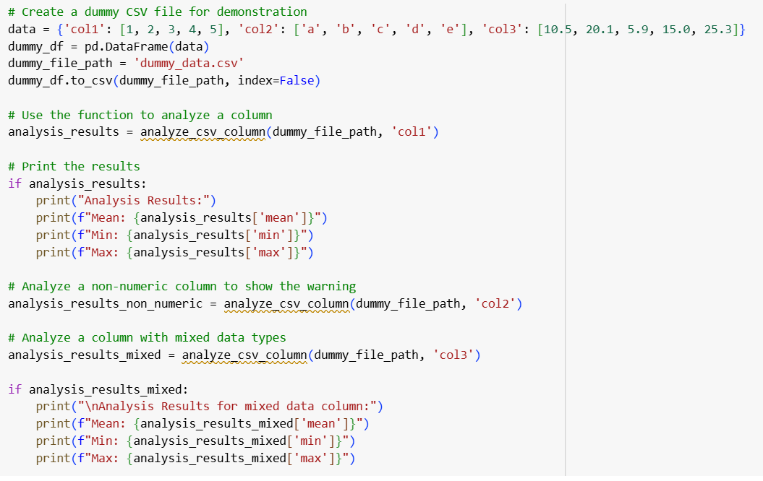
Output:
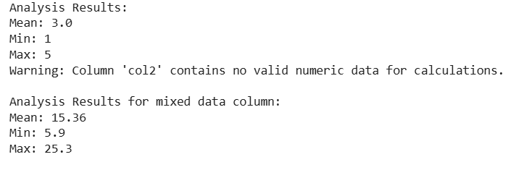
Task-2:
● Compare Gemini and Copilot outputs for a palindrome check function.
Expected Output#2
● Side-by-side comparison and observations
Prompt:generate code for palindrome check function.
Code:
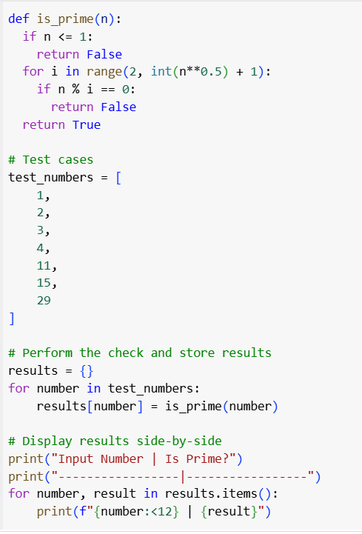

Output:
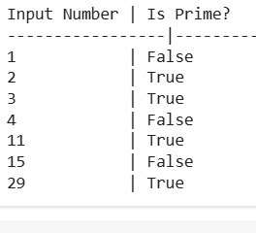
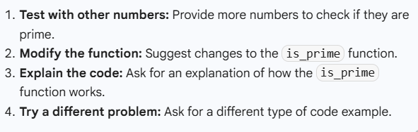

Task-3:
● Ask Gemini to explain a Python function (to calculate area of various shapes) line by line..
Expected Output#3
● Detailed explanation with code snippet.
Prompt:
Generate code Python function (to calculate area of various shapes)
Code:
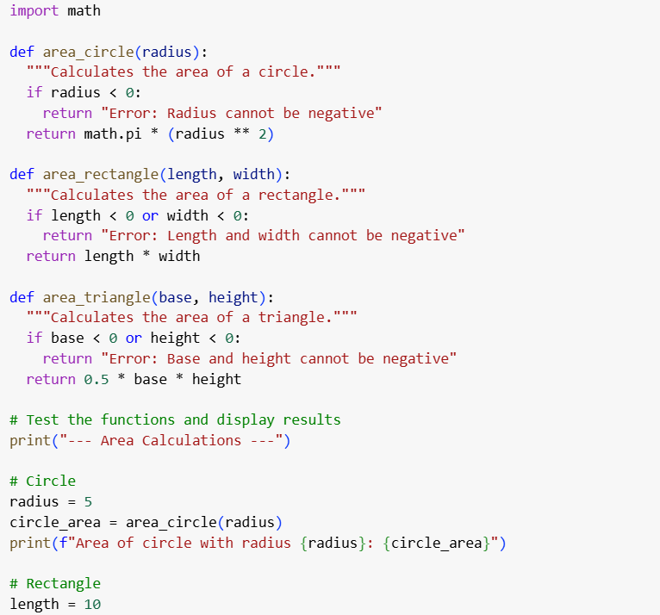
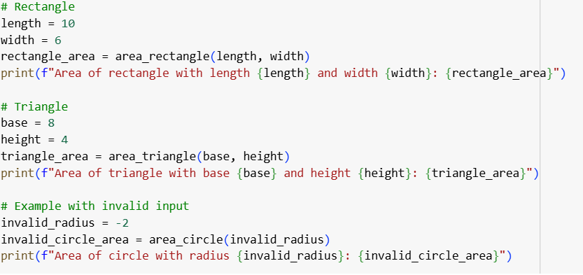
Output:
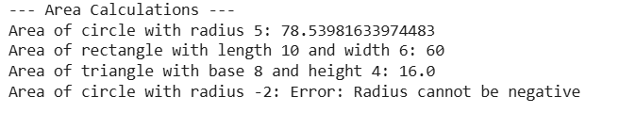
Explanation:
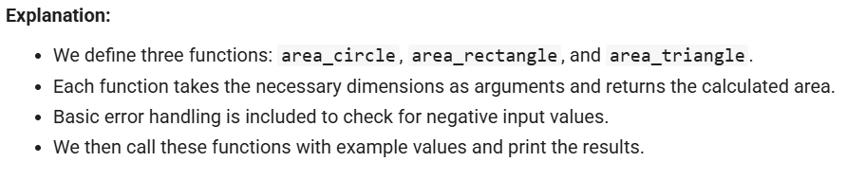
Task-4:
● Install and configure Cursor AI. Use it to generate a Python function(e.g.,sumof squares).
Expected Output#4
● Screenshots of working environments with few prompts to generate python code
Prompt:
Generate code on python function of sum of squares
Code:
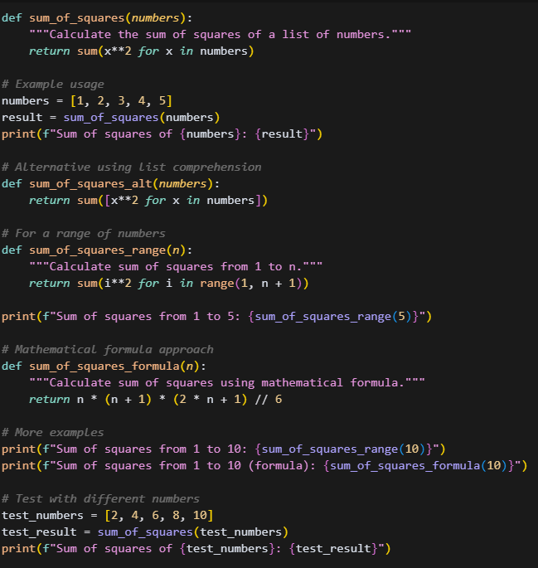
Output:
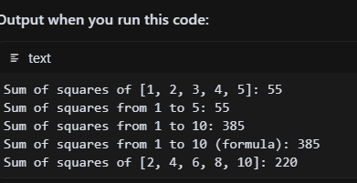

Task-5:
● Student need to write code to calculate sum of add number and even numbers in the list
Expected Output#5
● Refactored code written by student with improved logic.
Prompt: write code to calculate sum of add number and even numbers in the list
Code:
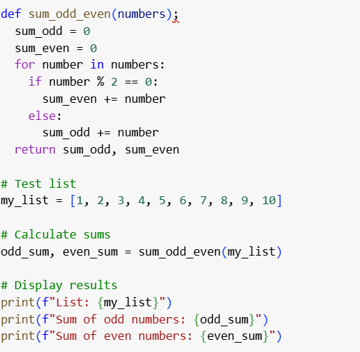
Output:
