AI ASSISTED CODING
Lab-4.3:
Advanced Prompt Engineering-Techniques

Name : Rokalboyana Varshith
Enroll no : 2403A510D7
Batch : 05

Task-1: Zero-shot

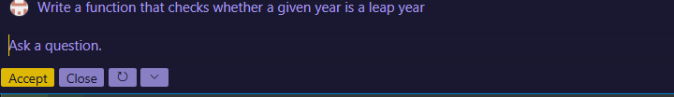
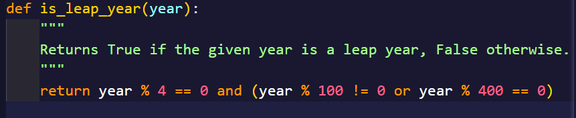

Task-2: One-shot

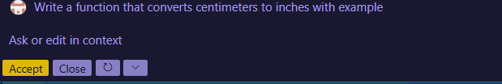
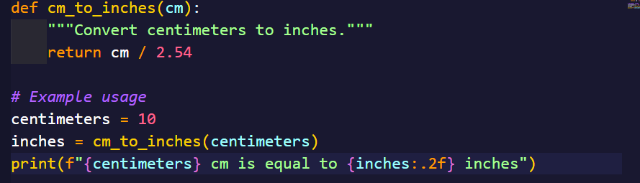

Task-3:
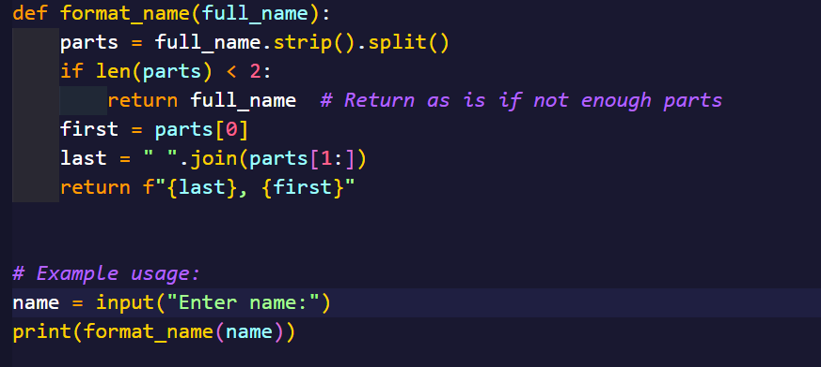
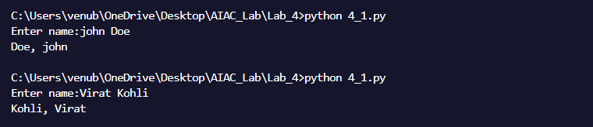

Task-4:

Zero-shot:
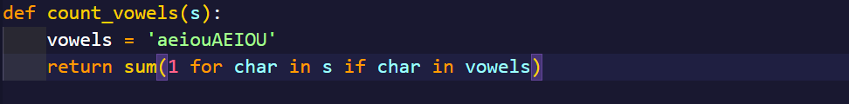
Few-shot:
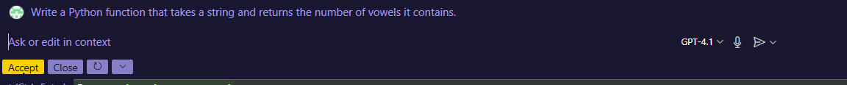
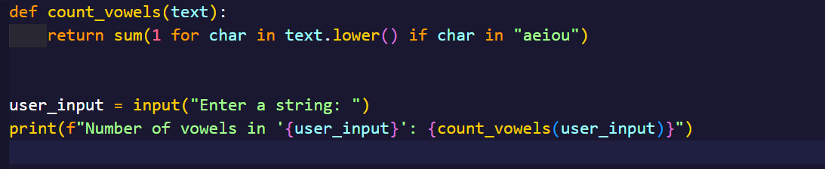
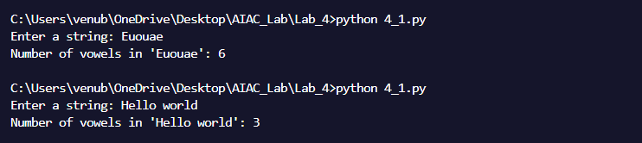
Comparison:
The zero-shot method gives a basic and correct solution. It works even without examples, but the code is usually longer and more manual. The AI has to guess what you want just from the question.
The few-shot method includes examples, so the AI understands better. It gives shorter, cleaner, and more efficient code.
Task-5:
