Name : Rokalboyana Varshith Enroll no : 2403A510D7 Batch : 05
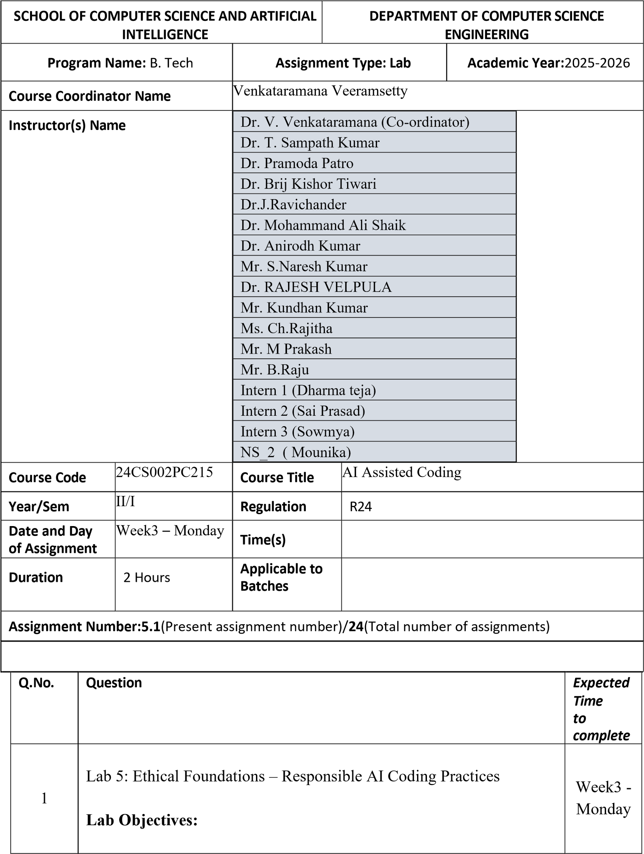

- To explore the ethical risks associated with AI-generated code.
- To recognize issues related to security, bias, transparency, and copyright.
- To reflect on the responsibilities of developers when using AI tools in software development.
- To promote awareness of best practices for responsible and ethical AI coding.

Lab Outcomes (LOs):
After completing this lab, students will be able to:

- Identify and avoid insecure coding patterns generated by AI tools.
- Detect and analyze potential bias or discriminatory logic in AIgenerated outputs.
- Evaluate originality and licensing concerns in reused AIgenerated code.
- Understand the importance of explainability and transparency in AI-assisted programming.
- Reflect on accountability and the human role in ethical AI coding practices..

Task Description #1 (Privacy in API Usage)
Task: Use an AI tool to generate a Python program that connects to a weather API.
Prompt:
"Generate code to fetch weather data securely without exposing API keys in the code." Expected Output:
- Original AI code (check if keys are hardcoded).
- Secure version using environment variables Prompt:
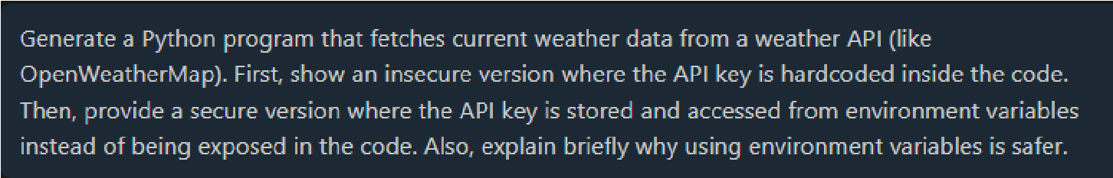
Code:

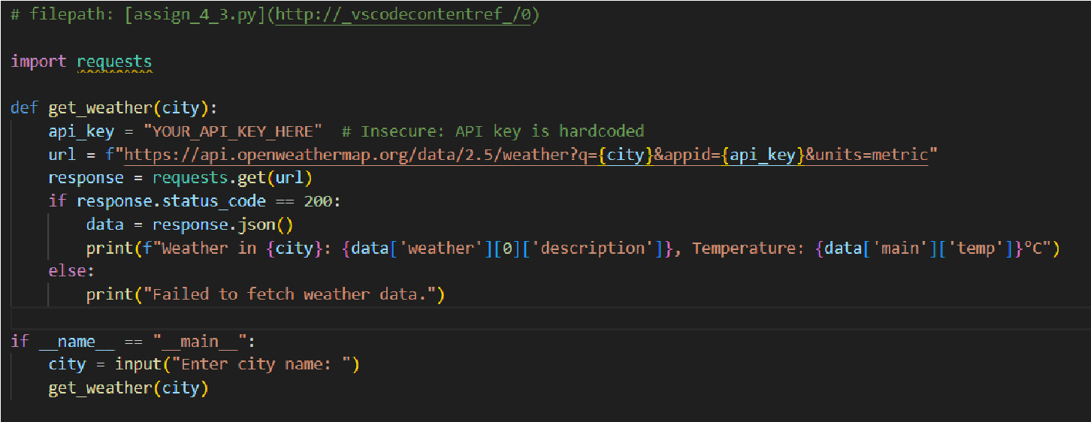
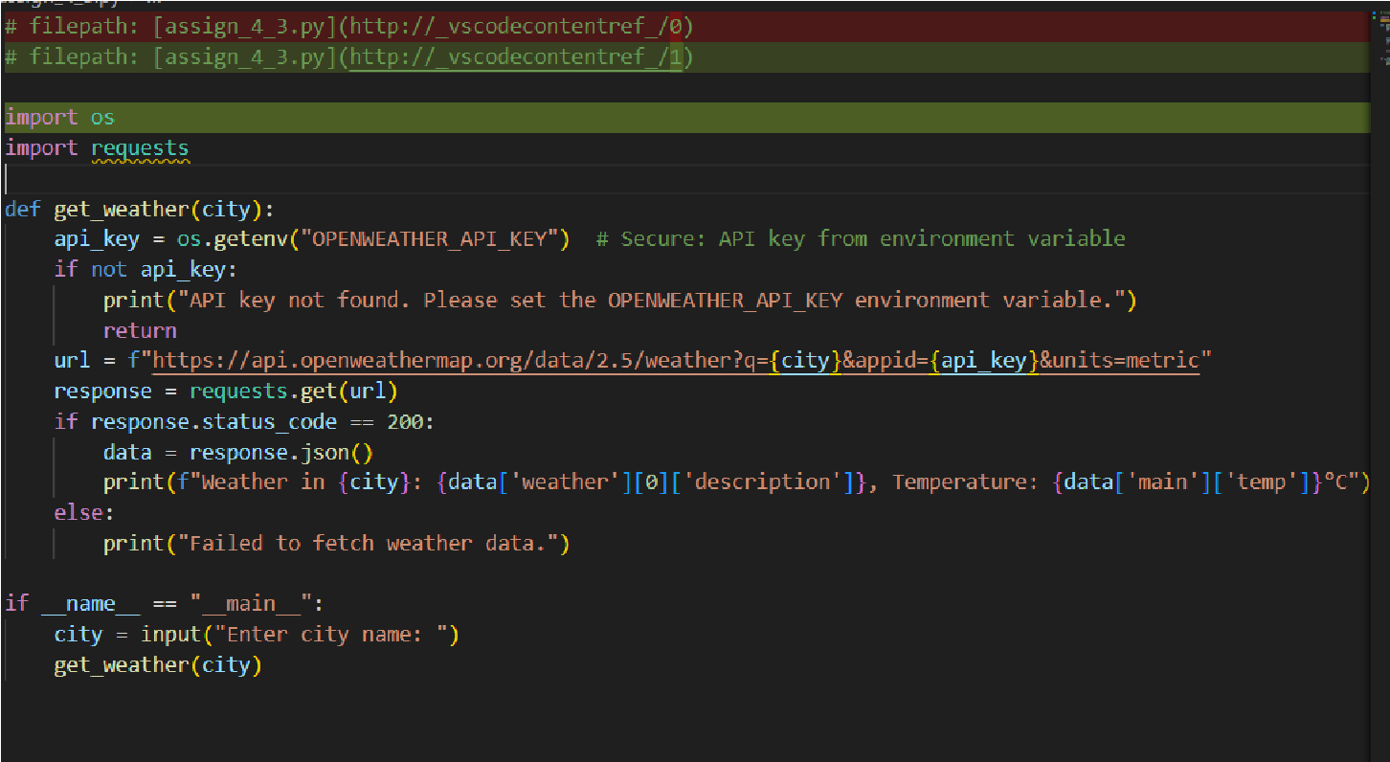

Output:
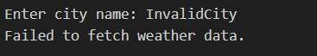
Task Description #2 (Privacy & Security in File Handling)
Task: Use an AI tool to generate a Python script that stores user data (name, email, password) in a file.
Analyze: Check if the AI stores sensitive data in plain text or without encryption.
Expected Output:
- Identified privacy risks.
- Revised version with encrypted password storage (e.g., hashing).
Prompt:

Code:
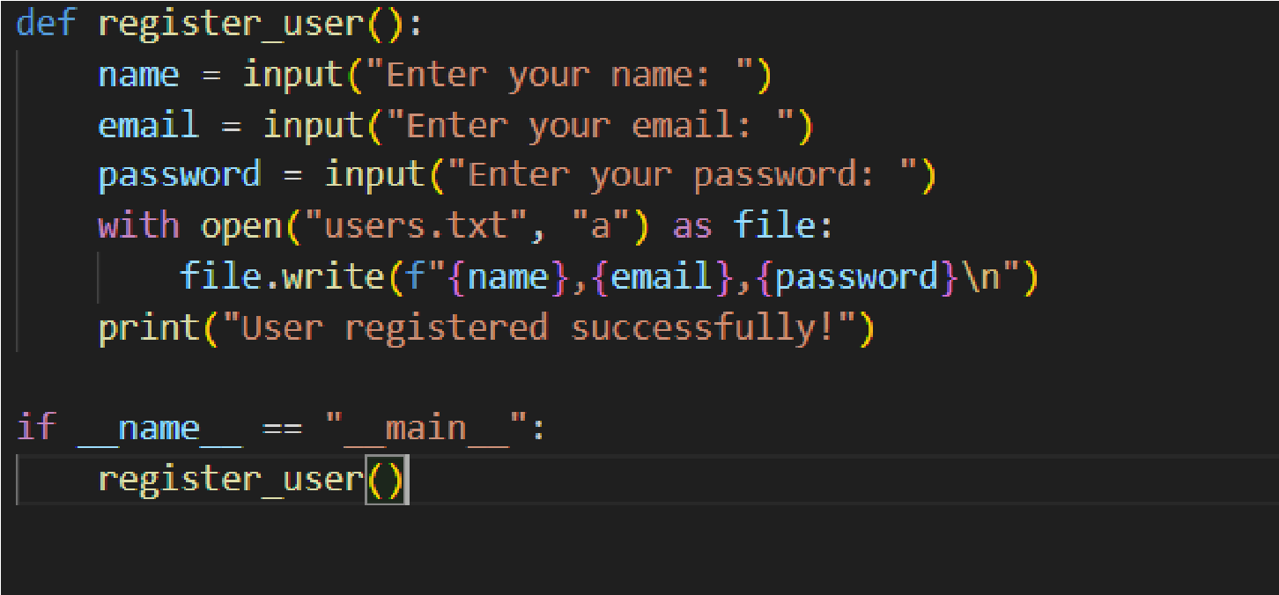
Output:
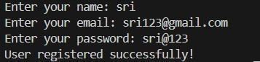
IN the file:
- Plain-text password storage: Passwords are stored exactly as entered.
- No hashing or encryption: A data breach would expose user passwords.
- Vulnerable to insider threats: Anyone with access to the file can read sensitive data.
Task Description #3 (Transparency in Algorithm Design)
Objective: Use AI to generate an Armstrong number checking function with comments and explanations.
Instructions:
- Ask AI to explain the code line-by-line.
- Compare the explanation with code functionality.
Expected Output:
- Transparent, commented code.
- Correct, easy-to-understand explanation.
Prompt:
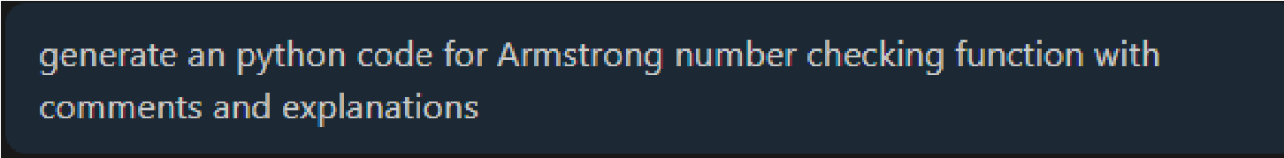
Code:

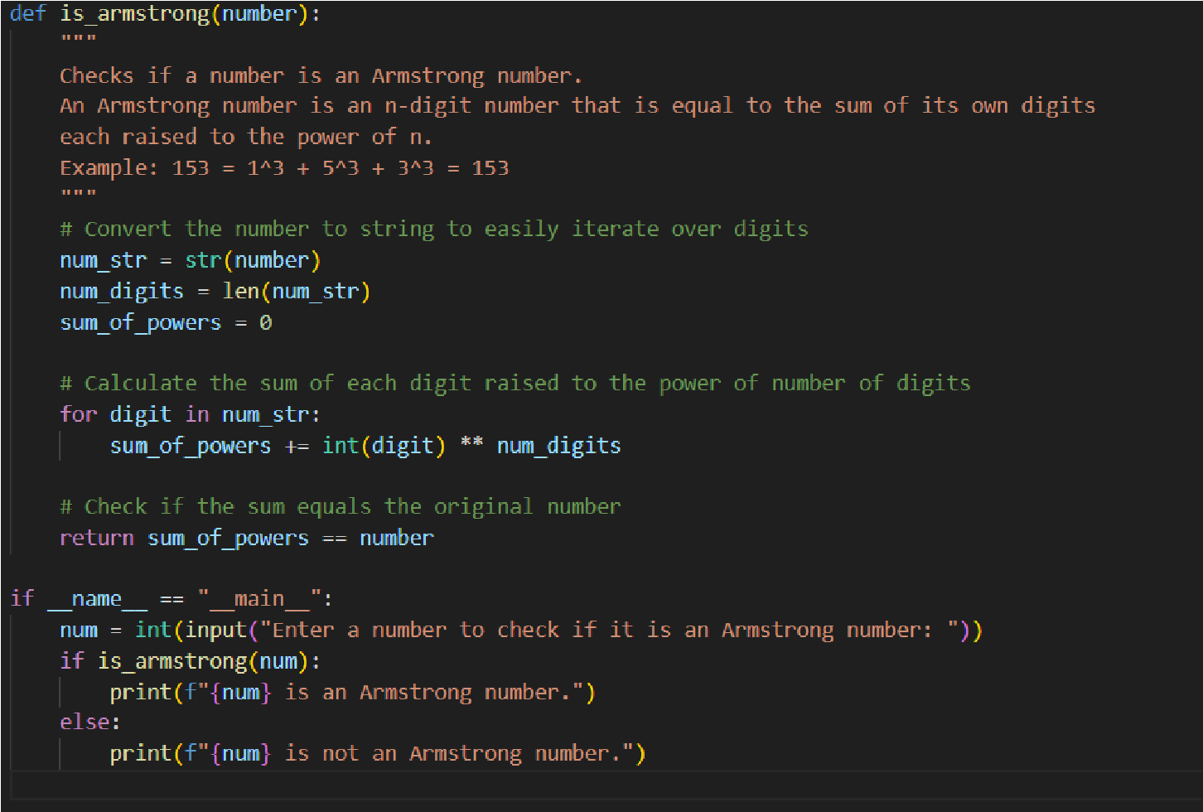
Output:
Task Description #4 (Transparency in Algorithm Comparison)
Task: Use AI to implement two sorting algorithms (e.g., QuickSort and BubbleSort).
Prompt:
"Generate Python code for QuickSort and BubbleSort, and include comments explaining step-by-step how each works and where they differ."
Expected Output:
- Code for both algorithms.
- Transparent, comparative explanation of their logic and efficiency.
Prompt:
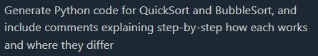
Code:

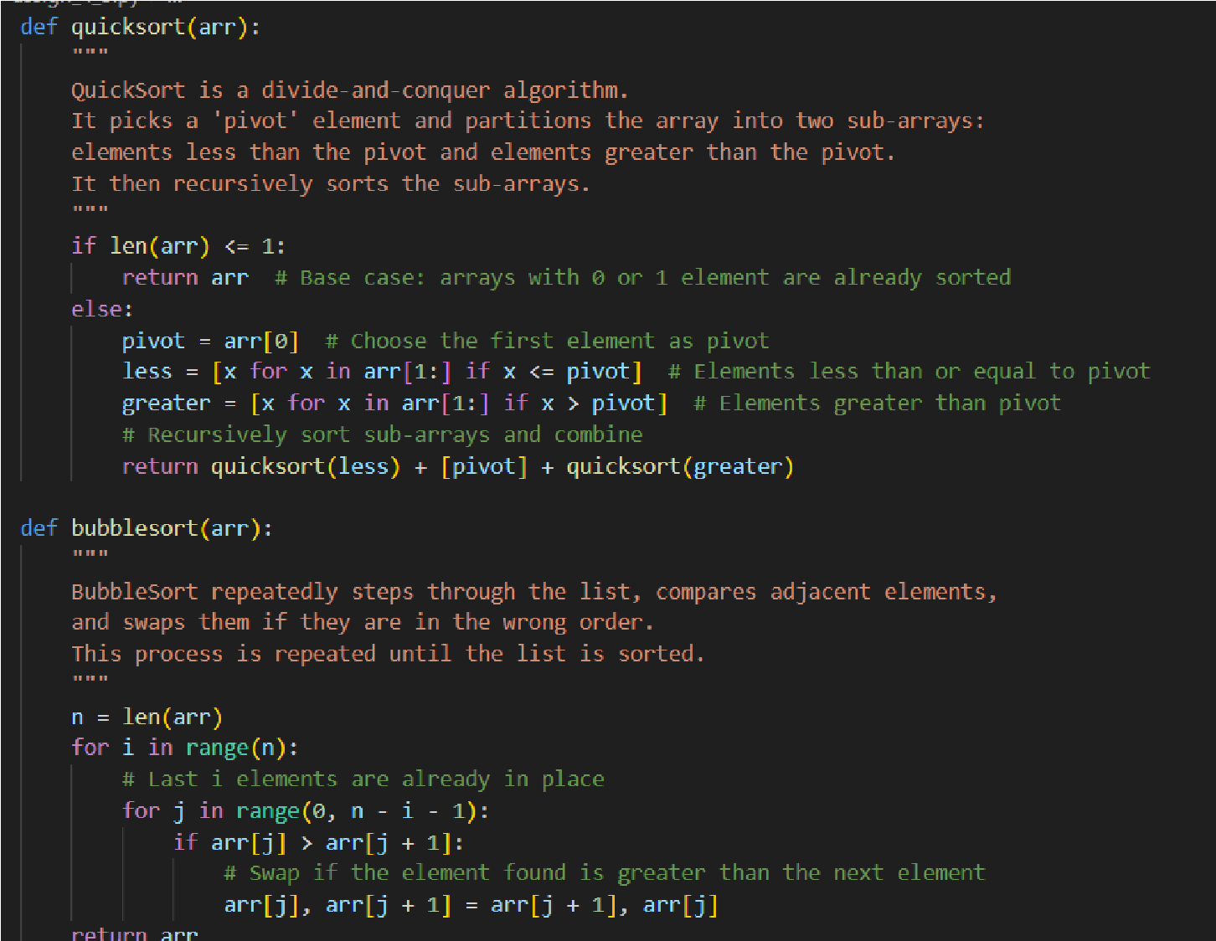
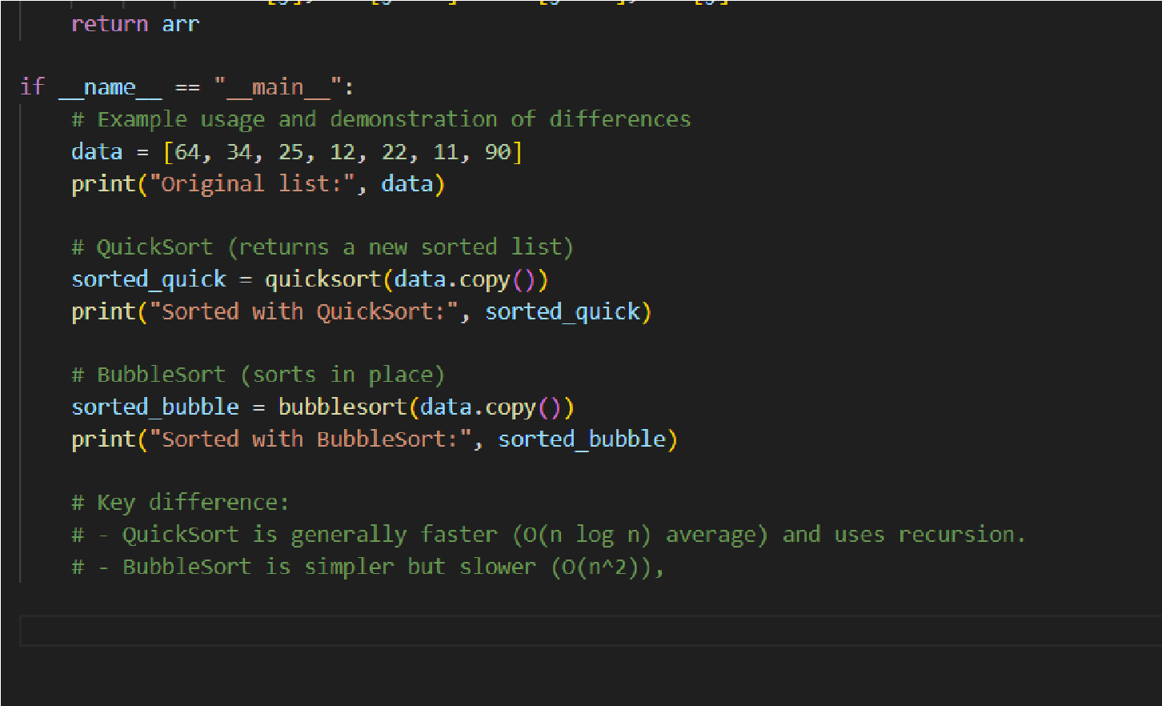
Output:
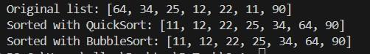

Task Description #5 (Transparency in AI Recommendations) Task: Use AI to create a product recommendation system.
Prompt:
"Generate a recommendation system that also provides reasons for each suggestion."

Expected Output:
- Code with explainable recommendations.
- Evaluation of whether explanations are understandable.
Prompt:
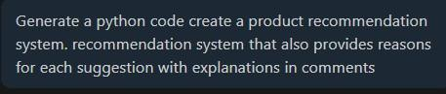
Code:
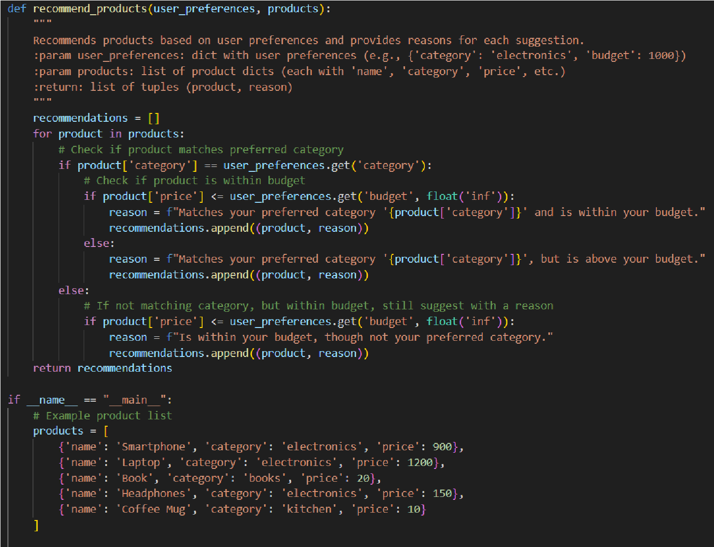
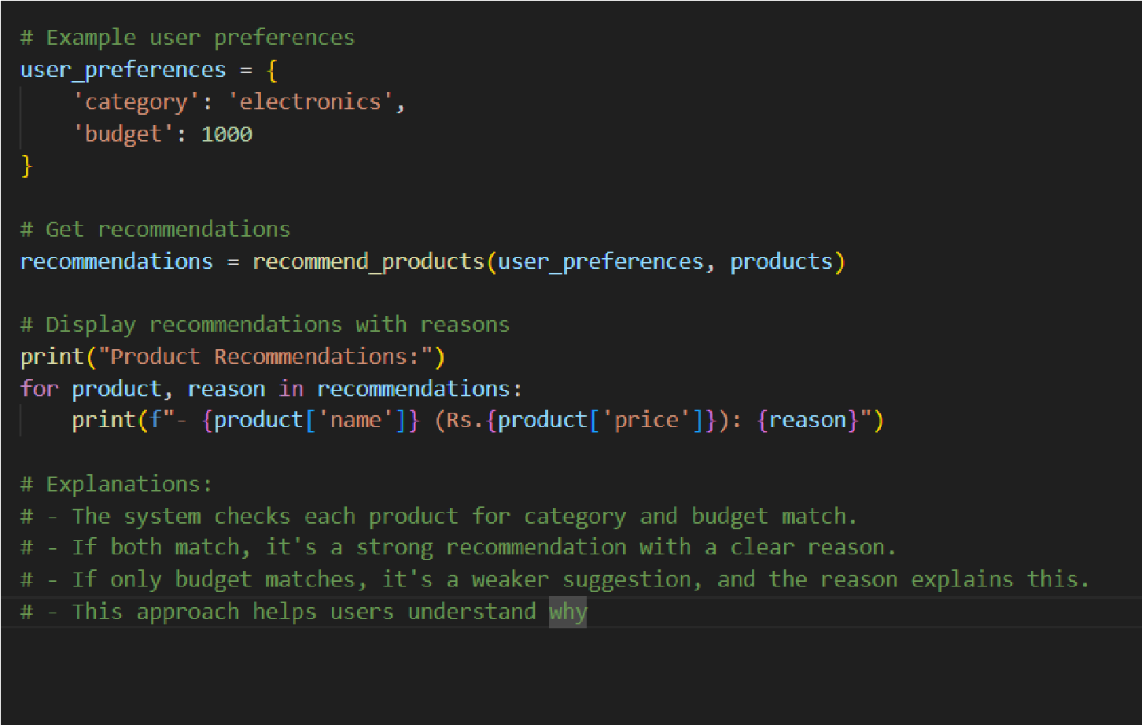

Output:
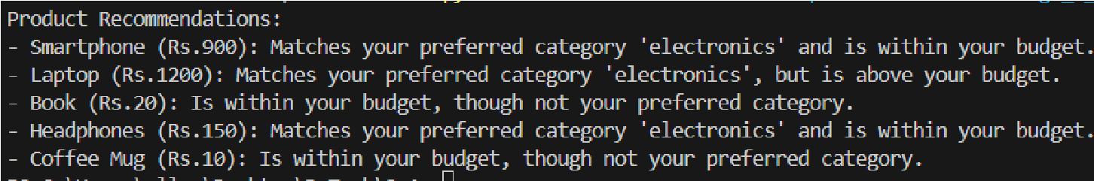

Task Description #6 (Transparent Code Generation)
Task: Ask AI to generate a Python function for calculating factorial using recursion.
Prompt:
"Generate a recursive factorial function with comments that explain each line and a final summary of the algorithm’s flow." Expected Output:
- Fully commented code.
- Clear documentation of how recursion works.
Prompt:
Code:
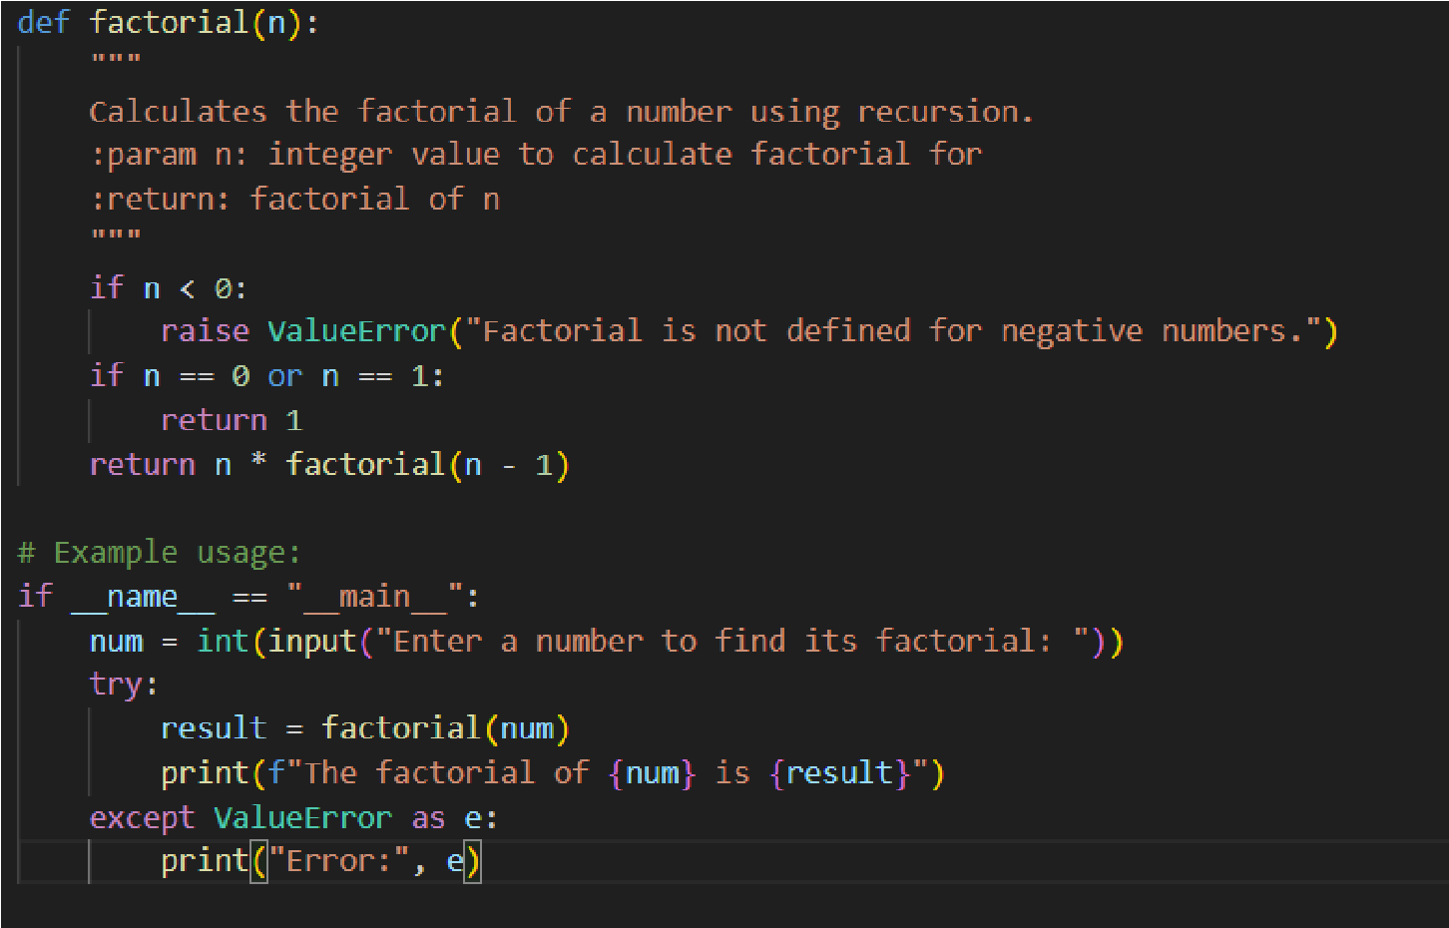
Output:
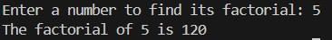
Task Description #7 (Inclusiveness in Customer Support) Code Snippet:

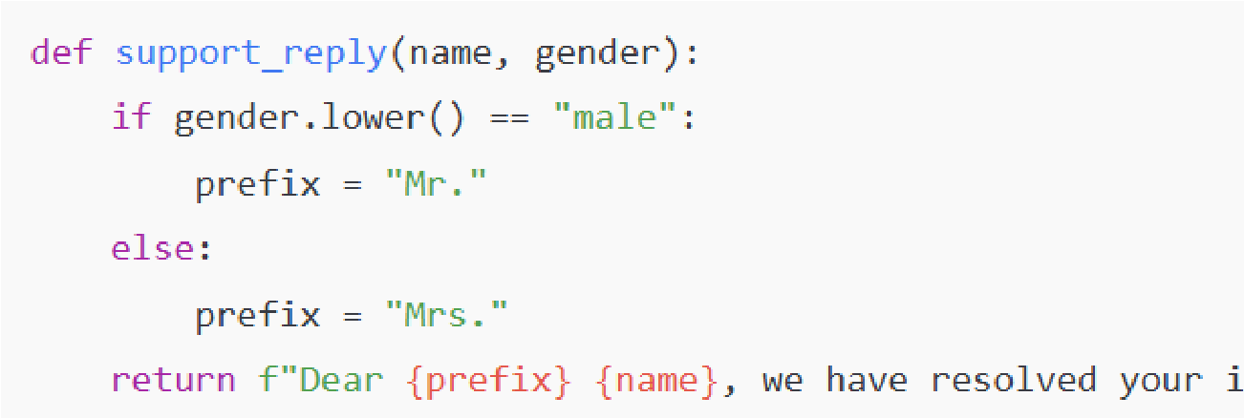

Task:
Regenerate the code so that support messages use neutral language (e.g., “Dear {name}”) and optionally accept preferred titles.
Expected Output:
• Neutral, user-friendly support responses.

Prompt:
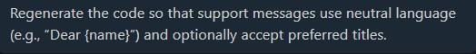
Code:
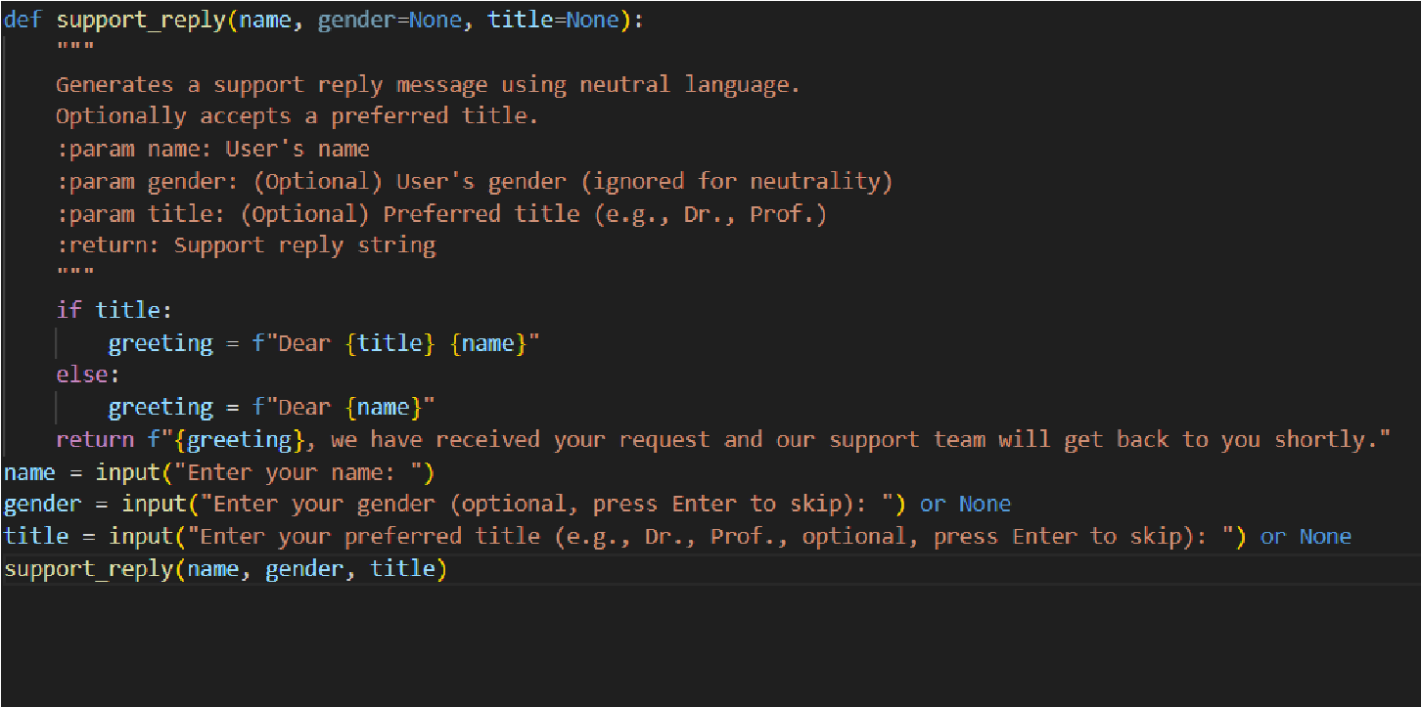
Output:

Note: Report should be submitted a word document for all tasks in a single document with prompts, comments & code explanation, and output and if required, screenshots

Evaluation Criteria:

 |  | Criteria | Max Marks
 |  | Transparency | 1
 |  | Inclusiveness | 0.5
 |  | Data security and Privacy | 1
 |  | Total | 2.5 Marks

