AI ASSISTED CODING
Name: Rokalboyana Varshith
Htno:2403A510D7
ASSIGNMENT:10.3
BATCH:06
 | 1 | TASK1#  PROMPT:  I have a Python script with syntax, indentation, and variable errors. Please identify and fix them  # buggy_code_task1.py  def add_numbers(a, b)  result = a + b  return reslt  print(add_numbers(10 20))  CODE:  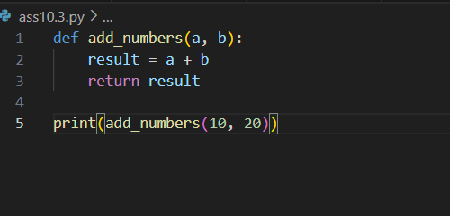  OUTPUT:  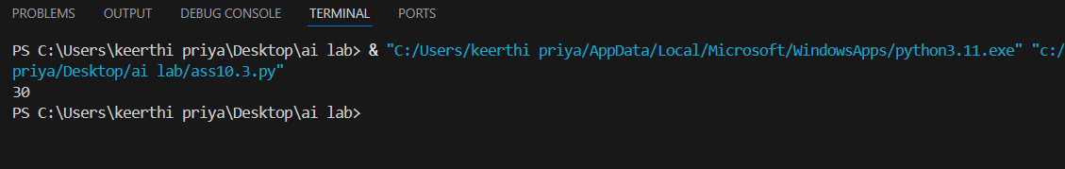  OBSERVATION:  • Missing Colon in Function Definition:  - Original: def add_numbers(a, b)  - Issue: Python function definitions require a colon (:) at the end of the def line to indicate the start of the function's code block.  - Fix: def add_numbers(a, b):  • Incorrect Indentation:  - Original: The lines result = a + b and return reslt were not properly indented under the function definition.  - Issue: Python uses indentation to define code blocks. All statements within a function must be indented consistently.  - Fix: The lines result = a + b and return result have been indented to align correctly with the function definition.  Task 2  PROMPT:  I have a Python script that finds duplicate numbers in a list, but the logic is inefficient because it uses nested loops. Please optimize the code so that it still produces the correct result but runs more efficiently.  CODE:  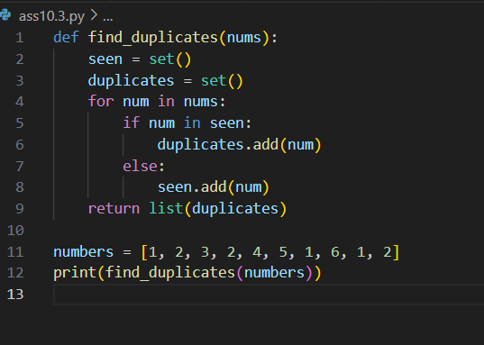  OUTPUT:  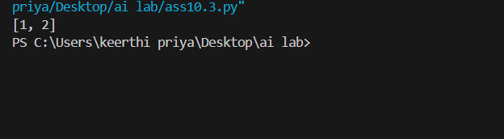  OBSERVATION:  • The original code used two nested loops (O(n²) time complexity) to compare every element with every other element.  • In the optimized code, we use two sets (seen and duplicates) to track numbers efficiently.  - seen keeps track of elements we’ve already encountered.  - If a number is already in seen, it gets added to duplicates.  • This reduces the time complexity to O(n) and makes the solution much faster for large input lists.  • The output remains the same:  Task 3  PROMPT:  I have a Python script that calculates the factorial of a number, but the code is messy and not PEP 8–compliant. Please refactor it into a clean, well-structured version with:  - Proper indentation and formatting.  - A meaningful function name (calculate_factorial).  - Clear variable naming.  - A docstring explaining the function.  CODE:  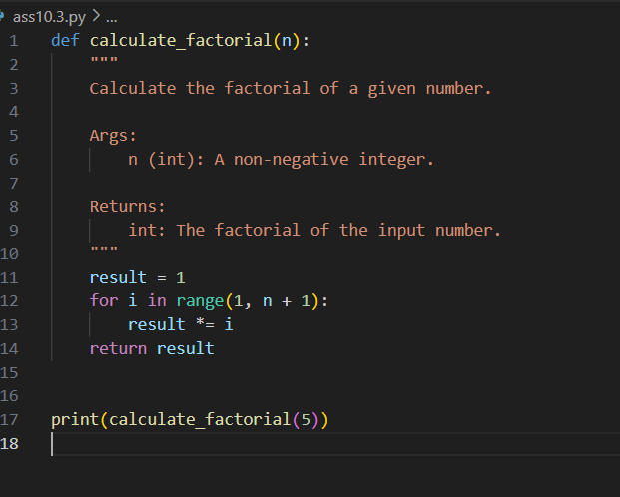  OUTPUT:  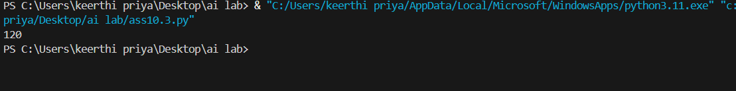  OBSERVATION:  • Function name changed from c → calculate_factorial for clarity.  • Variable x renamed to result, making the purpose more descriptive.  • PEP 8 formatting applied: proper indentation, spaces around operators, blank lines for readability.  • Docstring added to explain parameters, return type, and purpose.  • Loop logic preserved but made more readable with result *= i.  Task 4:  PROMPT:  I have a Python script that fetches user data from a SQLite database. The current code is unsafe because it uses string formatting in SQL queries, which makes it vulnerable to SQL injection. Please:  - Use parameterized queries (? placeholders) instead of string concatenation.  - Add try–except blocks to handle database errors gracefully.  - Include input validation before executing the query.  - Refactor the code to follow clean practices.  CODE:  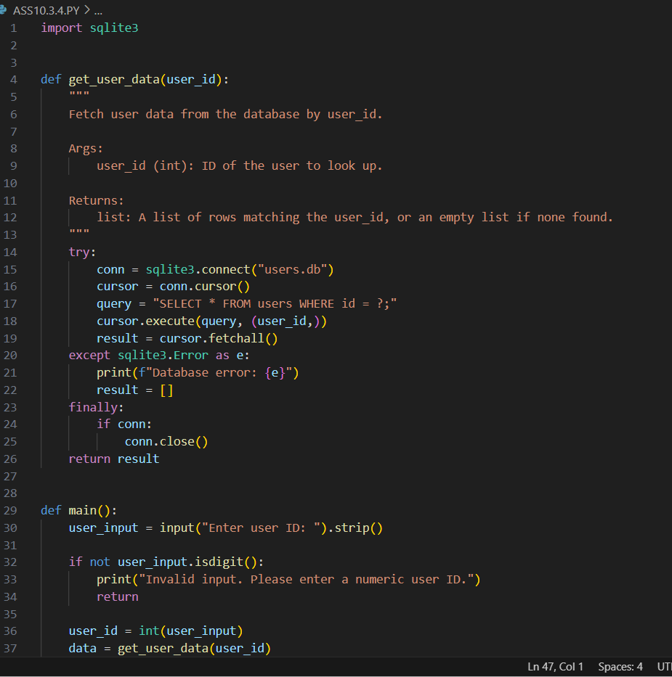  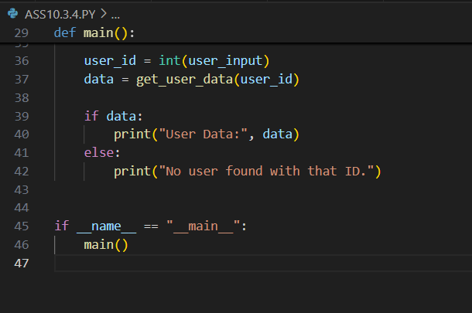  OUTPUT:  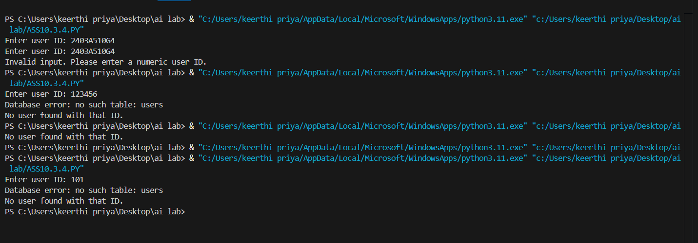  OBSERVATION:  • Exception Handling:  - Added try–except to catch sqlite3.Error.  - Ensures the program doesn’t crash on DB errors.  • Input Validation:  - Checked user_input.isdigit() before converting to integer.  - Prevents invalid input like "abc" from reaching the query.  • Resource Management:  - Used finally to close the DB connection safely.  Task 5: Automated Code Review Report Generation  Task: Generate a review report for this messy code.  # buggy_code_task5.py  def calc(x,y,z):  if z=="add":  return x+y  elif z=="sub": return x-y  elif z=="mul":  return x*y  elif z=="div":  return x/y  else: print("wrong")  print(calc(10,5,"add"))  print(calc(10,0,"div"))  Expected Output:  AI-generated review report should mention:  - Missing docstrings  - Inconsistent formatting (indentation, inline return)  - Missing error handling for division by zero  - Non-descriptive function/variable names  - Suggestions for readability and PEP 8 compliance  PROMPT:  I have a Python script that performs basic arithmetic operations, but it is messy and not PEP 8–compliant. Please generate a review report identifying issues such as:  - Missing docstrings.  - Inconsistent formatting and indentation.  - Inline return statements without readability.  - Missing error handling (division by zero).  - Non-descriptive function and variable names.  - Suggestions for improving readability and PEP 8 compliance.  After that, provide a refactored version of the code.  CODE:  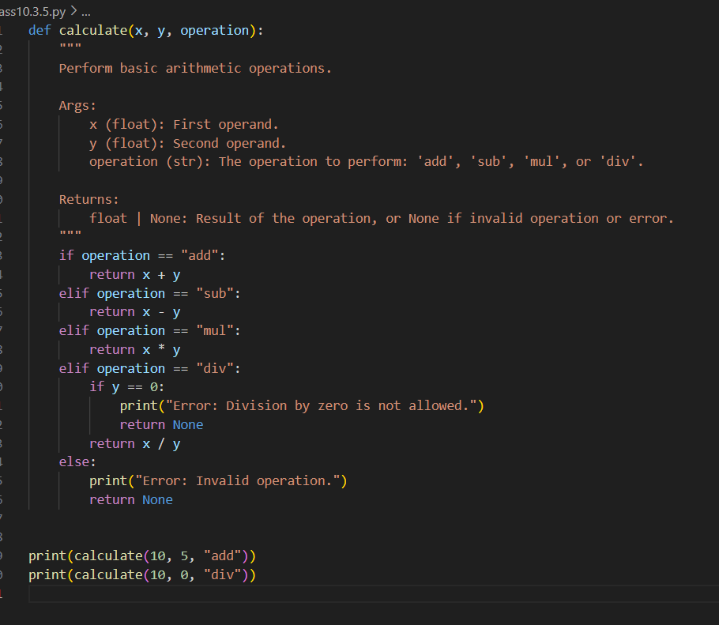  OUTPUT:  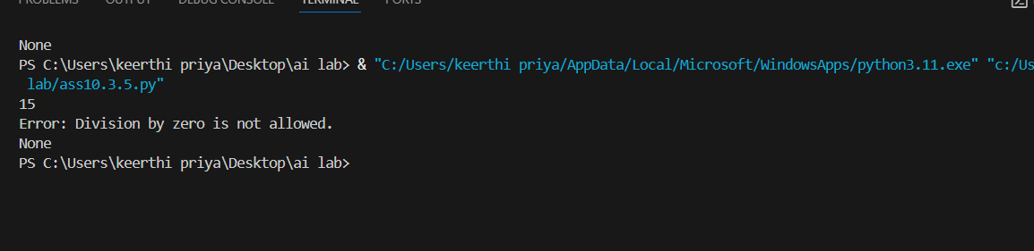  OBSERVATION:  Issues in Original Code:  - Missing docstrings – The function has no explanation of purpose, arguments, or return values.  - Inconsistent formatting – Mixed inline and block returns (elif z=="sub": return x-y).  - Division by zero – No error handling, which can cause runtime exceptions.  - Non-descriptive names – Function calc and parameter z are not descriptive; replaced with calculate and operation.  - PEP 8 Violations – Missing spaces after commas, no blank lines between function and calls, inconsistent indentation.

