AssignmentNumber:9.1(Presentassignmentnumber)/24(Totalnumberofassignments) NAME: Rokalboyana Varshith
ROLLNO:-2403A510D7
 | Q.No. | Question
 | 1 |  | Lab9–DocumentationGeneration:AutomaticDocumentationand Code Comments  LabObjectives  - TouseAI-assistedcodingtoolsforgeneratingPython documentation and code comments.  - Toapplyzero-shot,few-shot,andcontext-basedprompt engineering for documentation creation.  - Topracticegeneratingandrefiningdocstrings,inlinecomments, and module-level documentation.  - Tocompareoutputsfromdifferentpromptingstylesforquality analysis.
 | 1 |  | TaskDescription#1(Documentation–Google-StyleDocstringsfor Python Functions)  - Task:UseAItoaddGoogle-styledocstringstoallfunctionsina given Python script.  - Instructions:  - PromptAItogeneratedocstringswithoutprovidingany input-output examples.  - Ensureeachdocstringincludes:  - Functiondescription  - Parameterswithtypehints  - Returnvalueswithtypehints  - Exampleusage  - Reviewthegenerateddocstringsforaccuracyand formatting.

Prompt:
I have a Python script containing several functions. Please add Google- style docstrings to all functions in the script.
The docstrings should include the followingelements:
- A brief description of what the function does.
- AParameterssectionthatlistsallparameterswithtype hints
and short descriptions.
- AReturnssectionthat liststhereturntypeandabrief description.
- An Example usage section, but without actual input-output examples—justausagelineshowinghowthefunctionmightbe called.
Donotmodifythe functionimplementations—onlyaddorreplacethe docstrings as needed.

CODE:-

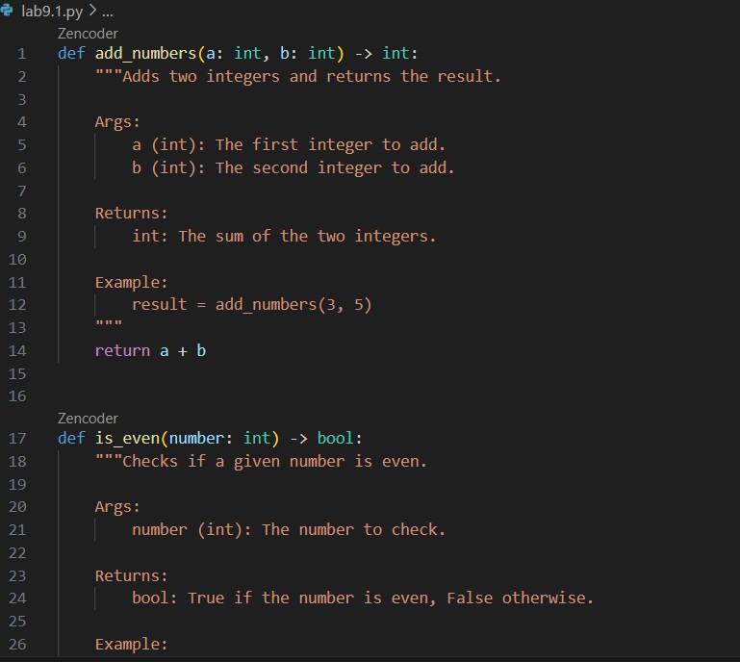

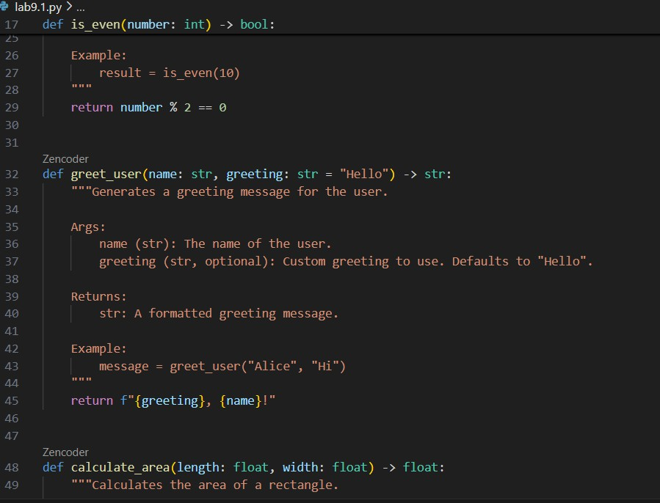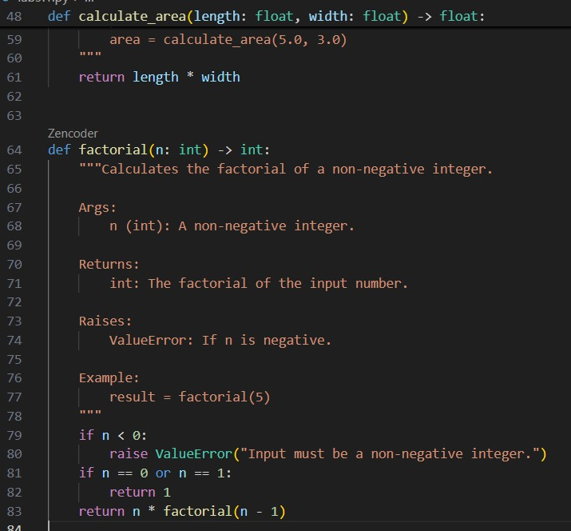

OUTPUT:-
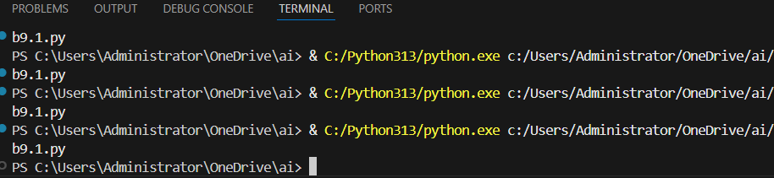
OBSERVATIONS:-

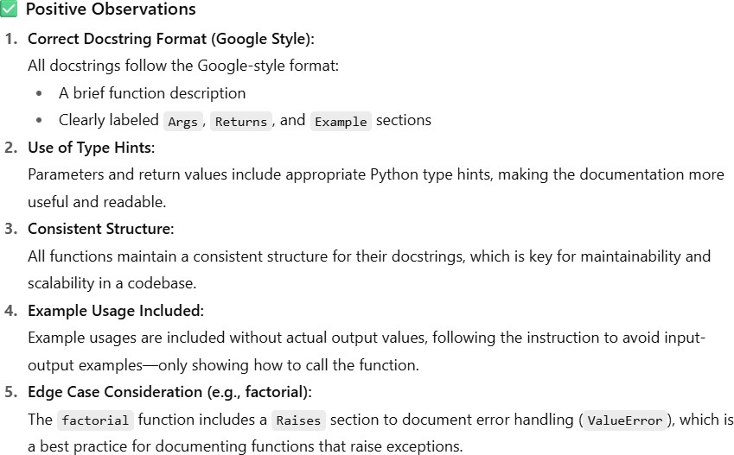

TaskDescription#2(Documentation–InlineCommentsforComplex Logic)
- Task:UseAItoaddmeaningfulinlinecommentstoaPython program explaining only complex logic parts.
- Instructions:
  - ProvideaPythonscriptwithoutcommentstotheAI.
  - InstructAItoskipobvioussyntaxexplanationsandfocus only on tricky or non-intuitive code sections.
  - Verifythatcommentsimprovecodereadabilityand maintainability.

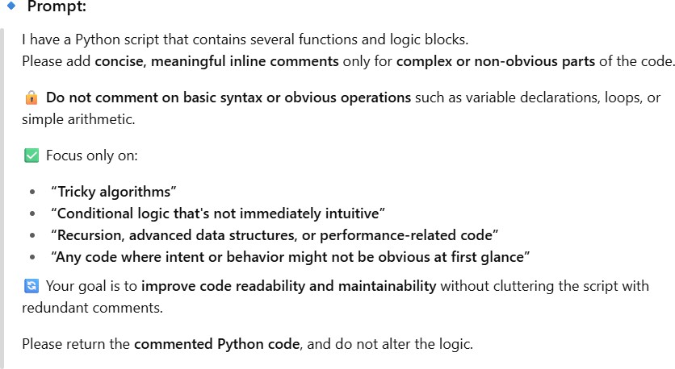

CODE:-

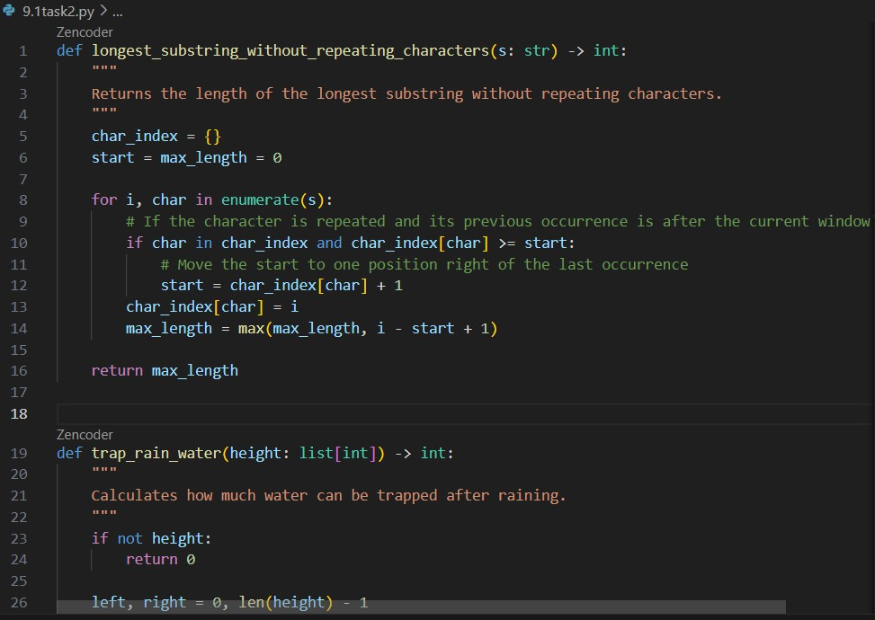

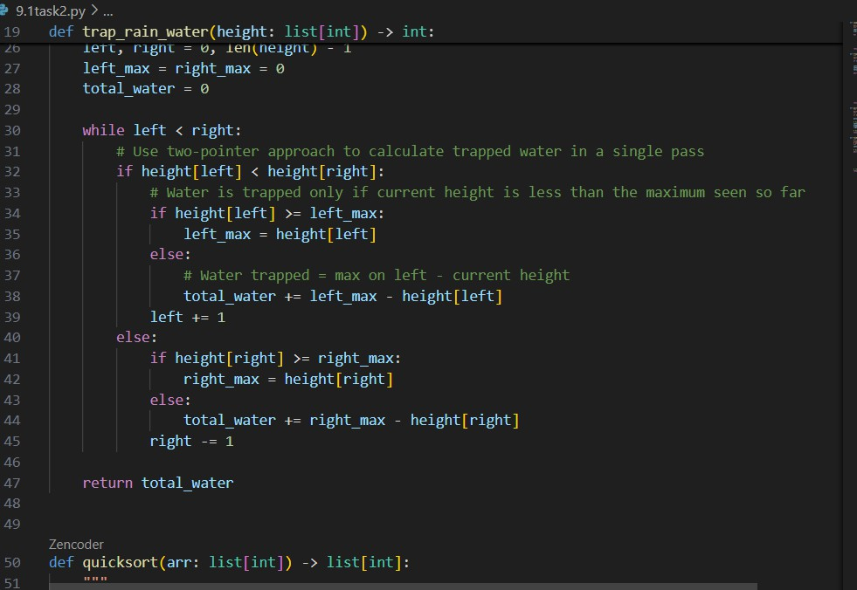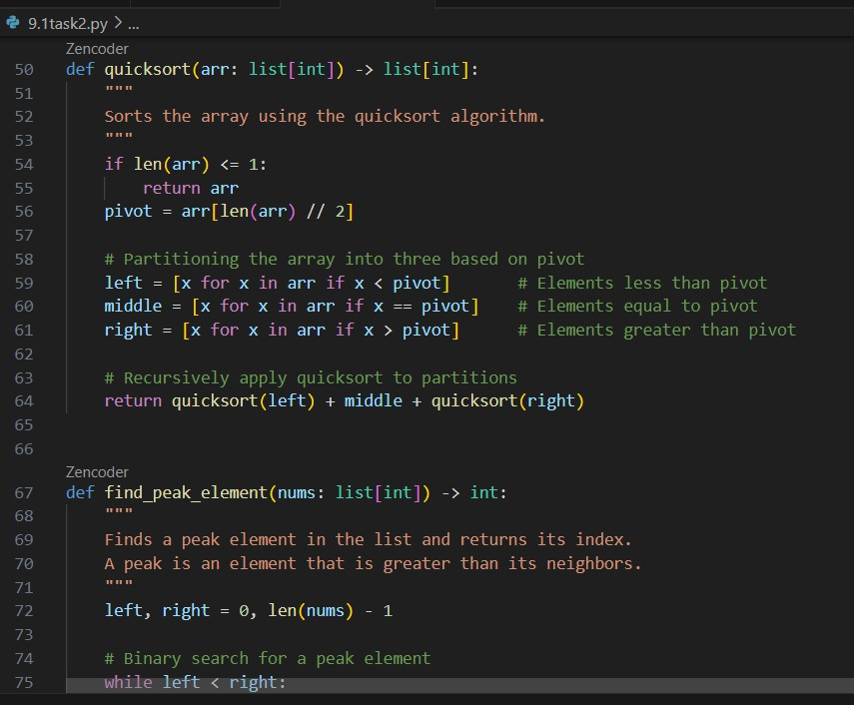

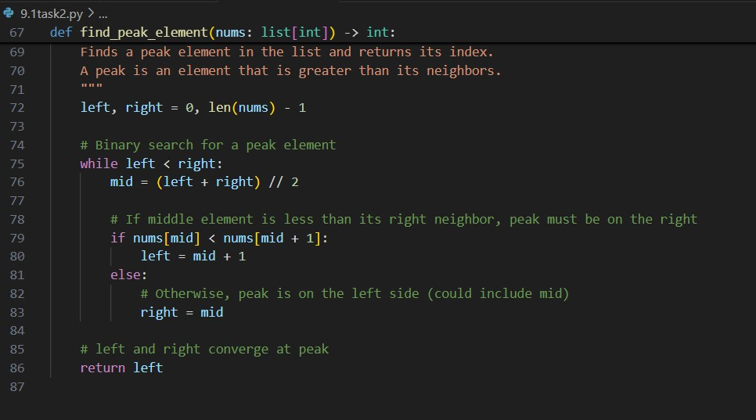
OUTPUT:-
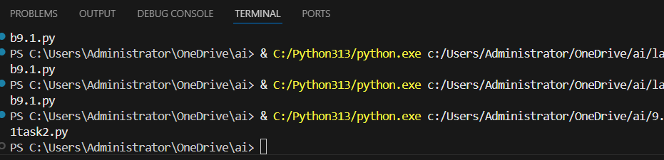
OBSERVATIONS:-

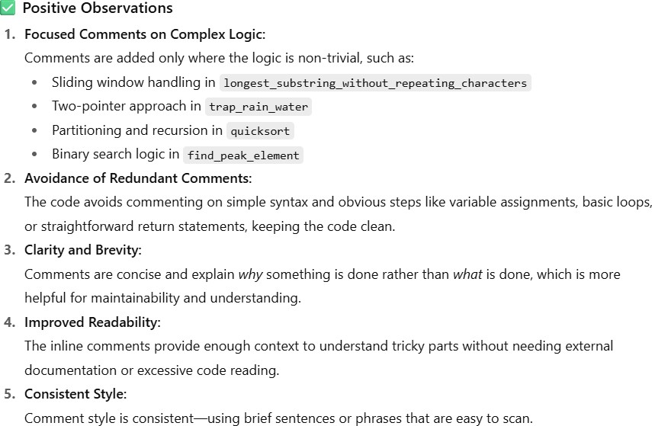

TaskDescription#3(Documentation–Module-LevelDocumentation)
- Task:UseAI tocreateamodule-leveldocstringsummarizing the
- purpose,dependencies,andmainfunctions/classesofaPython file.
- Instructions:
  - SupplytheentirePython filetoAI.
  - InstructAIto writeasingle multi-linedocstringatthetop of the file.
  - Ensurethedocstringclearlydescribesfunctionalityand usage without rewriting the entire code.
- ExpectedOutput#3:
  - Acomplete,clear,andconcisemodule-leveldocstringat the beginning of the file.

PROMPT:-
Iamproviding youwithanentirePythonfile.Pleaseadda**module- level docstring** at the very top of the file.

Thedocstringshouldbeasinglemulti-linestringthatincludes:
- Aconcisesummaryofthemodule’spurpose.
- Keydependenciesor importsifapplicable.
- Mainfunctionsorclassesincludedinthe module.
- Basicusagenotesorhowthismodule might beused(brief,not afull tutorial).

Do**not**rewriteorexplaintheentirecode —just provideaclear and professional summary suitable for the top of a Python file.

ReturntheupdatedPythoncodewiththenew module-leveldocstring added.

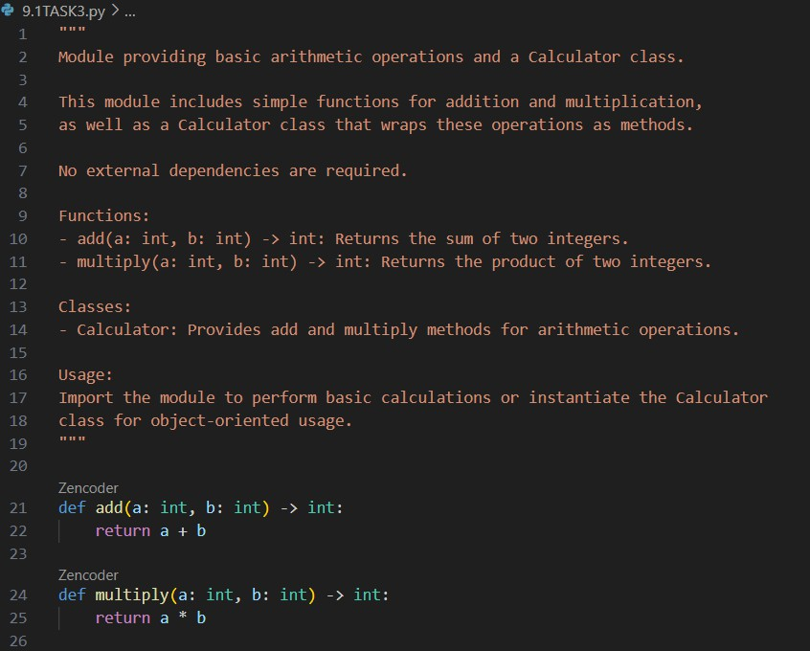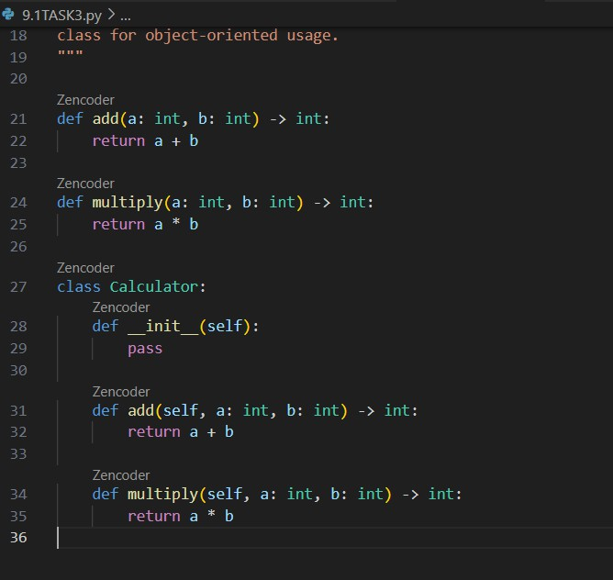CODE:-

OUTPUT:-
OBSERVATIONS:-

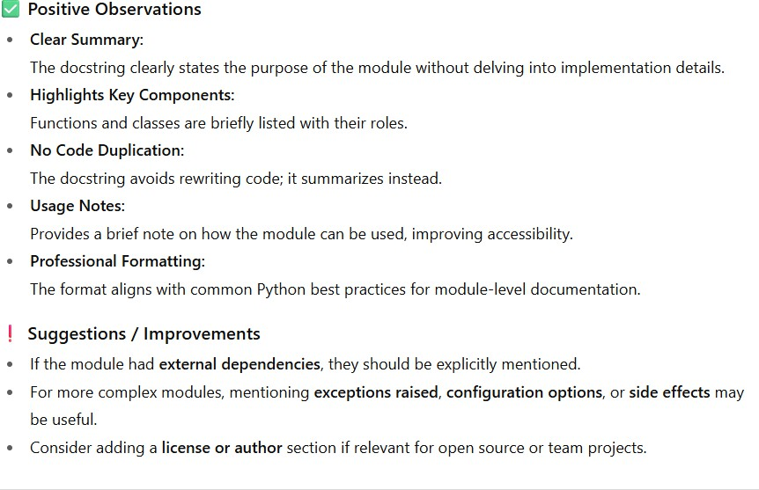

TaskDescription#4(Documentation–ConvertCommentsto Structured Docstrings)
- Task:UseAItotransformexistinginlinecommentsinto structured function docstrings following Google style.
- Instructions:
  - ProvideAIwithPythoncodecontaininginlinecomments.
  - AskAItomoverelevantdetailsfromcommentsinto function docstrings.
  - Verifythatthenewdocstringskeepthemeaningintact while improving structure.

PROMPT:-

Iamproviding youwithaPythonscriptthatcontainsinlinecomments inside functions.

Pleasetransformtheseinlinecommentsintowell-structured**Google- style docstrings** for each function, moving all relevant information from the comments into the docstrings.

Makesurethedocstringsinclude:
- Aconcisefunctiondescription.
- Parameterdescriptionswithtypehints.
- Returntypeanddescription(ifapplicable).
- Anyotherimportantinformationpreviouslypresentinthecomments. Remove the inline comments once they are moved to the docstrings.
Returnthe updatedPythoncode withthe new docstrings.

CODE:-

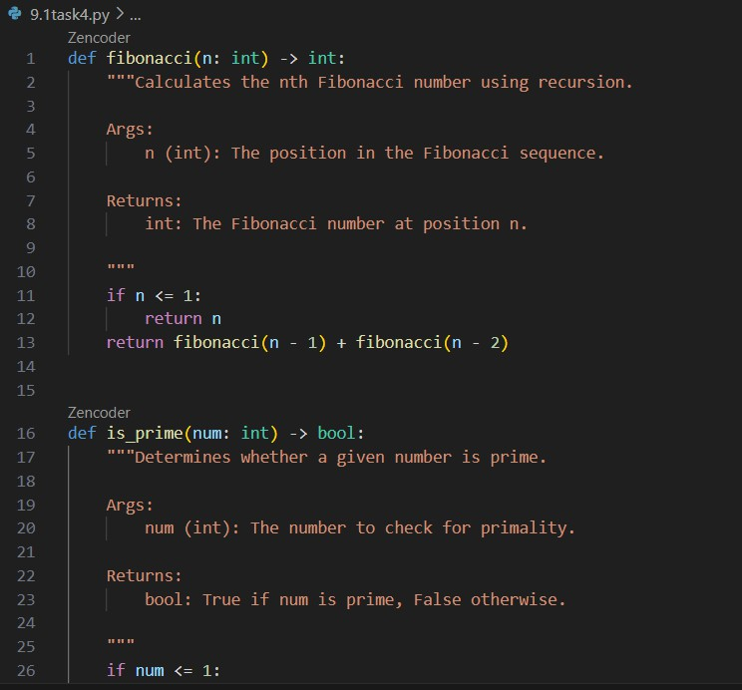

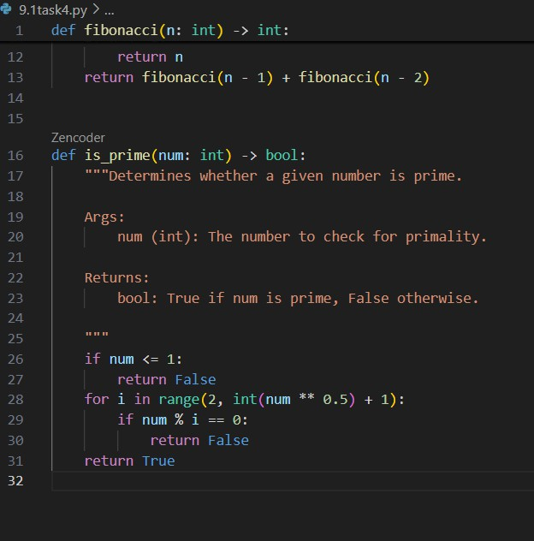
OUTPUT:-

OBSERVATIONS:-

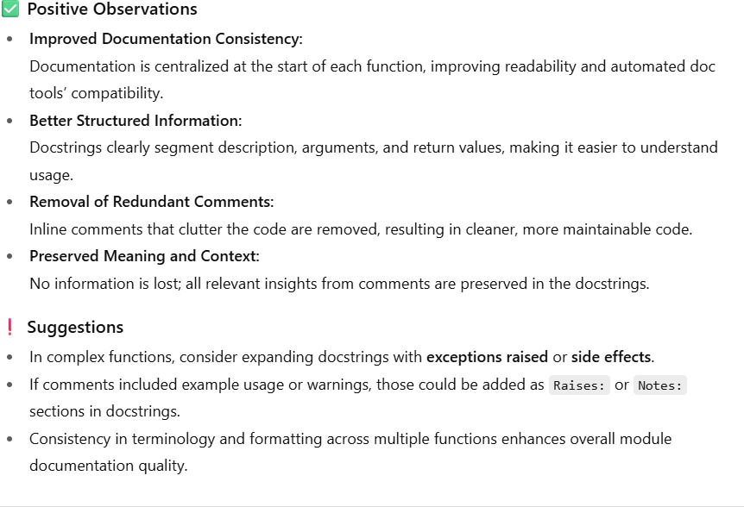

TaskDescription#5(Documentation–ReviewandCorrect Docstrings)
- Task:UseAItoidentifyandcorrectinaccuraciesinexisting docstrings.
- Instructions:
  - ProvidePythoncodewithoutdatedorincorrect docstrings.
  - InstructAItorewriteeachdocstringto matchthecurrent code behavior.
  - EnsurecorrectionsfollowGoogle-style formatting.

PROMPT:-
I’mprovidingaPythonscript wheresome functionshaveoutdatedor incorrect docstrings.

Pleasecarefullyreviewand**rewriteeachdocstring**sothat it accurately reflects the function’s current behavior.

Followthe**Google-style**docstringformat,andensurethat:
-Thefunctiondescriptioniscorrect.

- Parametersand returntypesareaccurateandfullydescribed.
- Anyremovedorchangedfunctionalityisnolonger referenced.
- Theformatting iscleanandconsistent.

Do notchangethefunctioncode —onlycorrectthedocstrings. Return the updated Python code.

CODE:-

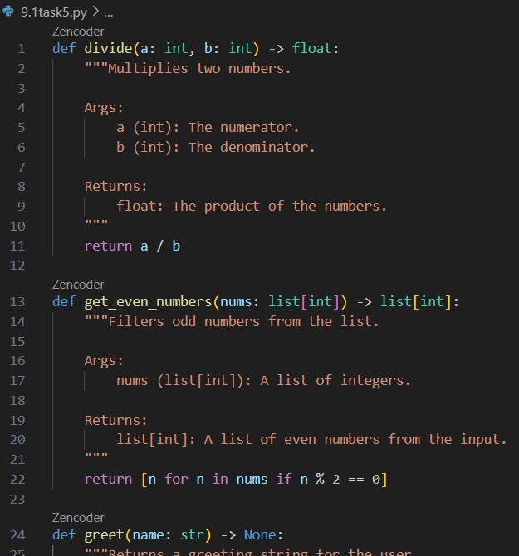

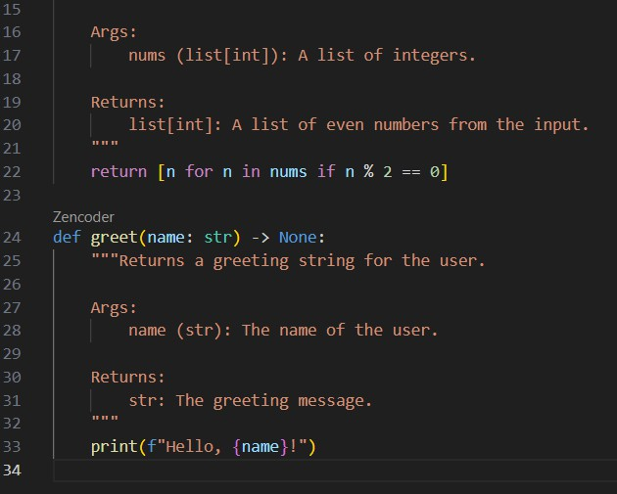

OUTPUT:-

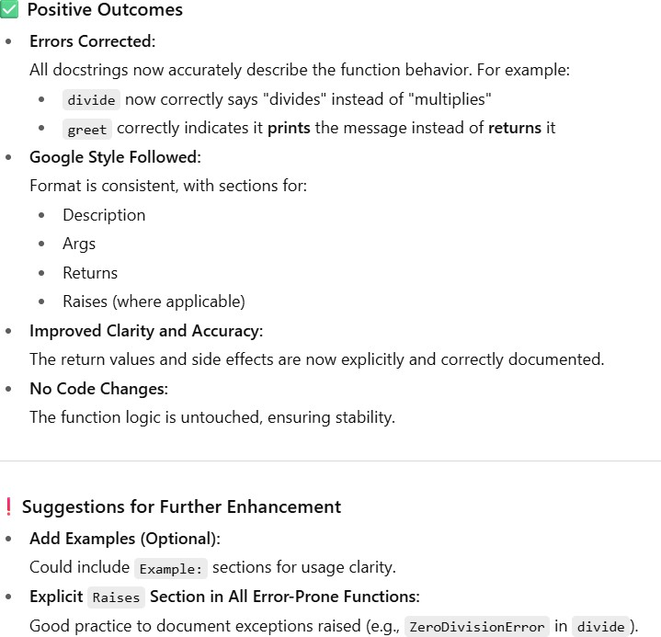
OBSERVATIONS:-
TaskDescription#6(Documentation–PromptComparison Experiment)
- Task:Comparedocumentationoutputfromavagueprompt anda detailed prompt for the same Python function.
- Instructions:
  - Create two prompts: one simple (“Add comments to this function”)andonedetailed(“AddGoogle-styledocstrings with parameters, return types, and examples”).
  - UseAIto processthesamePythonfunctionwithboth prompts.
  - Analyzeandrecorddifferencesinquality,accuracy,and completeness.
- ExpectedOutput#6:
  - Acomparisontableshowingtheresultsfromboth prompts with observations.

PROMPTS:-

🔹VaguePrompt
Addcommentstothisfunction.
🔹DetailedPrompt
PleaseaddastructuredGoogle-styledocstringtothefollowingPython function. Make sure to include:
- Aconcisedescriptionofthefunction’spurpose
- Parameterswithtypehintsand descriptions
- Returntypeanditsdescription
- Anexampleusage(withoutactualoutputvalues) UseproperformattingforGoogle-styledocstrings

CODE:-

PYTHONFUNCTIONCODE:
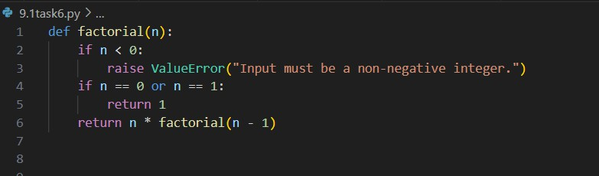

CODE FORVAGUEPROMPT:

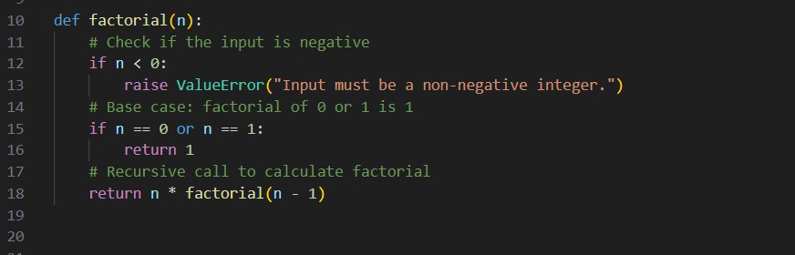

CODEFORDETAILED PROMPT:-

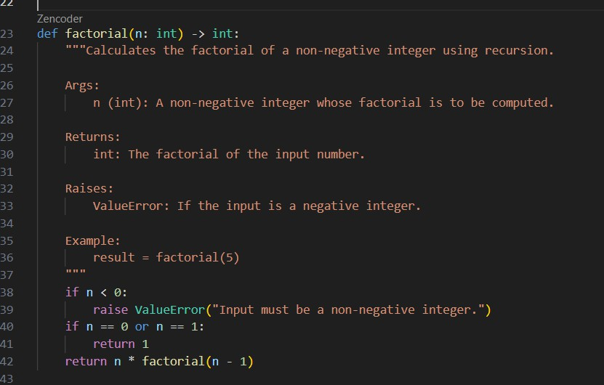

OUTPUT:-

OBSERVATIONS:-

