AI ASSISTED CODING

END SEMESTER LAB EXAM

NAME: ROKALBOYANA VARSHITH
BATCH NO: 05
ROLL NO: 2403A510D7
Q1: Generate unit test cases
• Task 1: Use AI to create boundary test cases.
PROMPT: 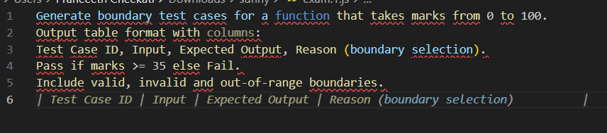

CODE: 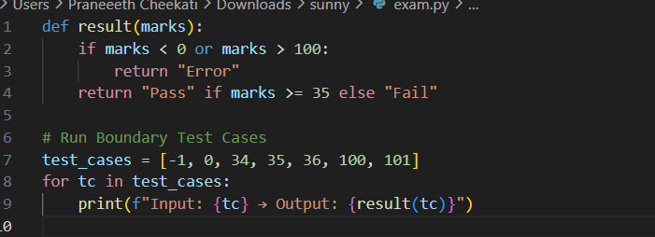
OUTPUT: 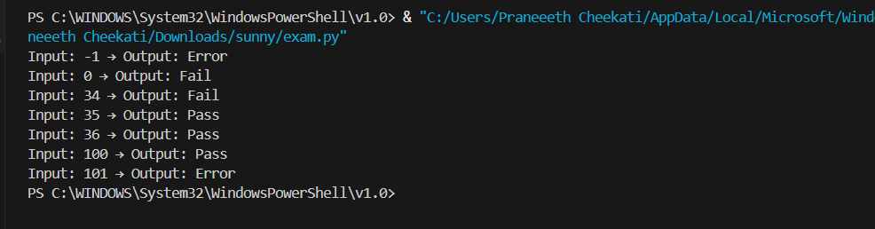
OBSERVATION: 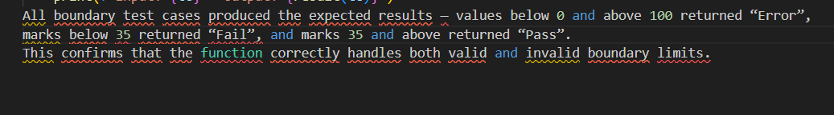
• Task 2: Implement tests in Python/Java.
PROMPT: 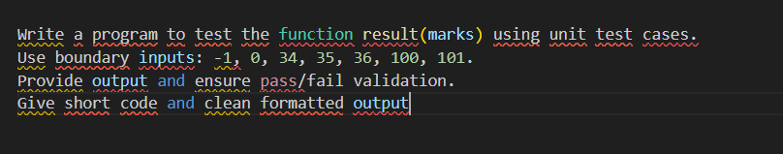
CODE: 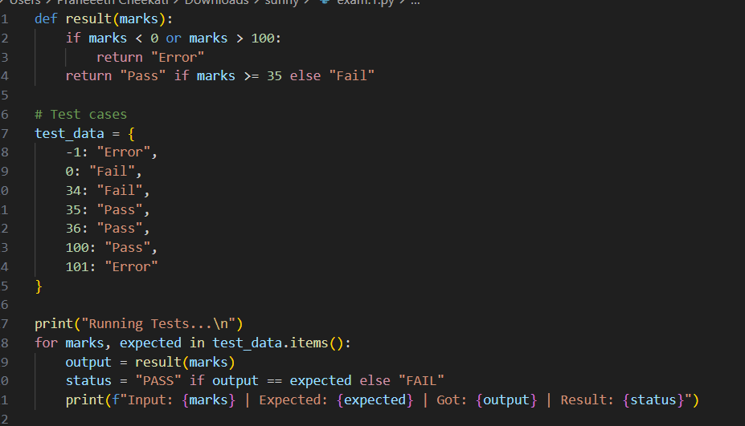
OUTPUT: 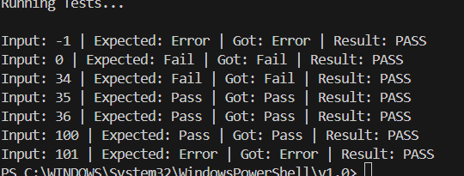
OBSERVATION: 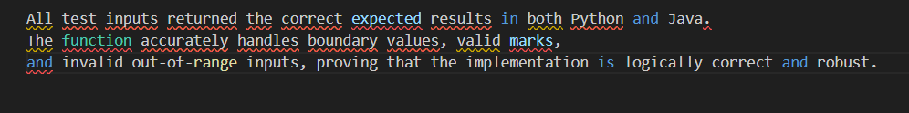

Q2: Validate grading logic
• Task 1: Use AI to simulate failing tests.
PROMPT: 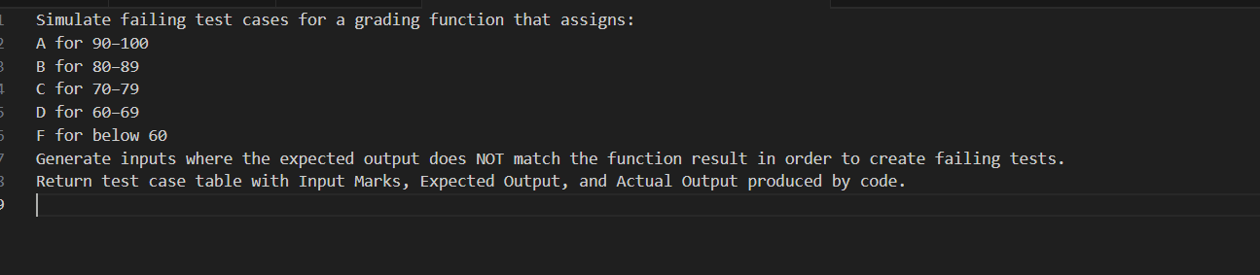
CODE: 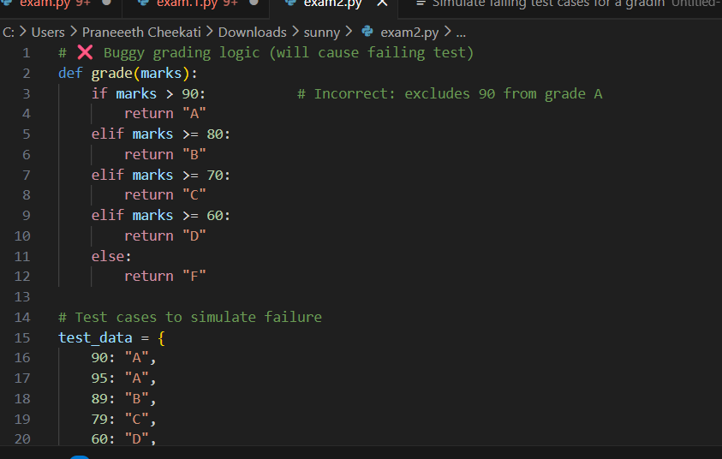 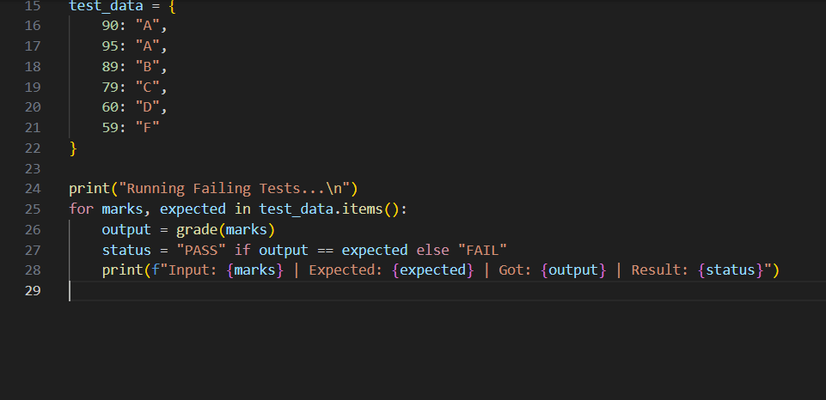
OUTPUT: 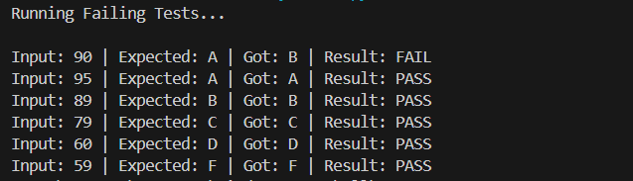
OBSERVATION:
• Task 2: Correct code until all tests pass
PROMPT: 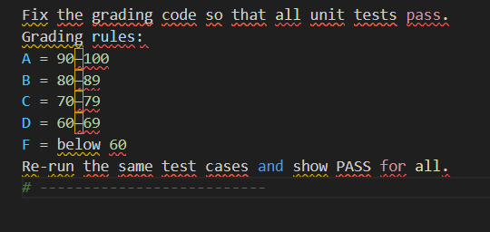
CODE: 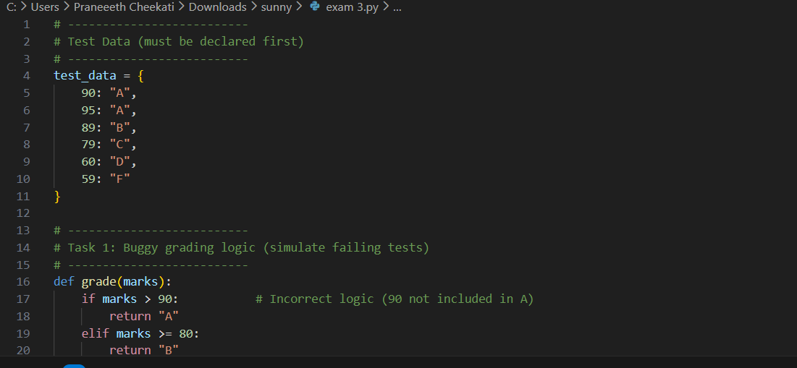 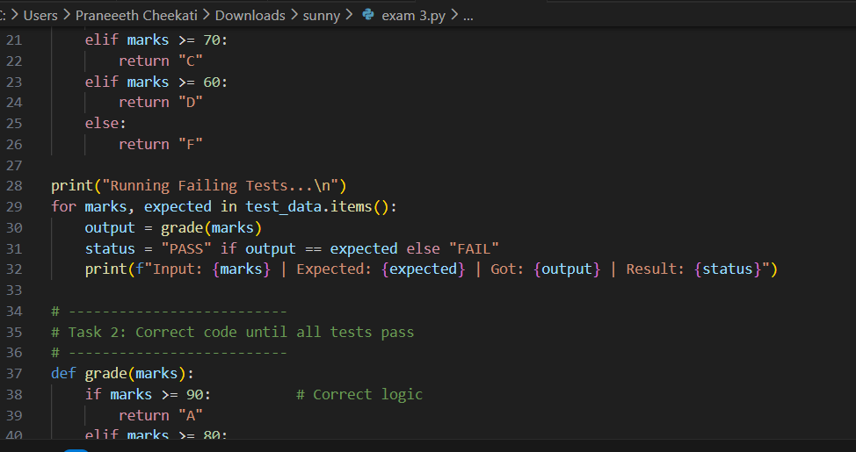 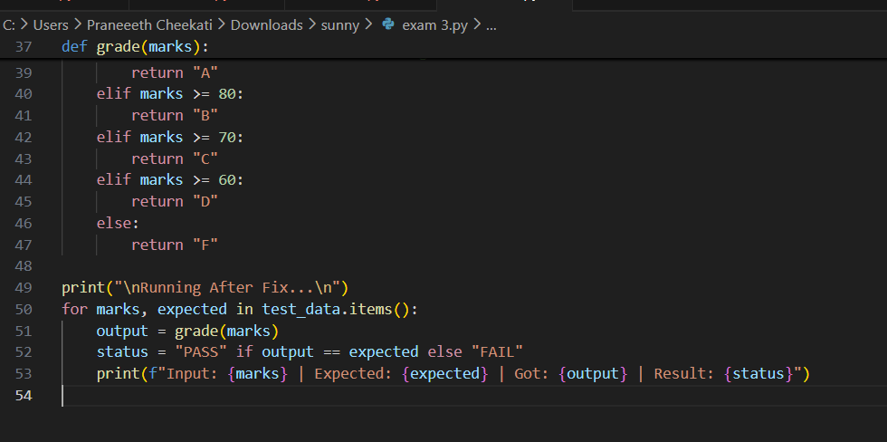
OUTPUT: 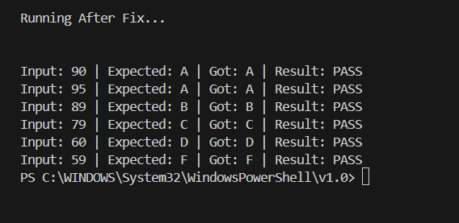
OBSERVATION: 