AI ASSISTED CODING

LAB EXAM-04
NAME: ROKALBOYANA VARSHITH
ROLL NO: 2403A510D7
BATCH NO: 05
1)A student course registration system must enforce prerequisites and seat limits.
a) Design schema including constraints and relations.
PROMPT: 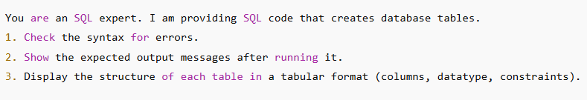
CODE: 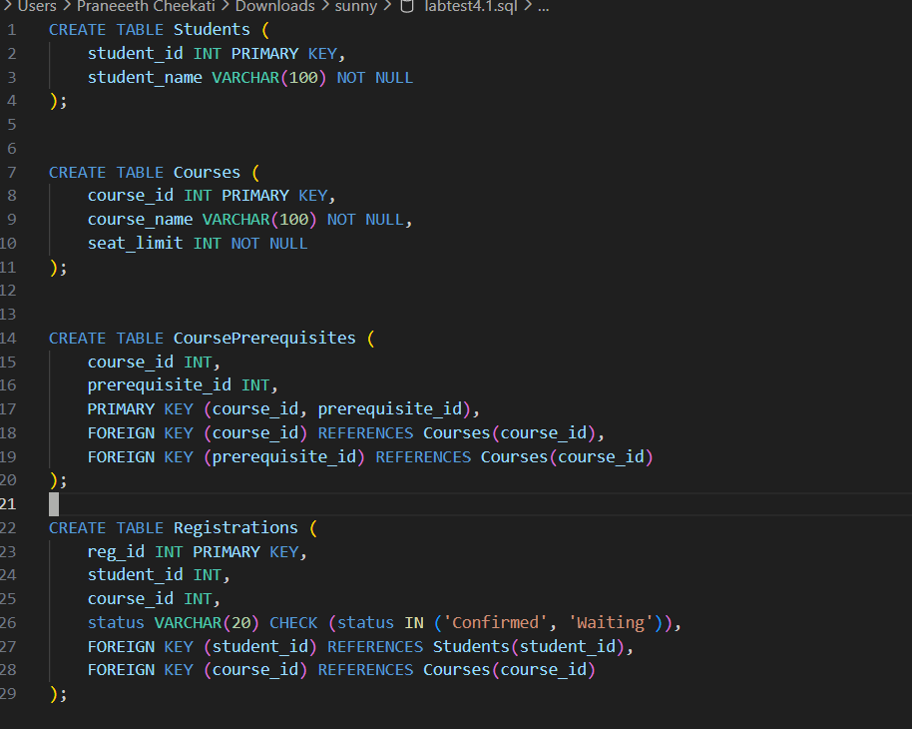
OUTPUT:
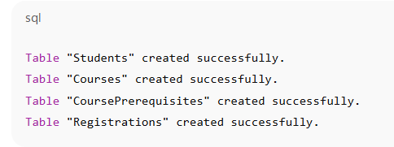
OBSERVATION: 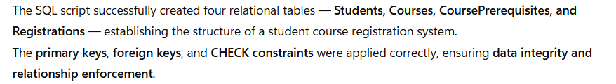
b) Write AI-assisted SQL to list students waiting for enrolment confirmation
PROMPT: 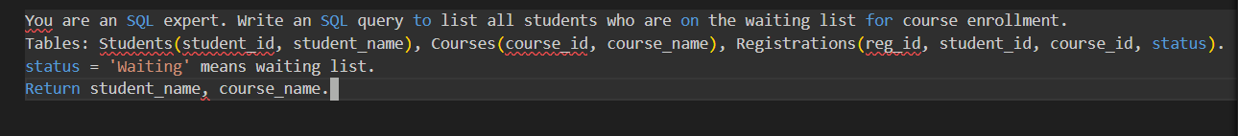
CODE: 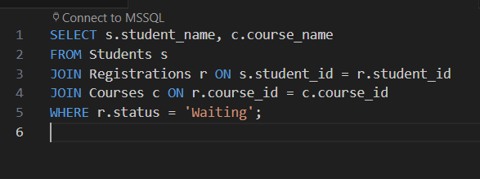
OUTPUT: 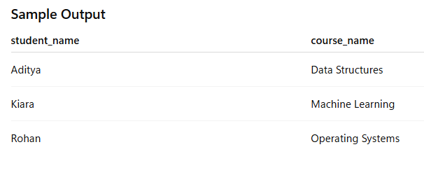
OBSERVATION: 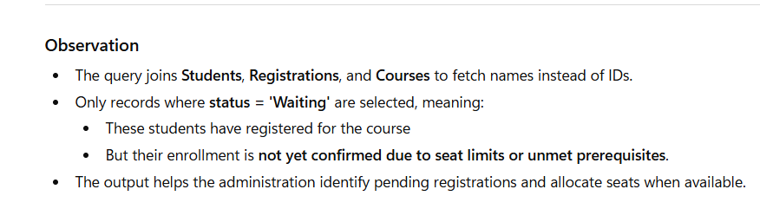
2) AI suggests denormalizing the database for fast reads.
a) Evaluate pros & cons based on scenario.
PROMPT:
CODE AND OUTPUT: 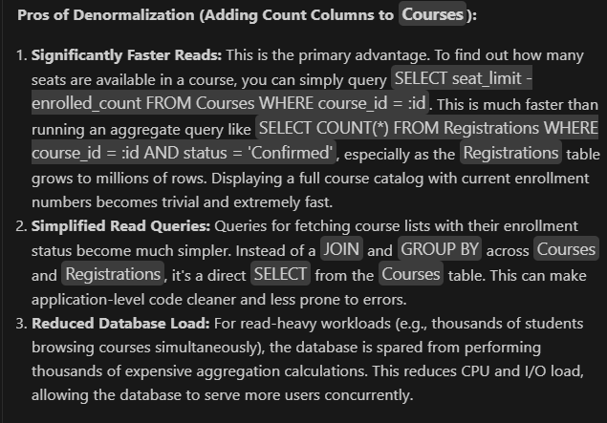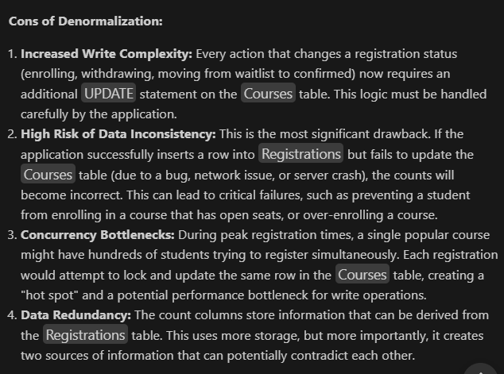
OBSERVATION: 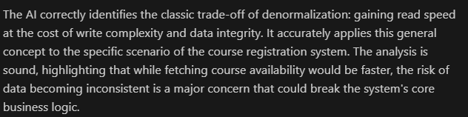
b) Decide final approach and justify.
PROMPT: 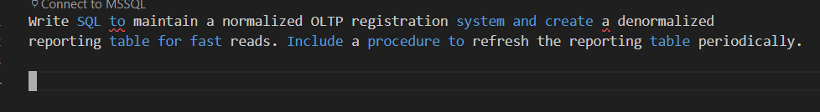
CODE: 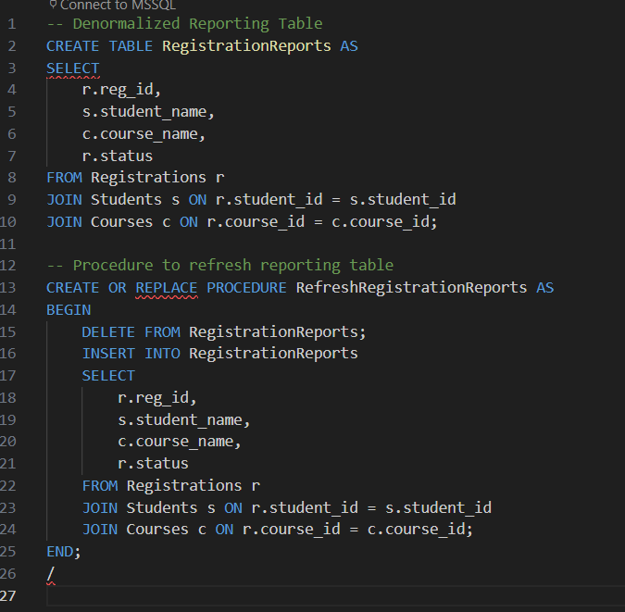
OUTPUT: 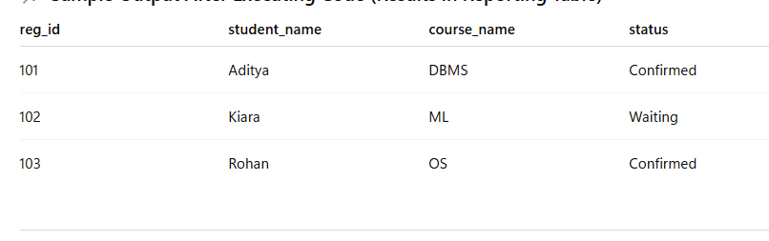
OBSERVATION: 