Week 1 Report
Data Exploration and Problem Definition
Exploratory analysis of the Diamonds dataset using Python (pandas, NumPy, Matplotlib, Seaborn, SciPy)
Prepared by: Varshith
Data Analytics using Python – Week 1

1. Introduction and Objective
This report documents the first stage of a data analytics project: choosing a public dataset, exploring it with Python, defining a clear analytics problem, and planning the analysis for the coming weeks. The goals of this week are to understand the data types and key variables, detect missing or anomalous values, visualise basic distributions, and identify the questions the data can realistically answer.
The work follows five steps: dataset selection, exploratory data analysis (EDA), problem definition, analysis strategy, and documentation of limitations and future improvements.

2. Dataset Selection
Dataset: Diamonds (originally distributed with the ggplot2 R package and widely available on Kaggle; the CSV used here was loaded from the public seaborn-data repository on GitHub).
Size: 53,940 rows and 10 columns – each row is one diamond with its physical measurements, quality grades and sale price in US dollars.
Why this dataset was chosen:
- It mixes numeric variables (carat, dimensions, price) with ordered categorical variables (cut, colour, clarity), so it exercises both numeric and categorical analysis.
- It is large enough for reliable statistics and for later modelling, yet small enough to run on a laptop.
- It contains realistic data-quality issues (impossible zero dimensions, extreme outliers, duplicates) that make the cleaning step meaningful.
- Pricing is a clear business problem: understanding what drives price supports valuation and decision-making.

2.1 Data dictionary
Column | Type | Description
carat | Numeric | Weight of the diamond (0.2 – 5.01)
cut | Ordinal categorical | Quality of cut: Fair, Good, Very Good, Premium, Ideal
color | Ordinal categorical | Colour grade from D (best) to J (worst)
clarity | Ordinal categorical | Clarity: I1 (worst), SI2, SI1, VS2, VS1, VVS2, VVS1, IF (best)
depth | Numeric | Total depth % = z / mean(x, y) × 100
table | Numeric | Width of the top facet relative to the widest point (%)
price | Numeric (target) | Price in US dollars (326 – 18,823)
x, y, z | Numeric | Length, width and depth in mm

3. Exploratory Data Analysis

3.1 Structure and data quality
- Shape: 53,940 observations × 10 variables; 7 numeric columns and 3 categorical columns.
- Missing values: none in any column (0 nulls).
- Duplicates: 146 fully duplicated rows (about 0.27%).
- Impossible values: 20 rows have a zero in x, y or z (a diamond cannot have zero length, width or depth). Breakdown: x = 0 in 8 rows, y = 0 in 7 rows, z = 0 in 20 rows.
- Extreme outliers: y = 58.9 mm and y = 31.8 mm, z = 31.8 mm on diamonds of about 0.5 to 2 carat (almost certainly data-entry errors); table = 95 (maximum plausible is about 80); depth = 78.2 and 79.0 with unusual proportions. In total 23 rows fail the dimension checks and would be removed before modelling.

3.2 Summary statistics
Variable | Mean | Std | Min | 25% | 50% | 75% | Max
carat | 0.80 | 0.47 | 0.20 | 0.40 | 0.70 | 1.04 | 5.01
depth | 61.75 | 1.43 | 43.0 | 61.0 | 61.8 | 62.5 | 79.0
table | 57.46 | 2.23 | 43.0 | 56.0 | 57.0 | 59.0 | 95.0
price | 3,932.8 | 3,989.4 | 326 | 950 | 2,401 | 5,324 | 18,823
x | 5.73 | 1.12 | 0.00 | 4.71 | 5.70 | 6.54 | 10.74
y | 5.73 | 1.14 | 0.00 | 4.72 | 5.71 | 6.54 | 58.90
z | 3.54 | 0.71 | 0.00 | 2.91 | 3.53 | 4.04 | 31.80

Price has a mean ($3,933) far above its median ($2,401), indicating a long right tail. Its skewness is 1.62; carat is also right-skewed (1.12). After a log transform the skewness of price falls to 0.12, which suggests that modelling log(price) will be more appropriate than raw price.

3.3 Distributions
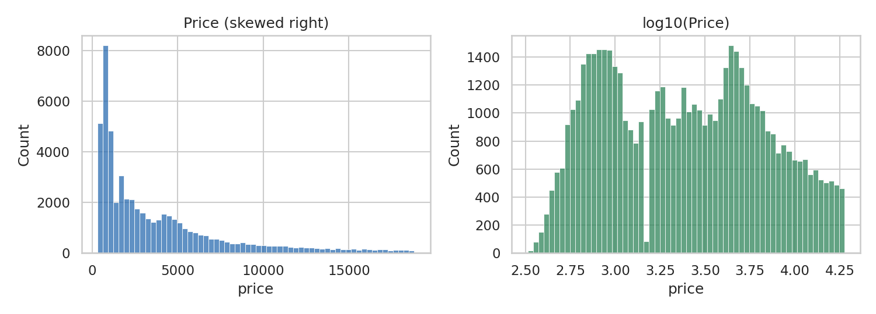
Figure 1: Distribution of price before and after a log transform
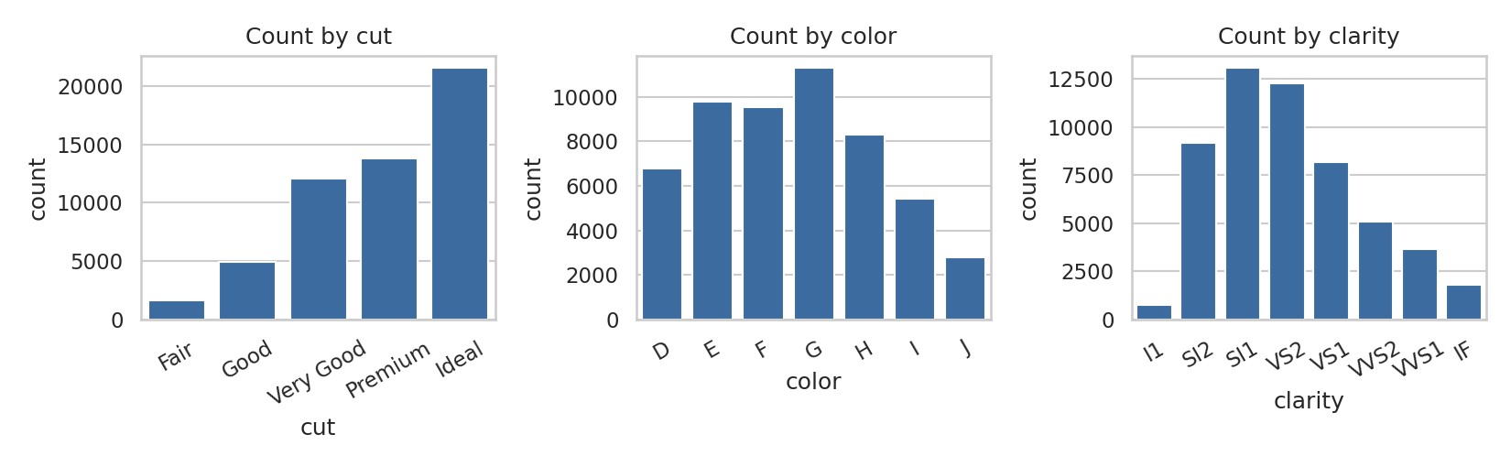
Figure 2: Number of diamonds in each cut, colour and clarity category
Most diamonds are of Ideal or Premium cut (about 66% together), and colours G, E and F plus clarities SI1, VS2 and SI2 dominate. The lowest grades (Fair cut: 1,610 rows; I1 clarity: 741 rows) are rare, so conclusions about them will have wider uncertainty.

3.4 Relationships between variables
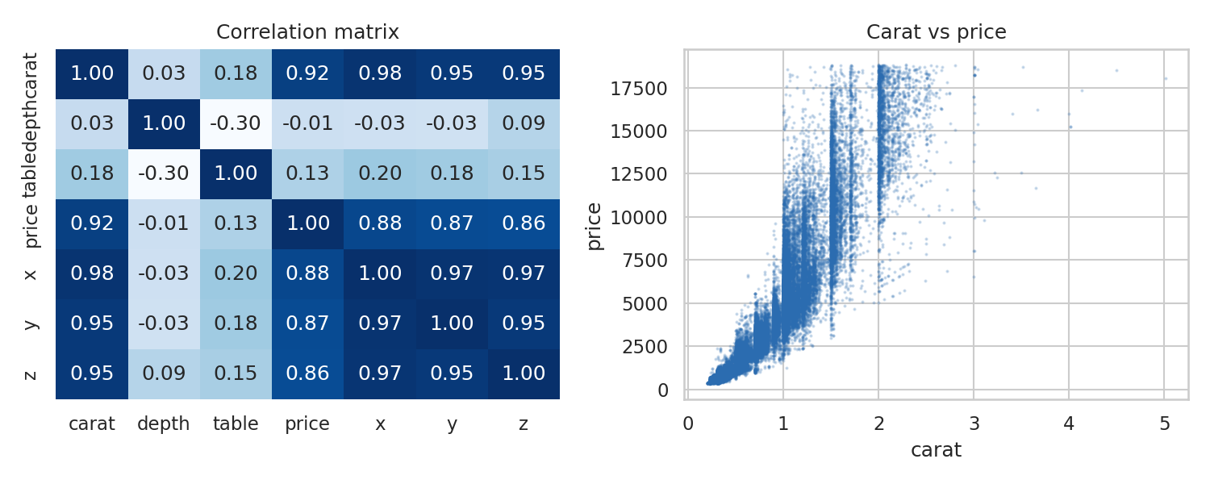
Figure 3: Correlation matrix and carat versus price scatter plot
- Carat has a very strong positive correlation with price (r = 0.92), and with the physical dimensions x, y, z (0.95 – 0.98). Because x, y, z and carat are nearly collinear, they carry overlapping information (multicollinearity) that must be handled in regression.
- Depth (r = −0.01) and table (r = 0.13) are almost uncorrelated with price on their own.
- The carat–price relationship is curved and the spread of price widens as carat increases (heteroscedasticity), another reason to use a log scale.
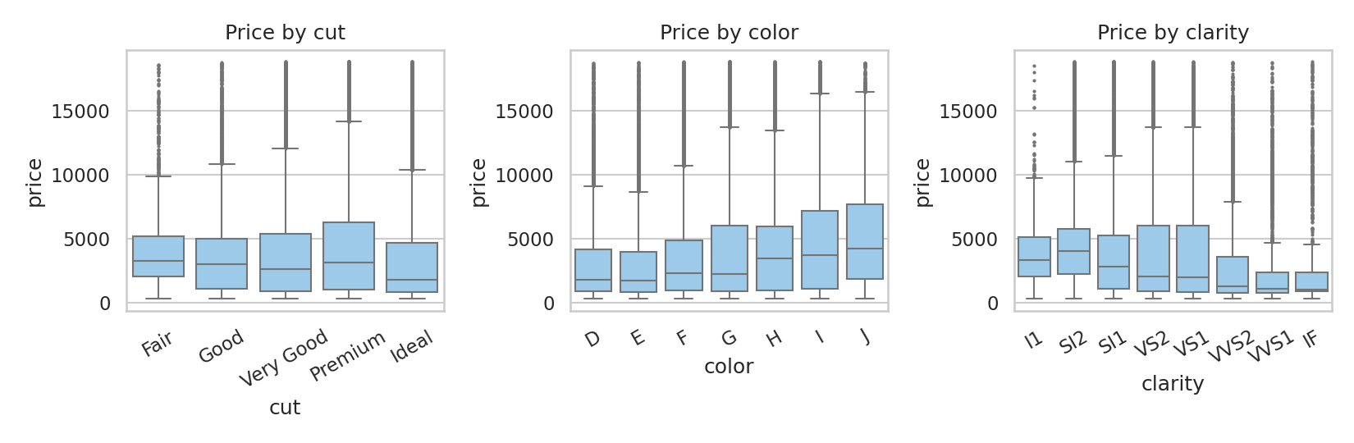
Figure 4: Price by cut, colour and clarity

3.5 Key findings and a counter-intuitive pattern
A naive reading of the grouped averages contradicts what one would expect from quality grades:
Cut | Mean price ($) | Mean carat | Observation
Fair | 4,359 | 1.05 | Lowest quality but heavy stones
Good | 3,929 | 0.85
Very Good | 3,982 | 0.81
Premium | 4,584 | 0.89 | Highest mean price
Ideal | 3,458 | 0.70 | Best cut, lowest mean price

Ideal-cut diamonds have the lowest average price because they are on average much smaller (0.70 carat), while Fair-cut diamonds are the largest. The same effect appears for colour: the worst grade J has the highest mean price ($5,324) because those stones are heavier. In other words carat weight is a confounder, and the effect of cut, colour and clarity can only be understood after controlling for size. Differences in price across cut groups are statistically significant (one-way ANOVA F = 175.7, p < 0.001; Kruskal–Wallis H = 978.6, p < 0.001), but this test alone does not separate the effect of cut from the effect of carat.

4. Problem Definition
Problem statement: Determine which physical characteristics and quality grades of a diamond (carat, cut, colour, clarity, depth, table and dimensions) drive its price, quantify the independent effect of each after controlling for carat weight, and build a model that predicts diamond price with a measurable level of accuracy.
This is relevant to data analytics because it combines descriptive analysis (what the market looks like), diagnostic analysis (why prices differ) and predictive analysis (what price a diamond of given characteristics should have). A reliable price model helps buyers detect over-priced stones and helps sellers set consistent prices.

5. Analysis Plan

5.1 Key questions
- How is price distributed, and which transformation makes it suitable for modelling?
- How strongly does carat explain price, and is the relationship linear on a log–log scale?
- After controlling for carat, do better cut, colour and clarity grades lead to higher prices?
- Which variables are redundant (for example x, y, z versus carat), and how should multicollinearity be handled?
- How accurately can price be predicted from the available features, and which features matter most?

5.2 Hypotheses
ID | Hypothesis | Planned test
H1 | Carat has a strong positive effect on price, and log(price) is approximately linear in log(carat). | Pearson/Spearman correlation, log–log regression
H2 | Holding carat constant, mean price differs across cut categories. | ANCOVA / regression with categorical terms; Tukey post-hoc
H3 | Holding carat constant, price falls as colour moves from D to J and rises with clarity grade. | Regression with ordered dummies; Kruskal–Wallis
H4 | Depth and table have little independent effect on price. | Regression coefficients with confidence intervals
H5 | A multi-feature model predicts log(price) significantly better than a carat-only model. | Cross-validated R² and RMSE comparison

5.3 Methods and tools
- Data cleaning: remove the 23 rows with impossible or extreme dimensions, review the 146 duplicates, and encode ordered categories (pandas).
- Feature engineering: log(price), log(carat), price per carat, volume (x·y·z) and depth consistency checks.
- Visualisation: Seaborn/Matplotlib – histograms, box/violin plots, pair plots, heatmaps and faceted scatter plots by quality grade.
- Statistical testing: ANOVA, Kruskal–Wallis, Tukey HSD, Spearman correlation, normality checks (SciPy, statsmodels).
- Modelling: linear regression with regularisation (Ridge/Lasso) as a baseline, then Random Forest and Gradient Boosting (scikit-learn); evaluation with 5-fold cross-validation, R², MAE and RMSE; variable importance for interpretation.

5.4 Proposed timeline
Week | Planned activity
Week 2 | Data cleaning, outlier treatment, feature engineering
Week 3 | In-depth visual analysis and statistical hypothesis testing (H1–H4)
Week 4 | Regression and machine learning models, evaluation (H5)
Week 5 | Interpretation, insights, final report and presentation

6. Limitations and Future Improvements

6.1 Limitations
- The data has no date or location, so time trends, market shifts or regional pricing cannot be studied; prices reflect one snapshot.
- Only a handful of attributes are included. Variables such as certification body, fluorescence, polish, symmetry and brand also influence price but are missing.
- Prices are in US dollars and not adjusted for inflation or exchange rate, so the model may not generalise to other markets such as India.
- Heavy class imbalance (rare Fair cut and I1 clarity) and the strong collinearity among carat, x, y and z reduce the reliability of coefficient estimates.
- Some outliers could be genuine rare stones rather than errors, so removal decisions need to be documented and justified.

6.2 Future improvements
- Enrich the data with certification details and market data from a second source, and compare with Indian market prices.
- Test non-linear and interaction effects (carat × clarity) and use SHAP values for model explanation.
- Build a small interactive dashboard so a non-technical user can estimate a fair price.
- Package the cleaning and modelling steps as a reproducible pipeline with unit tests.

7. Conclusion
The Diamonds dataset is complete (no missing values) and mostly clean, but contains 20 impossible zero-dimension records, a few extreme outliers and 146 duplicates. Price is right-skewed and behaves much better on a log scale. Carat weight is by far the strongest driver of price and acts as a confounder for cut, colour and clarity, which is why simple group averages are misleading. The next step is to clean the data and model the effect of quality grades after adjusting for carat, following the plan above.

Appendix: Core Python code
import pandas as pd, numpy as np
df = pd.read_csv("diamonds.csv")
df.shape; df.dtypes; df.isna().sum()
df.describe(); df.duplicated().sum()
(df[["x","y","z"]] == 0).sum() # impossible values
df[["carat","price"]].skew() # skewness
np.log(df.price).skew() # after log transform
df.groupby("cut").price.agg(["mean","median","count"])
df.groupby("cut").carat.mean() # confounding check
from scipy import stats
stats.f_oneway(*[g.price for _, g in df.groupby("cut")])
stats.kruskal(*[g.price for _, g in df.groupby("cut")])

