DAY 3 - ASSIGNMENT
--CREATING TABLES
CREATE TABLE air_passenger_profile (
profile_id VARCHAR(10) PRIMARY KEY,
password VARCHAR(10),
first_name VARCHAR(10),
last_name VARCHAR(10),
address VARCHAR(100),
mobile_number BIGINT,
email_id VARCHAR(30)
);

CREATE TABLE air_flight (
flight_id VARCHAR(10) PRIMARY KEY,
airline_id VARCHAR(10),
airline_name VARCHAR(30),
from_location VARCHAR(20),
to_location VARCHAR(20),
departure_time TIME,
arrival_time TIME,
duration TIME,
total_seats INT
);

CREATE TABLE air_flight_details (
flight_id VARCHAR(10),
flight_departure_date DATE,
price DECIMAL(8,2),
available_seats INT,
CONSTRAINT pk_air_flight_details
PRIMARY KEY (flight_id, flight_departure_date),
CONSTRAINT fk_afd_flight
FOREIGN KEY (flight_id)
REFERENCES air_flight(flight_id)
);

CREATE TABLE air_ticket_info (
ticket_id VARCHAR(10) PRIMARY KEY,
profile_id VARCHAR(10),
flight_id VARCHAR(10),
flight_departure_date DATE,
status VARCHAR(10),
CONSTRAINT fk_ticket_profile
FOREIGN KEY (profile_id)
REFERENCES air_passenger_profile(profile_id),
CONSTRAINT fk_ticket_flight
FOREIGN KEY (flight_id)
REFERENCES air_flight(flight_id)
);

CREATE TABLE air_credit_card_details (
profile_id VARCHAR(10),
card_number BIGINT,
card_type VARCHAR(10),
expiration_month INT,
expiration_year INT,
CONSTRAINT pk_credit_card
PRIMARY KEY (profile_id, card_number),
CONSTRAINT fk_cc_profile
FOREIGN KEY (profile_id)
REFERENCES air_passenger_profile(profile_id)
);

- Write a query to display the average monthly ticket cost for each flight in ABC Airlines. The query should display the Flight_Id, From_location, To_Location, Month Name as “Month_Name” and average price as “Average_Price”. Display the records sorted in ascending order based on flight id and then by Month Name.

SELECT a1.flight_id,a1.from_location,a1.to_location,avg(a2.price) as "average_price",DATENAME(MONTH,a2.flight_departure_date) from air_flight a1 join air_flight_details a2 on a1.flight_id=a2.flight_id group by a1.flight_id,a1.from_location,a1.to_location,DATENAME(MONTH,a2.flight_departure_date) order by a1.flight_id, DATENAME(MONTH,a2.flight_departure_date);

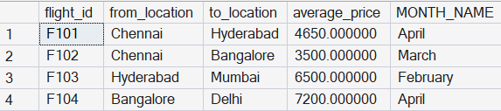

- Write a query to display the customer(s) who has/have booked least number of tickets in ABC Airlines. The Query should display profile_id, customer’s first_name, Address and Number of tickets booked as “No_of_Tickets”. Display the records sorted in ascending order based on customer's first name.
SELECT TOP 1 P.PROFILE_ID,P.FIRST_NAME,COUNT(*) AS " No_of_Tickets " FROM AIR_PASSENGER_PROFILE P JOIN AIR_TICKET_INFO T ON P.PROFILE_ID=T.PROFILE_ID GROUP BY (T.PROFILE_ID),P.PROFILE_ID,P.FIRST_NAME ORDER BY COUNT(*);
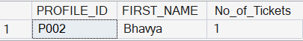
- Write a query to display the number of flight services between locaƟons in a month. The Query should display From_LocaƟon, To_LocaƟon, Month as “Month_Name” and number of flight services as “No_of_Services”. Hint: The Number of Services can be calculated from the number of scheduled departure dates of a flight. The records should be displayed in ascending order based on From_LocaƟon and then by To_LocaƟon and then by month name.
Select a1.from_location,a1.to_location,COUNT(*) AS "MONTHLY FLIGHTS",DATENAME(MONTH,a2.flight_departure_date) "MONTH" from air_flight a1 join air_flight_details a2 on a1.flight_id=a2.flight_id group by a1.from_location,a1.to_location,DATENAME(MONTH,a2.flight_departure_date) order by a1.from_location,a1.to_location;
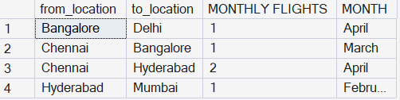

- Write a query to display the customer(s) who has/have booked maximum number of tickets in ABC Airlines. The Query should display profile_id, customer’s first_name, Address and Number of tickets booked as “No_of_Tickets”. Display the records in ascending order based on customer's first name
SELECT TOP 1 P.PROFILE_ID,P.FIRST_NAME,P.ADDRESS,COUNT(*) AS " No_of_Tickets " FROM AIR_PASSENGER_PROFILE P JOIN AIR_TICKET_INFO T ON P.PROFILE_ID=T.PROFILE_ID GROUP BY (T.PROFILE_ID),P.PROFILE_ID,P.FIRST_NAME ORDER BY COUNT(*) DESC;

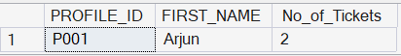

- Write a query to display the number of tickets booked from Chennai to Hyderabad. The Query should display passenger profile_id,first_name,last_name, Flight_Id , Departure_Date and number of tickets booked as “No_of_Tickets”. Display the records sorted in ascending order based on profile id and then by flight id and then by departure date.
SELECT p.profile_id, p.first_name, p.last_name, f.flight_id, t.flight_departure_date AS Departure_Date, COUNT(t.ticket_id) AS No_of_Tickets FROM air_ticket_info t JOIN air_passenger_profile p ON t.profile_id = p.profile_id JOIN air_flight f ON t.flight_id = f.flight_id WHERE f.from_location = 'Chennai' AND f.to_location = 'Hyderabad' GROUP BY p.profile_id, p.first_name, p.last_name, f.flight_id, t.flight_departure_date ORDER BY p.profile_id, f.flight_id, t.flight_departure_date;
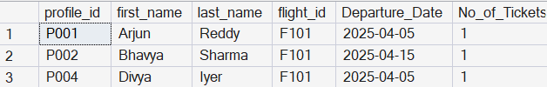
- Write a query to display flight id,from location, to location and ticket price of flights whose departure is in the month of april.
SELECT f.flight_id, f.from_location, f.to_location, fd.price FROM air_flight f JOIN air_flight_details fd ON f.flight_id = fd.flight_id WHERE MONTH(fd.flight_departure_date) =4;
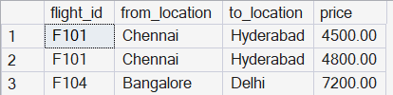

- Write a query to display the average cost of the tickets in each flight on all scheduled dates. The query should display flight_id, from_location, to_location and Average price as “Price”. Display the records sorted in ascending order based on flight id and then by from_location and then by to_location
SELECT f.flight_id, f.from_location, f.to_location, AVG(fd.price) AS Price FROM air_flight f JOIN air_flight_details fd ON f.flight_id = fd.flight_id GROUP BY f.flight_id, f.from_location, f.to_location ORDER BY f.flight_id, f.from_location, f.to_location;
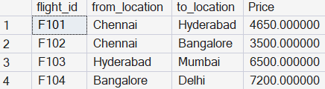
- Write a query to display the customers who have booked Ɵckets from Chennai to Hyderabad. The query should display profile_id, customer_name (combine first_name & last_name with comma in b/w), address of the customer. Give an alias to the name as customer_name. Hint: Query should fetch unique customers irrespective of multiple tickets booked. Display the records sorted in ascending order based on profile id.
SELECT DISTINCT p.profile_id, CONCAT(p.first_name, ',', p.last_name) AS customer_name, p.address FROM air_passenger_profile p JOIN air_ticket_info t ON p.profile_id = t.profile_id JOIN air_flight f ON t.flight_id = f.flight_id WHERE f.from_location = 'Chennai' AND f.to_location = 'Hyderabad' ORDER BY p.profile_id;

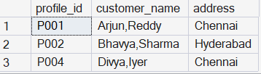
- Write a query to display profile id of the passenger(s) who has/have booked maximum number of Ɵckets. In case of mulƟple records, display the records sorted in ascending order based on profile id.

SELECT f.flight_id, f.from_location, f.to_location, AVG(fd.price) AS Price FROM air_flight f JOIN air_flight_details fd ON f.flight_id = fd.flight_id GROUP BY f.flight_id, f.from_location, f.to_location ORDER BY f.flight_id, f.from_location, f.to_location;

- Write a query to display the total number of tickets as “No_of_Tickets” booked in each flight in ABC Airlines. The Query should display the flight_id, from_location, to_location and the number of Ɵckets. Display only the flights in which atleast 1 ticket is booked. Display the records sorted in ascending order based on flight id.

SELECT DISTINCT p.profile_id, CONCAT(p.first_name, ',', p.last_name) AS customer_name, p.address FROM air_passenger_profile p JOIN air_ticket_info t ON p.profile_id = t.profile_id JOIN air_flight f ON t.flight_id = f.flight_id WHERE f.from_location = 'Chennai' AND f.to_location = 'Hyderabad' ORDER BY p.profile_id;

