Module 4.4 Practical Project Assignment
- Create Database command.
CREATE DATABASE InsuranceDB;

- Create table commands for all the tables with constraints, relationships etc.
CREATE TABLE CUSTOMERS(
CUSTOMERID INT PRIMARY KEY,
FirstName VARCHAR(50),
LastName VARCHAR(50),
DateOfBirth Date,
PHONE INT,
EMAIL VARCHAR(50));

CREATE TABLE POLICIES(
POLICYID INT PRIMARY KEY,
POLICYNAME VARCHAR(50),
POLICYTYPE VARCHAR(50),
PREMIMUMACCOUNT VARCHAR(50),
DURATIONYEARS INT
);

CREATE TABLE AGENTS(
AGENTID INT PRIMARY KEY,
AGENTNAME VARCHAR(50),
PHONE TEXT,
CITY VARCHAR(20)
);

CREATE TABLE CLAIM(
CLAIMID INT PRIMARY KEY,
ASSIGNMENTID INT FOREIGN KEY REFERENCES POLICYASSIGNEMNTS(ASSIGNMENTID) ,
CLAIMDATE DATE,
CLAIMAMOUNT INT,
CLAIMSTATUS BIT
);

CREATE TABLE ASSIGNMENTS(
ASSIGNMENTID INT PRIMARY KEY,
POLICYID INT FOREIGN KEY REFERENCES POLICIES(POLICYID),
AGENTID INT FOREIGN KEY REFERENCES AGENTS(AGENTID),
CUSTOMERID INT FOREIGN KEY REFERENCES CUSTOMERS(CUSTOMERID),
STARTDATE DATE,
ENDDATE DATE
);
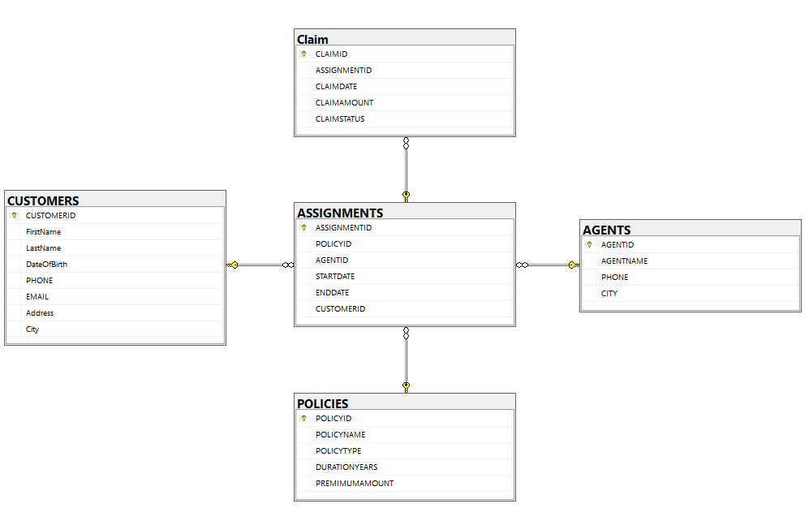
- SELECT COMMANDS
- View all records Customers table.
SELECT * FROM CUSTOMERS;
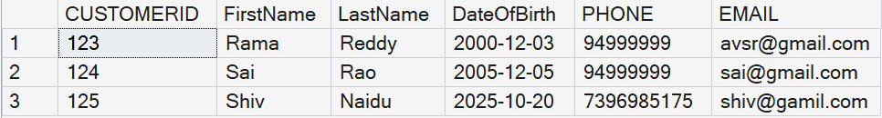

- View all records of PolicyAssignment table with AssignmentId, PolicyId, StartDate and EndDate columns only.
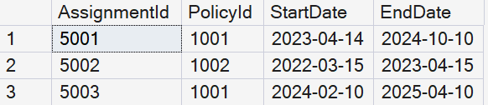
- Display all policies of Health type.
SELECT * FROM policies where POLICYTYPE='HEALTH';

- Display policies having premium amount more than 10000 and DurationYears is 1.
SELECT * FROM POLICIES WHERE PREMIUMAMOUNT>10000 AND DURATIONYEARS=1;
- List policies of type Life, Health, Motor use IN operator.
SELECT * FROM POLICIES WHERE POLICYTYPE IN ('LIFE','HEALTH','MOTOR');

STRING FUNCTIONS
1. Display customer full name by concatenating FirstName and LastName.
SELECT CONCAT(FirstName, ' ', LastName) AS FullName FROM CUSTOMERS;
2. Find customers whose FirstName starts with ‘A’.
SELECT * FROM CUSTOMERS WHERE FirstName LIKE 'A%';
3. Display LastName in uppercase.
SELECT UPPER(LastName) FROM CUSTOMERS;
4. Find customers whose LastName length is more than 6 characters.
SELECT * FROM CUSTOMERS WHERE LEN(LastName) > 6;
5. Display the first 3 characters of FirstName.
SELECT SUBSTRING(FirstName,1,3) FROM CUSTOMERS;
NUMERIC FUNCTIONS
6. Display ClaimAmount rounded to nearest integer.
SELECT ROUND(CLAIMAMOUNT,0) FROM CLAIMS;
7. Display absolute value of ClaimAmount.
SELECT ABS(CLAIMAMOUNT) FROM CLAIMS;
8. Calculate 10% tax on ClaimAmount.
SELECT CLAIMAMOUNT*0.10 AS Tax FROM CLAIMS;
9. Display ceiling value of ClaimAmount.
SELECT CEILING(CLAIMAMOUNT) FROM CLAIMS;
10. Display floor value of ClaimAmount.
SELECT FLOOR(CLAIMAMOUNT) FROM CLAIMS;
DATE FUNCTIONS
11. Display current system date.
SELECT GETDATE();
12. Find claims filed in last 6 months.
SELECT * FROM CLAIMS WHERE CLAIMDATE >= DATEADD(MONTH,-6,GETDATE());
13. Display ClaimDate in DD-MM-YYYY format.
SELECT FORMAT(CLAIMDATE,'dd-MM-yyyy') FROM CLAIMS;
14. Find year of ClaimDate.
SELECT YEAR(CLAIMDATE) FROM CLAIMS;
15. Find month name from ClaimDate.
SELECT DATENAME(MONTH,CLAIMDATE) FROM CLAIMS;
AGGREGATE FUNCTIONS
16. Find total number of customers.
SELECT COUNT(*) FROM CUSTOMERS;
17. Find maximum ClaimAmount.
SELECT MAX(CLAIMAMOUNT) FROM CLAIMS;
18. Find minimum ClaimAmount.
SELECT MIN(CLAIMAMOUNT) FROM CLAIMS;
19. Find average ClaimAmount.
SELECT AVG(CLAIMAMOUNT) FROM CLAIMS;
20. Count number of claims.
SELECT COUNT(CLAIMID) FROM CLAIMS;

21. List all Policies for a CustomerId = 5
SELECT *
FROM POLICIES
WHERE CUSTOMERID = 5;
22. View all customers with their policies
SELECT c.CUSTOMERID, c.FirstName,c.LastName,p.POLICYID,p.POLICYNAME,p.POLICYTYPE
FROM CUSTOMERS c JOIN POLICIES p ON c.CUSTOMERID = p.CUSTOMERID;
23. View claims with customer name
SELECT c.FirstName,c.LastName,cl.CLAIMID,cl.CLAIMAMOUNT,cl.CLAIMDATE,cl.CLAIMSTATUS
FROM CUSTOMERS c JOIN POLICIES p ON c.CUSTOMERID = p.CUSTOMERIDJOIN CLAIMS cl ON p.POLICYID = cl.POLICYID;
24. Display FirstName, PolicyName, AgentName, StartDate and EndDate
SELECT
c.FirstName, p.POLICYNAME, a.AGENTNAME, p.STARTDATE, p.ENDDATE FROM CUSTOMERS c JOIN POLICIES p ON c.CUSTOMERID = p.CUSTOMERID JOIN AGENTS ON p.AGENTID = a.AGENTID;
25. Display claims report with FirstName, PolicyName, ClaimAmount, ClaimStatus, ClaimDate
SELECT c.FirstName, p.POLICYNAME, cl.CLAIMAMOUNT, cl.CLAIMSTATUS, cl.CLAIMDATE FROM CUSTOMERS c JOIN POLICIES p ON c.CUSTOMERID = p.CUSTOMERID JOIN CLAIMS cl ON p.POLICYID = cl.POLICYID;
SUBQUERIES
26. Find customers who have policies (using IN)
SELECT *
FROM CUSTOMERS
WHERE CUSTOMERID IN (
SELECT CUSTOMERID
FROM POLICIES
);
27. Find customers who do NOT have any policies (using NOT IN)
SELECT *
FROM CUSTOMERS
WHERE CUSTOMERID NOT IN (
SELECT CUSTOMERID
FROM POLICIES
);
28. Find policies that have at least one claim (using EXISTS)
SELECT *
FROM POLICIES p
WHERE EXISTS (
SELECT 1
FROM CLAIMS c
WHERE c.POLICYID = p.POLICYID
);
29. Find policies that have no claims (using NOT EXISTS)
SELECT *
FROM POLICIES p
WHERE NOT EXISTS (
SELECT 1
FROM CLAIMS c
WHERE c.POLICYID = p.POLICYID
);
30. Find claims whose amount is greater than ANY claim amount of policy ID = 1
SELECT *
FROM CLAIMS
WHERE CLAIMAMOUNT > ANY (
SELECT CLAIMAMOUNT
FROM CLAIMS
WHERE POLICYID = 1
);
31. Find claims whose amount is greater than ALL claim amounts of policy ID = 1
SELECT *
FROM CLAIMS
WHERE CLAIMAMOUNT > ALL (
SELECT CLAIMAMOUNT
FROM CLAIMS
WHERE POLICYID = 1
);
32. Find policies whose premium is greater than ANY other policy premium
SELECT *
FROM POLICIES
WHERE PREMIMUMACCOUNT > ANY (
SELECT PREMIMUMACCOUNT
FROM POLICIES
);
33. Find policies whose premium is greater than ALL other policy premiums
SELECT *
FROM POLICIES
WHERE PREMIMUMACCOUNT > ALL (
SELECT PREMIMUMACCOUNT
FROM POLICIES
);

CASE STATEMENT
34. Display claim status as text (Approved / Rejected)
SELECT
CLAIMID,
CLAIMAMOUNT,
CASE
WHEN CLAIMSTATUS = 1 THEN 'Approved'
ELSE 'Rejected'
END AS ClaimStatusText
FROM CLAIMS;
35. Categorize policies based on duration
SELECT
POLICYID,
POLICYNAME,
CASE
WHEN DURATIONYEARS >= 10 THEN 'Long Term'
WHEN DURATIONYEARS BETWEEN 5 AND 9 THEN 'Medium Term'
ELSE 'Short Term'
END AS PolicyCategory
FROM POLICIES;
MERGE STATEMENT
36. Merge data from TEMP_CUSTOMERS into CUSTOMERS
MERGE INTO CUSTOMERS AS target
USING TEMP_CUSTOMERS AS source
ON target.CUSTOMERID = source.CUSTOMERID
WHEN MATCHED THEN
UPDATE SET
target.FirstName = source.FirstName,
target.LastName = source.LastName
WHEN NOT MATCHED THEN
INSERT (CUSTOMERID, FirstName, LastName, DateOfBirth, PHONE, EMAIL)
VALUES (source.CUSTOMERID, source.FirstName, source.LastName, source.DateOfBirth, source.PHONE, source.EMAIL);
37. Merge policy updates from TEMP_POLICIES
MERGE INTO POLICIES AS target
USING TEMP_POLICIES AS source
ON target.POLICYID = source.POLICYID
WHEN MATCHED THEN
UPDATE SET
target.POLICYNAME = source.POLICYNAME,
target.DURATIONYEARS = source.DURATIONYEARS
WHEN NOT MATCHED THEN
INSERT (POLICYID, POLICYNAME, POLICYTYPE, PREMIMUMACCOUNT, DURATIONYEARS)
VALUES (source.POLICYID, source.POLICYNAME, source.POLICYTYPE, source.PREMIMUMACCOUNT, source.DURATIONYEARS);

QUERIES USING ROLLUP
38. Total claim amount per year with grand total
SELECT
YEAR(CLAIMDATE) AS ClaimYear,
SUM(CLAIMAMOUNT) AS TotalAmount
FROM CLAIMS
GROUP BY ROLLUP (YEAR(CLAIMDATE));
39. Total claim amount by status with grand total
SELECT
CLAIMSTATUS,
SUM(CLAIMAMOUNT) AS TotalAmount
FROM CLAIMS
GROUP BY ROLLUP (CLAIMSTATUS);
QUERIES USING CUBE
40. Total claim amount by year and status (all combinations)
SELECT
YEAR(CLAIMDATE) AS ClaimYear,
CLAIMSTATUS,
SUM(CLAIMAMOUNT) AS TotalAmount
FROM CLAIMS
GROUP BY CUBE (YEAR(CLAIMDATE), CLAIMSTATUS);
QUERIES USING SET OPERATORS
41. UNION
SELECT CUSTOMERID AS ID FROM CUSTOMERS
UNION
SELECT AGENTID FROM AGENTS;
42. UNION ALL
SELECT CUSTOMERID AS ID FROM CUSTOMERS
UNION ALL
SELECT AGENTID FROM AGENTS;
43. INTERSECT
SELECT CUSTOMERID AS ID FROM CUSTOMERS
INTERSECT
SELECT AGENTID FROM AGENTS;
44. EXCEPT / MINUS
SELECT CUSTOMERID AS ID FROM CUSTOMERS
EXCEPT
SELECT AGENTID FROM AGENTS;
45. INTERSECT (Policies having Claims)
SELECT POLICYID FROM POLICIES
INTERSECT
SELECT POLICYID FROM CLAIMS;
46. Total ClaimAmount by PolicyID and Grand Total
SELECT POLICYID, SUM(CLAIMAMOUNT) AS TotalClaimAmount FROM CLAIMS GROUP BY GROUPING SETS ((POLICYID), ());

47. Number of Customers by City and Overall Total
SELECT CITY, COUNT(*) AS TotalCustomers FROM CUSTOMERS GROUP BY GROUPING SETS ((CITY), ());

