- Create Database command.
CREATE DATABASE InsuranceDB;
- Create table commands for all the tables with constraints, relationships etc.
CREATE TABLE CUSTOMERS(
CUSTOMERID INT PRIMARY KEY,
FirstName VARCHAR(50),
LastName VARCHAR(50),
DateOfBirth Date,
PHONE INT,
EMAIL VARCHAR(50));

CREATE TABLE POLICIES(
POLICYID INT PRIMARY KEY,
POLICYNAME VARCHAR(50),
POLICYTYPE VARCHAR(50),
PREMIMUMACCOUNT VARCHAR(50),
DURATIONYEARS INT
);

CREATE TABLE AGENTS(
AGENTID INT PRIMARY KEY,
AGENTNAME VARCHAR(50),
PHONE TEXT,
CITY VARCHAR(20)
);

CREATE TABLE CLAIMS(
CLAIMID INT PRIMARY KEY,
ASSIGNMENTID INT FOREIGN KEY REFERENCES POLICYASSIGNEMNTS(ASSIGNMENTID) ,
CLAIMDATE DATE,
CLAIMAMOUNT INT,
CLAIMSTATUS BIT
);

CREATE TABLE POLICYASSIGNEMNTS(
ASSIGNMENTID INT PRIMARY KEY,
POLICYID INT FOREIGN KEY REFERENCES POLICIES(POLICYID),
AGENTID INT FOREIGN KEY REFERENCES AGENTS(AGENTID),
CUSTOMERID INT FOREIGN KEY REFERENCES CUSTOMERS(CUSTOMERID),
STARTDATE DATE,
ENDDATE DATE
);
- View all records Customers table.
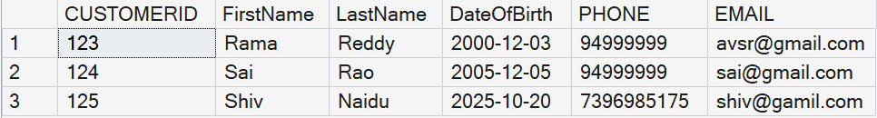

- View all records of PolicyAssignment table with AssignmentId, PolicyId, StartDate and EndDate columns only.
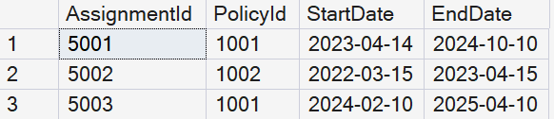
- Display all policies of Health type.
SELECT * FROM policies where POLICYTYPE='HEALTH';

- Display policies having premium amount more than 10000 and DurationYears is 1.
SELECT * FROM POLICIES WHERE PREMIUMAMOUNT>10000 AND DURATIONYEARS=1;
- Display unique city names from where agents belong to.
SELECT DISTINCT CITY FROM AGENTS;
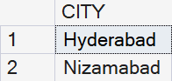
- List policies of type Life, Health, Motor use OR operator.
- List policies of type Life, Health, Motor use IN operator.
SELECT * FROM POLICIES WHERE POLICYTYPE IN ('LIFE','HEALTH','MOTOR');
- Display list of customers born after January 1 st , 2001 and before December 31 st , 2020 using between operator
SELECT * FROM CUSTOMERS WHERE DateOfBirth BETWEEN '2001-01-01' AND '2020-12-31';
- Display the list of customers born after January 1, 2001 and before December 31, 2020 using >= and <= operators.
SELECT * FROM CUSTOMERS WHERE DateOfBirth >= '2001-01-01' AND DateOfBirth <= '2020-12-31';
- Display claims data where claim status is Rejected.
SELECT * FROM CLAIMS WHERE CLAIMSTATUS = 0;

- Display records of Agents who stay in a city whose second letter is 'a'
SELECT * FROM AGENTS WHERE CITY LIKE '_a%';
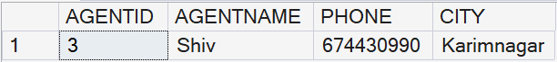
- Display highest and lowest claimAmount from Claims table.
SELECT MAX(CLAIMAMOUNT) AS HighestClaim, MIN(CLAIMAMOUNT) AS LowestClaim FROM CLAIMS;
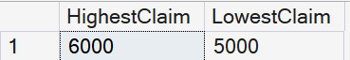
- Display latest claim record.
SELECT TOP 1 * FROM CLAIMS ORDER BY CLAIMDATE DESC;
- Increase premium amount by 10% for all health insurance policies.
UPDATE POLICIES SET PREMIMUMACCOUNT = PREMIMUMACCOUNT * 1.10 WHERE POLICYTYPE = 'Health';
17. Delete the record of PolicyAssignments whose EndDate is before today’s date.
DELETE FROM POLICYASSIGNEMNTS WHERE ENDDATE < GETDATE();
18. Display number of claims rejected.
SELECT COUNT(*) AS RejectedClaims FROM CLAIMS WHERE CLAIMSTATUS = 0;
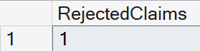
- Write a command to add Address and City Columns in the Customers table.
ALTER TABLE CUSTOMERS
ADD Address VARCHAR(100), City VARCHAR(50);
- List all Policies for a CustomerId 123.
SELECT p.*
FROM POLICIES p
JOIN POLICYASSIGNEMNTS pa ON p.POLICYID = pa.POLICYID
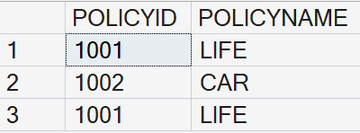
21. Select p.policyId,p.policyName
from Policies p
JOIN PolicyAssignments pa on pa.PolicyId = p.PolicyId where pa.CustomerId = 5;
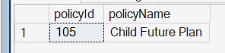

22. Select c.CustomerId,
c.FirstName,
c.LastName,
p.PolicyName
from Customers c
JOIN PolicyAssignments pa on pa.CustomerId = c.CustomerId
JOIN Policies p on p.PolicyId = pa.PolicyId;
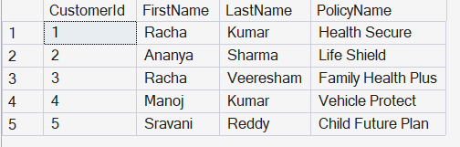
23.
Select
cl.ClaimId,
cl.AssignmentId,
cl.ClaimDate,
cl.ClaimAmount,
cl.ClaimStatus
from Claims as cl
JOIN PolicyAssignments pa on cl.AssignmentId = pa.AssignmentId
JOIN Customers c on pa.CustomerId = c.CustomerId;

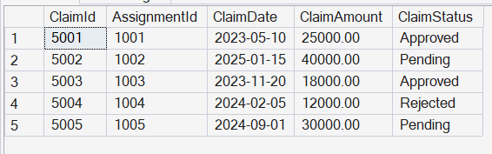
24.
Select
c.FirstName,
p.PolicyName,
a.AgentName,
pa.StartDate,
pa.EndDate
from Customers c
JOIN PolicyAssignments pa on pa.CustomerId = c.CustomerId
JOIN Policies p on pa.PolicyId = p.PolicyId
JOIN Agents a on pa.AgentId = a.AgentId;
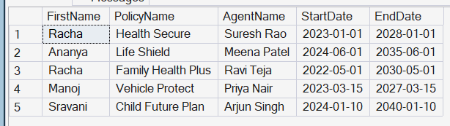
25.
Select
c.FirstName,
p.PolicyName,
cl.ClaimAmount,
cl.ClaimStatus,
cl.ClaimDate
from Claims cl
JOIN PolicyAssignments pa on cl.AssignmentId = pa.AssignmentId
JOIN Policies p on pa.PolicyId = p.PolicyId
JOIN Customers c on pa.CustomerId = c.CustomerId;

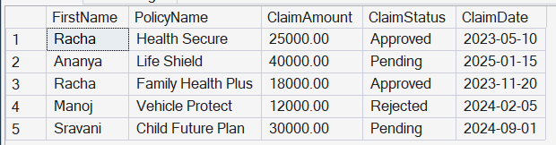

26.
Select
c.CustomerId,
c.FirstName,
c.LastName,
p.PolicyName,
pa.StartDate,
pa.EndDate
from Customers c
Left JOIN PolicyAssignments pa on c.CustomerId = pa.CustomerId
LEFT JOIN Policies p on pa.PolicyId= p.PolicyId
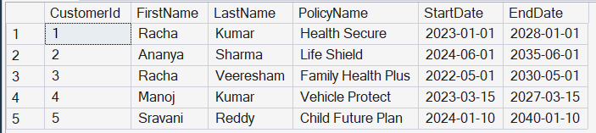

27.
SELECT DISTINCT
c.CustomerId,
c.FirstName,
c.LastName
FROM Customers c
LEFT JOIN PolicyAssignments pa
ON c.CustomerId = pa.CustomerId
LEFT JOIN Claims cl
ON pa.AssignmentId = cl.AssignmentId
WHERE cl.ClaimId IS NULL;
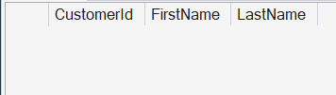

28.
SELECT
c.CustomerId,
c.FirstName,
c.LastName,
SUM(cl.ClaimAmount)
FROM Customers c
JOIN PolicyAssignments pa ON c.CustomerId = pa.CustomerId
JOIN Claims cl ON pa.AssignmentId = cl.AssignmentId
GROUP BY
c.CustomerId,
c.FirstName,
c.LastName;

29. SELECT
c.FirstName,
c.LastName,
SUM(cl.ClaimAmount) AS TotalClaimAmount
FROM Customers c
JOIN PolicyAssignments pa
ON c.CustomerId = pa.CustomerId
JOIN Claims cl ON pa.AssignmentId = cl.AssignmentId
GROUP BY
c.FirstName,
c.LastName
HAVING SUM(cl.ClaimAmount) > 50000;
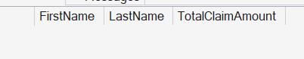

SELECT
a.AgentId,
a.AgentName,
COUNT(pa.PolicyId)
FROM Agents a
LEFT JOIN PolicyAssignments pa
ON a.AgentId = pa.AgentId
GROUP BY
a.AgentId,
a.AgentName;
