Database Management Systems
HOSTEL ACCOMMODATION &
STUDENT SERVICES
MANAGEMENT SYSTEM
Project Documentation
A Web-Based Hostel Management System Built on a Normalised Relational Database

Submitted By: Navari Varshith Reddy
Roll Number: 25WU0102181
Submitted To: Dr. Cheekati Nagaraju
College / University: Woxsen University
Academic Year: 2025–2029
ACKNOWLEDGEMENT
I express my sincere gratitude to Woxsen University, School of Technology, for providing the opportunity to complete this Project-Based Learning activity as part of the Database Management Systems course.
I thank Dr. Cheekati Nagaraju for the guidance and academic support provided during the development of the Hostel Accommodation & Student Services Management System. This project helped me apply database concepts including entity-relationship modelling, normalization, SQL operations, integrity constraints, views, triggers, indexing, transactions and application development.
I also acknowledge the tools used during the project, namely Visual Studio Code and MySQL, and the documentation listed in the References.
UNDERTAKING
I hereby declare that the project entitled “Hostel Accommodation & Student Services Management System” is submitted as part of the Project-Based Learning activity for the Database Management Systems course.
I confirm that the report describes the project work to the best of my knowledge and that external resources, software documentation and tools used have been acknowledged where applicable. I understand that the final submission must accurately represent the implemented database, application behavior, screenshots and test outcomes.
Name | Navari Varshith Reddy
Roll Number | 25WU0102181
Program | B.Tech
Date | 13-10-26
Signature | Varshith
TABLE OF CONTENTS
Section | Page
Abstract | 8
List of Tables | 5
List of Figures | 6
List of Acronyms | 7
1. Problem Statement, Solution Strategy and ER Diagram | 9
1.1 Problem Statement | 9
1.2 Objectives | 9
1.3 Scope and Assumptions | 9
1.4 Proposed Solution Strategy | 10
1.5 Functional Requirements | 11
1.6 Entity-Relationship Diagram (ERD) | 11
1.7 Entity and Relationship Summary | 12
2. Logical Database Design | 14
2.1 Relational Schema | 14
2.2 Keys and Integrity Constraints | 15
2.3 Functional Dependencies | 16
2.4 Normalization up to Third Normal Form | 16
2.5 Data Dictionary | 17
2.6 Implementation of Logical Design: DDL and Sample Data | 19
3. Application Development Using Logical Database Design | 22
3.1 Application Overview | 22
3.2 Development Environment and Database Connectivity | 22
3.3 Application Modules and Database Mapping | 23
3.4 CRUD Operations | 23
3.5 Business Rules, Validation and Error Handling | 23
3.6 Reports and Database Operations | 24
3.7 Application Screens | 26
3.8 Testing and Results | 32
4. Conclusion | 35
4.1 Limitations and Future Enhancements | 35
5. References | 36
6. Appendices | 37
LIST OF TABLES
Table No. | Table Title
Table 1 | Scope and Assumptions
Table 2 | Proposed Solution Strategy
Table 3 | Functional Requirements
Table 4 | Entity and Relationship Summary
Table 5 | Relational Schema
Table 6 | Keys and Integrity Constraints
Table 7 | Business Rules and Enforcement
Table 8 | Functional Dependencies
Table 9 | Normalization Status up to 3NF
Table 10 | Table-Level Data Dictionary
Table 11 | Data Dictionary: student
Table 12 | Data Dictionary: allocation
Table 13 | Data Dictionary: payment
Table 14 | Database Implementation Environment
Table 15 | Triggers
Table 16 | Views
Table 17 | Database Results Summary
Table 18 | Application Development Environment
Table 19 | Application Module-to-Database Mapping
Table 20 | CRUD Operations
Table 21 | Business Rules, Validation and Error Handling
Table 22 | Reports and Database Operations
Table 23 | Test Cases
Table 24 | Database Integrity Tests
LIST OF FIGURES
Figure No. | Figure Title
Figure 1 | Layered architecture of the Hostel Accommodation & Student Services Management System
Figure 2 | ER diagram of the Hostel Accommodation & Student Services Management System
Figure 3 | Database result: students table (3 records)
Figure 4 | Database result: rooms table (3 records)
Figure 5 | Database result: beds table (7 records retrieved in 0.747 ms)
Figure 6 | Dashboard: summary cards, occupancy chart, room availability donut, recent student records and activity
Figure 7 | Students screen: student directory with search box, status filter and Add student button
Figure 8 | Register new student form filled in with sample details
Figure 9 | Student saved: confirmation message and new record with Pending status
Figure 10 | Rooms & Beds screen: summary cards and room inventory with capacity, occupied, available and monthly fee
Figure 11 | Allocations screen: allocation register with Allocate bed button
Figure 12 | Allocate a bed form: only unallocated students and rooms with free beds are listed
Figure 13 | Allocation recorded: confirmation message and new Active row in the register
Figure 14 | Complaints & maintenance screen: status cards and complaint register
Figure 15 | Complaint marked as resolved: status badge changes and the action is replaced
Figure 16 | Visitor Log screen: visitor register with entry time and status
Figure 17 | Reports & Analytics screen: summary cards, occupancy by block, complaint distribution and database entities
Figure 18 | Appendix: student search with no match shows “No matching students found.” (HT-05)
Figure 19 | Appendix: room inventory filtered by Block B (HT-07)
Figure 20 | Appendix: room A-102 shown as Full after allocation (HT-11)
Figure 21 | Appendix: allocation form with no unallocated students; confirm button disabled (HT-13)
Figure 22 | Appendix: Register a visitor form (HT-16)
Figure 23 | Appendix: visitor checked out (HT-17)
Figure 24 | Appendix: mobile layout (420 px wide)
Figure 25 | Appendix: dark theme layout
LIST OF ACRONYMS
Acronym | Expansion
BR | Business Rule
CRUD | Create, Read, Update, Delete
CSS | Cascading Style Sheets
DBMS | Database Management System
DDL | Data Definition Language
DML | Data Manipulation Language
ER / ERD | Entity-Relationship / Entity-Relationship Diagram
FD | Functional Dependency
FK | Foreign Key
FR | Functional Requirement
HTML | HyperText Markup Language
PK | Primary Key
SQL | Structured Query Language
UI | User Interface
UQ | Unique Constraint
3NF | Third Normal Form
ABSTRACT
A college hostel must coordinate blocks, rooms, beds, students, allocations, transfers, fees, visitors, complaints and maintenance. When these activities are managed through disconnected registers, it becomes difficult to maintain consistent data, enforce allocation rules and obtain reliable summaries: a bed may be given to two students, rooms may exceed capacity and fee dues may be missed. The objective of this project is to design and implement a database-driven Hostel Accommodation & Student Services Management System using a normalised relational schema, SQL and a web interface built with HTML, CSS and JavaScript.
The conceptual design contains 17 entities and is converted into 17 relations in Third Normal Form. The schema is implemented in SQL with primary keys, foreign keys, UNIQUE, NOT NULL, CHECK and DEFAULT constraints, two partial unique indexes, 6 triggers, 17 indexes and 8 views. It was loaded with sample data and verified with 11 reporting queries and 11 deliberate rule violations, all of which behaved as expected. The HostelHub web interface, developed in Visual Studio Code, provides a dashboard, student directory, rooms and beds inventory, bed allocation, complaint tracking, visitor log and reports, and applies the capacity and one-bed-per-student rules when beds are allocated. Eighteen test cases executed against the running interface all passed. The project demonstrates how relational database concepts can support a connected, maintainable hostel management application.
Keywords: Hostel Management, Relational Database, ER Diagram, Normalization, SQL Triggers, MySQL, Web Interface
CHAPTER 1
PROBLEM STATEMENT, SOLUTION STRATEGY AND ER DIAGRAM
1.1 Problem Statement
A college hostel manages many related records: hostel blocks, rooms, beds, students, bed allocations, transfers, fees, payments, visitors, complaints and maintenance work. If each activity is kept in a separate register or spreadsheet, the same information is entered repeatedly and the records become inconsistent. A bed may be given to two students, a room may be filled beyond its capacity, a student may be placed in a block meant for the other gender, fee dues may be missed, and complaints may never be closed.
This project addresses the need for a single database-backed application that keeps these records consistent and enforces the hostel’s rules automatically. It uses a relational design normalised to Third Normal Form, an SQL implementation with constraints, triggers and views, and a web interface named HostelHub for the daily hostel operations. The scope is an academic prototype; it is not represented as a production hostel ERP or a payment gateway.
1.2 Objectives
- Identify the entities, attributes, relationships and users of a hostel and represent them in an ER diagram.
- Convert the ER model into a relational schema normalised up to Third Normal Form.
- Implement the schema in SQL with primary keys, foreign keys and CHECK, UNIQUE, NOT NULL and DEFAULT constraints, triggers, indexes and views.
- Provide a web interface (HostelHub) with screens for the dashboard, students, rooms and beds, allocations, complaints and maintenance, visitor log and reports.
- Apply business rules such as one active resident per bed, room-capacity control, valid dates and payment limits.
- Test the database and the application systematically and record actual results.
1.3 Scope and Assumptions
Table 1. Scope and Assumptions
Item | Project-specific description
In scope | Database design for 17 entities (students, blocks, rooms, beds, allocation, transfer, vacating, fees, payments, visitors, complaints, maintenance, staff, users) with SQL constraints, triggers and views; HostelHub web interface with seven screens: Dashboard, Students, Rooms & Beds, Allocations, Complaints, Visitor Log and Reports.
Out of scope | Live connection of the interface to a database server, fee and payment screens, transfer and vacating screens, mess management, biometric attendance, online payment gateway, SMS or e-mail notices and production-grade authentication.
Assumptions | One student occupies one bed at a time; every room type has a fixed capacity; fee is charged per academic year at the rate of the room type first allotted; blocks are for a single gender.
Data integrity | Business rules are placed in the database (constraints and triggers) as well as in the application, so that invalid data is rejected even if the application is bypassed.

1.4 Proposed Solution Strategy
The system uses a layered approach. HTML and CSS provide the HostelHub interface; JavaScript validates input and applies the allocation rules; and the data layer is specified by a normalised relational schema implemented in SQL. A dashboard gives an overview of occupancy, available beds and open complaints, while module screens support students, rooms, allocations, complaints, visitors and reports. Figure 1 shows how a user action flows through the layers.
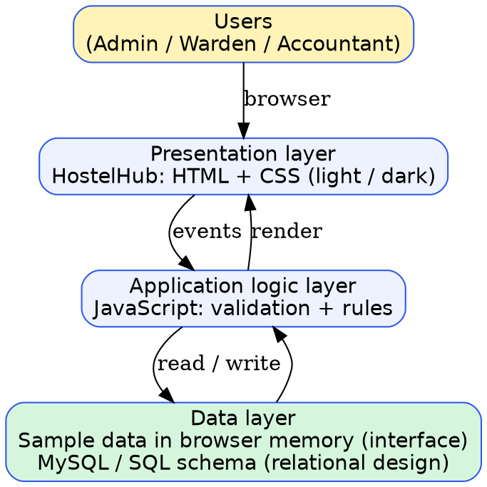
Figure 1. Layered architecture of the Hostel Accommodation & Student Services Management System
Table 2. Proposed Solution Strategy
Solution element | Project-specific description
Primary users | Hostel warden, accounts officer, maintenance staff and system administrator (in the academic prototype, a student demonstrator).
Major modules | Dashboard, Students, Rooms & Beds, Allocations, Complaints & Maintenance, Visitor Log and Reports. The database additionally models transfers, vacating, fee schedules, bills, payments, maintenance staff and users.
Proposed workflow | Student Registration → Room and Bed Check → Bed Allocation → Complaints / Visitors → Reports. In the database design the lifecycle continues with fee bill, payment, transfer and vacating.
Business rules | One active resident per bed; one active allocation per student; room-capacity control; gender-matched blocks; valid allocation and vacating dates; payment limit; visitors only for residents.
Expected outputs | Occupancy, vacancy, fee-dues, allocation-history, visitor, unresolved-complaint and maintenance-status reports.

1.5 Functional Requirements
Table 3. Functional Requirements
Req. ID | Functional requirement | Implemented in
FR-01 | The system shall register, search and list student records. | Database + HostelHub
FR-02 | The system shall maintain blocks, rooms and beds and show occupancy and availability. | Database + HostelHub
FR-03 | The user shall be able to allocate a bed with free capacity to an unallocated student. | Database + HostelHub
FR-04 | The system shall support transfer of a resident while keeping the history. | Database (transfer table)
FR-05 | The system shall support vacating a resident and freeing the bed. | Database (allocation, vacating_record)
FR-06 | The system shall bill residents by room type and academic year. | Database (fee_schedule, fee_bill)
FR-07 | The system shall record payments and enforce a payment limit. | Database (payment, trigger)
FR-08 | The system shall record visitor entry and exit. | Database + HostelHub
FR-09 | The system shall register complaints and track them until resolved. | Database + HostelHub
FR-10 | The system shall store maintenance requests and assigned staff. | Database (maintenance_request, staff)
FR-11 | The system shall provide reports on occupancy, fees and service requests. | Database views + HostelHub Reports
FR-12 | Input shall be validated and errors reported clearly. | Database + HostelHub

1.6 Entity-Relationship Diagram (ERD)
Seventeen entities were identified: department, hostel_block, room_type, room, bed, student, allocation, transfer, vacating_record, fee_schedule, fee_bill, payment, visitor, complaint, maintenance_request, staff and app_user. Figure 2 shows the ER diagram in crow’s-foot notation. Each box lists the primary key (underlined), foreign keys and principal attributes. The bar (|) marks the “one” side of a relationship and the crow’s foot marks the “many” side.
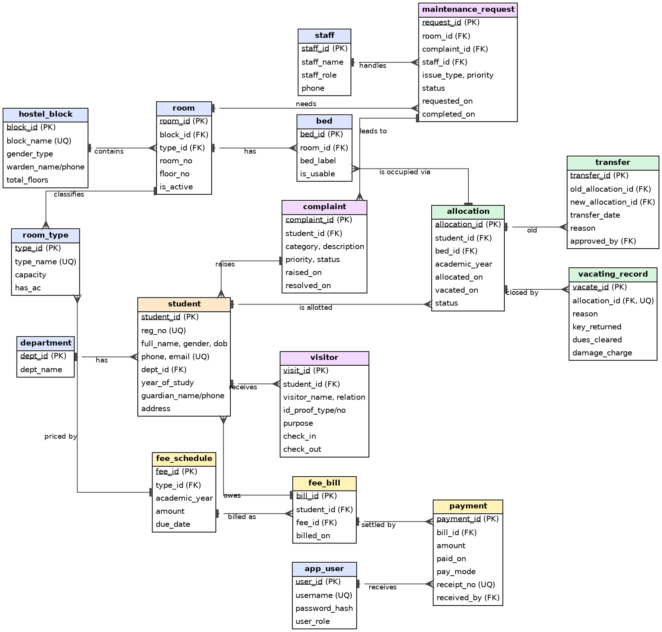
Figure 2. ER diagram of the Hostel Accommodation & Student Services Management System
1.7 Entity and Relationship Summary
Table 4. Entity and Relationship Summary
Entity / relationship | Cardinality | Purpose
department – student | 1 : N | Each student belongs to one department.
hostel_block – room | 1 : N | A block contains many rooms; the block fixes the gender served.
room_type – room | 1 : N | The room type fixes capacity and air-conditioning.
room – bed | 1 : N | A room has as many beds as its capacity.
student – allocation | 1 : N | A student can have many allocations over time, one active at a time.
bed – allocation | 1 : N | A bed can have many allocations over time, one active at a time.
allocation – transfer | 1 : 1 (old), 1 : 1 (new) | A transfer closes one allocation and opens another.
allocation – vacating_record | 1 : 0..1 | Records the exit checklist for a closed allocation.
room_type – fee_schedule | 1 : N | Fee is defined per room type and academic year.
fee_schedule – fee_bill – payment | 1 : N – 1 : N | Many students are billed at a scheduled fee; a bill is paid in instalments.
student – visitor / complaint | 1 : N | A student receives visitors and raises complaints.
room – maintenance_request | 1 : N | A room can need many repairs.
complaint – maintenance_request | 1 : N (optional) | A complaint may lead to repair work.
staff – maintenance_request | 1 : N | A staff member handles many requests.

CHAPTER 2
LOGICAL DATABASE DESIGN
2.1 Relational Schema
The ER model was converted into 17 relations. Primary keys are single-column auto-numbered identifiers; natural keys such as registration number and receipt number are declared UNIQUE. Table 5 lists each relation with its primary key and foreign keys.
Table 5. Relational Schema
S.No. | Relation (attributes) | PK | Foreign keys
1 | department(dept_id, dept_name) | dept_id | –
2 | hostel_block(block_id, block_name, gender_type, warden_name, warden_phone, total_floors) | block_id | –
3 | room_type(type_id, type_name, capacity, has_ac) | type_id | –
4 | staff(staff_id, staff_name, staff_role, phone) | staff_id | –
5 | app_user(user_id, username, password_hash, full_name, user_role) | user_id | –
6 | room(room_id, block_id, type_id, room_no, floor_no, is_active) | room_id | block_id, type_id
7 | bed(bed_id, room_id, bed_label, is_usable) | bed_id | room_id
8 | student(student_id, reg_no, full_name, gender, dob, phone, email, dept_id, year_of_study, guardian_name, guardian_relation, guardian_phone, address, registered_on) | student_id | dept_id
9 | allocation(allocation_id, student_id, bed_id, academic_year, allocated_on, vacated_on, status) | allocation_id | student_id, bed_id
10 | transfer(transfer_id, old_allocation_id, new_allocation_id, transfer_date, reason, approved_by) | transfer_id | old_allocation_id, new_allocation_id, approved_by
11 | vacating_record(vacate_id, allocation_id, reason, key_returned, dues_cleared, damage_charge, remarks) | vacate_id | allocation_id
12 | fee_schedule(fee_id, type_id, academic_year, amount, due_date) | fee_id | type_id
13 | fee_bill(bill_id, student_id, fee_id, billed_on) | bill_id | student_id, fee_id
14 | payment(payment_id, bill_id, amount, paid_on, pay_mode, receipt_no, received_by) | payment_id | bill_id, received_by
15 | visitor(visit_id, student_id, visitor_name, relation, id_proof_type, id_proof_no, visitor_phone, purpose, check_in, check_out) | visit_id | student_id
16 | complaint(complaint_id, student_id, category, description, priority, status, raised_on, resolved_on, resolution_notes) | complaint_id | student_id
17 | maintenance_request(request_id, room_id, complaint_id, staff_id, issue_type, description, priority, status, requested_on, completed_on) | request_id | room_id, complaint_id, staff_id

2.2 Keys and Integrity Constraints
Integrity is enforced in the database itself. Besides ordinary constraints, two rules are implemented as partial unique indexes that cover only ACTIVE rows, because a bed or student legitimately appears many times in the allocation history. They are uq_active_bed on allocation(bed_id) and uq_active_student on allocation(student_id), each restricted to rows where status = ACTIVE.
Table 6. Keys and Integrity Constraints
Constraint type | Role in the database | Examples in this project
PRIMARY KEY | Uniquely identifies a row in each relation. | All 17 tables.
FOREIGN KEY | Maintains valid relationships; default RESTRICT prevents deleting a parent that has children. | allocation → student, bed; room → hostel_block, room_type; payment → fee_bill; and others.
UNIQUE | Prevents duplicate business keys. | reg_no, email, block_name, receipt_no, username, (block_id, room_no), (room_id, bed_label), (type_id, academic_year), (student_id, fee_id).
NOT NULL / DEFAULT | Requires essential values and provides defaults. | status = ACTIVE, priority = MEDIUM, registered_on / billed_on / paid_on / raised_on = current date, is_usable = 1.
CHECK | Restricts values to an allowed domain. | gender, 10-digit phone, e-mail format, year 1–5, capacity 1–6, amount > 0, status lists, vacated_on ≥ allocated_on, resolved_on ≥ raised_on.
Triggers (6) | Enforce rules that span tables. | Bed capacity, bed usable, gender match, room capacity, payment limit, visitor must be resident.

Business rules and their enforcement
Table 7. Business Rules and Enforcement
ID | Business rule | Database enforcement | HostelHub interface
BR-01 | One active resident per bed | Partial UNIQUE index uq_active_bed | Allocation is offered only for rooms with a free bed
BR-02 | One active allocation per student | Partial UNIQUE index uq_active_student | Only students without a room are offered
BR-03 | Room-capacity control | Triggers trg_bed_capacity, trg_alloc_room_capacity | Full rooms are not offered and are refused
BR-04 | Valid allocation / vacating dates | CHECK on allocation (dates and status) | Allocation date is set by the system
BR-05 | Payment limit | Trigger trg_payment_limit; CHECK amount > 0 | No payment screen (database only)
BR-06 | Gender-matched blocks | Trigger trg_alloc_gender | Not applied in the interface (database only)
BR-07 | Only residents receive visitors | Trigger trg_visitor_resident | Not applied in the interface (database only)
BR-08 | Unique registration number, e-mail, receipt | UNIQUE constraints | Student IDs are generated automatically
BR-09 | Resolved complaint needs a resolution date | CHECK on complaint | Status changes to Resolved with one click
BR-10 | Students with history cannot be deleted | FOREIGN KEY (RESTRICT) | No delete option in the interface

2.3 Functional Dependencies
The functional dependencies below were derived from the candidate keys and business rules of each relation. In every relation, each determinant is a candidate key.
Table 8. Functional Dependencies
Relation | Functional dependencies
student | student_id → all other attributes; reg_no → student_id; email → student_id
room | room_id → block_id, type_id, room_no, floor_no, is_active; (block_id, room_no) → room_id
room_type | type_id → type_name, capacity, has_ac; type_name → type_id
bed | bed_id → room_id, bed_label, is_usable; (room_id, bed_label) → bed_id
allocation | allocation_id → student_id, bed_id, academic_year, allocated_on, vacated_on, status
fee_schedule | fee_id → type_id, academic_year, amount, due_date; (type_id, academic_year) → fee_id
fee_bill | bill_id → student_id, fee_id, billed_on; (student_id, fee_id) → bill_id
payment | payment_id → bill_id, amount, paid_on, pay_mode, receipt_no, received_by; receipt_no → payment_id
complaint | complaint_id → student_id, category, description, priority, status, raised_on, resolved_on, resolution_notes
maintenance_request | request_id → room_id, complaint_id, staff_id, issue_type, description, priority, status, requested_on, completed_on

2.4 Normalization up to Third Normal Form (3NF)
Normalization was carried out from the functional dependencies. 1NF requires atomic values and no repeating groups; 2NF requires non-key attributes to depend on the whole key; 3NF requires that non-key attributes do not depend transitively on the key. A first draft that stored beds as a list inside the room record and payments as a repeating group inside the bill was split into the separate relations bed and payment.
Table 9. Normalization Status up to 3NF
Relation group | 1NF | 2NF | 3NF | Evidence
Master tables (department, hostel_block, room_type, staff, app_user) | Yes | Yes | Yes | Single-column keys; no non-key dependencies
Structure (room, bed) | Yes | Yes | Yes | Capacity held in room_type, not copied to room or bed
Student (student) | Yes | Yes | Yes | Department name held once in department
Allocation lifecycle (allocation, transfer, vacating_record) | Yes | Yes | Yes | Vacated date stored only in allocation
Fees (fee_schedule, fee_bill, payment) | Yes | Yes | Yes | Amount held only in fee_schedule; bill refers to it
Services (visitor, complaint, maintenance_request) | Yes | Yes | Yes | Each row depends only on its own key

The following redundancies were removed to reach 3NF:
- Room capacity: capacity depends on room type, so it is stored once in room_type; otherwise room_id → type_id → capacity would be a transitive dependency.
- Fee amount: stored only in fee_schedule; fee_bill refers to it through fee_id, so a change of fee is made in one place.
- Block gender: stored in hostel_block and reached through room, not copied into every bed or allocation.
- Vacating date: stored only in allocation.vacated_on; vacating_record keeps only the extra facts.
- Derived values: occupancy, vacancy and balance are never stored; they are computed by views so they cannot become inconsistent.
Normalization status: all 17 relations are in 3NF (and in BCNF, since every determinant is a candidate key).
2.5 Data Dictionary
Table 10. Table-Level Data Dictionary
Table | Purpose | Key constraints
department | Academic departments | UQ dept_name
hostel_block | Hostel buildings and warden | UQ block_name; gender_type CHECK; 10-digit phone
room_type | Sharing types and capacities | UQ type_name; capacity 1–6
room | Rooms in a block | UQ (block_id, room_no); FK block, type
bed | Beds in a room | UQ (room_id, bed_label); trigger caps beds at capacity
student | Student master data | UQ reg_no, email; CHECK gender, phone, e-mail, year
allocation | Student-to-bed assignment history | Partial UQ on active bed and active student; date CHECK
transfer | Link between old and new allocation | UQ old, UQ new; CHECK old ≠ new
vacating_record | Exit checklist | UQ allocation_id; damage_charge ≥ 0
fee_schedule | Fee per room type and year | UQ (type_id, academic_year); amount > 0
fee_bill | Bill raised for a student | UQ (student_id, fee_id)
payment | Instalments received | amount > 0; UQ receipt_no; trigger limits total
visitor | Visitor log | check_out ≥ check_in; trigger needs resident
complaint | Student complaints | status / date CHECK
maintenance_request | Repair work orders | status / date CHECK; staff required once assigned
staff | Maintenance staff | staff_role CHECK
app_user | Login accounts and roles | UQ username; role CHECK

Column details: student
Table 11. Data Dictionary: student
Column | Type | Constraints | Description
student_id | INTEGER | PK, auto-increment | Internal identifier
reg_no | VARCHAR(20) | NOT NULL, UNIQUE | Registration number
full_name | VARCHAR(80) | NOT NULL | Student name
gender | VARCHAR(6) | CHECK MALE / FEMALE | Matched with block
dob | DATE | NOT NULL | Date of birth
phone | CHAR(10) | NOT NULL, 10 digits | Mobile number
email | VARCHAR(100) | NOT NULL, UNIQUE, format check | E-mail address
dept_id | INTEGER | FK department | Department
year_of_study | INTEGER | CHECK 1–5 | Current year
guardian_name / relation / phone | VARCHAR, CHAR | NOT NULL | Guardian details
address | VARCHAR(200) | NOT NULL | Home address
registered_on | DATE | DEFAULT current date | Registration date

Column details: allocation
Table 12. Data Dictionary: allocation
Column | Type | Constraints | Description
allocation_id | INTEGER | PK | Identifier
student_id | INTEGER | FK student | Resident
bed_id | INTEGER | FK bed | Bed assigned
academic_year | VARCHAR(7) | format YYYY-YY | Year of stay
allocated_on | DATE | NOT NULL | Start date
vacated_on | DATE | NULL while ACTIVE; ≥ allocated_on otherwise | End date
status | VARCHAR(12) | ACTIVE / VACATED / TRANSFERRED | Current state

Column details: payment
Table 13. Data Dictionary: payment
Column | Type | Constraints | Description
payment_id | INTEGER | PK | Identifier
bill_id | INTEGER | FK fee_bill | Bill being paid
amount | DECIMAL(10,2) | CHECK > 0; trigger limit | Amount received
paid_on | DATE | DEFAULT current date | Payment date
pay_mode | VARCHAR(10) | CASH / UPI / CARD / CHEQUE / NEFT | Mode of payment
receipt_no | VARCHAR(20) | UNIQUE | Receipt number
received_by | INTEGER | FK app_user | Accounts officer

2.6 Implementation of Logical Design: DDL and Sample Data
Table 14. Database Implementation Environment
Item | Details
DBMS | MySQL (implementation database); SQLite 3.45 used for automated verification of the design
Database objects | 17 tables, 17 user indexes, 6 triggers, 8 views
Foreign keys | Enforced (PRAGMA foreign_keys = ON)
Test data | 3 blocks, 6 rooms, 17 beds, 8 students, 7 allocations, 7 bills, 5 payments, 2 visitors, 3 complaints and 2 maintenance requests, loaded to verify the design
Implementation database | MySQL database hostelhub; result screenshots in Figures 3 to 5

Triggers
Table 15. Triggers
Trigger | Fires | Rule enforced
trg_bed_capacity | BEFORE INSERT ON bed | A room cannot have more beds than its room-type capacity.
trg_alloc_bed_usable | BEFORE INSERT ON allocation | An unusable bed cannot be allocated.
trg_alloc_gender | BEFORE INSERT ON allocation | Student gender must match the block gender.
trg_alloc_room_capacity | BEFORE INSERT ON allocation | Active residents in a room cannot exceed its capacity.
trg_payment_limit | BEFORE INSERT ON payment | Total paid cannot exceed the billed fee.
trg_visitor_resident | BEFORE INSERT ON visitor | A visitor can be recorded only for a current resident.

Indexes and views
Seventeen indexes were created on columns used in searches and joins: student(full_name), student(dept_id), room(block_id), bed(room_id), allocation(student_id), allocation(bed_id), allocation(status), fee_bill(student_id), payment(bill_id), visitor(student_id), visitor(check_in), complaint(student_id), complaint(status), maintenance_request(room_id), maintenance_request(status), maintenance_request(staff_id) and fee_schedule(type_id).
Table 16. Views
View | Report it provides
v_room_occupancy | Capacity, occupied and vacant beds for every room
v_vacant_beds | Every usable bed with no active resident
v_fee_dues | Billed, paid and balance per bill
v_allocation_history | Complete allocation history with block, room and bed
v_visitor_log | Visitors with INSIDE / LEFT status
v_unresolved_complaints | Complaints that are OPEN or IN_PROGRESS
v_maintenance_status | Repair requests with assigned staff
v_current_residents | Who is living where right now

Transaction handling
A transfer has three steps that must succeed or fail together: close the old allocation (status TRANSFERRED with a vacated date), open the new allocation (status ACTIVE) and record the transfer row linking the two. If any step fails, the transaction is rolled back and the student keeps the original bed. This transaction was executed on the test database and produced the expected result: the old allocation became TRANSFERRED, a new ACTIVE allocation was created, and one transfer row linked them.
Database results
The following results were obtained from the implementation database hostelhub in MySQL. The tables students, rooms and beds correspond to the student, room and bed relations of Table 5, with their own column naming. Figure 3 lists the registered students, Figure 4 the rooms with sharing type, capacity and monthly fee, and Figure 5 the seven beds with their status.
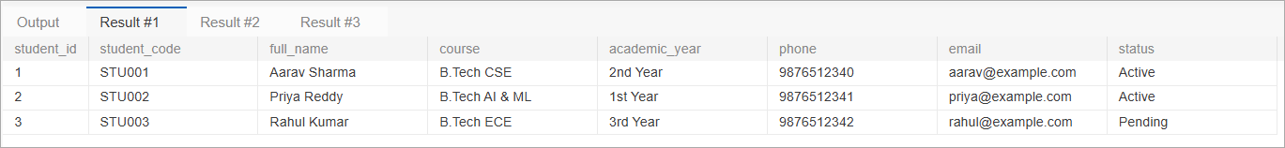
Figure 3. Database result: students table (3 records)
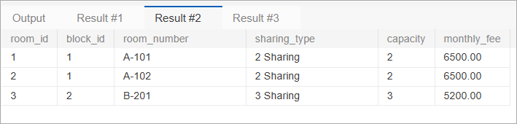
Figure 4. Database result: rooms table (3 records)
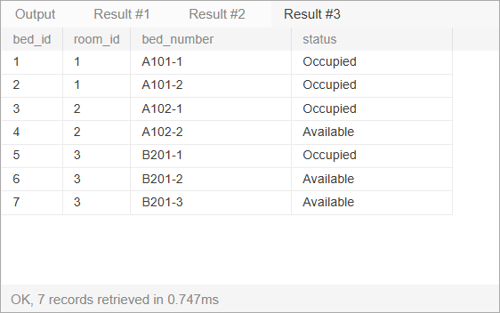
Figure 5. Database result: beds table (7 records retrieved in 0.747 ms)
Table 17. Database Results Summary
Result | Table | Records | Observation
Result #1 | students | 3 | Columns student_id, student_code, full_name, course, academic_year, phone, email, status; two students Active and one Pending.
Result #2 | rooms | 3 | A-101 and A-102 are 2-sharing at ₹6,500; B-201 is 3-sharing at ₹5,200; total capacity 7 beds.
Result #3 | beds | 7 | Four beds Occupied (A101-1, A101-2, A102-1, B201-1) and three Available (A102-2, B201-2, B201-3); the bed count equals the total room capacity.

CHAPTER 3
APPLICATION DEVELOPMENT USING LOGICAL DATABASE DESIGN
3.1 Application Overview
The application, named HostelHub, is a browser-based management interface implemented with HTML, CSS and JavaScript in a single file (hostel_management_preview.html) written in Visual Studio Code. A navigation sidebar gives access to seven screens: Dashboard, Students, Rooms & Beds, Allocations, Complaints, Visitor Log and Reports. The JavaScript layer keeps the hostel records, validates each operation, updates the summary figures immediately and shows a short confirmation message after every action. The interface follows the device’s light or dark theme and adapts to narrow screens.
The interface is a demonstration front end. It works on sample records held in the browser’s memory and, as its own footer states, it is not connected to a MySQL server. The relational design in Chapter 2 is the specification of the data layer, and the interface implements the part of that design that a student demonstration needs: students, rooms and beds, allocations, complaints and visitors.
3.2 Development Environment and Database Connectivity
Table 18. Application Development Environment
Item | Details
Programming languages | HTML5, CSS3 and JavaScript
Editor / IDE | Visual Studio Code
Database | MySQL (database hostelhub); result screenshots in Section 2.6
SQL verification in this report | The queries (Section 3.6) and rule-violation tests (Section 3.8) were executed with automated scripts on SQLite 3.45; syntax differences for MySQL are listed in Section 4.1
Application file | hostel_management_preview.html (single file; opens in any modern browser)
Data used by the interface | Sample students, rooms, complaints, visitors and allocations held in browser memory; changes last until the page is reloaded
Testing tools | Headless Chromium for automated interface tests and screenshots

Note on connectivity: the interface does not open a connection to a database server. Records created in the interface exist only in the current browser session. The business rules that the interface does not apply, such as gender-matched blocks, payment limits and date checks, are enforced by the SQL schema and were verified against the database directly (Section 3.8).
3.3 Application Modules and Database Mapping
Table 19. Application Module-to-Database Mapping
Module / screen | Purpose | Tables / operations
Dashboard | Shows registered students, bed occupancy, available beds, open complaints, occupancy chart and recent records. | student, bed, allocation, complaint; SELECT with COUNT and SUM (see v_room_occupancy).
Students | Register, search and filter students. | student, department; INSERT, SELECT.
Rooms & Beds | Room inventory with sharing type, capacity, occupied and available beds and monthly fee; search and block filter. | hostel_block, room_type, room, bed, fee_schedule; v_room_occupancy.
Allocations | Allocation register; allocate a bed to an unallocated student in a room with free capacity. | allocation, bed, student; INSERT; v_vacant_beds.
Complaints | Complaint register with priority and status; create complaint; mark resolved. | complaint; INSERT, UPDATE; v_unresolved_complaints.
Visitor Log | Visitor register; register visitor; check out. | visitor; INSERT, UPDATE; v_visitor_log.
Reports | Occupancy rate, monthly fee estimate, active residents, unresolved requests, occupancy by block, complaint status distribution. | Aggregations over allocation, room, fee_schedule and complaint (Section 3.6).

3.4 CRUD Operations
Table 20. CRUD Operations
Operation | Application feature | Tables affected | Evidence
Create | Register student; allocate bed; create complaint; register visitor. | student, allocation, complaint, visitor | HT-03, HT-10, HT-14, HT-16
Read / Search | Dashboard, student search and status filter, room search and block filter, registers, reports. | All tables and views | HT-01, HT-05 to HT-08, HT-18
Update | Room occupancy after allocation; complaint status to Resolved; visitor status to Checked out. | allocation, bed, complaint, visitor | HT-11, HT-15, HT-17
Delete | Not offered in the interface, so history is preserved. In the database, foreign keys prevent deleting a student who has allocations. | student | DB test N-11

3.5 Business Rules, Validation and Error Handling
Table 21. Business Rules, Validation and Error Handling
Rule / validation | How it is applied | Evidence
Required fields | Student name and course, complaint description, visitor name and purpose are required; the form cannot be submitted with them empty. | HT-04
Room capacity | Only rooms with at least one free bed are offered for allocation; a full room is refused with the message “Please select a valid available bed.” | HT-09, HT-11, HT-12
One bed per student | Only students without a room are offered; when none remain the list shows “No unallocated students” and the confirm button is disabled. | HT-13
Allocation updates the records | Allocation increases the room’s occupied count, sets the student’s room and status to Active and adds a register row. | HT-10, HT-11
Status workflows | Complaint: Open → Resolved. Visitor: Inside campus → Checked out. Student: Pending → Active on allocation. | HT-10, HT-15, HT-17
Search with no match | A clear “No matching students found.” message is shown instead of an empty table. | HT-05
Rules enforced by the database | Gender-matched blocks, one active resident per bed, one active allocation per student, valid allocation dates, payment limit and visitors only for residents are enforced by constraints and triggers (Table 7). | DB tests N-01 to N-11

3.6 Reports and Database Operations
The Reports screen shows four summary cards, occupancy by block, and the complaint status distribution. Each figure corresponds to a SQL aggregation on the database design. The queries below were executed on the test database loaded with sample data, using joins, aggregate functions, nested queries and views. The outputs shown are the real results.
Table 22. Reports and Database Operations
Report / operation | Database concept | Source
Occupancy rate and occupancy by block | Join, COUNT, GROUP BY | v_room_occupancy, Q1, Q2
Available beds | Anti-join (NOT EXISTS) | v_vacant_beds, Q3
Monthly fee estimate / fee dues | Join, SUM | v_fee_dues, Q4, Q10
Allocation register | Multi-table join | v_allocation_history, Q6
Active residents | Selection on a view | v_current_residents
Unresolved requests and status distribution | Selection and grouping on complaints | v_unresolved_complaints, Q7
Visitor register | Conditional expression | v_visitor_log, Q9

Q1 Room-wise occupancy and vacancies (view)

block_name | room_no | capacity | occupied_beds | vacant_beds
Aryabhata Block | 101 | 2 | 2 | 0
Aryabhata Block | 102 | 3 | 0 | 3
Aryabhata Block | 103 | 4 | 0 | 4
Bhaskara Block | 102 | 3 | 1 | 2
Kalpana Block | 101 | 2 | 2 | 0
Kalpana Block | 102 | 3 | 1 | 2

Q2 Block-wise occupancy (aggregate + join)

block_name | total_beds | occupied | vacant
Aryabhata Block | 9 | 2 | 7
Bhaskara Block | 3 | 1 | 2
Kalpana Block | 5 | 3 | 2

Q3 Vacant beds in the female block (view)

block_name | room_no | bed_label | type_name
Kalpana Block | 102 | 2 | Triple Sharing
Kalpana Block | 102 | 3 | Triple Sharing

Q4 Fee dues (view, balance > 0)

reg_no | full_name | academic_year | fee_amount | paid_amount | balance
26IT009 | Ananya Iyer | 2026-27 | 50000 | 0 | 50000
26MEC007 | Imran Khan | 2026-27 | 42000 | 0 | 42000
26CIV003 | Sneha Patel | 2026-27 | 42000 | 10000 | 32000
26ECE014 | Karthik Rao | 2026-27 | 50000 | 20000 | 30000

Q5 Students with no hostel allocation (nested query)

reg_no | full_name
26ECE031 | Rohan Verma
25CSE040 | Vikram Singh

Q6 Allocation history of one student (view)

reg_no | full_name | block_name | room_no | bed_label | academic_year | allocated_on | vacated_on | status
25CSE040 | Vikram Singh | Aryabhata Block | 102 | 1 | 2025-26 | 2025-07-20 | 2026-05-30 | VACATED

Q7 Unresolved complaints (view)

reg_no | full_name | category | priority | status
26MEC007 | Imran Khan | ELECTRICAL | HIGH | OPEN
26IT009 | Ananya Iyer | NETWORK | MEDIUM | IN_PROGRESS

Q8 Maintenance status (view)

block_name | room_no | issue_type | status | assigned_to
Bhaskara Block | 102 | ELECTRICAL | ASSIGNED | Ravi Kumar
Kalpana Block | 101 | PLUMBING | COMPLETED | Suresh Babu

Q9 Visitors currently inside (view)

student_name | visitor_name | relation | check_in
Priya Sharma | Anil Sharma | Father | 2026-10-12 16:00

Q10 Total fee collected per department (join + group by)

dept_name | collected
CSE | 140000
ECE | 20000
CIVIL | 10000

Q11 Rooms that are completely full (HAVING)

block_name | room_no
Aryabhata Block | 101
Kalpana Block | 101

3.7 Application Screens
The screenshots below were captured from the running HostelHub application. They document each screen and its principal operation. Further screenshots showing search results, filters, the capacity guard and the responsive and dark layouts are given in Appendix A.
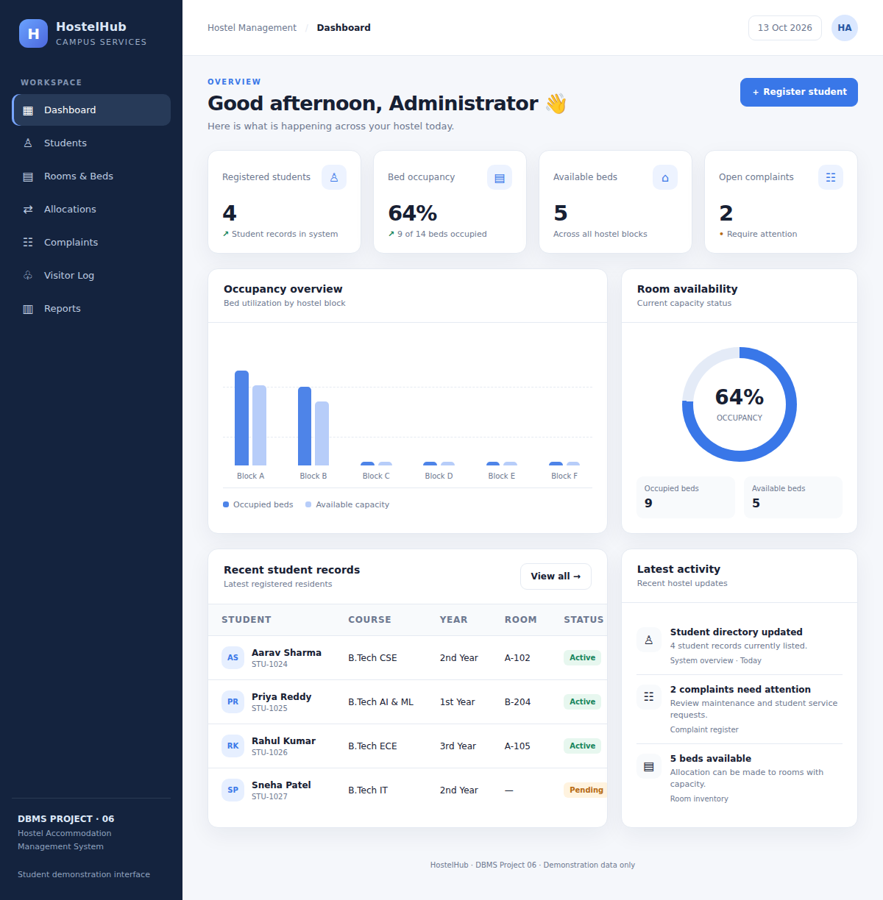
Figure 6. Dashboard: summary cards, occupancy chart, room availability donut, recent student records and activity
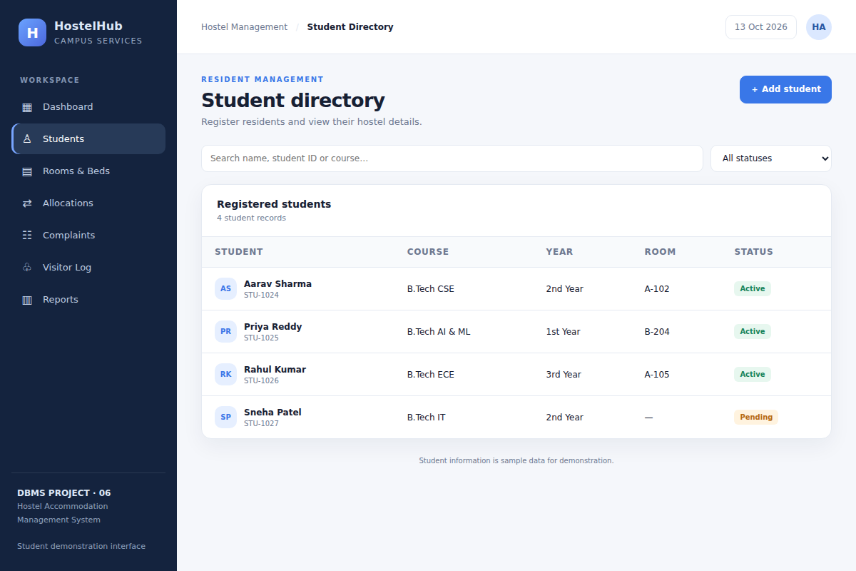
Figure 7. Students screen: student directory with search box, status filter and Add student button
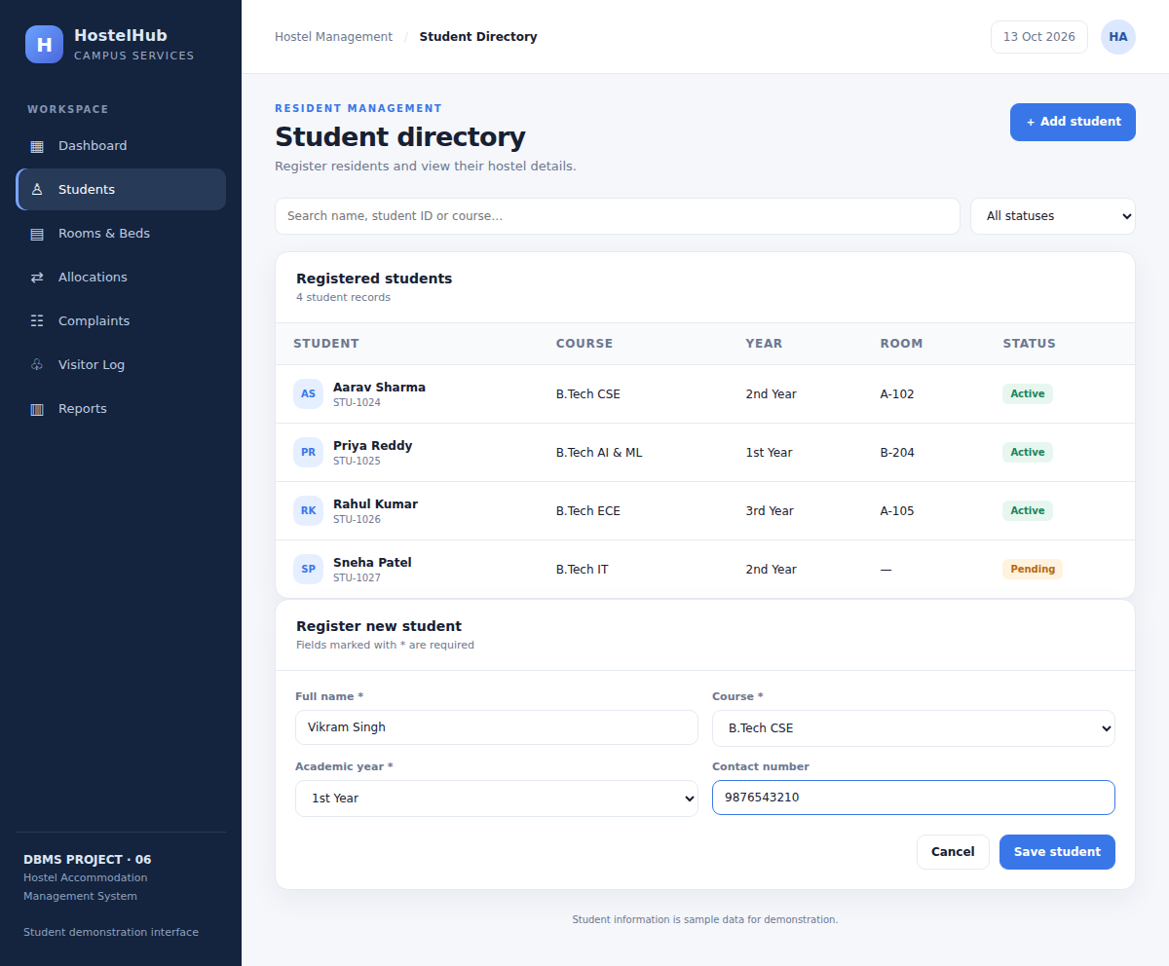
Figure 8. Register new student form filled in with sample details
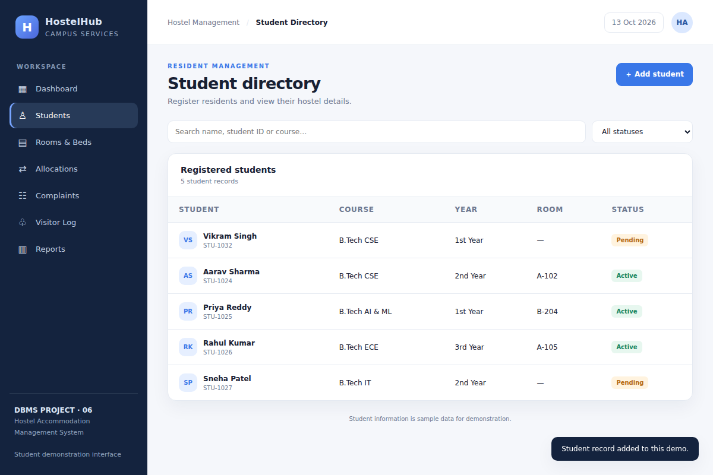
Figure 9. Student saved: confirmation message and new record with Pending status
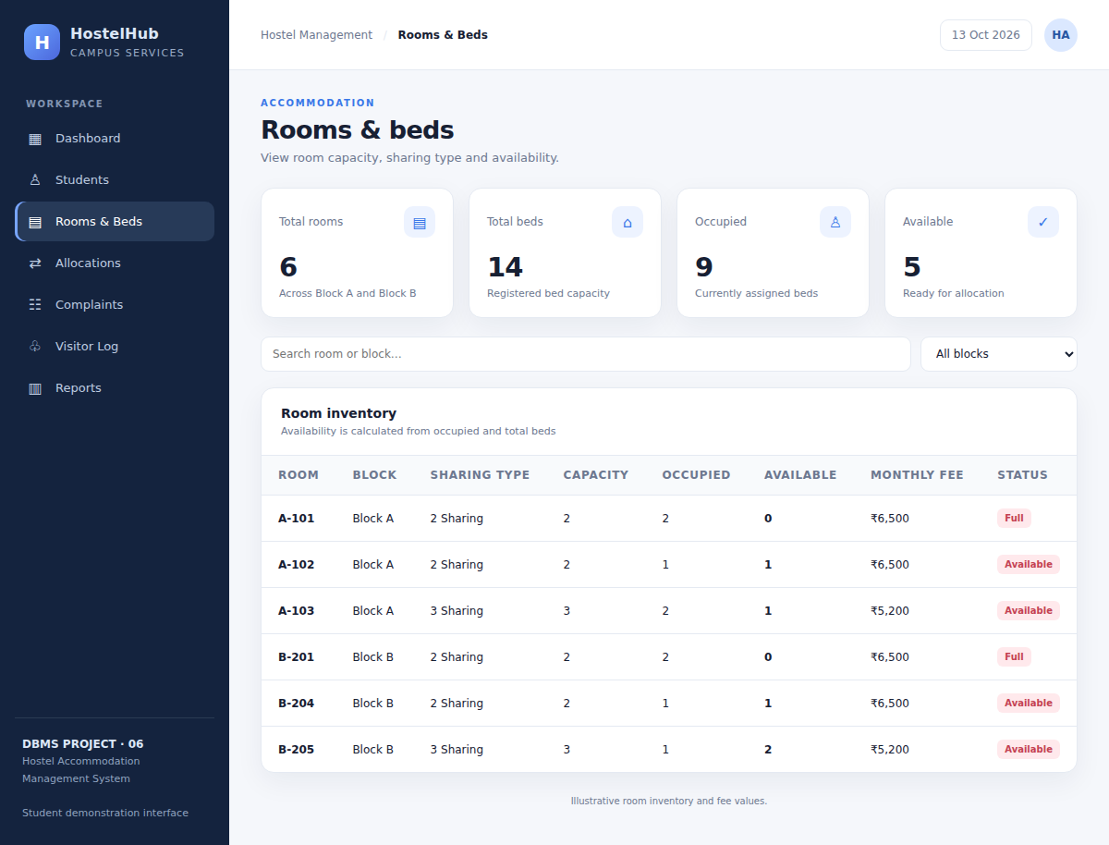
Figure 10. Rooms & Beds screen: summary cards and room inventory with capacity, occupied, available and monthly fee
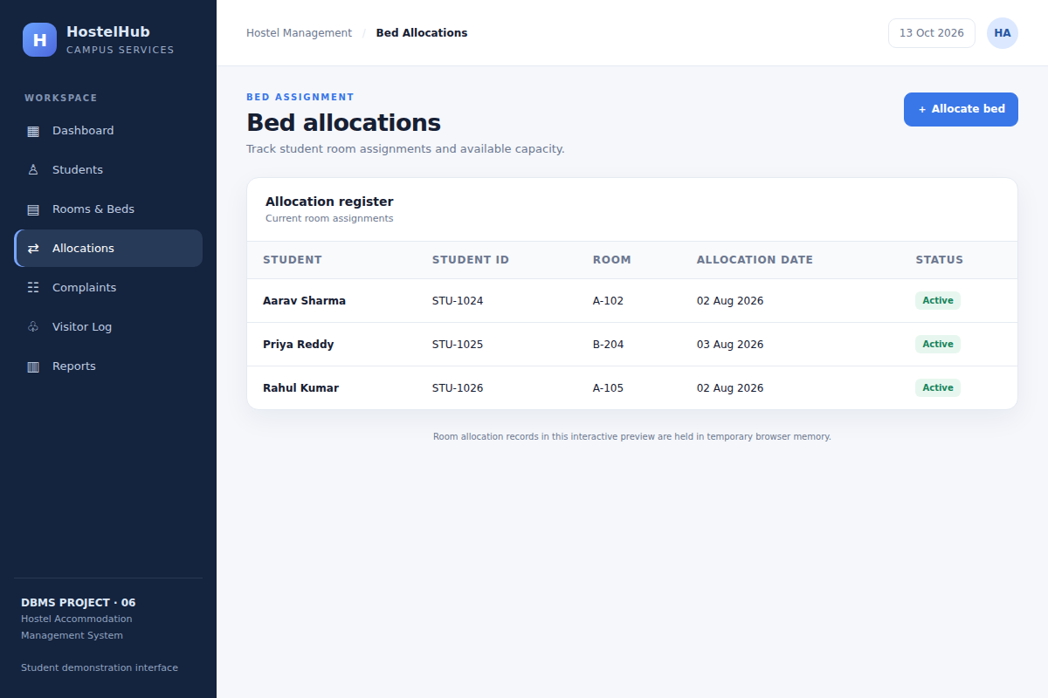
Figure 11. Allocations screen: allocation register with Allocate bed button
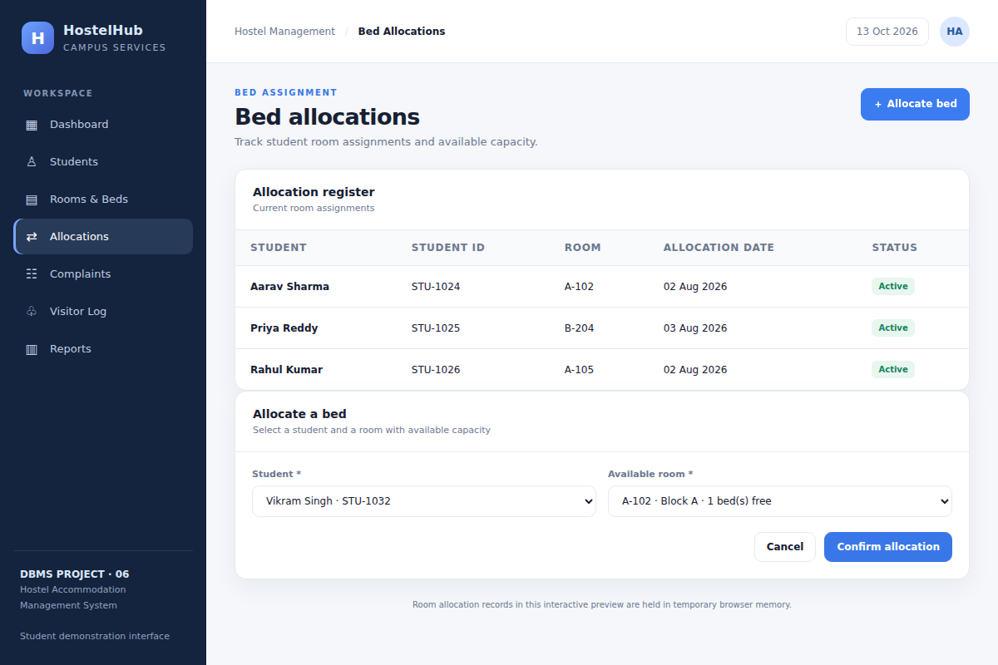
Figure 12. Allocate a bed form: only unallocated students and rooms with free beds are listed
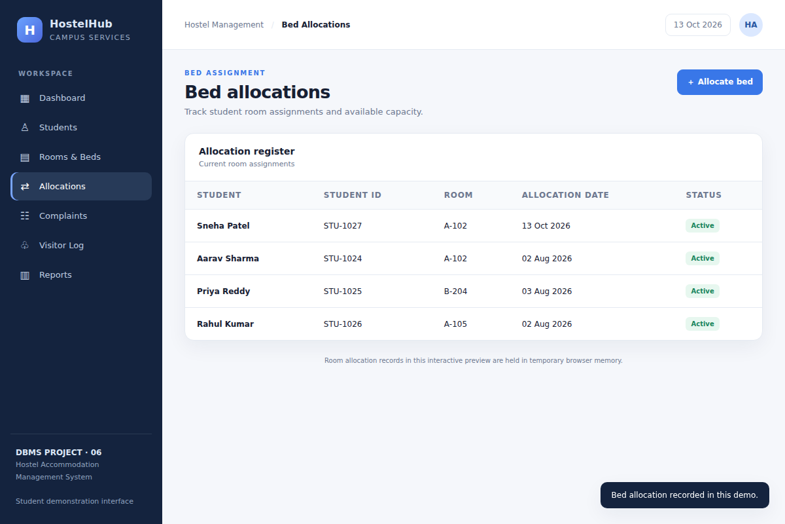
Figure 13. Allocation recorded: confirmation message and new Active row in the register
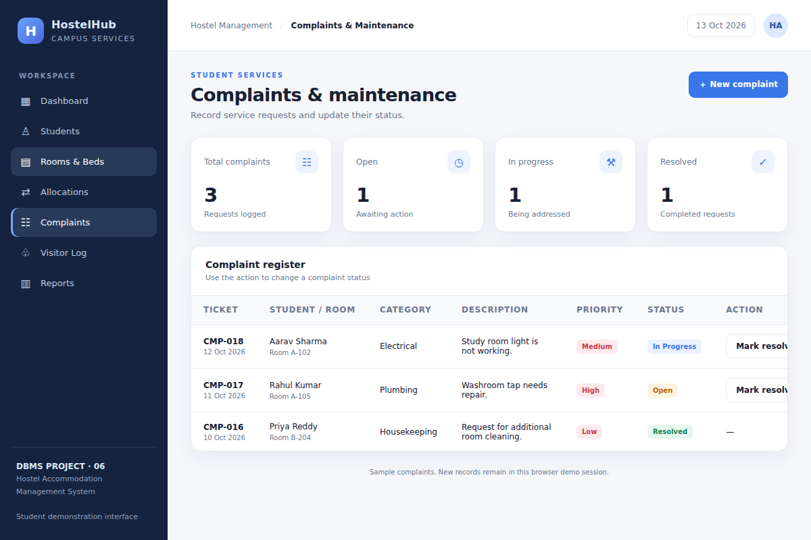
Figure 14. Complaints & maintenance screen: status cards and complaint register
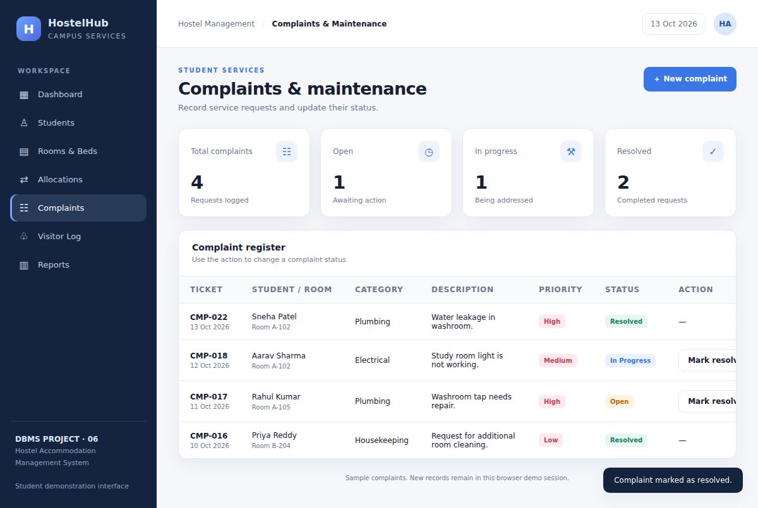
Figure 15. Complaint marked as resolved: status badge changes and the action is replaced
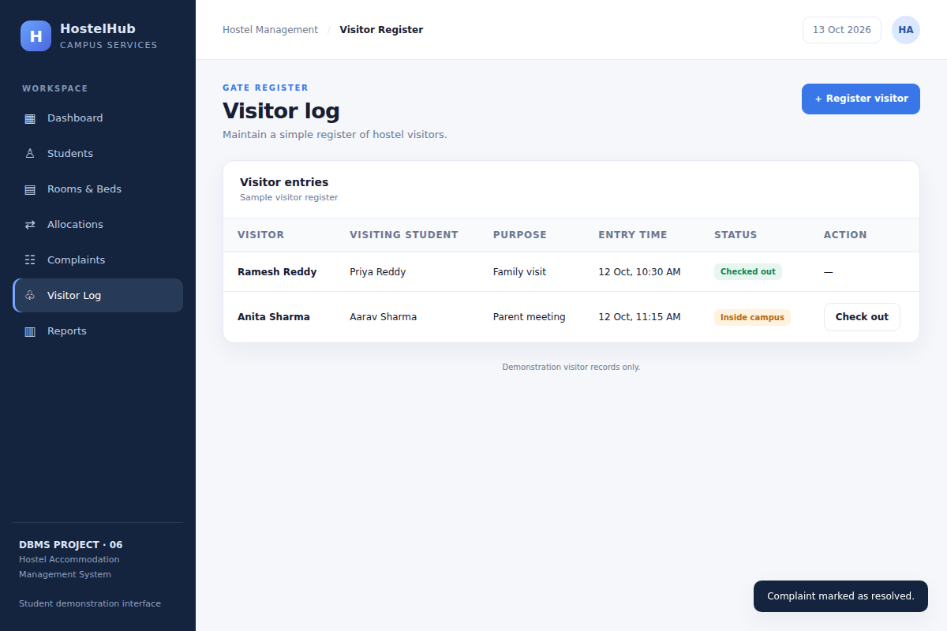
Figure 16. Visitor Log screen: visitor register with entry time and status
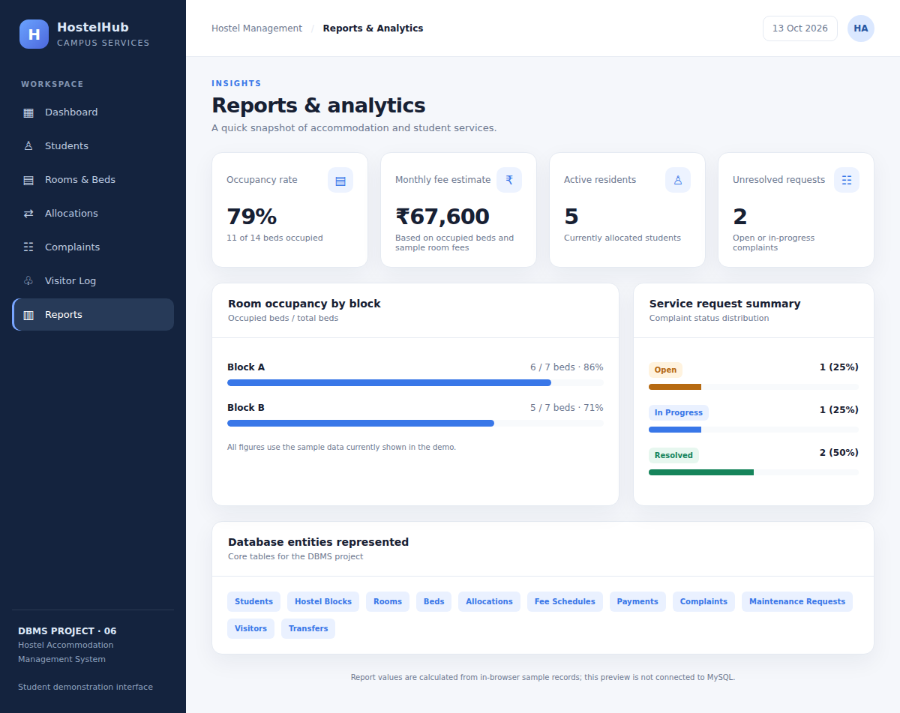
Figure 17. Reports & Analytics screen: summary cards, occupancy by block, complaint distribution and database entities
3.8 Testing and Results
Eighteen interface test cases were run automatically against the HostelHub page using a headless browser, and the message or value actually shown by the application was recorded. In addition, eleven statements that violate the business rules were run against the SQL database. All tests behaved as expected, and the browser reported no JavaScript errors during the run.
Table 23. Test Cases
Test ID | Feature | Action | Actual result | Status
HT-01 | Dashboard | Open the application | Four summary cards shown: Registered students = 4; Bed occupancy = 64%; Available beds = 5; Open complaints = 2 | PASS
HT-02 | Navigation | Click each of the 7 sidebar items | Breadcrumb changed to: Student Directory, Rooms & Beds, Bed Allocations, Complaints & Maintenance, Visitor Register, Reports & Analytics | PASS
HT-03 | Register student | Add Vikram Singh, B.Tech CSE, 1st Year | Student record added to this demo. New row: VS Vikram Singh STU-1032 | B.Tech CSE | 1st Year | — | Pending | PASS
HT-04 | Required-field validation | Submit the registration form with the name empty | Browser blocked submission (required field flagged); student count stays 5 | PASS
HT-05 | Student search | Search “priya” then “zzz” | “priya” returned 1 row (Priya Reddy); “zzz” showed “No matching students found.” | PASS
HT-06 | Status filter | Filter students by status = Pending | 2 rows shown: Vikram Singh, Sneha Patel | PASS
HT-07 | Room filter | Filter rooms by Block B | 3 rooms shown: B-201, B-204, B-205 | PASS
HT-08 | Room search | Search “3 sharing” | 2 rooms shown (A-103, B-205 are 3-sharing) | PASS
HT-09 | Capacity guard (offer) | Open the Allocate bed form | Only rooms with a free bed are offered (4 of 6): A-102; A-103; B-204; B-205. Full rooms A-101 and B-201 are not listed. | PASS
HT-10 | Allocate bed | Allocate Sneha Patel (STU-1027) to room A-102 | Bed allocation recorded in this demo. Register row: Sneha Patel | STU-1027 | A-102 | 13 Oct 2026 | Active | PASS
HT-11 | Occupancy update | Open Rooms & Beds after the allocation | Room A-102 row now: A-102 | Block A | 2 Sharing | 2 | 2 | 0 | ₹6,500 | Full | PASS
HT-12 | Capacity guard (full room) | Reopen the Allocate bed form | A-102 is no longer offered; remaining rooms: A-103, B-204, B-205 | PASS
HT-13 | One bed per student | Reopen the form after every student has a room | Student list shows “No unallocated students” and the Confirm button is disabled | PASS
HT-14 | Register complaint | Plumbing complaint for Sneha Patel, High priority | Complaint submitted in this demo. New row: CMP-022 13 Oct 2026 | Sneha Patel Room A-102 | Plumbing | Water leakage in washroom. | High | Open | Mark resolved | PASS
HT-15 | Resolve complaint | Click “Mark resolved” on the new complaint | Complaint marked as resolved. Row status now Resolved and action replaced by a dash | PASS
HT-16 | Register visitor | Register Sunita Singh visiting Vikram Singh | Visitor registered in this demo. New row: Sunita Singh | Vikram Singh | Parent meeting | 13 Oct, 09:21 am | Inside campus | Check out | PASS
HT-17 | Visitor check-out | Click “Check out” on the new entry | Visitor marked as checked out. Row status: Checked out | PASS
HT-18 | Reports | Open Reports & Analytics after the test run | Cards: Occupancy rate = 79%; Monthly fee estimate = ₹67,600; Active residents = 5; Unresolved requests = 2 | PASS

Table 24. Database Integrity Tests
Test ID | Attempted violation | Database response | Status
N-01 | Second active resident in an occupied bed | Room capacity exceeded: all beds in this room are occupied. | REJECTED
N-02 | Second active allocation for a student | UNIQUE constraint failed: allocation.student_id | REJECTED
N-03 | Male student in female block | Gender mismatch: student cannot be placed in a block of the other gender. | REJECTED
N-04 | Vacating date before allocation date | CHECK constraint failed: (status = 'ACTIVE' AND vacated_on IS NULL) OR (status <> 'ACTIVE' AND vacated_on IS NOT NULL AN | REJECTED
N-05 | Payment above billed amount | Payment limit exceeded: total paid cannot be more than the billed fee. | REJECTED
N-06 | Adding a bed beyond room capacity | Room capacity exceeded: cannot add more beds than the room type allows. | REJECTED
N-07 | Visitor for a non-resident student | Visitor not allowed: student has no active hostel allocation. | REJECTED
N-08 | Duplicate registration number | UNIQUE constraint failed: student.reg_no | REJECTED
N-09 | Invalid phone number format | CHECK constraint failed: phone GLOB '[0-9][0-9][0-9][0-9][0-9][0-9][0-9][0-9][0-9][0-9]' | REJECTED
N-10 | Resolved complaint without resolved date | CHECK constraint failed: (status IN ('OPEN','IN_PROGRESS') AND resolved_on IS NULL) OR (status IN ('RESOLVED','CLOSED') | REJECTED
N-11 | Deleting a student who has allocations | FOREIGN KEY constraint failed | REJECTED

Observed result summary: all 18 interface test cases passed and all 11 rule-violating database statements were rejected by the database itself. The interface tests describe the displayed application state on sample data; they are not evidence of a live database connection or a payment transaction.
CHAPTER 4
CONCLUSION
4. Conclusion
The Hostel Accommodation & Student Services Management System demonstrates how a normalised relational design can support a complete hostel workflow. It brings students, blocks, rooms, beds, allocations, fees, payments, visitors, complaints and maintenance into one consistent model with seventeen relations in Third Normal Form. Business rules such as one active resident per bed, room-capacity control, gender-matched blocks, valid dates and payment limits are enforced in the SQL schema by constraints, partial unique indexes and triggers, so invalid data is stopped by the database itself.
The HostelHub interface, built with HTML, CSS and JavaScript in Visual Studio Code, presents the daily operations through seven screens: dashboard, students, rooms and beds, allocations, complaints, visitor log and reports. It applies the capacity and one-bed-per-student rules when allocating beds and updates occupancy figures immediately. The schema was verified with eleven reporting queries and eleven rule-violation tests, and the interface was verified with eighteen test cases run against the live page. The project gave practical experience in ER modelling, normalization, SQL, triggers, views, indexing, transactions and interface development.
4.1 Limitations and Future Enhancements
- HostelHub is a demonstration front end. It works on sample data held in browser memory and is not connected to a MySQL server, so records are lost when the page is reloaded.
- The interface covers seven screens. Fee billing, payments, transfers, vacating, maintenance staff assignment and user accounts are part of the database design but do not yet have screens.
- The interface applies the capacity and one-bed-per-student rules only. Gender-matched blocks, payment limits and date checks are enforced by the database and should be added to the interface when it is connected.
- The bar chart in the dashboard’s occupancy overview uses illustrative values; the summary cards, donut and Reports screen are calculated from the records.
- The query and rule-violation results in this report were produced with automated tests on SQLite. The design uses standard constructs, but triggers, partial indexes and date defaults need syntax changes for MySQL (for example SIGNAL for errors in MySQL and a generated column in place of a partial index).
- Future work: connect HostelHub to MySQL through a server-side layer (for example Node.js or Python Flask), add the fee, transfer, vacating and maintenance screens, add login with role-based access, notices for fee dues and report export.
CHAPTER 5
REFERENCES
[1] R. Elmasri and S. B. Navathe, Fundamentals of Database Systems. Pearson.
[2] A. Silberschatz, H. F. Korth and S. Sudarshan, Database System Concepts. McGraw-Hill.
[3] R. Ramakrishnan and J. Gehrke, Database Management Systems. McGraw-Hill.
[4] SQLite, “SQLite Documentation.” Available: https://www.sqlite.org/docs.html. Accessed: Oct. 13, 2026.
[5] Oracle, “MySQL 8.4 Reference Manual.” Available: https://dev.mysql.com/doc/. Accessed: Oct. 13, 2026.
[6] Microsoft, “Visual Studio Code Documentation.” Available: https://code.visualstudio.com/docs. Accessed: Oct. 13, 2026.
[7] MDN Web Docs, “HTML, CSS and JavaScript.” Available: https://developer.mozilla.org/. Accessed: Oct. 13, 2026.
CHAPTER 6
APPENDICES
APPENDIX A: SCREENSHOTS AND TEST EVIDENCE
The screenshots below are further evidence captured from the running HostelHub application during the test run: search and filter results, the capacity guard, visitor registration and the responsive and dark layouts.
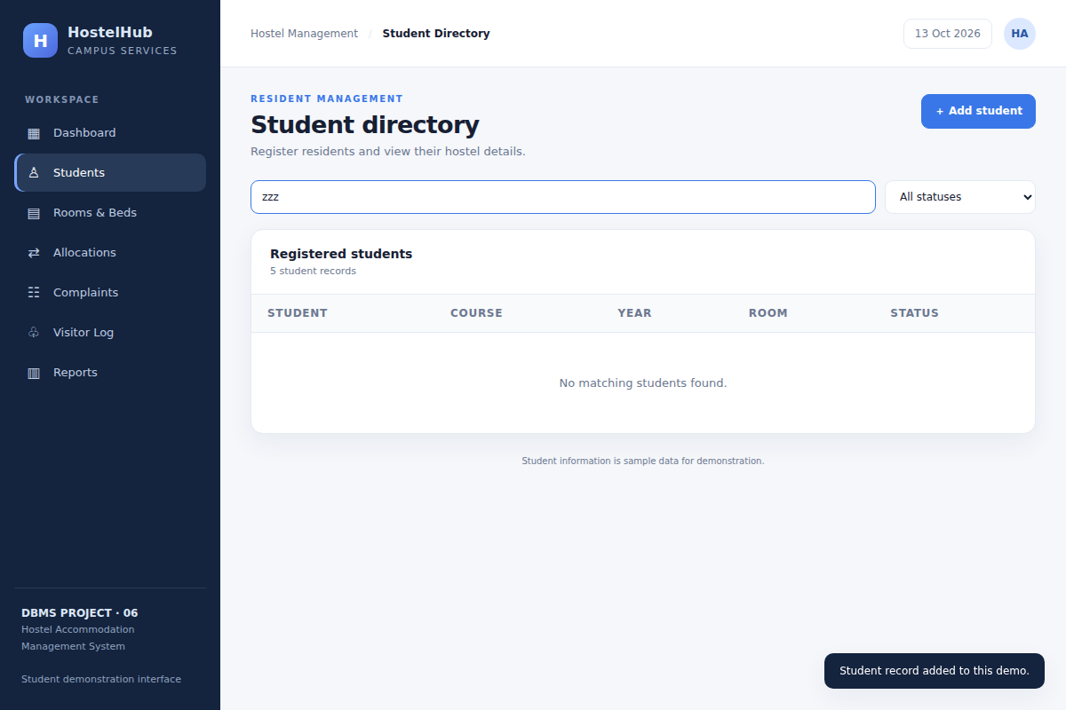
Figure 18. Appendix: student search with no match shows “No matching students found.” (HT-05)
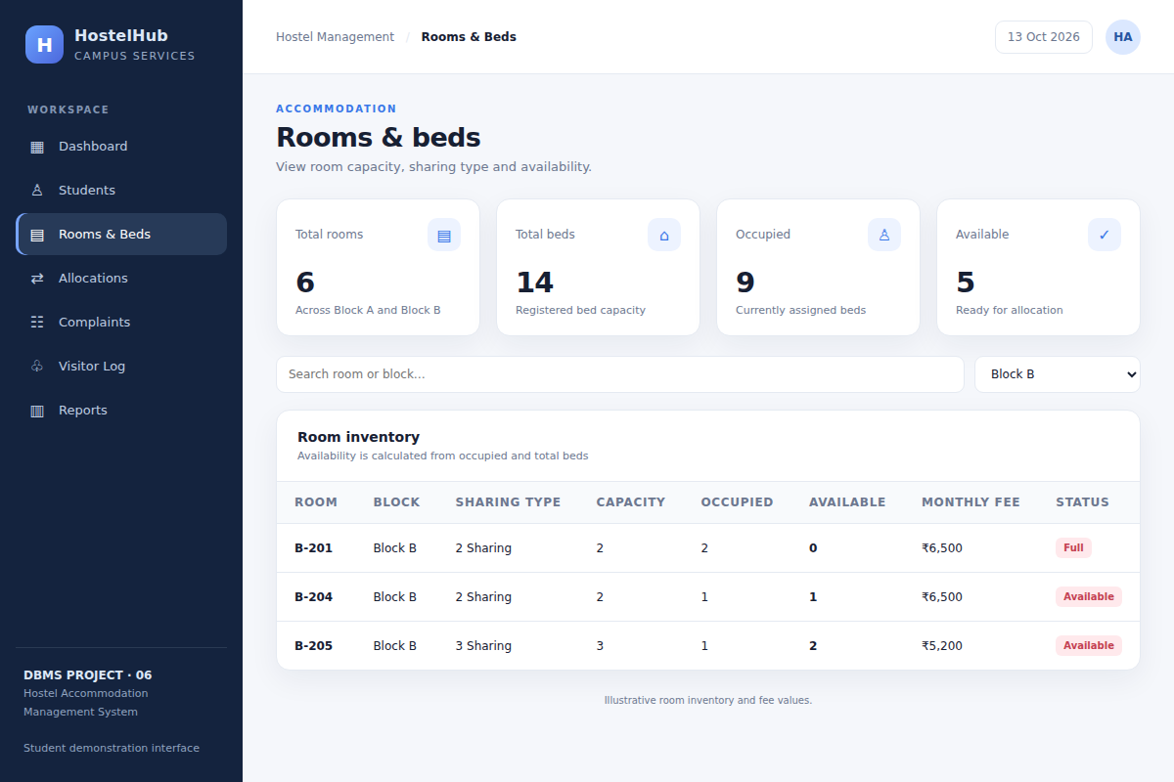
Figure 19. Appendix: room inventory filtered by Block B (HT-07)
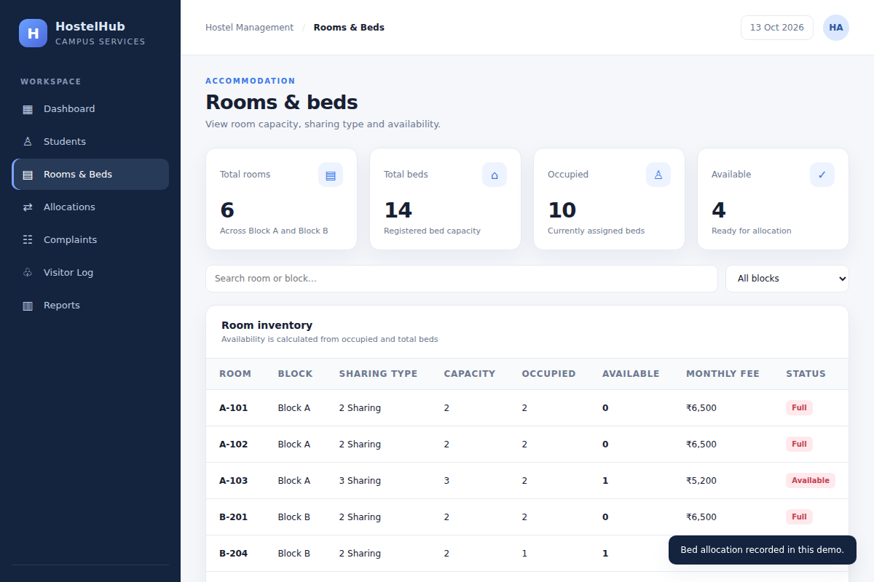
Figure 20. Appendix: room A-102 shown as Full after allocation (HT-11)
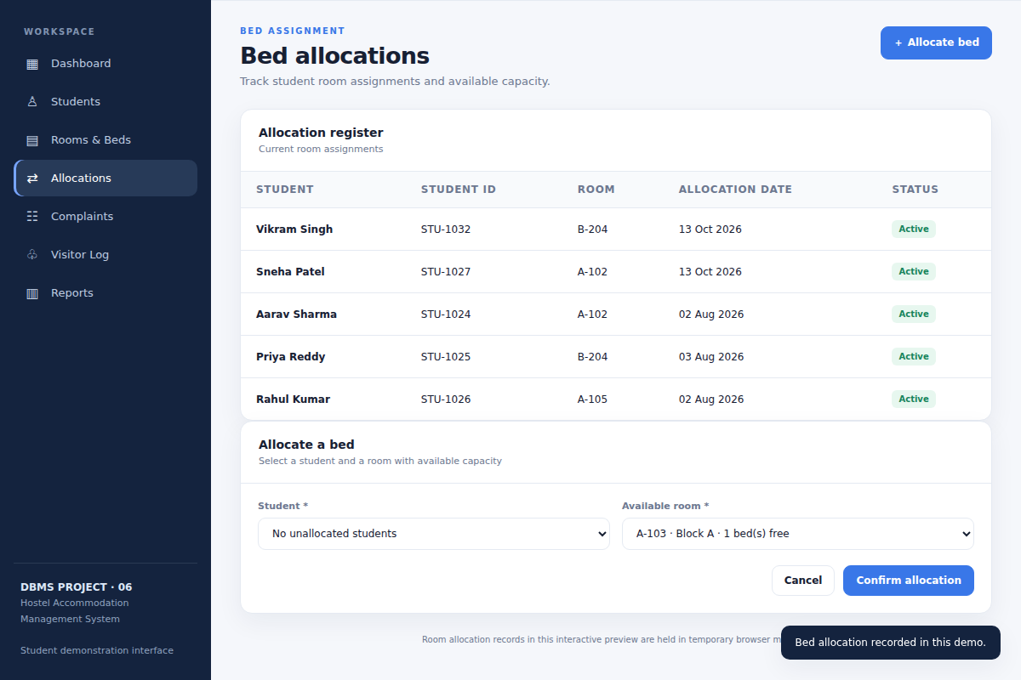
Figure 21. Appendix: allocation form with no unallocated students; confirm button disabled (HT-13)
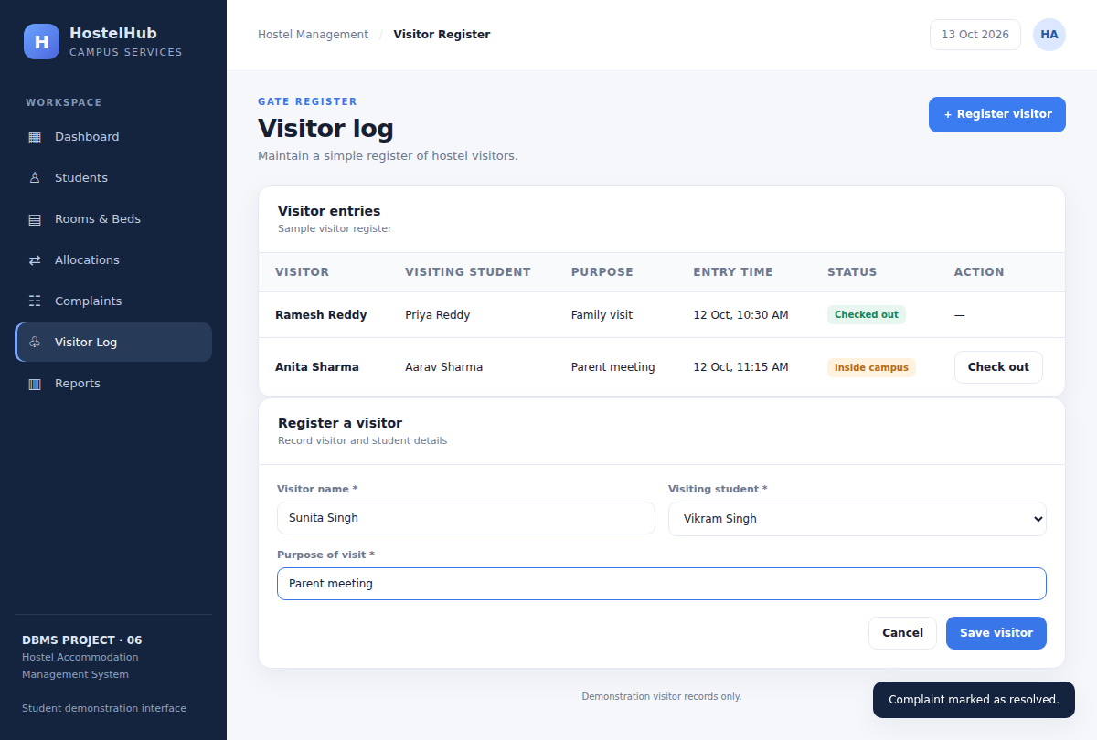
Figure 22. Appendix: Register a visitor form (HT-16)
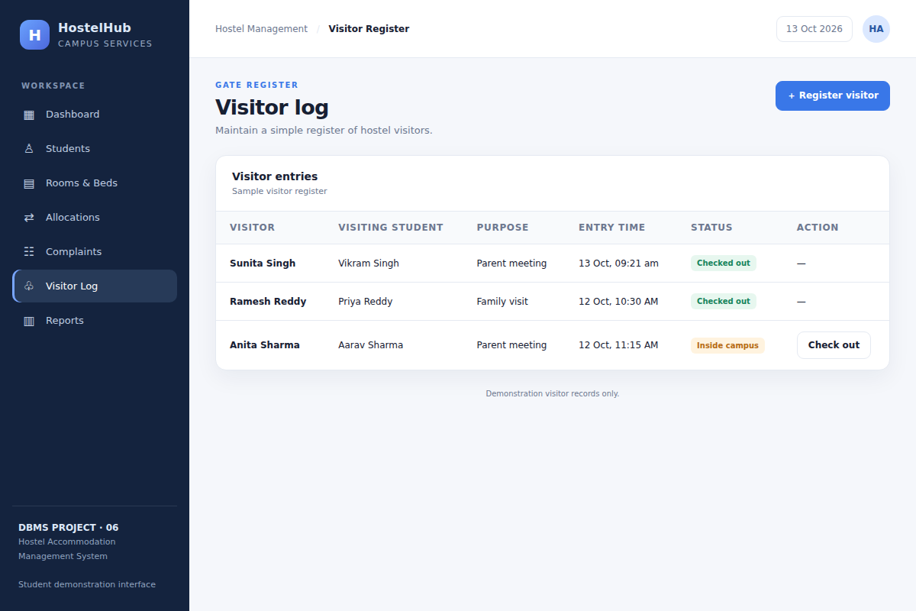
Figure 23. Appendix: visitor checked out (HT-17)
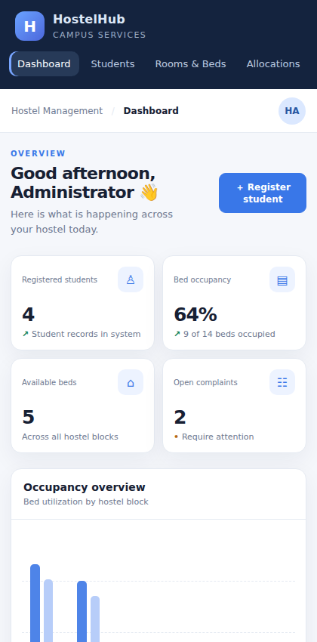
Figure 24. Appendix: mobile layout (420 px wide)
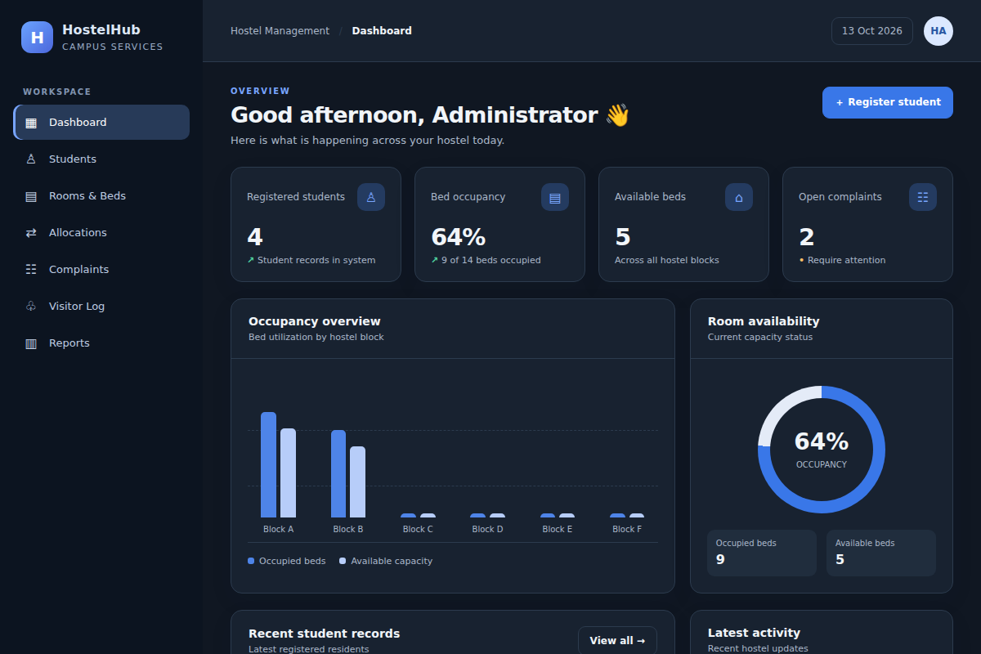
Figure 25. Appendix: dark theme layout

