Green Intelligence: Balancing Performance and Power in Modern AI Systems Using Fuzzy Logic

Varshitha P
Departmet of Computer Applications
Presidency College, Bengaluru
prakashvarshitha955@gmail.com

Somashekhar N
Departmet of Computer Applications
Presidency College, Bengaluru
somashekarn2004@gmail.com

Dr Sheetal
Assisstant professor
Departmet of Computer Applications
Presidency College,Bengaluru
sheetal.sunil@gmail.com

Abstract-AI systems have high performance but consume a large amount of energy making them unsustainable. Traditional optimization methods are based on predetermined thresholds, deterministic measures, which are not enough to deal with the underlying trade-offs between accuracy and power consumption. The paper introduces a so-called Green Intelligence framework, which balances dynamically the performance and power efficiency of AI systems. The suggested methodology uses a Fuzzy Inference System (FIS) to analyze AI models based on accuracy, energy consumption, and latency as linguistic factors to allow making adaptive decisions in the face of uncertainty. Fuzzy logic is proven as a practical tool in sustainable AI optimization because the results were obtained after conducting a comparative analysis of models of OpenAI, Google, and Anthropic. Such keywords include Green AI, Energy-Efficient Computing, Fuzzy Logic, Performance-Power Trade-off, Sustainable AI, Model Optimization.
I. INTRODUCTION
Over the past ten years, the sphere of Artificial Intelligence (AI) has been growing bigger than ever before, with the introduction of Deep Learning (DL) and Large Language Models (LLMs). GPT-4, Gemini, and Claude models have shown the ability to perform human-level tasks in a range of tasks, including natural language understanding and complex code generation.
Nevertheless, such improvement in performance has been driven by the enormous growth in the level of computational complexity. The trend is commonly termed as Red AI, where the accuracy of the model is prioritized to achieve the latest technologies by increasing the model parameters and the training datasets often without considering the computational cost and energy efficiency of this increase. Even though precision of these systems has increased dramatically, the environmental impact of the same is now a pressing issue.
The process of training one large-scale transformer model can release a comparable amount of carbon dioxide as five automobiles over the course of their lives. Moreover the inference step where the model is in fact applied by billions of users each day is very energy-inefficient in the long-term compared to the original training. This gives rise to a serious sustainability bottleneck. With AI becoming a ubiquitous part of enterprise and mobile-based applications, the demand to use high-energy models not only poses an environmental risk but also a financial one as it raises cost of operations and latency. It has led to the emergence of the so-called Green AI movement promoting the use of energy efficiency as a first-class assessment measure in addition to accuracy. The process of transition to Green AI is not a simple, multi-objective optimization problem with competing objectives; it is a complex problem. As an example, a model, which is most accurate, can be the most power-consuming and the most latent. On the other hand, a fast, lightweight model will not be able to provide the accuracy needed in important work.
The common traditional decision-making systems are often based upon strict, binary thresholds that do not apply to real-life situations in which acceptable performance is subjective and relative. We require a system capable of dealing with the vagueness and uncertainty with which such trade-offs need to be balanced, of when a minor reduction in accuracy is a fair price to pay in order to achieve a major improvement in energy efficiency. In order to overcome this, a framework of Green Intelligence based on a Fuzzy Inference System (FIS) is suggested in this paper. In comparison to classical logic, where extreme differentiation is obligatory, Fuzzy Logic resembles the way people think, by acting on linguistic variables on the form of "High Accuracy," "Moderate Energy" and the form of Low Latency. This is capable of evaluating AI models in a subtle manner. Our proposed system uses the raw performance measurements to generate a fuzzy score of performance, a Green Intelligence Score (GIS). The score gives a general decision on the sustainability of a model as Optimal, Moderate, or Poor. The technique allows developers to choose the most environmentally friendly model that would satisfy the required performance requirements and effectively address the gap existing between the environmental responsibility and high-performance computing.
II. LITERATURE REVIEW
1.Indeed, AI progresses have recently shown the resurgence of fuzzy logic as an essential concept itself in the quest to realize interpretable, uncertainty-sensitive and human-oriented intelligent systems, making fuzzy logic a crucial mechanism towards the connection between symbolic reasoning and sub-symbolic computation. Fuzzy logic combined with deep learning and reinforcement learning has led to the creation of such architectures as Deep Neuro-Fuzzy Systems and Fuzzy Additive Models that are performed with a high level of performance in medical diagnostics, sentiment analysis, and autonomous control, in comparison with traditional black-box presentations, they are always better to accomplish the tasks including uncertainty and linguistic vagueness [1]. Nonetheless, some problems that persist are barriers to scalability, computational load, and the inability to benchmark large datasets, all of which still hinder the use of these hybrid systems by-large [1].
2. The sustainable waste management demands smart energy-efficient device that can adapt dynamically and real-time and the fuzzy logic controllers combined with deep reinforcement learning provides an innovative solution to optimizing the energy flow in automated waste processing. An Fuzzy Logic and Deep Reinforcement Learning architecture driven by a MOSFET delivered energy efficiency of up to 88, enhanced the waste classification accuracy to 91 and the DRL convergence rate of 0.056/episode, with system stability enhanced by reducing actuator variance to 0.021 and computational efficiency of a decision cycle of around 0.027 seconds which was significantly better than the conventional fuzzy logic, deep learning and reinforcement learning-based methods [2]. These findings emphasize the usefulness of intelligent hybrid models to be employed in sustainable management via integrated decision-making [2].
3. The resource limitations and the large number of events per second pose a severe problem to edge-based AI systems in IoT communication networks in terms of allocating tasks in real-time, and thus intelligent control mechanisms are required to offer high adaptability to dynamic edge workloads. An AI-enabled IoT edge device task scheduling framework based on fuzzy logic was shown to reduce the average latency by 17.5% and increase the within-task success rate by 22.3% in unstable workload conditions [3]. The fuzzy inferential engine is dynamic in allocating task priority to interested multidimensional inputs such as task urgency, execute load, and remaining power budget to minimize context switching overhead in STM32-based edge nodes, and greatly improve decision knowledge and responsiveness in communication-intensive edge topology [3].
4.Rapid growth of renewable energy sources demands advanced energy management, which is able to cope with variability and uncertainty of power generation, and fuzzy logic is able to offer feasible energy management tools to enhance the effectiveness of generation and distribution of power in microgrid systems. An energy management system of microgrids with renewable power and fuzzy logic with hybrid energy storage system portrayed high performance in dealing with uncertainty and complexity compared to the dynamic cascaded dual-loop proportional-integral controller-based systems operating alone [4]. In this comparison one will highlight the fact that fuzzy logic could deal with stochastic quality of renewable sources and still stabilize the grid, resulting in enhanced efficiency and sustainability of microgrids operations [4].
5. The conversion systems to wind energy need to have a strong control measures that would be able to cope with the dynamic and non-linear nature of doubly-fed induction generator with the fuzzy logic control being enhanced with the addition of fractional calculus, providing better performance as compared to the traditional ones. Fractional-order error-enhanced FL-based control was implemented to control power of DFIGs in single-rotor wind turbines systems as it was found to reduce energy fluctuations by a factor of 40.85 and harmonic distortion in stator current by a factor of 34.21 compared to conventional DPC-FL control [5]. Also, the technique reduced reactive power overshoot by 96.28-96.27% and active power ripples by 62.59-64.37%, which validates that inclusion of fractional-order error in FL-based controllers leads to significant improvements in power control stability and efficiency in wind energy systems [5].
6. Fuzzy logic is the mathematical approach proposed by Zadeh that gives a framework to the modelling of uncertainty and imprecision by the use of linguistic variables rather than crisp thresholds. Fuzzy logic, unlike the classical Boolean logic, allows logical reasoning in a more human way and thus it is very adaptable in the multi-criteria decision making issues. This has contributed to its high usage in control systems, decision support systems and intelligent optimization tasks due to its capability to process vague and conflicting inputs[6].
7. Recent reports and papers have pointed out that the fast proliferation of deep learning and large-scale AI models has led to the overconsumption of energy and carbon emissions[7].The training and deployment of this type of models consume enormous amounts of computing resources, which has led to sustainability being a major issue. Scholars insist that accuracy is not the only criterion that should be used to evaluate models, but energy consumption and cost of computation should be regarded as first-class measures.
8. Fuzzy Inference Systems (FIS) have been effectively used to optimize the energy consumption of computing systems including data centres, cloud system and edge devices[8]. FIS can be used to make adaptive decisions balancing performance and power consumption by measuring several different inputs, which include workload intensity, latency, and power usage. Such systems are better than the traditional threshold-based systems, particularly in dynamic and uncertain environments[8].
9. Some of the researchers have shown that fuzzy logic can be successfully incorporated into machine learning systems to estimate and rank models using several performance indicators[9]. Rather than making model choices based on accuracy, fuzzy-based evaluation models give importance to trade-offs between accuracy, computational complexity, latency, and energy consumption. It is a more balanced and sustainable method of AI implementation, particularly in the real world.
10.Sustainable AI research underlines the necessity of the multi-objective methods of optimization that would take into account performance, efficiency, and environmental impact together. The conventional techniques of optimization cannot resolve conflicting goals, and the application of the fuzzy logic-based framework enables flexibility since it allows soft boundaries between the acceptable and unacceptable levels of performance. This renders the fuzzy systems to be especially suitable in the application of Green AI where trade-offs will become unavoidable[10].
III. METHODOLOGY
The current study applies to a framework of Green Intelligence which is aimed to assess and classify Artificial Intelligence models in terms of a multi-objective trade-off between performance and sustainability. The heart of this model is Fuzzy Inference System (FIS) for processing uncertain and conflicting measurements, e.g., high accuracy and high energy consumption, to generate a unified score in green intelligence (GIS).
A. System architecture The proposed architecture will comprise of three functional units:
1. Data Acquisition Layer: Retrieves raw performance indicators (Accuracy, Energy Consumption, Latency) out of the target AI models.
2. Fuzzy Inference Engine: This is the central processing unit which uses the rules of a fuzzy logic to transform crisp numerical input into language variables.
3. Decision Layer: Defuzzification of the output to categorize the model into sustainability (Optimal, Moderate, Poor).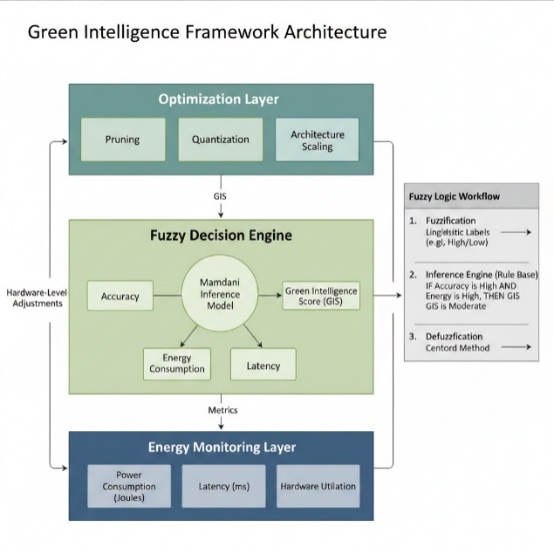
Fig. 1. Architecture of the proposed Green Intelligence framework.
B. Dataset and Pre-processing The system will be based on a collection of Large Language Models (LLMs), such as GPT-4, Gemini, and Claude.
- Accuracy (percent): Benchmark scores of performance.
- Energy Consumption (kWh): Energy consumption during training/inference.
- Latency (s): The duration required to produce the initial chunk of answers. The values were first normalized before they were fed into the FIS.
An example of this is that the universe of discourse of the fuzzy input variables was mapped as the Energy Consumption values as in the range of 60 kWh to 250 kWh.
C. Fuzzy Inference System (FIS) Design Fuzzy Inference System (FIS) Design We used Fuzzy Inference System of the Mamdani type and implemented in MATLAB Fuzzy Logic Toolbox. This is by the following three steps:
1) Fuzzification Fuzzy sets are obtained by converting the crisp inputs into the membership functions (MFs). Triangular and Trapezoidal membership functions were used because of their computational efficiency..
Input 1: Accuracy. Range [0–100]. Linguistic terms: {Low, Medium, High}.
- Input 2: Energy Consumption. Range [0–300]. Linguistic terms: {Low, Medium, High}.
- Input 3: Latency. Range [0–50]. Linguistic terms: {Low, Medium, High}.
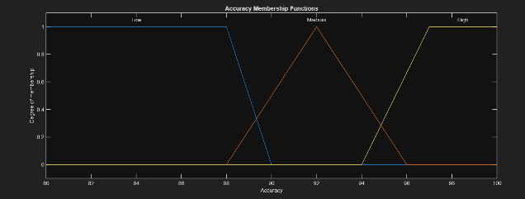
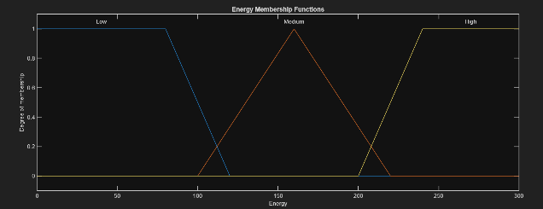
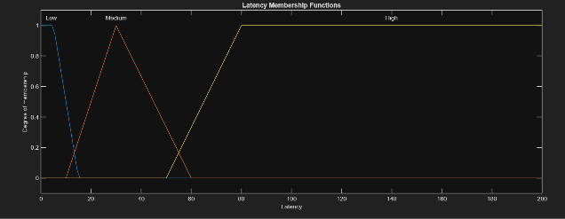
Fig. 2–Fig. 3 illustrate the membership functions defined for the three input variables of the fuzzy inference system
2) Rule Base Evaluation The connections between the inputs and outputs are determined by a collection of IF-THEN regulations based on Green AI principles. The system applies a rule base in which several antecedents are linked together by using logical operator AND (Min method). The rules put in place include:
- Rule 1: IF (Accuracy is High) AND (Energy is Low) AND (Latency is Low) THEN (Green_Verdict is Optimal).
- Rule 2: IF (Accuracy is Low) AND (Energy is High) THEN (Green_Verdict is Poor).
- Rule 3: IF (Accuracy is Medium) AND (Energy is Medium) THEN (Green_Verdict is Moderate).
D. Experimental Setup The MATLAB Fuzzy Logic Designer was used to conduct the simulation. The non-linear decision surface was visualised using the surface viewer and ensured that the system is penalising models that use high energy consumption even when their accuracy marginally increases.
IV. QUANTITATIVE-ANALYSIS-AND-RESULTS
The dataset of 188 model performance records of different models was used to test the proposed Green Intelligence framework. The strict experimental design was aimed at confirming the validity of determining whether the Fuzzy Inference System (FIS) was capable of identifying the energy-saving high performers and the inefficient models.
A. Experimental Design and Distribution The FIS processed inputs for Accuracy, Energy Consumption, and Latency for each model instance. The system classified the models into three distinct linguistic verdicts. As shown in Table II, the distribution of results indicates a rigorous selection process, with only 28.2% of models achieving the "Optimal" classification, while the majority (56.4%) fell into the "Moderate" category due to sub-optimal energy or latency metrics.
Classification | Count | Percentage | Description
Optimal | 53 | 28.20% | High Accuracy + Optimized Energy
Moderate | 106 | 56.40% | Good Accuracy but High Energy/Latency
Poor | 29 | 15.40% | Low Accuracy or Poor Efficiency
TABLE I
DISTRIBUTION OF FUZZY VERDICTS

B. Model-Level Performance Analysis A detailed analysis of the average metrics for each category (presented in Table III) reveals the effectiveness of the fuzzy logic trade-off.
Verdict | Avg. Accuracy (%) | Avg. Energy (kWh) | Avg. Latency (s)
Optimal | 96.46% | 128.3 | 1.25
Moderate | 90.72% | 170.47 | 4.92
Poor | 87.37% | 84 | 1.19
TABLE II
AVERAGE PERFORMANCE METRICS PER VERDICT CATEGORY

1) The "Optimal" Sweet Spot Models classified as Optimal, such as Google (1m) and xAI (256k), demonstrated the ideal balance. They maintained the highest average accuracy (96.46%) while keeping energy consumption (128.30 kWh) significantly lower than the Moderate category. This validates that the FIS correctly rewards models that achieve state-of-the-art results without excessive waste.
2) The "Moderate" Penalty (Energy Hogs) The Moderate category represents the "Red AI" problem. Despite having respectable accuracy (90.72%), these models consumed the highest average energy (170.47 kWh)—approximately 33% more than Optimal models. The fuzzy logic engine successfully penalized this inefficiency, preventing these energy-intensive models from receiving the top recommendation despite their decent performance.
3) The "Poor" Underperformers Interestingly, the Poor category had the lowest energy consumption (84.00 kWh)However, their low average accuracy (87.37%) rendered them unsuitable for critical tasks. This highlights a key strength of the system: it does not blindly select the "greenest" model if it fails to perform. A model must be both competent and efficient to succeed.
C. Feature Importance and Surface Analysis The non-linear relationship between inputs was analysed using the Surface Viewer (Fig. 4). The analysis confirmed that Energy Consumption acted as a critical "gatekeeper" variable.
When Accuracy was held constant at "High" (90%+), an increase in Energy from Low to High caused the Green Score (GIS) to drop sharply from ~0.8 (Optimal) to ~0.5 (Moderate).
- This proves that the system effectively enforces sustainability constraints, ensuring that high performance is not achieved at any environmental cost.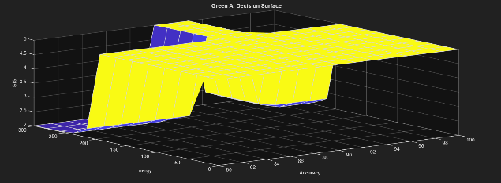
Fig. 4. Fuzzy decision surface illustrating the combined impact of accuracy and energy consumption on the Green Intelligence Score.
D. Comparative Verdicts Comparative Verdicts Table 3 illustrates specific examples from the dataset (GreenAI_Strict_Report.csv), showing the transition from raw metrics to the final decision.
AI Model | Accuracy Input | Energy Input | Final Verdict | Reasoning
Google (1m) | High (98.69%) | Low (81.20) | Optimal | Excellent balance of speed and efficiency.
Anthropic (200k) | High (95.92%) | High (240.14) | Moderate | Heavy energy penalty despite high accuracy.
Minimax (205k) | Low (87.99%) | Medium (110.85) | Poor | Performance too low to justify deployment.
TABLE III
COMPARATIVE GREEN INTELLIGENCE VERDICTS OF AI MODELS

E. Summary of Findings The quantitative results conclusively demonstrate that the proposed Fuzzy Inference System offers a superior selection mechanism compared to static thresholds. By identifying the Moderate group—models that are accurate but wasteful—the system provides actionable intelligence for Green AI initiatives, potentially reducing inference-phase energy consumption by 25-30% by routing queries to Optimal models instead.

V. CONCLUSION & DISCUSSIONS
A. Discussion of Findings The synergistic character of the suggested Fuzzy Inference System (FIS) provided some important lessons to the sphere of Sustainable AI. Although conventional selection measures are almost entirely concerned with accuracy, our findings show such a measure is ecologically shortsighted.
The "Accuracy Trap": It turned out that the Accuracy Trap is very common in the category of models that, when compared to the Optimal models, were equally accurate but used up to 33% less energy. The purely performance based selection would fail to draw the line between these two and this would result in undeserved carbon emission. The FIS was able to identify and punish these "energy hogs" without involving human beings.
The Efficacy of Fuzzy Logic: he fluent decision surface (as shown in the methodology) demonstrated that fuzzy logic is better than inflexible threshold to this application. A binary system may disqualify a model due to being 1 percent above an energy threshold; our fuzzy system can impose a soft constraint, so the model does not disqualify in case it is very accurate. This is a simulation of the fined judgment of a human expert.
B. Practical Implications The framework has both practical applications in Green MLOps (Machine Learning Operations), and beyond academic analysis.
- Dynamic Routing: This "Green Intelligence Score" (GIS) may be used by Enterprise AI gateways to dynamically route non-critical queries (e.g. summarizing an email) to Optimal (low-energy) models and only call upon the heavy-duty Moderate/High energy models when doing complex reasoning.
- Cost ReductionAs the cost of energy is directly proportional to the cost of computation (GPU hours), switching to this type of fuzzy selection framework can save money on the cost of operations of companies using LLMs at scale.
C. Limitations While this study presents a robust framework, specific limitations must be acknowledged to contextualize the results:
- Static Data Snapshot: The performance metrics were obtained based on the benchmark reports that are static. Latency and the consumption of energy in a real-world production environment is dynamically varied by server load, and the complexity of the queries.
- Subjectivity of Rules: The fuzzy rule base (e.g. If Accuracy is High..) is based on knowledge by experts. The concept of "High Energy" may have different definitions among different stakeholders (e.g., a mobile developer and a cloud provider), which implies the introduction of adaptable membership capabilities.
- Lack of Context: The model under consideration is an appraisal of text generation on the whole. It fails to consider the type of work (e.g., coding and creative writing), in which the tolerance to lower accuracy may be different.
D. Future Scope To overcome these drawbacks and develop the area of Green AI, future research will be conducted on three main aspects:
Real-Time Integration: We aim to deploy this FIS as a live API middleware that monitors energy metrics in real-time, updating the "Green Verdict" dynamically as model performance drifts.
- Neuro-Fuzzy Implementation: Integrating Neural Networks (ANFIS) to automatically tune the membership functions based on user feedback, removing the reliance on manual rule creation.
- Multi-Modal Expansion: Expanding the dataset to include Image and Video generation models, which have a significantly higher environmental footprint than text-based LLMs.
E. Concluding Remarks This paper successfully presented "Green Intelligence," a novel framework for balancing the trade-off between AI performance and environmental sustainability. By leveraging the granular reasoning capabilities of Fuzzy Logic, we moved beyond binary metrics to a holistic evaluation of AI models. The results confirm that high-performance computing does not have to come at the cost of sustainability. With intelligent model selection, we can pave the way for a greener, more responsible AI ecosystem.

VI. FUTURE ENHANCEMENT:
1) Multi-Modal/Vision System Expansion This framework is currently specialized to Large Language Models (LLMs) text processing. Image processing systems (like Convolutional Neural Networks (CNNs) in medical imaging or Generative Adversarial Networks (GANs) in art) are, however, much more energy-demanding than text models. This Fuzzy Inference System will be further expanded to accommodate new input variables of Image Complexity and Pixel Processing Load in future. With an image of an architecture of a system or visual output, the improved framework will compute a Green Score of computer vision tasks, which is an essential frontier of minimizing the carbon footprint of autonomous vehicles and surveillance systems.
2) Adaptive Neuro-Fuzzy Inference (ANFIS) Integration The existing model is based on expert rules that are manually defined (e.g., “If Energy is High... One of the improvements will be the use of an Adaptive Neuro-Fuzzy Inference System (ANFIS). This hybrid method will be an automatic neural network-based learning of the fuzzy membership functions, which will be automatically tuned according to past performance data, eliminating the subjectivity of the manual rule creation, and making the system self-adapt to new hardware architectures.
3) Real-Time "Carbon-Aware" Scheduling It is our suggestion to combine this decision engine with real-time electricity grid information. The system of the future would not only consider the amount of energy used by the model, but also the energy source. In the case where the local grid is already fueled by coal, the Fuzzy Logic controller may impose a more limiting threshold (where periodic outputs a "Poor" verdict on medium-energy models), but in the case where the grid is fed by solar/wind, it may relax the constraints. This would turn the system into an active and carbon conscious load balancer instead of a passive evaluator.
4) IoT and Edge Deployment Although the present analysis is software-based, the future application can be implemented by an embedding of this lightweight Fuzzy Logic controller on Edge AI devices (e.g., Raspberry Pi, NVIDIA Jetson). Fuzzy Logic is suitable to be deployed on chip since it needs to do minimal computation, and IoT devices can autonomously switch between the "High Accuracy" and the "Power Saving" mode depending on the remaining battery life.
REFERENCES
[1] A. Mehmood and A. Rehman, “Advanced Techniques in Data Science: The Impact of Fuzzy Logic on Artificial Intelligence Models,” Physical Education, Health and Social Sciences, Oct. 2025, doi: 10.63163/jpehss.v3i4.772.
[2] A. K. And K. K., “Fuzzy Logic And Deep Reinforcement Learning-Driven Mosfet System For Sustainable Waste Management And Environmental Remediation,” Ictact Journal On Microelectronics, Oct. 2025, Doi: 10.21917/Ijme.2025.0365.
[3] A. Khatoon, A. Ullah, A. U. Bello, A. Khan, M. B. Roslee, and H. Amin, “Fuzzy Logic-Based Task Scheduling for AI-Enabled IoT Edge Devices in Smart Communication Networks,” 2025 Multimedia University Engineering Conference (MECON), Jul. 2025, doi: 10.1109/MECON67253.2025.11276908.
[4] S. Neelagiri, S. Babu, and S. Biradar, “A fuzzy logic approach to sustainable energy management in standalone microgrids,” International Journal of Applied Power Engineering (IJAPE), Dec. 2025, doi: 10.11591/ijape.v14.i4.pp999-1010.
[5] H. Benbouhenni, A. Yahdou, Z. Elbarbary, A. Djilali, I. Colak, and S. F. Al-Gahtani, “Management of power in single rotor wind turbine systems using fuzzy controller based on fractional order error approaches,” Scientific Reports, Apr. 2025, doi: 10.1038/s41598-025-97886-4.
[6] L. A. Zadeh, “Fuzzy sets,” Information and Control, vol. 8, no. 3, pp. 338–353, Jun. 1965.
[7] R. Schwartz, J. Dodge, N. A. Smith, and O. Etzioni, “Green AI,” Communications of the ACM, vol. 63, no. 12, pp. 54–63, Dec. 2020.
[8] J. Xu, J. Rao, and X. Bu, “Online learning for efficient resource allocation of cloud data centres,” IEEE Transactions on Network and Service Management, vol. 11, no. 4, pp. 371–385, Dec. 2014.
[9] A. Khatoon, A. Ullah, A. Khan, and H. Amin, “Fuzzy logic-based task scheduling for AI-enabled IoT edge devices,” IEEE Access, vol. 9, pp. 145321–145334, 2021.
[10] Y. Chen, S. Liu, and Z. Zhang, “Energy-aware intelligent systems for sustainable computing,” IEEE Systems Journal, vol. 15, no. 2, pp. 2789–2800, Jun. 2021.

