Assignment_4FML

phani varshitha

2023-11-13

## Importing Dataset

Pharma <- read.csv("C:/Users/varshitha/Downloads/Pharmaceuticals.csv")  
(Pharma)

## Symbol Name Market_Cap Beta PE_Ratio ROE ROA  
## 1 ABT Abbott Laboratories 68.44 0.32 24.7 26.4 11.8  
## 2 AGN Allergan, Inc. 7.58 0.41 82.5 12.9 5.5  
## 3 AHM Amersham plc 6.30 0.46 20.7 14.9 7.8  
## 4 AZN AstraZeneca PLC 67.63 0.52 21.5 27.4 15.4  
## 5 AVE Aventis 47.16 0.32 20.1 21.8 7.5  
## 6 BAY Bayer AG 16.90 1.11 27.9 3.9 1.4  
## 7 BMY Bristol-Myers Squibb Company 51.33 0.50 13.9 34.8 15.1  
## 8 CHTT Chattem, Inc 0.41 0.85 26.0 24.1 4.3  
## 9 ELN Elan Corporation, plc 0.78 1.08 3.6 15.1 5.1  
## 10 LLY Eli Lilly and Company 73.84 0.18 27.9 31.0 13.5  
## 11 GSK GlaxoSmithKline plc 122.11 0.35 18.0 62.9 20.3  
## 12 IVX IVAX Corporation 2.60 0.65 19.9 21.4 6.8  
## 13 JNJ Johnson & Johnson 173.93 0.46 28.4 28.6 16.3  
## 14 MRX Medicis Pharmaceutical Corporation 1.20 0.75 28.6 11.2 5.4  
## 15 MRK Merck & Co., Inc. 132.56 0.46 18.9 40.6 15.0  
## 16 NVS Novartis AG 96.65 0.19 21.6 17.9 11.2  
## 17 PFE Pfizer Inc 199.47 0.65 23.6 45.6 19.2  
## 18 PHA Pharmacia Corporation 56.24 0.40 56.5 13.5 5.7  
## 19 SGP Schering-Plough Corporation 34.10 0.51 18.9 22.6 13.3  
## 20 WPI Watson Pharmaceuticals, Inc. 3.26 0.24 18.4 10.2 6.8  
## 21 WYE Wyeth 48.19 0.63 13.1 54.9 13.4  
## Asset_Turnover Leverage Rev_Growth Net_Profit_Margin Median_Recommendation  
## 1 0.7 0.42 7.54 16.1 Moderate Buy  
## 2 0.9 0.60 9.16 5.5 Moderate Buy  
## 3 0.9 0.27 7.05 11.2 Strong Buy  
## 4 0.9 0.00 15.00 18.0 Moderate Sell  
## 5 0.6 0.34 26.81 12.9 Moderate Buy  
## 6 0.6 0.00 -3.17 2.6 Hold  
## 7 0.9 0.57 2.70 20.6 Moderate Sell  
## 8 0.6 3.51 6.38 7.5 Moderate Buy  
## 9 0.3 1.07 34.21 13.3 Moderate Sell  
## 10 0.6 0.53 6.21 23.4 Hold  
## 11 1.0 0.34 21.87 21.1 Hold  
## 12 0.6 1.45 13.99 11.0 Hold  
## 13 0.9 0.10 9.37 17.9 Moderate Buy  
## 14 0.3 0.93 30.37 21.3 Moderate Buy  
## 15 1.1 0.28 17.35 14.1 Hold  
## 16 0.5 0.06 -2.69 22.4 Hold  
## 17 0.8 0.16 25.54 25.2 Moderate Buy  
## 18 0.6 0.35 15.00 7.3 Hold  
## 19 0.8 0.00 8.56 17.6 Hold  
## 20 0.5 0.20 29.18 15.1 Moderate Sell  
## 21 0.6 1.12 0.36 25.5 Hold  
## Location Exchange  
## 1 US NYSE  
## 2 CANADA NYSE  
## 3 UK NYSE  
## 4 UK NYSE  
## 5 FRANCE NYSE  
## 6 GERMANY NYSE  
## 7 US NYSE  
## 8 US NASDAQ  
## 9 IRELAND NYSE  
## 10 US NYSE  
## 11 UK NYSE  
## 12 US AMEX  
## 13 US NYSE  
## 14 US NYSE  
## 15 US NYSE  
## 16 SWITZERLAND NYSE  
## 17 US NYSE  
## 18 US NYSE  
## 19 US NYSE  
## 20 US NYSE  
## 21 US NYSE

## Loading Packages

library(tidyverse)

## Warning: package 'tidyverse' was built under R version 4.3.2

## Warning: package 'ggplot2' was built under R version 4.3.2

## ── Attaching core tidyverse packages ──────────────────────── tidyverse 2.0.0 ──  
## ✔ dplyr 1.1.3 ✔ readr 2.1.4  
## ✔ forcats 1.0.0 ✔ stringr 1.5.0  
## ✔ ggplot2 3.4.4 ✔ tibble 3.2.1  
## ✔ lubridate 1.9.3 ✔ tidyr 1.3.0  
## ✔ purrr 1.0.2   
## ── Conflicts ────────────────────────────────────────── tidyverse_conflicts() ──  
## ✖ dplyr::filter() masks stats::filter()  
## ✖ dplyr::lag() masks stats::lag()  
## ℹ Use the conflicted package (<http://conflicted.r-lib.org/>) to force all conflicts to become errors

library(ggplot2)  
library(factoextra)

## Warning: package 'factoextra' was built under R version 4.3.2

## Welcome! Want to learn more? See two factoextra-related books at https://goo.gl/ve3WBa

library(ISLR)  
library(gridExtra)

## Warning: package 'gridExtra' was built under R version 4.3.2

##   
## Attaching package: 'gridExtra'  
##   
## The following object is masked from 'package:dplyr':  
##   
## combine

library(cluster)

## Warning: package 'cluster' was built under R version 4.3.2

library(dplyr)

# 1. Use only the numerical variables (1 to 9) to cluster the 21 firms. Justify the various choices made in conducting the cluster analysis, such as weights for different variables, the specific clustering algorithm(s) used, the number of clusters formed, and so on.   
# Using numerical variables and removing the Null Value  
colSums(is.na(Pharma))

## Symbol Name Market_Cap   
## 0 0 0   
## Beta PE_Ratio ROE   
## 0 0 0   
## ROA Asset_Turnover Leverage   
## 0 0 0   
## Rev_Growth Net_Profit_Margin Median_Recommendation   
## 0 0 0   
## Location Exchange   
## 0 0

row.names(Pharma)<- Pharma[,1]  
Pharma1<- Pharma[, 3:11]  
(Pharma1)

## Market_Cap Beta PE_Ratio ROE ROA Asset_Turnover Leverage Rev_Growth  
## ABT 68.44 0.32 24.7 26.4 11.8 0.7 0.42 7.54  
## AGN 7.58 0.41 82.5 12.9 5.5 0.9 0.60 9.16  
## AHM 6.30 0.46 20.7 14.9 7.8 0.9 0.27 7.05  
## AZN 67.63 0.52 21.5 27.4 15.4 0.9 0.00 15.00  
## AVE 47.16 0.32 20.1 21.8 7.5 0.6 0.34 26.81  
## BAY 16.90 1.11 27.9 3.9 1.4 0.6 0.00 -3.17  
## BMY 51.33 0.50 13.9 34.8 15.1 0.9 0.57 2.70  
## CHTT 0.41 0.85 26.0 24.1 4.3 0.6 3.51 6.38  
## ELN 0.78 1.08 3.6 15.1 5.1 0.3 1.07 34.21  
## LLY 73.84 0.18 27.9 31.0 13.5 0.6 0.53 6.21  
## GSK 122.11 0.35 18.0 62.9 20.3 1.0 0.34 21.87  
## IVX 2.60 0.65 19.9 21.4 6.8 0.6 1.45 13.99  
## JNJ 173.93 0.46 28.4 28.6 16.3 0.9 0.10 9.37  
## MRX 1.20 0.75 28.6 11.2 5.4 0.3 0.93 30.37  
## MRK 132.56 0.46 18.9 40.6 15.0 1.1 0.28 17.35  
## NVS 96.65 0.19 21.6 17.9 11.2 0.5 0.06 -2.69  
## PFE 199.47 0.65 23.6 45.6 19.2 0.8 0.16 25.54  
## PHA 56.24 0.40 56.5 13.5 5.7 0.6 0.35 15.00  
## SGP 34.10 0.51 18.9 22.6 13.3 0.8 0.00 8.56  
## WPI 3.26 0.24 18.4 10.2 6.8 0.5 0.20 29.18  
## WYE 48.19 0.63 13.1 54.9 13.4 0.6 1.12 0.36  
## Net_Profit_Margin  
## ABT 16.1  
## AGN 5.5  
## AHM 11.2  
## AZN 18.0  
## AVE 12.9  
## BAY 2.6  
## BMY 20.6  
## CHTT 7.5  
## ELN 13.3  
## LLY 23.4  
## GSK 21.1  
## IVX 11.0  
## JNJ 17.9  
## MRX 21.3  
## MRK 14.1  
## NVS 22.4  
## PFE 25.2  
## PHA 7.3  
## SGP 17.6  
## WPI 15.1  
## WYE 25.5

# Scaling dataset  
Pharma_Data <- scale(Pharma1)  
(Pharma_Data)

## Market_Cap Beta PE_Ratio ROE ROA Asset_Turnover  
## ABT 0.1840960 -0.80125356 -0.04671323 0.04009035 0.2416121 0.0000000  
## AGN -0.8544181 -0.45070513 3.49706911 -0.85483986 -0.9422871 0.9225312  
## AHM -0.8762600 -0.25595600 -0.29195768 -0.72225761 -0.5100700 0.9225312  
## AZN 0.1702742 -0.02225704 -0.24290879 0.10638147 0.9181259 0.9225312  
## AVE -0.1790256 -0.80125356 -0.32874435 -0.26484883 -0.5664461 -0.4612656  
## BAY -0.6953818 2.27578267 0.14948233 -1.45146000 -1.7127612 -0.4612656  
## BMY -0.1078688 -0.10015669 -0.70887325 0.59693581 0.8617498 0.9225312  
## CHTT -0.9767669 1.26308721 0.03299122 -0.11237924 -1.1677918 -0.4612656  
## ELN -0.9704532 2.15893320 -1.34037772 -0.70899938 -1.0174553 -1.8450624  
## LLY 0.2762415 -1.34655112 0.14948233 0.34502953 0.5610770 -0.4612656  
## GSK 1.0999201 -0.68440408 -0.45749769 2.45971647 1.8389364 1.3837968  
## IVX -0.9393967 0.48409069 -0.34100657 -0.29136529 -0.6979905 -0.4612656  
## JNJ 1.9841758 -0.25595600 0.18013789 0.18593083 1.0872544 0.9225312  
## MRX -0.9632863 0.87358895 0.19240011 -0.96753478 -0.9610792 -1.8450624  
## MRK 1.2782387 -0.25595600 -0.40231769 0.98142435 0.8429577 1.8450624  
## NVS 0.6654710 -1.30760129 -0.23677768 -0.52338423 0.1288598 -0.9225312  
## PFE 2.4199899 0.48409069 -0.11415545 1.31287998 1.6322239 0.4612656  
## PHA -0.0240846 -0.48965495 1.90298017 -0.81506519 -0.9047030 -0.4612656  
## SGP -0.4018812 -0.06120687 -0.40231769 -0.21181593 0.5234929 0.4612656  
## WPI -0.9281345 -1.11285216 -0.43297324 -1.03382590 -0.6979905 -0.9225312  
## WYE -0.1614497 0.40619104 -0.75792214 1.92938746 0.5422849 -0.4612656  
## Leverage Rev_Growth Net_Profit_Margin  
## ABT -0.21209793 -0.52776752 0.06168225  
## AGN 0.01828430 -0.38113909 -1.55366706  
## AHM -0.40408312 -0.57211809 -0.68503583  
## AZN -0.74965647 0.14744734 0.35122600  
## AVE -0.31449003 1.21638667 -0.42597037  
## BAY -0.74965647 -1.49714434 -1.99560225  
## BMY -0.02011273 -0.96584257 0.74744375  
## CHTT 3.74279705 -0.63276071 -1.24888417  
## ELN 0.61983791 1.88617085 -0.36501379  
## LLY -0.07130879 -0.64814764 1.17413980  
## GSK -0.31449003 0.76926048 0.82363947  
## IVX 1.10620040 0.05603085 -0.71551412  
## JNJ -0.62166634 -0.36213170 0.33598685  
## MRX 0.44065173 1.53860717 0.85411776  
## MRK -0.39128411 0.36014907 -0.24310064  
## NVS -0.67286239 -1.45369888 1.02174835  
## PFE -0.54487226 1.10143723 1.44844440  
## PHA -0.30169102 0.14744734 -1.27936246  
## SGP -0.74965647 -0.43544591 0.29026942  
## WPI -0.49367621 1.43089863 -0.09070919  
## WYE 0.68383297 -1.17763919 1.49416183  
## attr(,"scaled:center")  
## Market_Cap Beta PE_Ratio ROE   
## 57.6514286 0.5257143 25.4619048 25.7952381   
## ROA Asset_Turnover Leverage Rev_Growth   
## 10.5142857 0.7000000 0.5857143 13.3709524   
## Net_Profit_Margin   
## 15.6952381   
## attr(,"scaled:scale")  
## Market_Cap Beta PE_Ratio ROE   
## 58.6029595 0.2567406 16.3102568 15.0849752   
## ROA Asset_Turnover Leverage Rev_Growth   
## 5.3213988 0.2167948 0.7813103 11.0483351   
## Net_Profit_Margin   
## 6.5620482

# Estimating the number of clusters  
# Here we are using WSS method to scale data, to calculate the value of k   
  
fviz_nbclust(Pharma_Data, kmeans, method = "wss") + labs(subtitle = "Elbow Method")

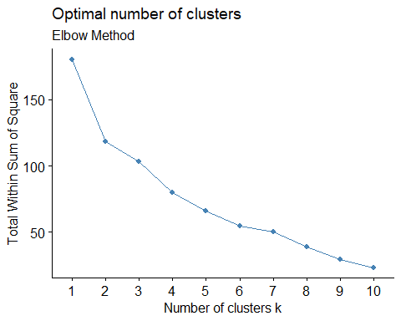

# Scaling the data using the silhouette method, to yields the cluster count.  
fviz_nbclust(Pharma_Data, kmeans, method = "silhouette") + labs(subtitle = "Silhouette Method")

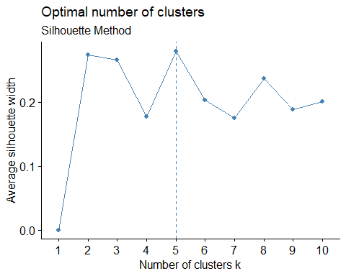

# Computing K-means clustering for multiple centers using a range of K values, then comparing the outcomes  
k2 <- kmeans(Pharma_Data, centers = 2, nstart = 25)  
k5 <- kmeans(Pharma_Data, centers = 5, nstart = 25)  
  
Plot1 <- fviz_cluster(k2, data = Pharma_Data)+ggtitle("k=2")  
Plot2 <- fviz_cluster(k5, data = Pharma_Data)+ggtitle("k=5")  
  
grid.arrange(Plot1,Plot2, nrow = 2)

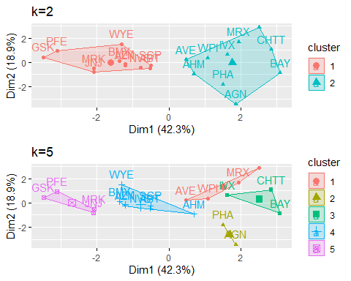

distance<- dist(Pharma_Data, method = "euclidean")  
fviz_dist(distance)

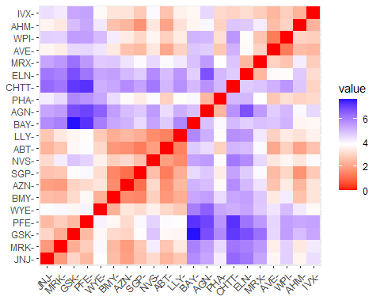

Aggre <- kmeans(Pharma_Data, 5)  
aggregate(Pharma_Data, by=list(Aggre$cluster), FUN=mean)

## Group.1 Market_Cap Beta PE_Ratio ROE ROA  
## 1 1 1.6955811 -0.1780563 -0.1984582 1.2349879 1.35034311  
## 2 2 -0.5246281 0.4451409 1.8498439 -1.0404550 -1.18658381  
## 3 3 -0.9624758 1.1949250 -0.3639982 -0.5200697 -0.96107919  
## 4 4 0.1680985 -0.5870295 -0.3885227 0.5869921 0.52349286  
## 5 5 -0.3384885 -0.5091299 -0.2909358 -0.3477127 -0.01521261  
## Asset_Turnover Leverage Rev_Growth Net_Profit_Margin  
## 1 1.153164e+00 -0.46807818 0.4671788 0.59124252  
## 2 1.480297e-16 -0.34435439 -0.5769454 -1.60954392  
## 3 -1.153164e+00 1.47737177 0.7120120 -0.36882358  
## 4 -2.306328e-01 -0.02011273 -1.0613321 1.10937343  
## 5 1.537552e-01 -0.48727670 0.2099002 -0.08308962

Pharma_Data1 <- data.frame(Pharma_Data, Aggre$cluster)  
Pharma_Data1

## Market_Cap Beta PE_Ratio ROE ROA Asset_Turnover  
## ABT 0.1840960 -0.80125356 -0.04671323 0.04009035 0.2416121 0.0000000  
## AGN -0.8544181 -0.45070513 3.49706911 -0.85483986 -0.9422871 0.9225312  
## AHM -0.8762600 -0.25595600 -0.29195768 -0.72225761 -0.5100700 0.9225312  
## AZN 0.1702742 -0.02225704 -0.24290879 0.10638147 0.9181259 0.9225312  
## AVE -0.1790256 -0.80125356 -0.32874435 -0.26484883 -0.5664461 -0.4612656  
## BAY -0.6953818 2.27578267 0.14948233 -1.45146000 -1.7127612 -0.4612656  
## BMY -0.1078688 -0.10015669 -0.70887325 0.59693581 0.8617498 0.9225312  
## CHTT -0.9767669 1.26308721 0.03299122 -0.11237924 -1.1677918 -0.4612656  
## ELN -0.9704532 2.15893320 -1.34037772 -0.70899938 -1.0174553 -1.8450624  
## LLY 0.2762415 -1.34655112 0.14948233 0.34502953 0.5610770 -0.4612656  
## GSK 1.0999201 -0.68440408 -0.45749769 2.45971647 1.8389364 1.3837968  
## IVX -0.9393967 0.48409069 -0.34100657 -0.29136529 -0.6979905 -0.4612656  
## JNJ 1.9841758 -0.25595600 0.18013789 0.18593083 1.0872544 0.9225312  
## MRX -0.9632863 0.87358895 0.19240011 -0.96753478 -0.9610792 -1.8450624  
## MRK 1.2782387 -0.25595600 -0.40231769 0.98142435 0.8429577 1.8450624  
## NVS 0.6654710 -1.30760129 -0.23677768 -0.52338423 0.1288598 -0.9225312  
## PFE 2.4199899 0.48409069 -0.11415545 1.31287998 1.6322239 0.4612656  
## PHA -0.0240846 -0.48965495 1.90298017 -0.81506519 -0.9047030 -0.4612656  
## SGP -0.4018812 -0.06120687 -0.40231769 -0.21181593 0.5234929 0.4612656  
## WPI -0.9281345 -1.11285216 -0.43297324 -1.03382590 -0.6979905 -0.9225312  
## WYE -0.1614497 0.40619104 -0.75792214 1.92938746 0.5422849 -0.4612656  
## Leverage Rev_Growth Net_Profit_Margin Aggre.cluster  
## ABT -0.21209793 -0.52776752 0.06168225 5  
## AGN 0.01828430 -0.38113909 -1.55366706 2  
## AHM -0.40408312 -0.57211809 -0.68503583 5  
## AZN -0.74965647 0.14744734 0.35122600 5  
## AVE -0.31449003 1.21638667 -0.42597037 5  
## BAY -0.74965647 -1.49714434 -1.99560225 2  
## BMY -0.02011273 -0.96584257 0.74744375 4  
## CHTT 3.74279705 -0.63276071 -1.24888417 3  
## ELN 0.61983791 1.88617085 -0.36501379 3  
## LLY -0.07130879 -0.64814764 1.17413980 4  
## GSK -0.31449003 0.76926048 0.82363947 1  
## IVX 1.10620040 0.05603085 -0.71551412 3  
## JNJ -0.62166634 -0.36213170 0.33598685 1  
## MRX 0.44065173 1.53860717 0.85411776 3  
## MRK -0.39128411 0.36014907 -0.24310064 1  
## NVS -0.67286239 -1.45369888 1.02174835 4  
## PFE -0.54487226 1.10143723 1.44844440 1  
## PHA -0.30169102 0.14744734 -1.27936246 2  
## SGP -0.74965647 -0.43544591 0.29026942 5  
## WPI -0.49367621 1.43089863 -0.09070919 5  
## WYE 0.68383297 -1.17763919 1.49416183 4

# Final analysis, results extraction utilizing 5 groupings, and visualization of the outcomes  
set.seed(125)  
F_Cluster<- kmeans(Pharma_Data, 5, nstart = 25)  
print(F_Cluster)

## K-means clustering with 5 clusters of sizes 3, 8, 4, 2, 4  
##   
## Cluster means:  
## Market_Cap Beta PE_Ratio ROE ROA Asset_Turnover  
## 1 -0.87051511 1.3409869 -0.05284434 -0.6184015 -1.1928478 -0.4612656  
## 2 -0.03142211 -0.4360989 -0.31724852 0.1950459 0.4083915 0.1729746  
## 3 -0.76022489 0.2796041 -0.47742380 -0.7438022 -0.8107428 -1.2684804  
## 4 -0.43925134 -0.4701800 2.70002464 -0.8349525 -0.9234951 0.2306328  
## 5 1.69558112 -0.1780563 -0.19845823 1.2349879 1.3503431 1.1531640  
## Leverage Rev_Growth Net_Profit_Margin  
## 1 1.36644699 -0.6912914 -1.320000179  
## 2 -0.27449312 -0.7041516 0.556954446  
## 3 0.06308085 1.5180158 -0.006893899  
## 4 -0.14170336 -0.1168459 -1.416514761  
## 5 -0.46807818 0.4671788 0.591242521  
##   
## Clustering vector:  
## ABT AGN AHM AZN AVE BAY BMY CHTT ELN LLY GSK IVX JNJ MRX MRK NVS   
## 2 4 2 2 3 1 2 1 3 2 5 1 5 3 5 2   
## PFE PHA SGP WPI WYE   
## 5 4 2 3 2   
##   
## Within cluster sum of squares by cluster:  
## [1] 15.595925 21.879320 12.791257 2.803505 9.284424  
## (between_SS / total_SS = 65.4 %)  
##   
## Available components:  
##   
## [1] "cluster" "centers" "totss" "withinss" "tot.withinss"  
## [6] "betweenss" "size" "iter" "ifault"

clusplot(Pharma_Data,F_Cluster$cluster, color = TRUE, labels = 2,lines = 0)

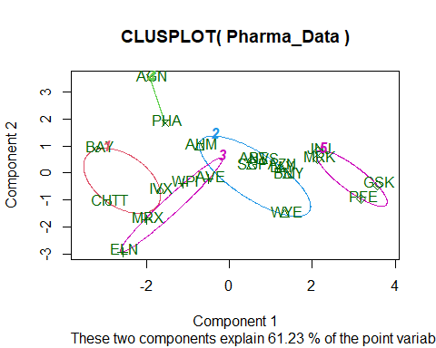

# 2.Interpret the clusters with respect to the numerical variables used in forming the clusters. Is there a pattern in the clusters with respect to the numerical variables (10 to 12)? (those not used in forming the clusters)  
  
#Cluster 1: BAY, CHTT, and IVX- lowest Rev Growth, highest Beta and levearge, lowest Net Profit Margin.  
#Cluster 2: AHM, SGP, WYE, BMY, AZN, ABT, NVS, and LLY- lowest Market Cap, lowest Beta, lowest PE Ratio, highest Leverage, and highest Revenue Growth.  
#Cluster 3:WPI, MRX, ELN, AVE- Lowest PE Ratio, Highest ROE, Lowest ROA, Lowest Net Profit Margin, Highest Rev Growth.  
#Cluster 4:AGN, PHA-highest PE Ratio, lowest Asset Turnover, and lowest Beta.  
#Cluster 5:JNJ, MRK, PFE, and GSK-Highest Market Cap, ROE, ROA, Asset Turnover Ratio, and Lowest Beta/PE Ratio  
  
P_Cluster <- Pharma[,c(12,13,14)]%>% mutate(clusters = F_Cluster$cluster)%>% arrange(clusters, ascending = TRUE)  
P_Cluster

## Median_Recommendation Location Exchange clusters  
## BAY Hold GERMANY NYSE 1  
## CHTT Moderate Buy US NASDAQ 1  
## IVX Hold US AMEX 1  
## ABT Moderate Buy US NYSE 2  
## AHM Strong Buy UK NYSE 2  
## AZN Moderate Sell UK NYSE 2  
## BMY Moderate Sell US NYSE 2  
## LLY Hold US NYSE 2  
## NVS Hold SWITZERLAND NYSE 2  
## SGP Hold US NYSE 2  
## WYE Hold US NYSE 2  
## AVE Moderate Buy FRANCE NYSE 3  
## ELN Moderate Sell IRELAND NYSE 3  
## MRX Moderate Buy US NYSE 3  
## WPI Moderate Sell US NYSE 3  
## AGN Moderate Buy CANADA NYSE 4  
## PHA Hold US NYSE 4  
## GSK Hold UK NYSE 5  
## JNJ Moderate Buy US NYSE 5  
## MRK Hold US NYSE 5  
## PFE Moderate Buy US NYSE 5

# pattern in the clusters   
  
plot1<-ggplot(P_Cluster, mapping = aes(factor(clusters), fill=Median_Recommendation))+geom_bar(position = 'dodge')+labs(x ='Number of clusters')  
plot2<- ggplot(P_Cluster, mapping = aes(factor(clusters),fill = Location))+geom_bar(position = 'dodge')+labs(x ='Number of clusters')  
plot3<- ggplot(P_Cluster, mapping = aes(factor(clusters),fill = Exchange))+geom_bar(position = 'dodge')+labs(x ='Number of clusters')  
grid.arrange(plot1, plot2, plot3)

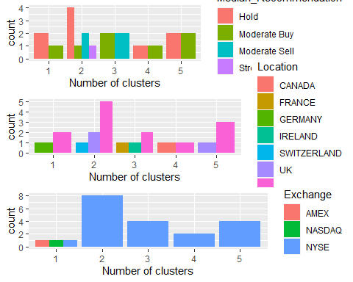

#Given the graph:  
#Cluster 1: Despite the fact that the firms are evenly divided among AMEX, NASDAQ, and NYSE, it has a distinct Hold and Moderate Buy median as well as a varied count between the US and Germany.   
#Cluster 2: The highest median in this cluster is the Hold median, which also comprises unique Hold, Moderate Buy, Moderate Sell, and Strong Buy medians. They are on the NYSE and hail from the US, the UK, and Switzerland.  
#Cluster 3: It has equal moderate buy and moderate sell medians, and distinct counts for France, Ireland, and the US, which is listed on the NYSE.  
#Cluster 4: It is equally scattred in the US and Canada, with Hold and Moderate Buy medians, which is entirely listed on the NYSE.   
#Cluster 5: It is uniformly distributed across the US and UK, with medians of Hold and Moderate Buy, which is only listed on the NYSE.  
#Considering the media recommendation variable, the clusters demonstrate a specific pattern:  
#Cluster 1 and Cluster 2 has Hold Recommendation.  
#Cluster 3, Cluster 4 and Cluster 5 has moderate buy Recommendation.

# 3.Provide an appropriate name for each cluster using any or all of the variables in the dataset.  
#Cluster 1 : Strong Hold cluster  
#Cluster 2 : Strong Buy cluster  
#Cluster 3 : Tolerable cluster  
#Cluster 4 : Fair Buy cluster  
#Cluster 5 : Sustained cluster