SCHOOL OF COMPUTER SCIENCE AND ARTIFICIAL INTELLIGENCE |  |  |  |  | DEPARTMENT OF COMPUTER SCIENCE ENGINEERING
Program Name: B. Tech |  |  |  | Assignment Type: Lab |  |  | Academic Year:2025-2026
Course Coordinator Name |  |  |  | Venkataramana Veeramsetty
Instructor(s) Name
  Dr. V. Venkataramana (Co-ordinator)
  Dr. T. Sampath Kumar
  Dr. Pramoda Patro
  Dr. Brij Kishor Tiwari
  Dr.J.Ravichander
  Dr. Mohammand Ali Shaik
  Dr. Anirodh Kumar
  Mr. S.Naresh Kumar
  Dr. RAJESH VELPULA
  Mr. Kundhan Kumar
  Ms. Ch.Rajitha
  Mr. M Prakash
  Mr. B.Raju
  Intern 1 (Dharma teja)
  Intern 2 (Sai Prasad)
  Intern 3 (Sowmya)
  NS_2 ( Mounika)
Course Code |  |  | 24CS002PC215 | Course Title |  | AI Assisted Coding
Year/Sem |  |  | II/I | Regulation |  | R24
Date and Day  of Assignment |  |  | Week5 - Thursday | Time(s)
Duration |  |  | 2 Hours | Applicable to  Batches
AssignmentNumber:10.4(Present assignment number)/24(Total number of assignments)
 | Q.No. | Question |  |  |  |  |  | Expected Time  to complete
 | 1 | Lab 10 – Code Review and Quality: Using AI to Improve Code Quality and Readability  Lab Objectives  - Use AI for automated code review and quality enhancement.  - Identify and fix syntax, logical, performance, and security issues in Python code.  - Improve readability and maintainability through structured refactoring and comments.  - Apply prompt engineering for targeted improvements.  - Evaluate AI-generated suggestions against PEP 8 standards and software engineering best practices  Task 1: Syntax and Error Detection  Task: Identify and fix syntax, indentation, and variable errors in the given script.  # buggy_code_task1.py  def add_numbers(a, b)  result = a + b  return reslt  print(add_numbers(10 20))  Expected Output:  - Corrected code with proper syntax (: after function, fixed variable name, corrected function call).  - AI should explain what was fixed.  Prompt:  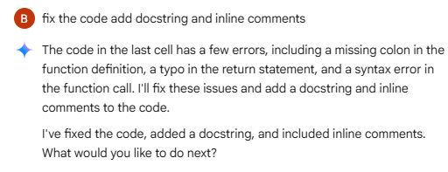  Code:  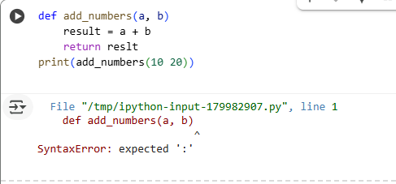  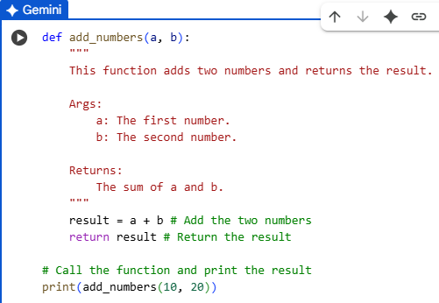  Output:    Task 2: Logical and Performance Issue Review  Task: Optimize inefficient logic while keeping the result correct.  # buggy_code_task2.py  def find_duplicates(nums):  duplicates = []  for i in range(len(nums)):  for j in range(len(nums)):  if i != j and nums[i] == nums[j] and nums[i] not in duplicates:  duplicates.append(nums[i])  return duplicates  numbers = [1,2,3,2,4,5,1,6,1,2]  print(find_duplicates(numbers))  Expected Output:  - More efficient duplicate detection (e.g., using sets).  - AI should explain the optimization.  Prompt:  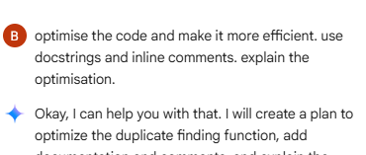  Code:  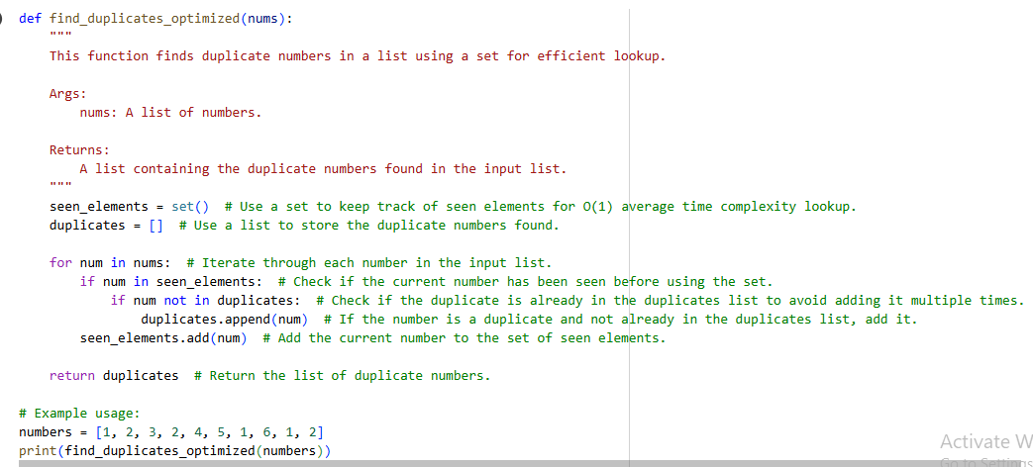  Output:    Explanation:  Efficiency Comparison:  - Original `find_duplicates` function had a time complexity of approximately O(n^3) due to nested loops and list lookups.  - The optimized `find_duplicates_optimized` function has an average time complexity of O(n).  Impact of using a set:  - The optimized code uses a set (`seen_elements`) to store numbers encountered so far.  - Checking if an element is in a set has an average time complexity of O(1), which is constant time regardless of the size of the set.  - In contrast, the original code likely used list lookups (e.g., 'num not in duplicates'), which have a time complexity of O(k), where k is the size of the list being searched. This could lead to significantly slower performance for larger lists.  Impact of single iteration:  - The optimized code iterates through the input list only once.  - The original code used nested loops, meaning for each element in the list, it iterated through the list again. This resulted in O(n^2) operations just for the iterations.  - The single pass in the optimized code directly contributes to its linear time complexity.  Summary of Efficiency Gains:  The optimized code is significantly faster for larger datasets primarily due to:  1. Using a set for near constant-time lookups (O(1) on average) compared to potentially linear-time list lookups (O(k)).  2. Employing a single pass through the input list instead of nested loops, reducing the number of operations from O(n^2) to O(n).  These factors combine to transform the time complexity from roughly O(n^3) to O(n), making the optimized code much more scalable and efficient for large inputs.  Task 3: Code Refactoring for Readability  Task: Refactor messy code into clean, PEP 8–compliant, well-structured code.  # buggy_code_task3.py  def c(n):  x=1  for i in range(1,n+1):  x=x*i  return x  print(c(5))  Expected Output:  Function renamed to calculate_factorial.  Proper indentation, variable naming, docstrings, and formatting.  AI should provide a more readable version.  Prompt:  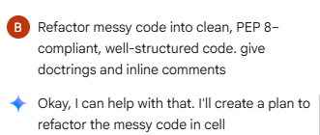  Code:  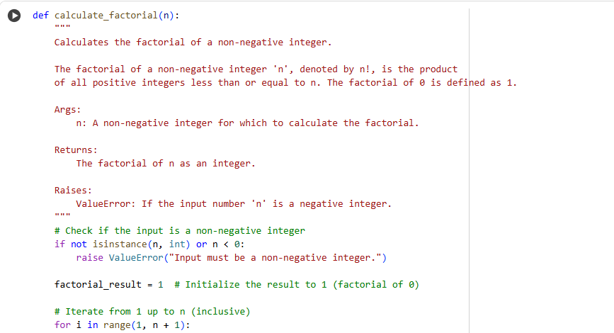  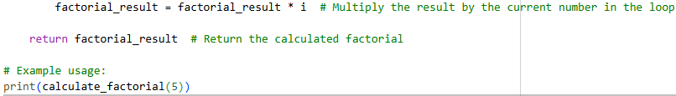  Output:  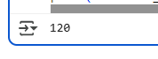  Explanation:  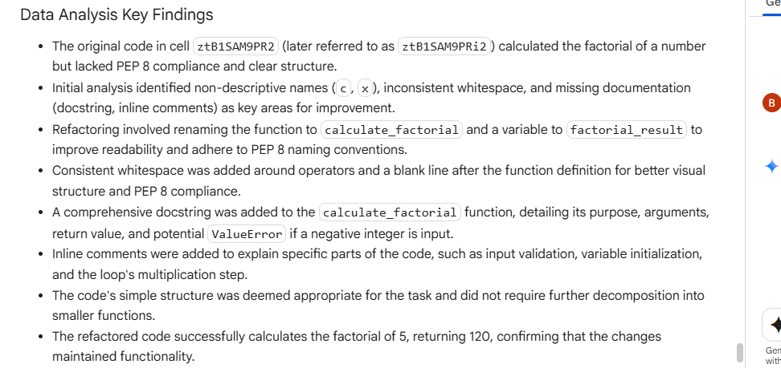  Task 4: Security and Error Handling Enhancement  Task: Add security practices and exception handling to the code.  # buggy_code_task4.py  import sqlite3  def get_user_data(user_id):  conn = sqlite3.connect("users.db")  cursor = conn.cursor()  query = f"SELECT * FROM users WHERE id = {user_id};" # Potential SQL injection risk  cursor.execute(query)  result = cursor.fetchall()  conn.close()  return result  user_input = input("Enter user ID: ")  print(get_user_data(user_input))  Expected Output:  Safe query using parameterized SQL (? placeholders).  Try-except block for database errors.  Input validation before query execution.  Prompt:  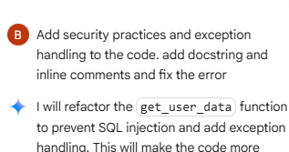  Code:  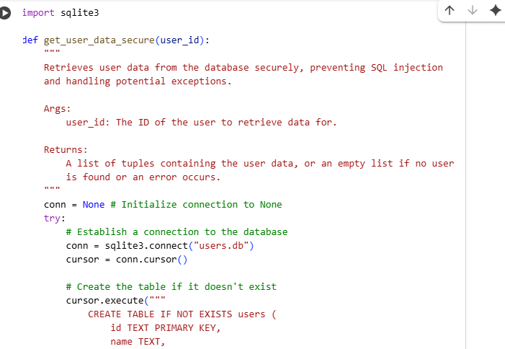  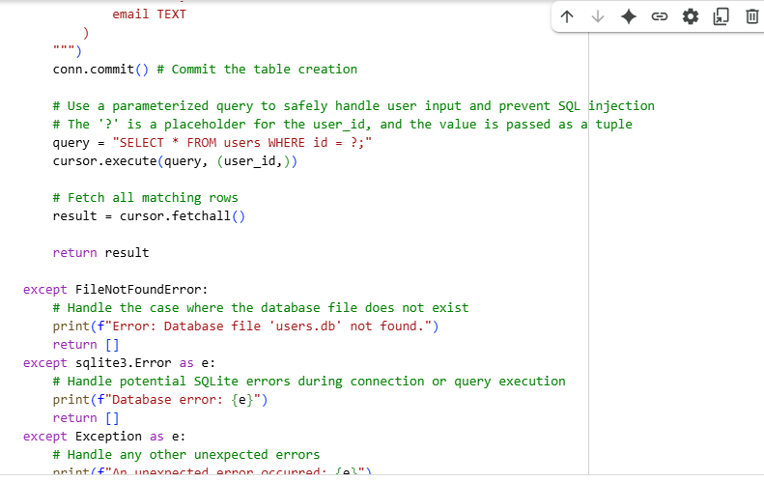  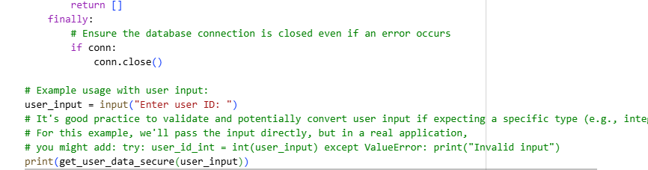  Output:  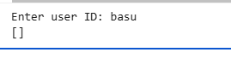  Task 5: Automated Code Review Report Generation  Task: Generate a review report for this messy code.  # buggy_code_task5.py  def calc(x,y,z):  if z=="add":  return x+y  elif z=="sub": return x-y  elif z=="mul":  return x*y  elif z=="div":  return x/y  else: print("wrong")  print(calc(10,5,"add"))  print(calc(10,0,"div"))  Expected Output:  AI-generated review report should mention:  - Missing docstrings  - Inconsistent formatting (indentation, inline return)  - Missing error handling for division by zero  - Non-descriptive function/variable names  - Suggestions for readability and PEP 8 compliance  Prompt:  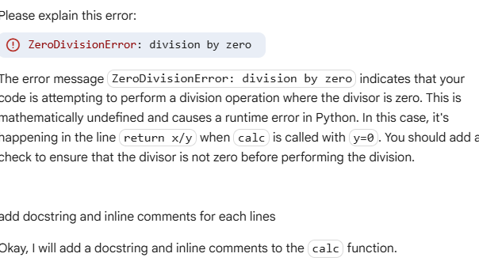  Code:  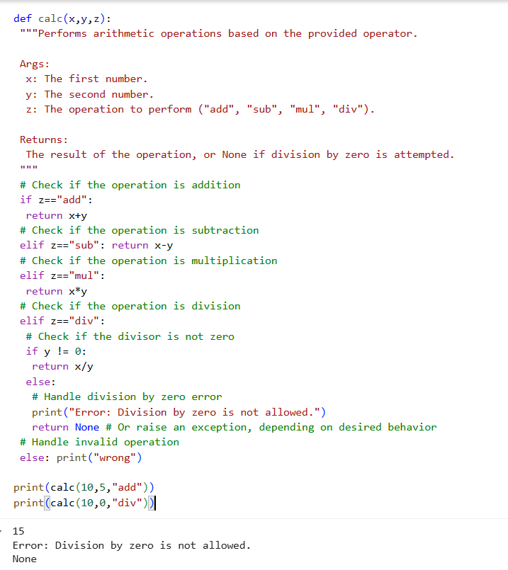  Output:  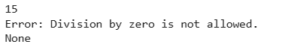  Explanation:  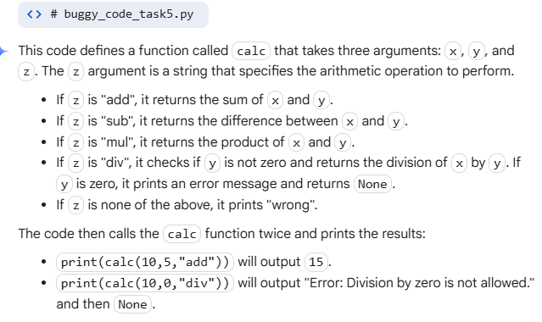 |  |  |  |  |  | Week5 - Thursday

