SCHOOL OF COMPUTER SCIENCE AND ARTIFICIAL INTELLIGENCE |  |  |  |  | DEPARTMENT OF COMPUTER SCIENCE ENGINEERING
Program Name: B. Tech |  |  |  | Assignment Type: Lab |  |  | Academic Year:2025-2026
Course Coordinator Name |  |  |  | Venkataramana Veeramsetty
Instructor(s) Name
  Dr. V. Venkataramana (Co-ordinator)
  Dr. T. Sampath Kumar
  Dr. Pramoda Patro
  Dr. Brij Kishor Tiwari
  Dr.J.Ravichander
  Dr. Mohammand Ali Shaik
  Dr. Anirodh Kumar
  Mr. S.Naresh Kumar
  Dr. RAJESH VELPULA
  Mr. Kundhan Kumar
  Ms. Ch.Rajitha
  Mr. M Prakash
  Mr. B.Raju
  Intern 1 (Dharma teja)
  Intern 2 (Sai Prasad)
  Intern 3 (Sowmya)
  NS_2 ( Mounika)
Course Code |  |  | 24CS002PC215 | Course Title |  | AI Assisted Coding
Year/Sem |  |  | II/I | Regulation |  | R24
Date and Day  of Assignment |  |  | Week7 - Thursday | Time(s)
Duration |  |  | 2 Hours | Applicable to  Batches
AssignmentNumber:13.1(Present assignment number)/24(Total number of assignments)
 | Q.No. | Question |  |  |  |  |  | Expected Time  to complete
 | 1 | Lab 13: Code Refactoring – Improving Legacy Code with AI Suggestions  Lab Objectives:  - Identify code smells and inefficiencies in legacy Python scripts.  - Use AI-assisted coding tools to refactor for readability, maintainability, and performance.  - Apply modern Python best practices while ensuring output correctness.  Task 1  - Task: Refactor repeated loops into a cleaner, more Pythonic approach.  Instructions:  - Analyze the legacy code.  - Identify the part that uses loops to compute values.  - Refactor using list comprehensions or helper functions while keeping the output the same.  Legacy Code:  numbers = [1, 2, 3, 4, 5]  squares = []  for n in numbers:  squares.append(n ** 2)  print(squares)  Expected Output:  [1, 4, 9, 16, 25]  PROMPT:  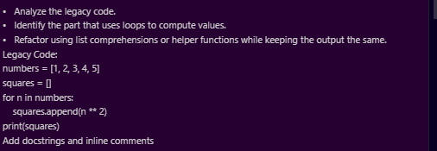  CODE:  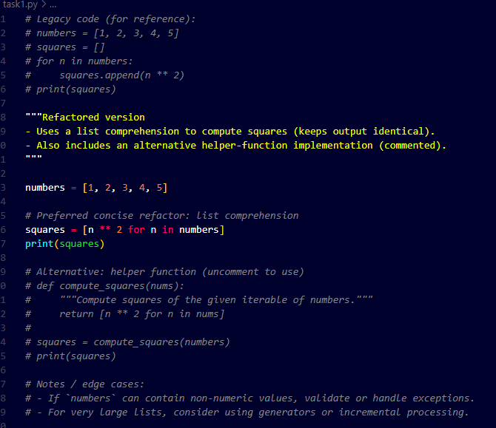  OUTPUT:  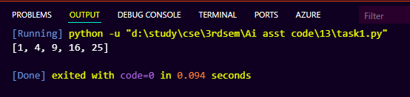  Task 2  Task: Simplify string concatenation.  Instructions:  - Review the loop that builds a sentence using +=.  - Refactor using " ".join() to improve efficiency and readability.  Legacy Code:  words = ["AI", "helps", "in", "refactoring", "code"]  sentence = ""  for word in words:  sentence += word + " "  print(sentence.strip())  Expected Output:  AI helps in refactoring code  PROMPT:  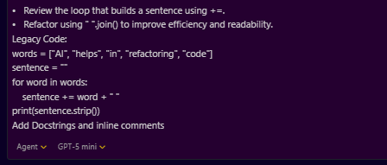  CODE:  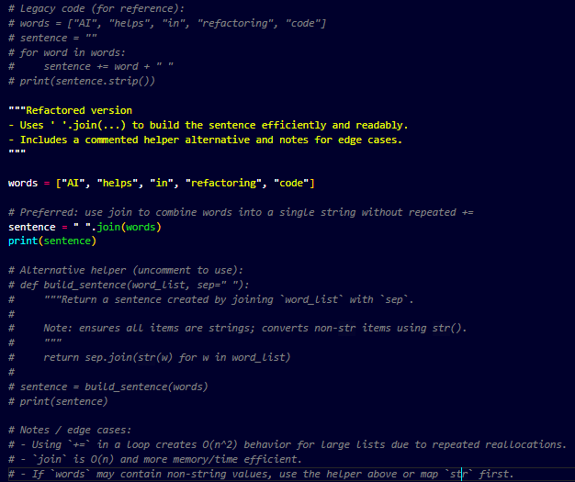  OUTPUT:  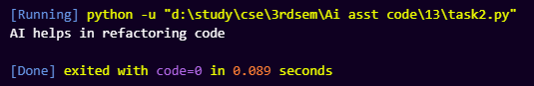  Task 3  Task: Replace manual dictionary lookup with a safer method.  Instructions:  - Check how the code accesses dictionary keys.  - Use .get() or another Pythonic approach to handle missing keys gracefully.  Legacy Code:  student_scores = {"Alice": 85, "Bob": 90}  if "Charlie" in student_scores:  print(student_scores["Charlie"])  else:  print("Not Found")  Expected Output:  Not Found  Prompt:  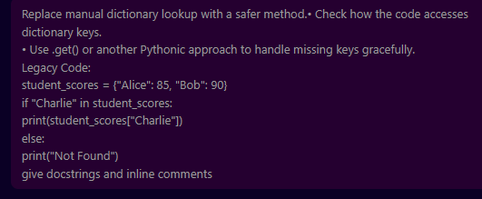  Code:  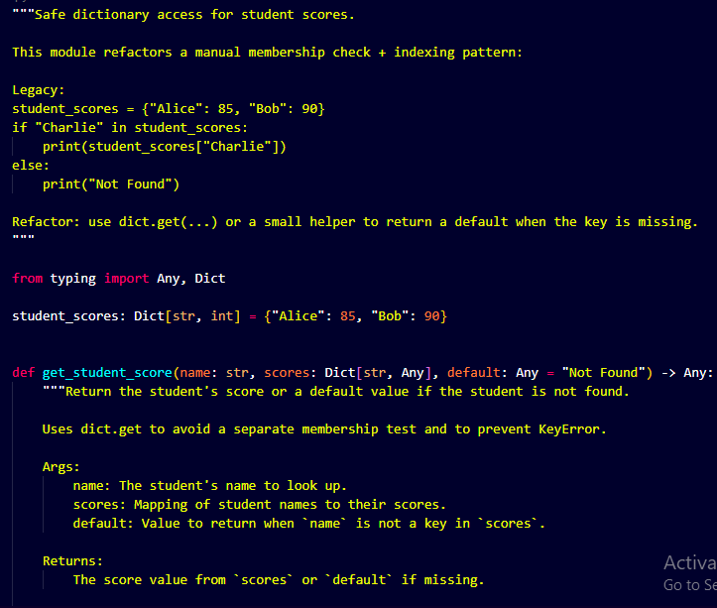  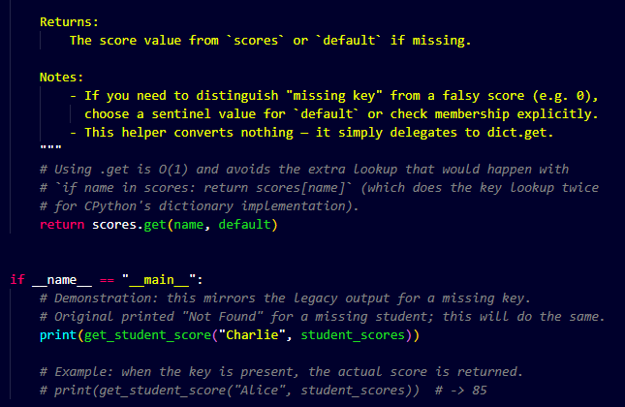  Task 4  Task: Refactor repetitive if-else blocks.  Instructions:  - Examine multiple if-elif statements for operations.  - Refactor using dictionary mapping to make the code scalable and clean.  Legacy Code:  operation = "multiply"  a, b = 5, 3  if operation == "add":  result = a + b  elif operation == "subtract":  result = a - b  elif operation == "multiply":  result = a * b  else:  result = None  print(result)  Expected Output:  15  PROMPT:  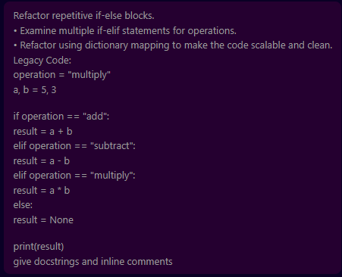  CODE:  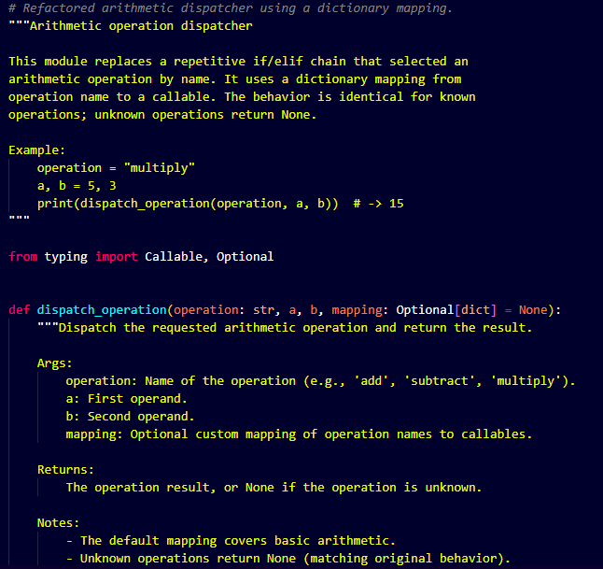  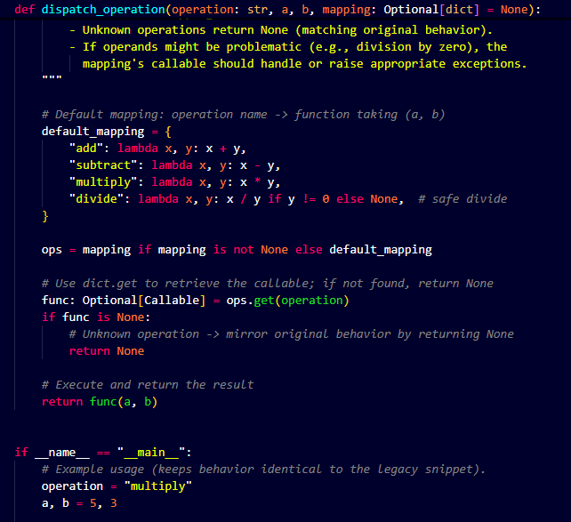  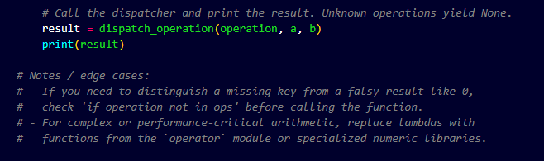  OUTPUT:  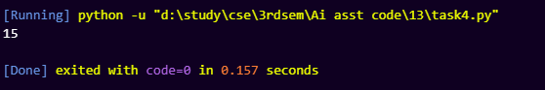  Task 5  Task: Optimize nested loops for searching.  Instructions:  - Identify the nested loop used to find an element.  - Refactor using Python’s in keyword or other efficient search techniques.  Legacy Code:  items = [10, 20, 30, 40, 50]  found = False  for i in items:  if i == 30:  found = True  break  print("Found" if found else "Not Found")  Expected Output:  Found  PROMPT:  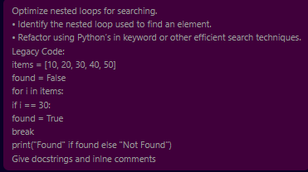  CODE:  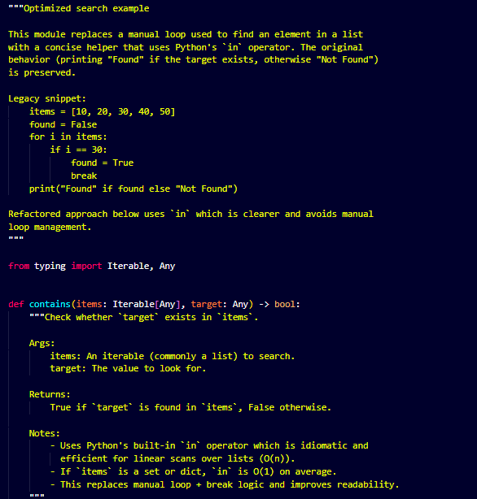  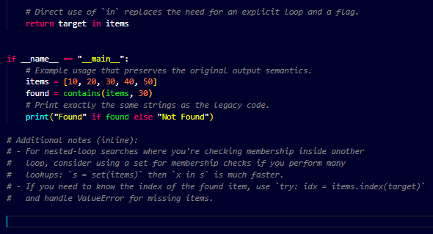  OUTPUT:  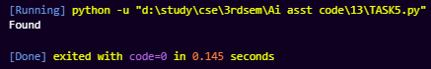 |  |  |  |  |  | Week7 - Thursday

