Oracle academy

Practice-6.2:

1. Describe the difference between a syntax error, a logic error, and an exception

Code:

Syntax error:

int number = 10 // Missing semicolon

logic error:

int a = 5;

int b = 3;

int result = a - b; // Intended to add, but used subtraction

exception:

int[] arr = new int[5];

int value = arr[10]; // ArrayIndexOutOfBoundsException

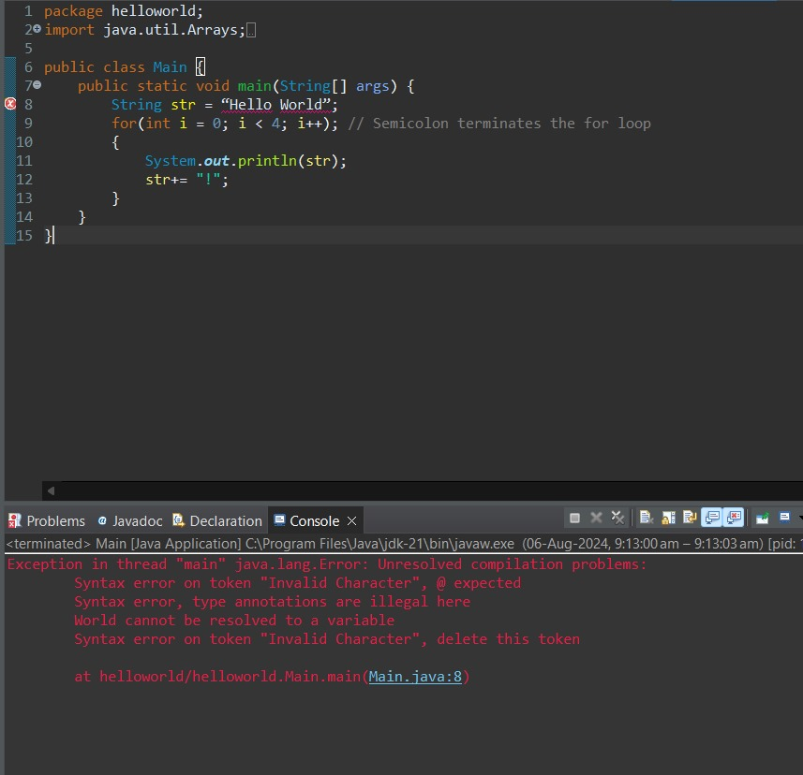

1. What is wrong with the following code? It should print "Hello World!" four times to the screen

Code:

String str = “Hello World”;

for(int i = 0; i < 4; i++); // Semicolon terminates the for loop

{

System.out.println(str);

str+= ”!”;

}

1. Describe an exception that you have experienced in your program before. Explain how it could be handled with a try/catch block of code.

Code:

int[] arr = new int[5];

System.out.println(arr[10]); // ArrayIndexOutOfBoundsException

1. Write a segment of code that has:

a. A syntax error

b. A logic error

c. An exception

syntax error:

int number = 10; // Missing semicolon

logic error:

int a = 5;

int b = 3;

int result = a - b; // Intended to add, but used subtraction

exeption:

int[] arr = new int[5];

System.out.println(arr[10]); // ArrayIndexOutOfBoundsException

1. What is the difference between a checked exception and an unchecked exception?

Code:

Checked exeption:

try {

FileReader file = new FileReader("somefile.txt");

} catch (FileNotFoundException e) {

e.printStackTrace();

}

Unchecked exeption:

String str = null;

System.out.println(str.length()); // NullPointerException