Varshitha.A

D-N0:4-112

Gajulamandyam (v)

Renigunta(M)

Tirupathi(D)

Andhra pradesh

(M)+91-7032855660

E-mail:varshitha20212021@gmail.com

# CARRER OBJECTIVE

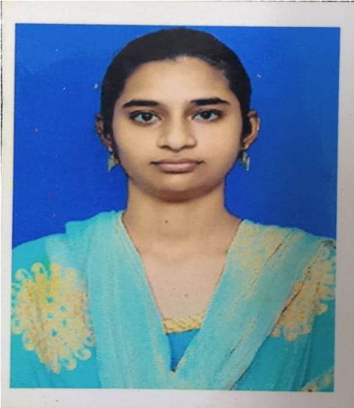

To work in software developer company where I will have experience and qualification in OOPS terms and paradigms.

# EDUCATION

* Bachelor of Technology ,Electronics and Communication,90%

Annamacharya Institute of Technology and

Sciences,Rajampet

* Intermediate ,80%

Sri Chaithanya Junior college,Tirupathi

* SSC,9.5 GPA

Sri Sai Ganesh Vidyalayam,Gajulamandyam

# SKILLS

* Good communication skills
* Passionate about software

CERTIFICATES AND ACHIEVEMENTS

* Essay Writing
* Winner in Science fair contest

# WORKSHOP AND SEMINAR

* MATLAB workshop
* PCB design workshop

|  |
| --- |
| ACTIVITES AN INTERESTS |

* Drawing,listening music
* kabbadi
* football

RESPONSIBILITIES

* Collabrating with software testers for efficient testing and Bug-Fixing.
* Providing high quality,maintainable and well documented code.

# LANGUAGES KNOWN

Telugu,English and Hindi

# REFERENCE

Prof. Fayaz Begum

Professor of ECE

AITS college of Engineering

Rajampet

6303987653

Fayazbegum23@gmail.com