**Name: YATHIN K V**

**USN: 1PE17IS105**

**Class: ISE 7B**

**Machine Learning Laboratory**

Program 1

**Implement and demonstrate the FIND-S algorithm for finding the most specific hypothesis based on a given set of training data samples. Read the training data from a .CSV file.**

Find-s Algorithm :

1. Load Data set

2. Initialize h to the most specific hypothesis in H

3. For each positive training instance x

For each attribute constraint ai in h

If the constraint ai in h is satisfied by x then do nothing

else replace ai in h by the next more general constraint that is satisfied by x

4. Output hypothesis h

**PROGRAM:**

import csv

def loadCsv(filename):

lines = csv.reader(open(filename, "rt"))

dataset = list(lines)

for i in range(len(dataset)):

dataset[i] = dataset[i]

return dataset

attributes = ['Sky','Temp','Humidity','Wind','Water','Forecast']

print(attributes)

num_attributes = len(attributes)

filename = "Weather.csv"

dataset = loadCsv(filename)

print(dataset)

target=['Yes','Yes','No','Yes']

print(target)

hypothesis=['0'] * num_attributes

print(hypothesis)

print("The Hypothesis are")

for i in range(len(target)):

if(target[i] == 'Yes'):

for j in range(num_attributes):

if(hypothesis[j]=='0'):

hypothesis[j] = dataset[i][j]

if(hypothesis[j]!= dataset[i][j]):

hypothesis[j]='?'

print(i+1,'=',hypothesis)

print("Final Hypothesis")

print(hypothesis)

**OUTPUT:**

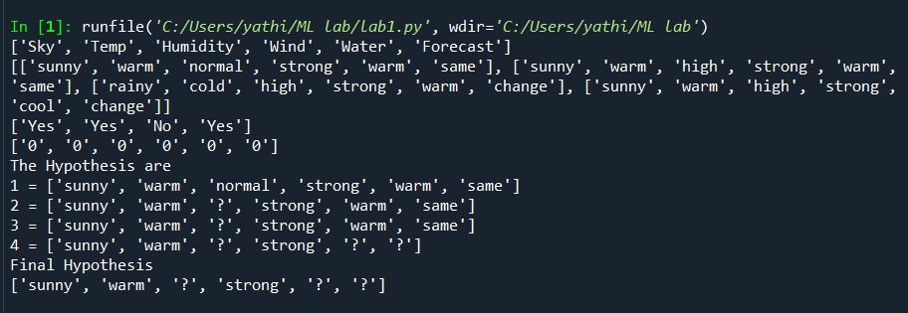

**CSV FILE:**

|  |  |  |  |  |  |
| --- | --- | --- | --- | --- | --- |
| sunny | warm | normal | strong | warm | same |
| sunny | warm | high | strong | warm | same |
| rainy | cold | high | strong | warm | change |
| sunny | warm | high | strong | cool | change |