**Name: YATHIN K V**

**USN: 1PE17IS105**

**Class: ISE 7B**

**Machine Learning Laboratory**

Program 2

**For a given set of training data examples stored in a .CSV file, implement and demonstrate the Candidate-Elimination algorithm to output a description of the set of all hypotheses consistent with the training examples.**

**Candidate-Elimination Algorithm:**

1. Load data set

2. G <-maximally general hypotheses in H

3. S <- maximally specific hypotheses in H

4. For each training example d=<x,c(x)>

Case 1 : If d is a positive example

Remove from G any hypothesis that is inconsistent with d

*For each hypothesis s in S that is not consistent with d*

• Remove s from S.

• Add to S all minimal generalizations h of s such that

• h consistent with d

• Some member of G is more general than h

• *Remove from S any hypothesis that is more general than another hypothesis in S*

Case 2: If d is a negative example

*Remove from S any hypothesis that is inconsistent with d*

*For each hypothesis g in G that is not consistent with d*

• Remove g from G.

• Add to G all minimal specializations h of g such that

o h consistent with d

o Some member of S is more specific than h

• Remove from G any hypothesis that is less general than another hypothesis in G

**PROGRAM:**

import numpy as np

import pandas as pd

data = pd.DataFrame(data=pd.read_csv('Training_examples.csv'))

print(data)

concepts = np.array(data.iloc[:,0:-1])

target = np.array(data.iloc[:,-1])

def learn(concepts, target):

specific_h = concepts[0].copy()

print("initialization of specific_h and general_h")

print(specific_h)

general_h = [["?" for i in range(len(specific_h))] for i in range(len(specific_h))]

print(general_h)

for i, h in enumerate(concepts):

if target[i] == "Yes":

for x in range(len(specific_h)):

if h[x] != specific_h[x]:

specific_h[x] = '?'

general_h[x][x] = '?'

if target[i] == "No":

for x in range(len(specific_h)):

if h[x] != specific_h[x]:

general_h[x][x] = specific_h[x]

else:

general_h[x][x] = '?'

print(" steps of Candidate Elimination Algorithm",i+1)

print(specific_h)

print(general_h)

indices = [i for i, val in enumerate(general_h) if val == ['?', '?', '?', '?', '?', '?']]

for i in indices:

general_h.remove(['?', '?', '?', '?', '?', '?'])

return specific_h, general_h

s_final, g_final = learn(concepts, target)

print("Final Specific_h:", s_final, sep="\n")

print("Final General_h:", g_final, sep="\n")

**OUTPUT:**

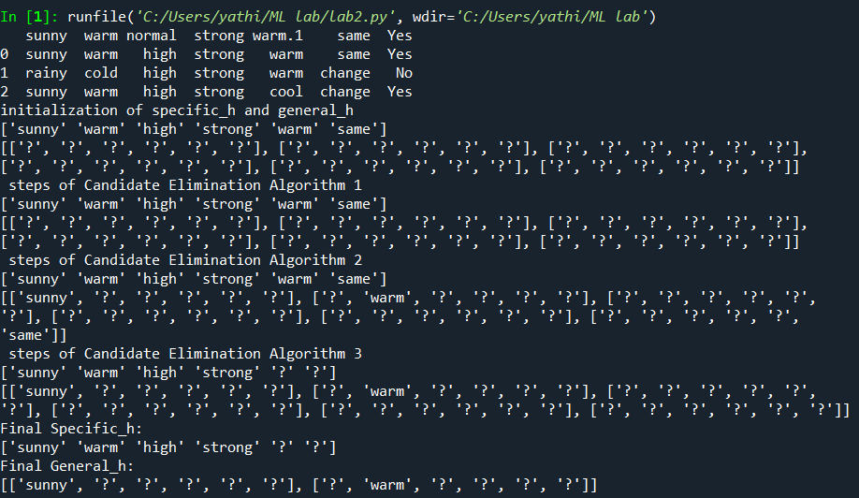

**CSV FILE:**

|  |  |  |  |  |  |  |
| --- | --- | --- | --- | --- | --- | --- |
| sunny | warm | normal | strong | warm | same | Yes |
| sunny | warm | high | strong | warm | same | Yes |
| rainy | cold | high | strong | warm | change | No |
| sunny | warm | high | strong | cool | change | Yes |