Operators:

Type of Operators:

1. Arithmetic Operators
2. Assignment Operators
3. Comparison operators
4. Logical Operators
5. Identity Operators
6. Membership Operators
7. Bitwise Operators.

1.Arithmetic Operators:

An operator that performs arithmetic operations on groups and numbers.

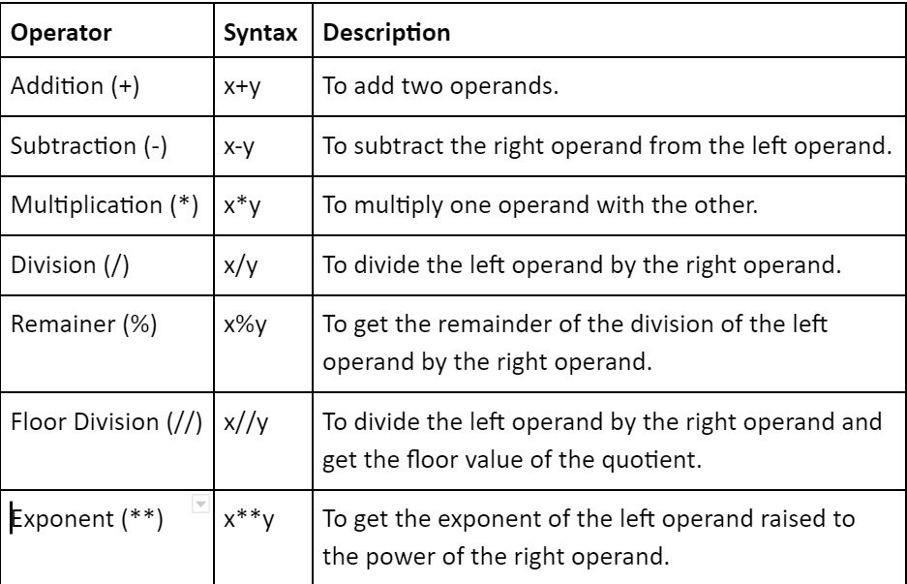

2.Assignment Operators:

The assignment operator assigns the value of its right-hand operand to a variable.

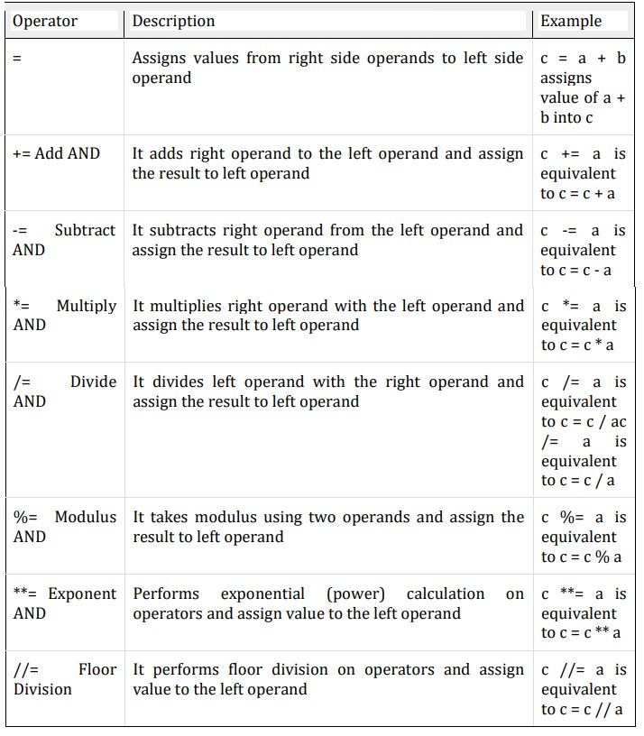

3.Comparison Operators:

Comparing operators can compare numbers or strings and perform evaluations.

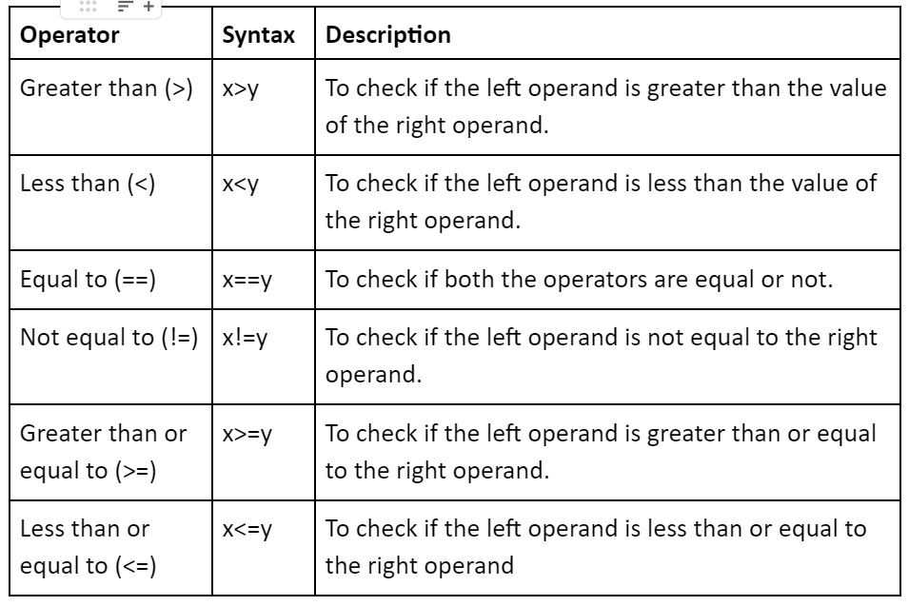

4.Logical Operators:

Logical operators carry out logical operations and return Boolean values based on the result.

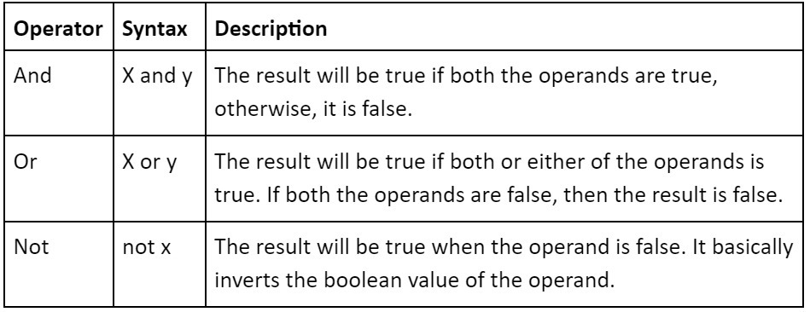

5.Identity Operators:

Identity Operators are used to compare the objects if both the objects are actually of the same datatype and share the same memory location.

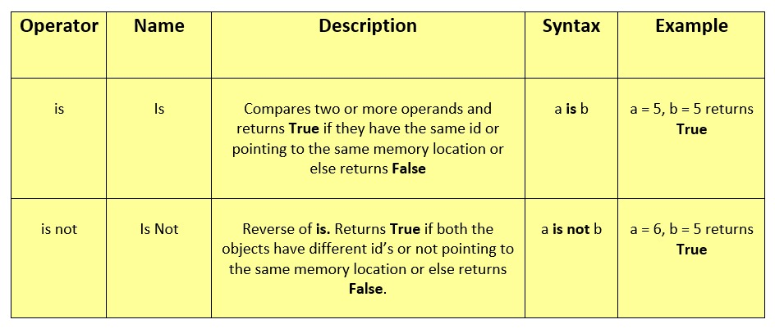

6.Membership Operators:

Membership Operators are operations used to validate the membership of a value.

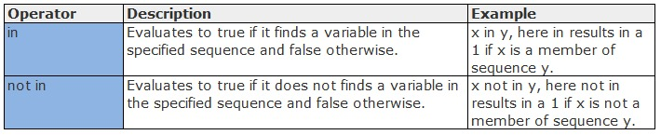

8.Bitwise Operators:

Bitwise operators are used to perform bitwise calculations on integers.

