Lab 10 – Code Review and Quality: Using AI to Improve Code Quality and Readability
NAME:P.Varshitha
Roll no:2503A52398
Batch:14
Task Description #1 – Syntax and Logic Errors
Task: Use AI to identify and fix syntax and logic errors in a faulty Python script.
INPUT:
# Calculate average score of a student
def calc_average(marks):
total = 0

for mark in marks:
total += mark

average = total / len(marks)
return average

marks = [85, 90, 78, 92]

print("Average Score is", calc_average(marks))

OUTPUT:
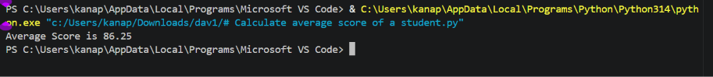

Task Description #2 – PEP 8 Compliance
Task: Use AI to refactor Python code to follow PEP 8 style
guidelines.
Input Code:
def area_of_rect(L,B) : return L*B
print(area_of_rect(10,20))
OUTPUT:
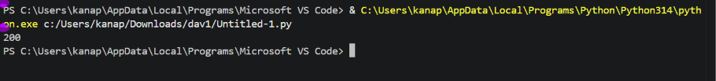

Task Description #3 – Readability Enhancement
Task: Use AI to make code more readable without changing its
logic.
Input Code:
def c(x,y):
return x*y/100
a=200
b=15
print(c(a,b))

OUTPUT:

Task Description #4 – Refactoring for Maintainability
Task: Use AI to break repetitive or long code into reusable functions.

Input Code:
students = ["Alice", "Bob", "Charlie"]
print("Welcome", students[0])
print("Welcome", students[1])
print("Welcome", students[2])

OUTPUT:
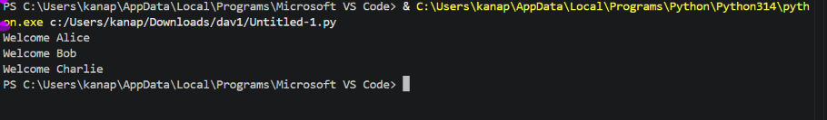

Task Description #5 – Performance Optimization
Task: Use AI to make the code run faster.

Input Code:
# Find squares of numbers
nums = [i for i in range(1,1000000)]
squares = []

for n in nums:
squares.append(n**2)
print(len(squares))
OUTPUT:
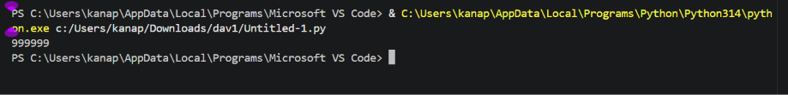
Task Description #6 – Complexity Reduction
Task: Use AI to simplify overly complex logic.

Input Code:

def grade(score):
if score &gt;= 90:
return &quot;A&quot;
else:
if score &gt;= 80:
return &quot;B&quot;
else:
if score &gt;= 70:
return &quot;C&quot;
else:
if score &gt;= 60:
return &quot;D&quot;
else:
return &quot;F&quot;
Print(grade(B))

OUTPUT:
