ASSINGNMENT NUMBER:5
Name:P.Varshitha
Roll no:2503a52398
Batch:14
Task Description #1 (Privacy &amp; Security in File Handling)
Task: Use an AI tool to generate a Python script that stores user data (name, email, password) in a file.

INPUT CODE:

import hashlib
import json
import secrets
from pathlib import Path

DATA_FILE = Path(__file__).with_name("users.json")

def load_users() -> dict[str, dict[str, str]]:
"""Load saved users, returning an empty mapping when none exists."""
if not DATA_FILE.exists():
return {}

with DATA_FILE.open("r", encoding="utf-8") as file:
return json.load(file)

def save_users(users: dict[str, dict[str, str]]) -> None:
"""Write users to disk as formatted JSON."""
with DATA_FILE.open("w", encoding="utf-8") as file:
json.dump(users, file, indent=2)

def hash_password(password: str, salt: bytes | None = None) -> tuple[str, str]:
"""Return a password hash and its salt, both encoded as hexadecimal."""
salt = salt or secrets.token_bytes(16)
password_hash = hashlib.pbkdf2_hmac(
"sha256", password.encode("utf-8"), salt, 300_000
)
return password_hash.hex(), salt.hex()

def verify_password(password: str, password_hash: str, salt: str) -> bool:
"""Check a password against a stored hash and salt."""
calculated_hash, _ = hash_password(password, bytes.fromhex(salt))
return secrets.compare_digest(calculated_hash, password_hash)

def register_user(name: str, email: str, password: str) -> None:
"""Add a user, rejecting duplicate email addresses."""
users = load_users()
email = email.strip().lower()

if email in users:
raise ValueError("A user with that email already exists.")

password_hash, salt = hash_password(password)
users[email] = {"name": name.strip(), "password_hash": password_hash, "salt": salt}
save_users(users)

def login_user(email: str, password: str) -> bool:
"""Return whether the email and password match a saved user."""
user = load_users().get(email.strip().lower())
return user is not None and verify_password(
password, user["password_hash"], user["salt"]
)

def main() -> None:
print("1. Register\n2. Log in")
choice = input("Choose an option: ").strip()

if choice == "1":
name = input("Name: ")
email = input("Email: ")
password = input("Password: ")
try:
register_user(name, email, password)
except ValueError as error:
print(error)
else:
print("User registered successfully.")
elif choice == "2":
email = input("Email: ")
password = input("Password: ")
print("Login successful." if login_user(email, password) else "Invalid credentials.")
else:
print("Invalid option.")

if __name__ == "__main__":
main()

OUTPUT:
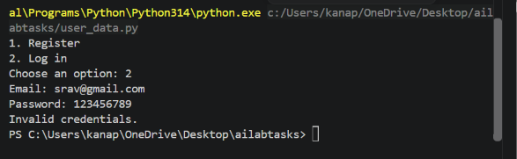

Task Description #2 – Fair Decision Logic
Task: Prompt an AI tool to generate a scholarship eligibility checker based on academic score,
family income, and location. Examine whether the logic unfairly favors or disadvantages any
group.

INPUT CODE:
academic_score = float(input("Enter academic score (0-100): "))
family_income = float(input("Enter annual family income: "))
location = input("Enter location (urban/rural): ").lower()

# Initial AI-generated decision logic
if academic_score >= 80 and family_income <= 300000:
eligible = True
elif academic_score >= 90 and location == "rural":
eligible = True
else:
eligible = False
if eligible:
print("Result: Eligible for scholarship")
else:
print("Result: Not eligible for scholarship")

OUTPUT:
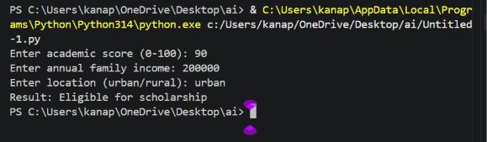

Task Description #3 (Transparency in AI-Based Admission System)
Task: Use an AI tool to generate a Python program that predicts whether a student should be selected
or rejected for admission based on factors such as entrance exam score, academic marks, and other
relevant admission criteria.

INPUT CODE:
entrance_score = float(input("Enter entrance exam score (0-100): "))
academic_marks = float(input("Enter academic marks (0-100): "))
interview_score = float(input("Enter interview score (0-100): "))

# Calculate admission score
final_score =(entrance_score * 0.5 +
academic_marks * 0.3 +
interview_score * 0.2)

if final_score >= 70:
decision = "SELECTED"
else:
decision = "REJECTED"

print("\nAdmission Decision:", decision)

OUTPUT:
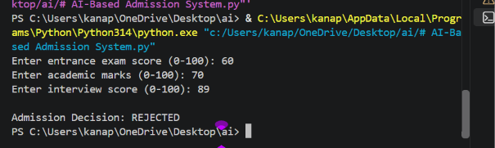

Task Description #4 – Ethical Scoring System

Task: Generate an employee performance evaluation system using inputs such as project
completion rate, teamwork score, and attendance. Analyze the scoring logic for any unethical
weighting or hidden bias.

INPUT CODE:
# Employee Performance Evaluation System

print("===== Employee Performance Evaluation =====")

# Get employee performance inputs
project_completion = float(
input("Enter project completion rate (0-100): ")
)

teamwork_score = float(
input("Enter teamwork score (0-100): ")
)

attendance = float(
input("Enter attendance percentage (0-100): ")

)

# Validate inputs
if not (0 <= project_completion <= 100 and
0 <= teamwork_score <= 100 and
0 <= attendance <= 100):
print("Error: All scores must be between 0 and 100.")
exit()

# Weights
project_weight = 0.50
teamwork_weight = 0.30
attendance_weight = 0.20

# Calculate individual contributions
project_contribution = project_completion * project_weight
teamwork_contribution = teamwork_score * teamwork_weight
attendance_contribution = attendance * attendance_weight

# Calculate final performance score
final_score = (
project_contribution +
teamwork_contribution +
attendance_contribution
)

# Determine performance level
if final_score >= 85:
rating = "Excellent"
elif final_score >= 70:
rating = "Good"
elif final_score >= 50:
rating = "Average"
else:
rating = "Needs Improvement"

# Display results
print("\n========== PERFORMANCE REPORT ==========")

print(f"Project Completion : {project_completion:.2f}")
print(f"Teamwork Score : {teamwork_score:.2f}")
print(f"Attendance : {attendance:.2f}")

print("\nWeights Used:")
print(f"Project Completion : {project_weight * 100:.0f}%")
print(f"Teamwork : {teamwork_weight * 100:.0f}%")
print(f"Attendance : {attendance_weight * 100:.0f}%")

print("\nScore Contributions:")
print(f"Project Contribution : {project_contribution:.2f}")
print(f"Teamwork Contribution: {teamwork_contribution:.2f}")
print(f"Attendance Contribution: {attendance_contribution:.2f}")

print(f"\nFinal Performance Score: {final_score:.2f}")
print(f"Performance Rating: {rating}")

print("========================================")

OUTPUT:
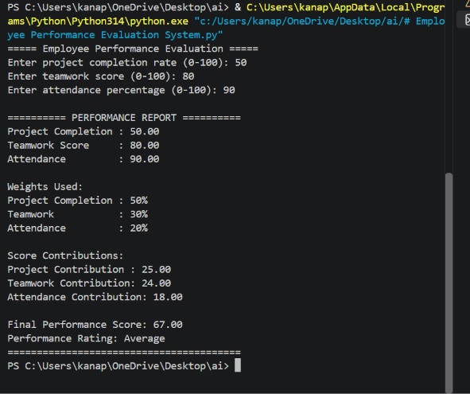

Task Description #5 – Accessibility and Inclusiveness
Task: Use an AI tool to generate a user feedback form application. Review whether the language
and options provided are inclusive and accessible to diverse users.

INPUT CODE:
# ==========================================================
# Accessible and Inclusive User Feedback Form
# ==========================================================
print("=" * 55)
print(" USER FEEDBACK FORM")
print("=" * 55)

print("\nYour feedback helps us improve our service.")
print("You may skip any question you do not wish to answer.\n")

# Name is optional
name = input("Name (optional): ").strip()

# Preferred communication language
language = input(
"Preferred language (optional): "
).strip()

# Overall satisfaction
print("\nHow satisfied are you with our service?")
print("1. Very satisfied")
print("2. Satisfied")
print("3. Neither satisfied nor dissatisfied")
print("4. Dissatisfied")
print("5. Very dissatisfied")
print("6. Prefer not to answer")

satisfaction = input("Please enter your choice (1-6): ").strip()

# Accessibility
print("\nDid you experience any difficulty using the service?")
print("1. No difficulty")
print("2. Some difficulty")
print("3. Significant difficulty")
print("4. Prefer not to answer")

difficulty = input("Please enter your choice (1-4): ").strip()

# Optional accessibility needs
print("\nWould any accessibility feature help you use the service?")
print("1. No")
print("2. Yes")
print("3. Not sure")
print("4. Prefer not to answer")

accessibility = input("Please enter your choice (1-4): ").strip()

# Open-ended feedback
print("\nWhat did you like about our service?")
liked = input("> ").strip()

print("\nWhat could we improve?")
improvements = input("> ").strip()

print("\nIs there anything else you would like us to know?")
additional_feedback = input("> ").strip()

# Display confirmation
print("\n" + "=" * 55)
print(" FEEDBACK SUMMARY")
print("=" * 55)

if name:
print(f"Name: {name}")
else:
print("Name: Not provided")

if language:
print(f"Preferred language: {language}")
else:
print("Preferred language: Not provided")

print(f"Satisfaction: Option {satisfaction}")
print(f"Difficulty experienced: Option {difficulty}")
print(f"Accessibility support needed: Option {accessibility}")

print(f"\nWhat you liked:")
print(liked if liked else "Not provided")

print(f"\nSuggested improvements:")
print(improvements if improvements else "Not provided")

print(f"\nAdditional feedback:")
print(additional_feedback if additional_feedback else "Not provided")

print("\nThank you for sharing your feedback!")
print("Your responses will help us improve the experience.")

OUTPUT: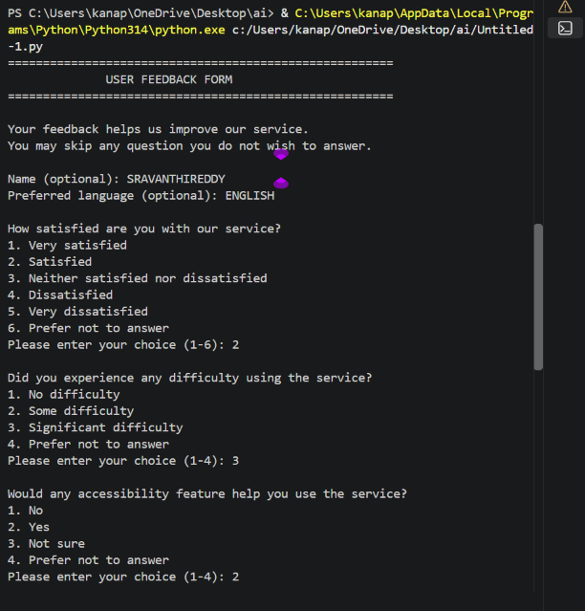
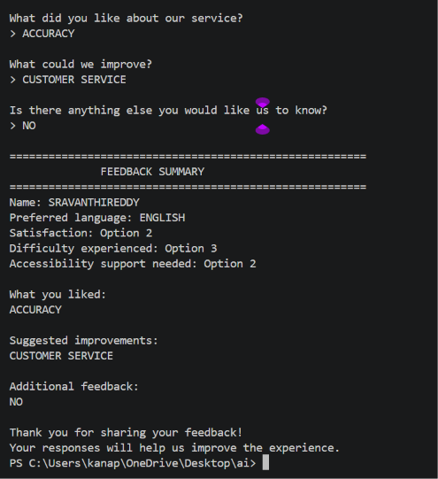

Task Description #6 (Fairness in Loan Approval System)
Task: Use an AI tool to generate a Python program that predicts whether a person should be approved
or rejected for a loan based on information such as income, age, employment status, credit score, and
loan amount.
INPUT CODE:

# ==========================================================
# BIASED LOAN APPROVAL SYSTEM - Example for Fairness Analysis
# ==========================================================

income = float(input("Enter annual income: "))
age = int(input("Enter age: "))
employment = input("Enter employment status: ").lower()
credit_score = int(input("Enter credit score: "))
loan_amount = float(input("Enter requested loan amount: "))

# Sensitive attributes
gender = input("Enter gender: ")
religion = input("Enter religion: ")
race = input("Enter race: ")

# BAD PRACTICE:
# Sensitive attributes are being used in the decision.
if (
income >= 500000
and credit_score >= 700
and employment == "employed"
and gender.lower() == "male"
and religion.lower() != "minority"
):
decision = "APPROVED"
else:
decision = "REJECTED"

print("\nLoan Decision:", decision)

OUTPUT:
