1. Frontend goals and technology
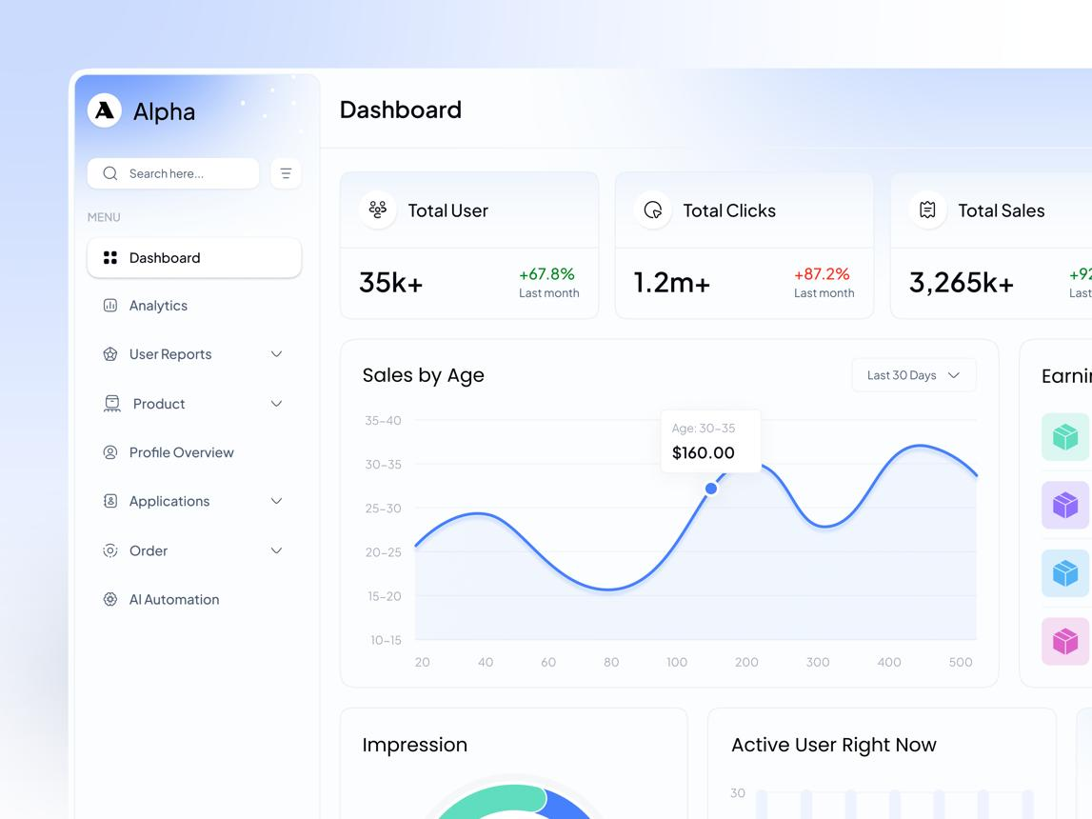
Design direction
Modern, minimal, professional, and security-focused. Use a light theme with a restrained navy or indigo accent, neutral backgrounds, clear typography, and consistent spacing.
Area | Proposed choice
Frontend | React + TypeScript
Build tool | Vite
Styling | Tailwind CSS or CSS modules
UI components | Reusable components with a consistent design system
Icons | Lucide React
API communication | Axios or Fetch with a centralized API layer
Server state | TanStack Query
Forms | React Hook Form + schema validation
Routing | React Router
Authentication | Backend-managed session or token flow, finalized with backend design
Testing | Vitest, React Testing Library, Playwright
The frontend should not decide who is authorized to access company information. It can hide unavailable actions and guide users, but the backend must enforce every permission.

2. Main application layout
SecureAI
WORKSPACE
Overview
Projects
Work updates
People
Documents
AI Assistant
SETTINGS
Settings
Good morning, Varshitha
Your workspace at a glance.
Active projects

—
Pending reviews

—
Recent updates

—
Documents

—
Recent activity
Updates and tasks will appear here.
Conceptual layout preview. The actual dashboard will use live data and adapt to the signed-in user's permissions.
Primary navigation
- Overview
- Projects
- Work updates
- People
- Documents
- AI Assistant
- Notifications
- Settings
The sidebar should be collapsible on desktop and become a drawer or bottom navigation on smaller screens. Administrative sections such as user management and access controls should appear only to users with the relevant permissions.

3. Screens and modules
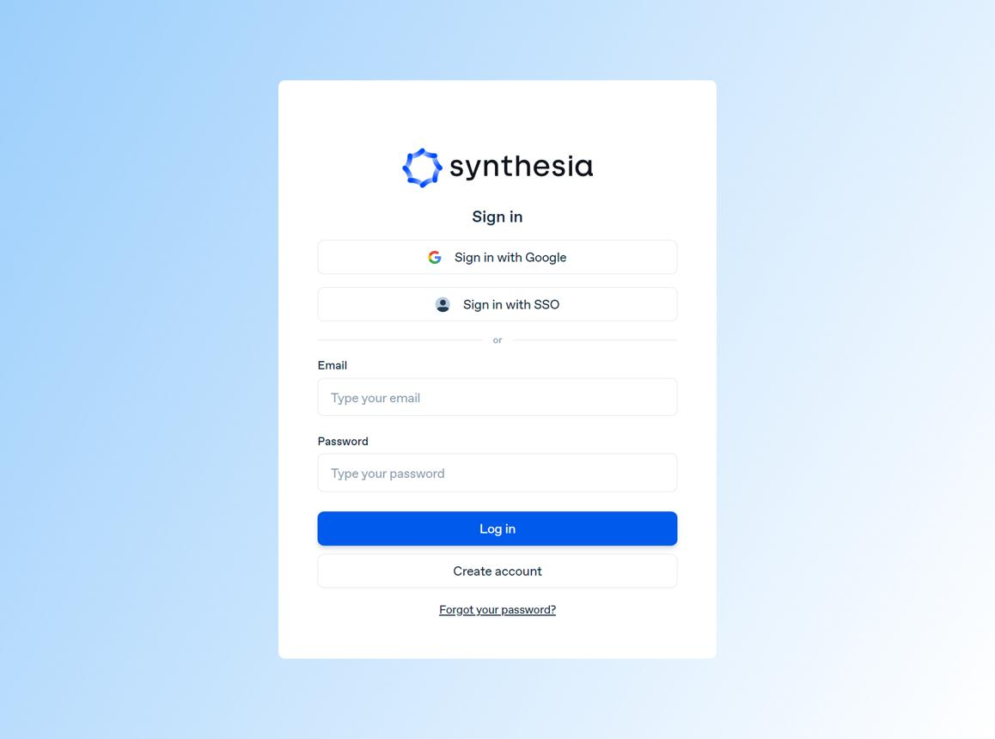
1. Authentication
- Sign in and sign out.
- Forgot-password and password-reset screens.
- Session-expired and unauthorized states.
- Optional invitation acceptance flow.
- Clear errors without revealing whether a private account exists.
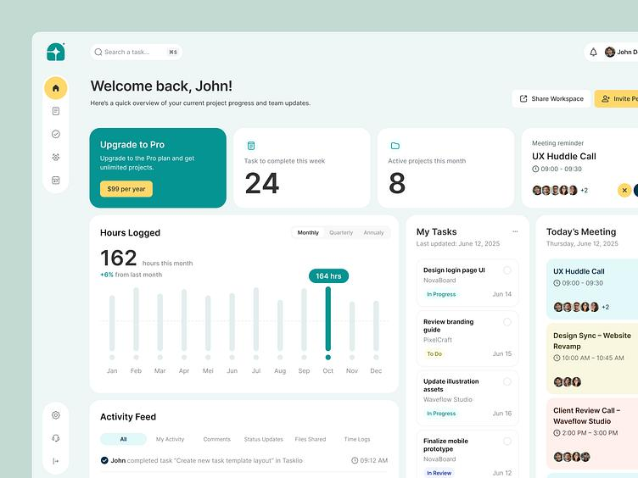
2. Overview dashboard
- Personal work summary.
- Assigned tasks and recent updates.
- Pending approvals for leads.
- Recently accessed projects and documents.
- AI Assistant entry point.
The dashboard should be role-aware without creating separate, duplicated applications.
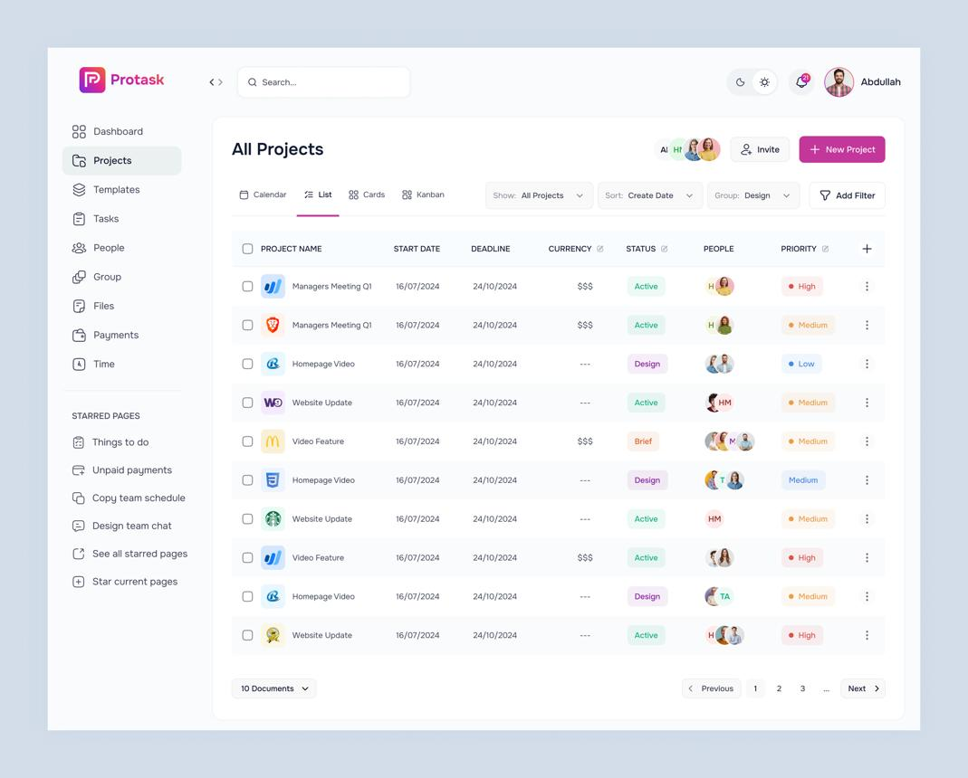
3. Projects
- Project list with search and filters.
- Project overview, members, and activity.
- Related tasks and documents.
- Project access and membership management for authorized users.
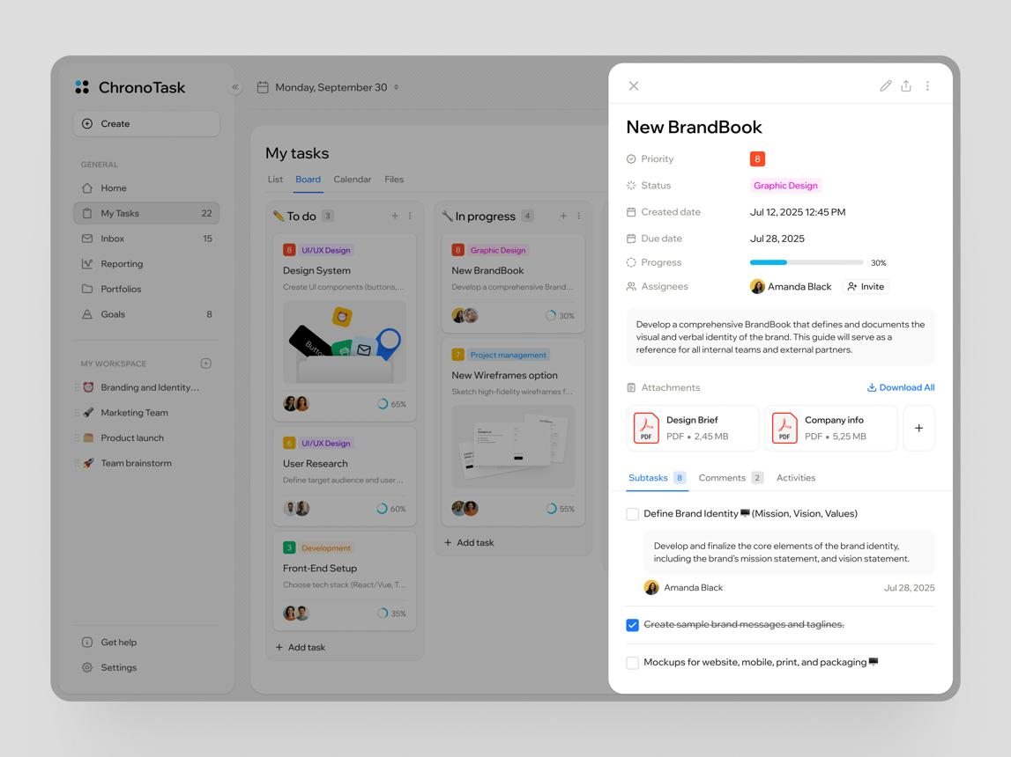
4. Work updates and reviews
- Assigned work and task details.
- Submit progress updates.
- Submit completed work for review.
- Lead review queue with approve or request-changes actions.
- Work history and status tracking.
A completed submission should not appear as finally approved until the backend confirms approval.
5. People and profiles
- Employee directory with permitted profile fields.
- Profile details and team/project memberships.
- Edit profile screens based on field-level permissions.
- Separate restricted information views for authorized users.
Sensitive profile fields should not be fetched merely because the UI hides them.
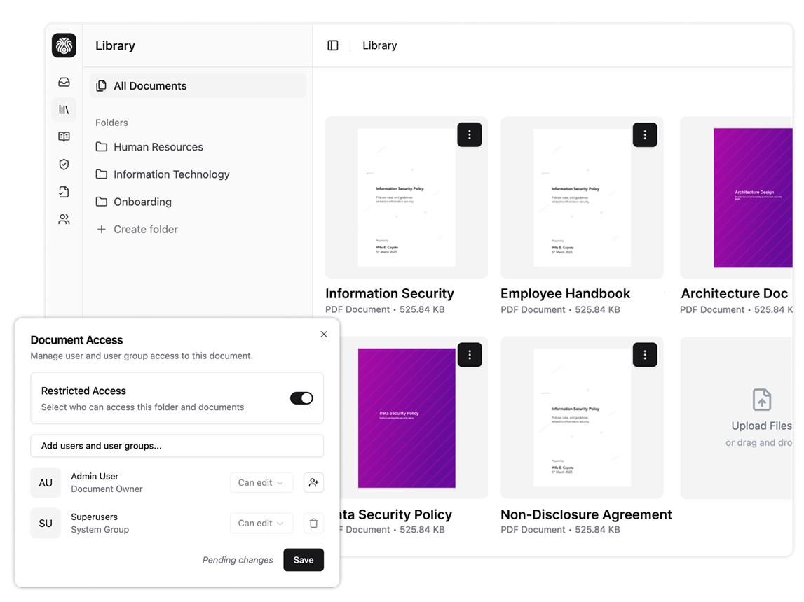
6. Document management
- Document list, search, and filters.
- Upload and processing status.
- Document details, versions, and access information.
- Grant or revoke access for authorized users.
- Clear states for processing failures and unavailable documents.
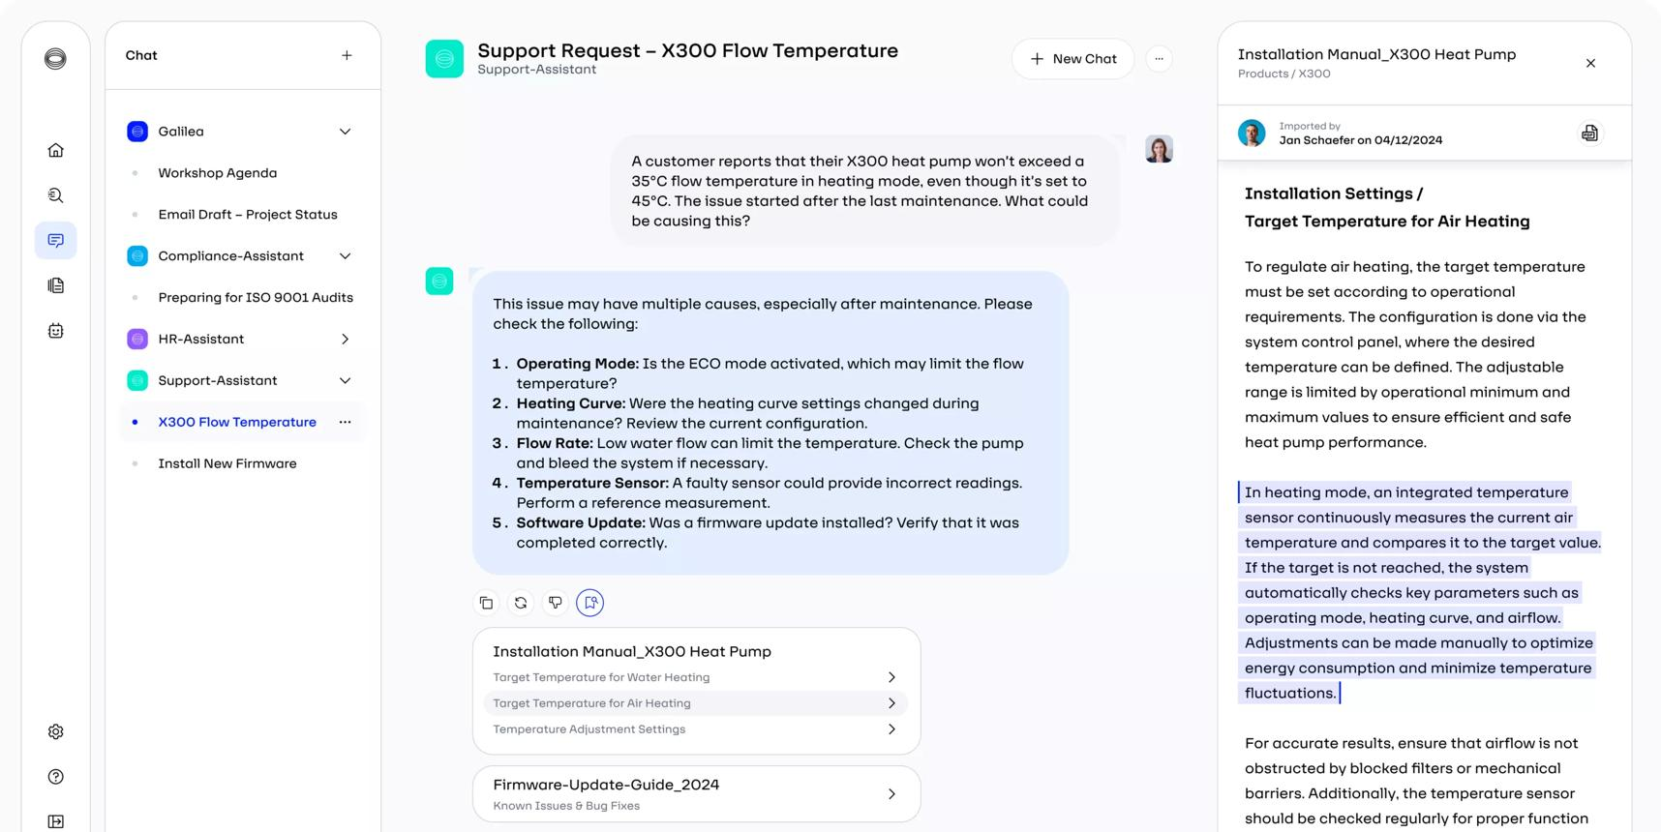
7. AI Assistant
- Chat interface with conversation history.
- Suggested example questions.
- Streaming or loading response state, depending on backend support.
- Source citations linked to authorized documents or sections.
- Feedback controls and report-an-answer action.
- Clear “I couldn't find enough information” responses.
Citations and saved conversations must be checked against current permissions, not just permissions at the time the answer was created.
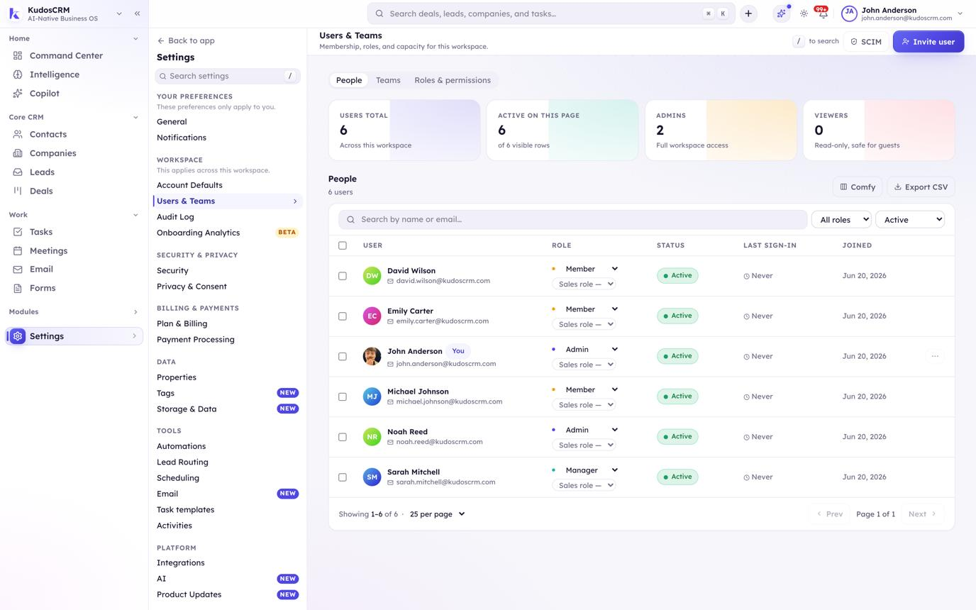
8. Administration and settings
- User invitations and membership management.
- Roles and permissions.
- Document access administration.
- Audit and security event views for authorized administrators.
- Workspace settings and account preferences.

4. User journeys
User | Main journey
Employee | Sign in → view dashboard → open assigned work → submit update → find permitted documents → ask AI questions
Lead | Sign in → review team activity → assign or manage work → review submissions → access permitted project information
Admin | Manage users and roles → configure access → manage workspace resources → review audit/security information
AI user | Ask a question → retrieve authorized information → read answer and citations → open permitted source → revisit saved conversation
The UI should show clear loading, empty, success, error, and access-denied states throughout these journeys.

5. Frontend architecture
Organize the code by feature so the application stays maintainable as new modules are added.
frontend/
├── public/
├── src/
│ ├── app/
│ │ ├── router.tsx
│ │ ├── providers.tsx
│ │ └── queryClient.ts
│ ├── components/
│ │ ├── layout/
│ │ ├── ui/
│ │ ├── feedback/
│ │ └── data-display/
│ ├── features/
│ │ ├── auth/
│ │ ├── dashboard/
│ │ ├── projects/
│ │ ├── work-updates/
│ │ ├── people/
│ │ ├── documents/
│ │ ├── assistant/
│ │ ├── notifications/
│ │ └── administration/
│ ├── services/
│ │ ├── api/
│ │ └── auth/
│ ├── hooks/
│ ├── types/
│ ├── utils/
│ ├── styles/
│ └── main.tsx
├── tests/
├── .env.example
├── package.json
└── vite.config.ts
Important architectural choices
- Keep each feature's pages, components, hooks, API functions, and types close together.
- Use shared components for tables, forms, dialogs, alerts, empty states, and page headers.
- Keep API calls out of visual components. Feature-specific API functions should use a centralized API client.
- Use TanStack Query for server data, caching, and invalidation.
- Keep local UI state—such as an open menu or selected tab—inside the relevant components.
- Avoid putting all application data into one large global state store.

6. Route plan
Route | Screen | Access
/login | Sign in | Public
/forgot-password | Password recovery | Public
/ | Overview | Authenticated
/projects | Project list | Authenticated, scoped
/projects/:id | Project details | Authorized members
/work | Work updates | Authenticated, scoped
/work/:id | Work detail | Authorized users
/reviews | Review queue | Users with review permission
/people | Employee directory | Authenticated, scoped
/people/:id | Employee profile | Authorized fields only
/documents | Document library | Authenticated, scoped
/documents/:id | Document details | Authorized users
/assistant | AI chat | Authenticated
/assistant/:id | Saved conversation | Authorized conversation owner or permitted user
/settings | Account settings | Authenticated
/admin/users | User management | Admin permission
/admin/access | Access management | Admin permission
/admin/audit | Audit events | Specific audit permission
Use route guards for navigation and experience, but do not treat them as security controls. Every API endpoint must independently check access.

7. Design system
Define the design system before building every page separately.

Proposed visual tokens
Primary
#294B83
Accent
#5276B8
Page background
#F6F8FB
Surface
#FFFFFF
Main text
#1F2937
Muted text
#64748B
Reusable UI elements
- Buttons: primary, secondary, destructive, text.
- Inputs: text, password, search, select, date, file upload.
- Status labels: pending, in progress, approved, rejected, failed.
- Layout: page header, sidebar, top bar, content container.
- Data display: table, list, cards, pagination, filters.
- Feedback: toast, alert, confirmation dialog, skeleton, empty state.
Use a consistent spacing scale, readable font sizes, keyboard-accessible controls, visible focus indicators, and responsive layouts. Status should never be communicated through color alone.

8. API integration and frontend security
The frontend should be designed around the backend API contract rather than making assumptions about response shapes.
Integration rules
- Centralize the API base URL and request configuration.
- Define TypeScript types for API requests and responses.
- Handle authentication expiry and permission errors consistently.
- Invalidate relevant cached data after updates, approvals, membership changes, and access changes.
- Show user-friendly messages while keeping technical details in logs where appropriate.
- Use pagination and server-side filtering for large datasets.
- Upload files through backend-controlled endpoints or short-lived upload authorization.
Security requirements
- Never store database credentials, LLM provider keys, or privileged secrets in frontend code.
- Do not rely on hidden buttons or client-side role checks to protect data.
- Avoid persisting sensitive API responses in browser storage.
- Recheck access when opening documents, viewing citations, and loading saved AI conversations.
- Handle logout and session expiration by clearing sensitive cached data.
- Sanitize or safely render AI-generated Markdown and document previews.
- Avoid exposing private document content in URLs, browser logs, analytics, or error messages.

9. Implementation phases
- Phase 1 — Foundation
Set up React, TypeScript, Vite, routing, design tokens, shared components, API client, and the main application shell.
Deliverable: a navigable interface with placeholder pages and responsive layout.
- Phase 2 — Authentication and access-aware navigation
Integrate login, session handling, route states, account settings, and permission-aware navigation.
Deliverable: authenticated users see the appropriate application areas.
- Phase 3 — Core workspace
Build dashboard, projects, work updates, reviews, people, and document screens.
Deliverable: employees and leads can complete the main work-management flows.
- Phase 4 — AI Assistant
Build chat history, question input, response rendering, citations, feedback, and saved conversations.
Deliverable: users can ask questions and inspect the sources they are authorized to access.
- Phase 5 — Administration
Add user management, access configuration, and permitted audit views.
Deliverable: authorized administrators can manage the workspace through the UI.
- Phase 6 — Quality and release
Test responsive behavior, accessibility, permission edge cases, error states, API failures, and critical user journeys.
Deliverable: a release-ready frontend integrated with the backend.

10. Testing plan
Test area | What to verify
Component tests | Forms, tables, dialogs, navigation, and feedback states
API integration | Loading, successful responses, validation errors, and server errors
Access behavior | Unauthorized actions are unavailable in the UI and rejected by the backend
AI interface | Citations, long answers, empty results, failures, and saved chats
File handling | Upload progress, unsupported files, processing errors, and access-denied states
Responsive design | Desktop, tablet, and mobile layouts
Accessibility | Keyboard navigation, labels, contrast, focus, and screen-reader behavior
End-to-end | Login → submit work → review → upload document → ask AI
Include specific negative tests—for example, a user who loses document access should no longer be able to open its citation from an old AI conversation.

11. Decisions to finalize before development
These are the main UI and frontend choices that still need confirmation during design review:
- Visual style: light-only initially or light and dark themes.
- Navigation: fixed sidebar or collapsible sidebar as the desktop default.
- Dashboard: personal work summary as the default landing page, with lead/admin-specific sections.
- AI experience: dedicated full-page chat or a persistent assistant panel available across the workspace.
- Mobile scope: responsive web experience for all modules or a limited mobile workflow initially.
- Authentication: exact session and login behavior based on the backend security design.
- Design fidelity: build directly from the proposed design system or create detailed screen mockups first.
Recommended next step: review this plan and finalize the navigation, dashboard, and AI Assistant layout first. Those three decisions establish the core experience and reusable layout patterns for the rest of the frontend.

