Create a database by name employee
Query:
use employee
Output:
switched to db employee

Question 2

Create a collection by name employee_info
Query:
db.createCollection("employee_info")
Output:
{ ok: 1 }

Question 3

Insert values into the collection (Batch Insert)
Query:
db.employee_info.insertMany([
{ Emp_Id: 120, Emp_Name: "Asha", Designation: "Manager", Date_Of_Joining: ISODate("2021-04-01"), Salary: 30000, Dept_Name: "CSE" },
{ Emp_Id: 121, Emp_Name: "Kiran", Designation: "Emp", Date_Of_Joining: ISODate("2019-04-20"), Salary: 20000, Dept_Name: "CSE" },
{ Emp_Id: 122, Emp_Name: "Tarun", Designation: "Emp", Date_Of_Joining: ISODate("2019-05-01"), Salary: 22000, Dept_Name: "CSE" },
{ Emp_Id: 123, Emp_Name: "Samarth", Designation: "Emp", Date_Of_Joining: ISODate("2020-08-01"), Salary: 22500, Dept_Name: "CSE" },
{ Emp_Id: 124, Emp_Name: "Rohan", Designation: "Emp", Date_Of_Joining: ISODate("2019-06-01"), Salary: 21000, Dept_Name: "CSE" }
])
Output: 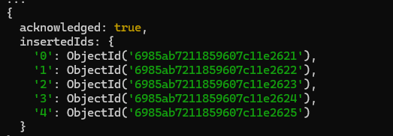

Question 4

Update Employee Name & Department of Emp_Id = 121
Query:
db.employee_info.updateOne(
{ Emp_Id: 121 },
{ $set: { Emp_Name: "David", Dept_Name: "ECE" } }
)
Output:
{ acknowledged: true, matchedCount: 1, modifiedCount: 1 }

Question 5

Sort Employee Records Based on Salary (Ascending)
Query:
db.employee_info.find().sort({ Salary: 1 })
Output:
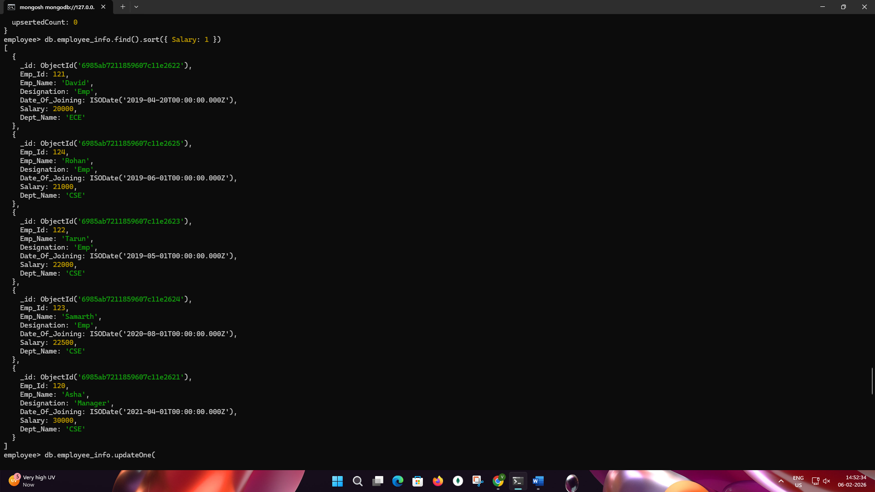

Question 6 & 7

Add & Update Projects Field
Queries:
db.employee_info.updateOne({ Emp_Id: 120 }, { $set: { Projects: ["Research"] } })
db.employee_info.updateOne({ Emp_Id: 121 }, { $set: { Projects: ["Reporting"] } })
db.employee_info.updateOne({ Emp_Id: 122 }, { $set: { Projects: ["Data Analysis"] } })
db.employee_info.updateOne({ Emp_Id: 123 }, { $set: { Projects: ["Data Migration"] } })
db.employee_info.updateOne({ Emp_Id: 124 }, { $set: { Projects: ["Research"] } })

Output

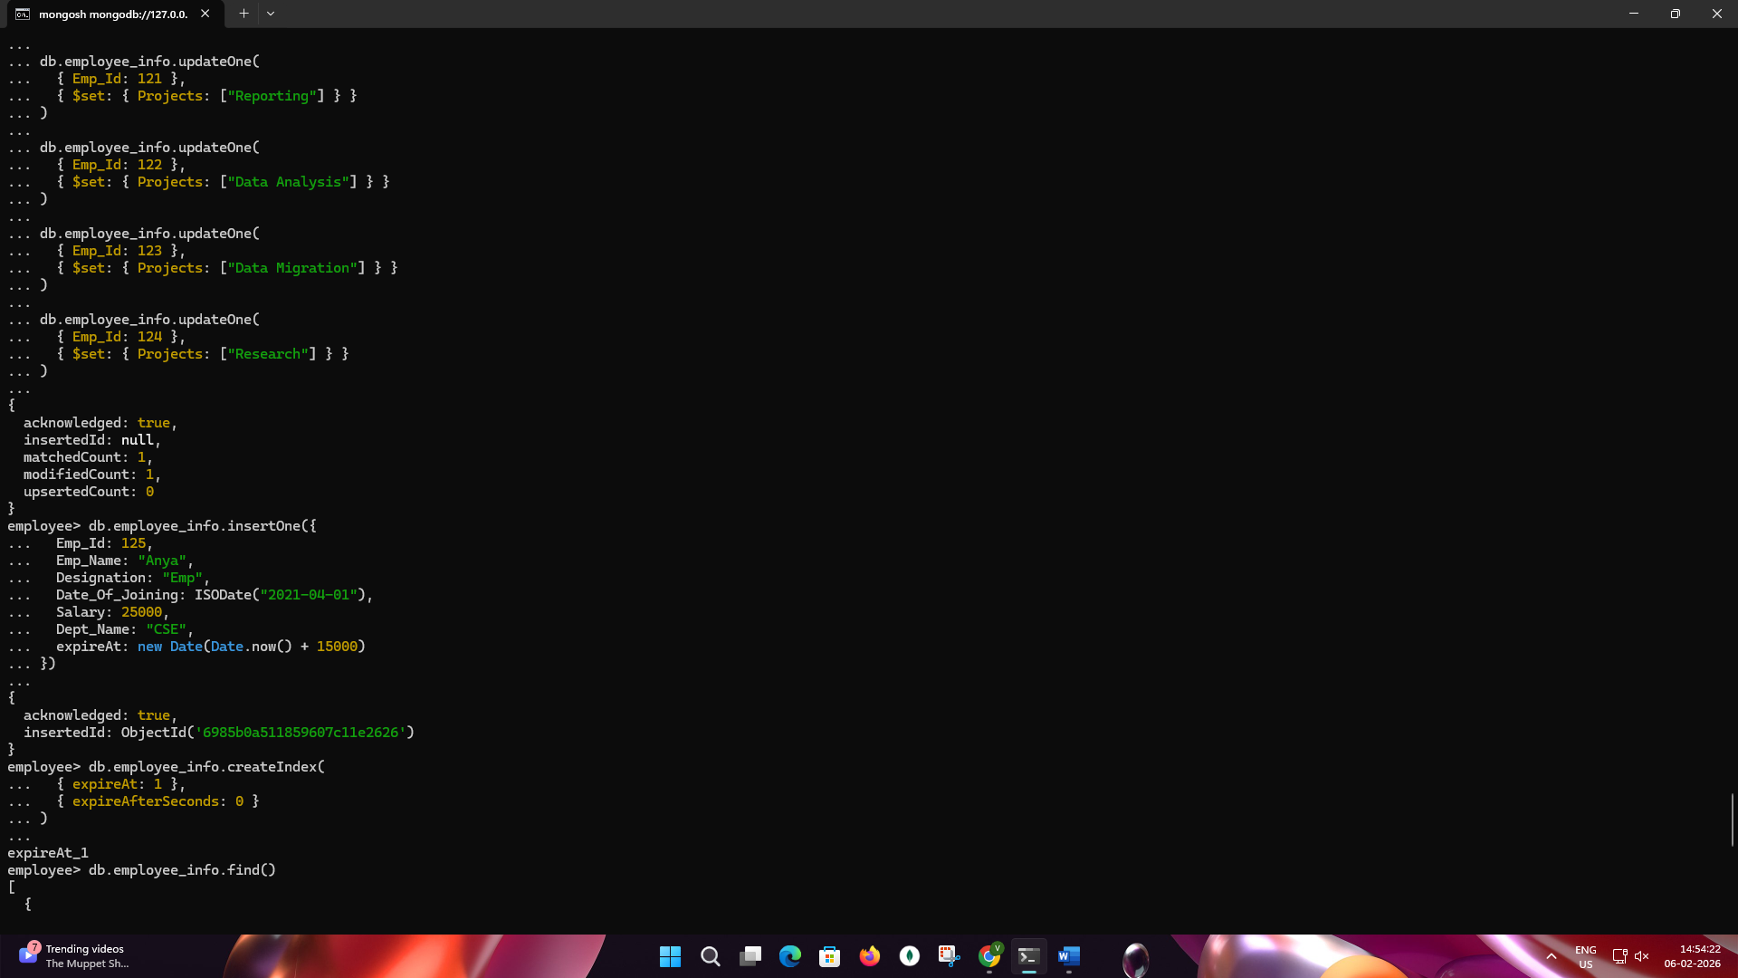

Question 8

Insert Record with TTL = 15 Seconds
Query:
db.employee_info.insertOne({
Emp_Id: 125,
Emp_Name: "Anya",
Designation: "Emp",
Date_Of_Joining: ISODate("2021-04-01"),
Salary: 25000,
Dept_Name: "CSE",
expireAt: new Date(Date.now() + 15000)
})
db.employee_info.createIndex({ expireAt: 1 }, { expireAfterSeconds: 0 })
Output:

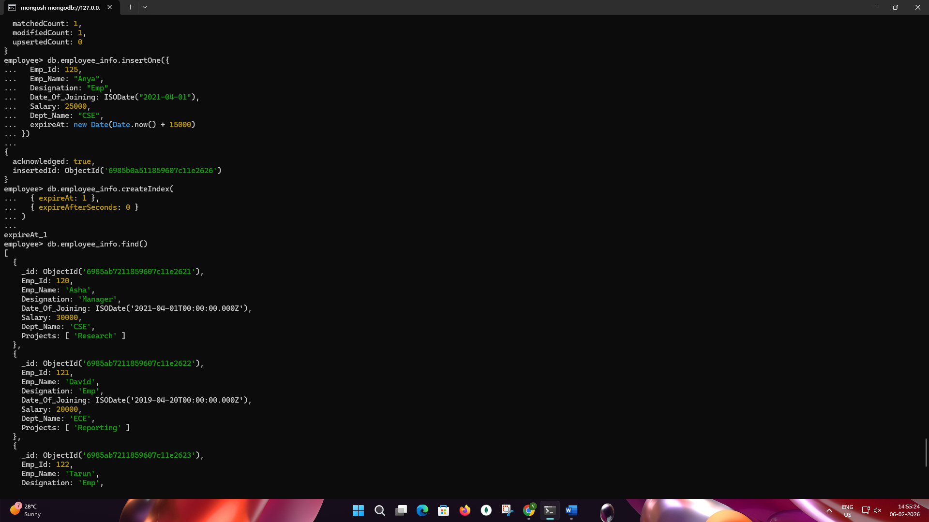

db.employee_info.find()

