**DBMS LAB-3:**

**TABLE BRANCH:**

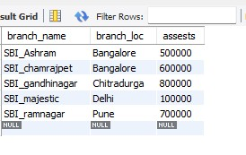

**TABLE BANKACCOUNT:**

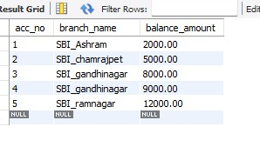

**TABLE DEPOSIT:**

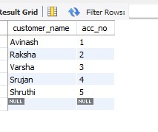

**TABLE BANKCUSTOMER:**

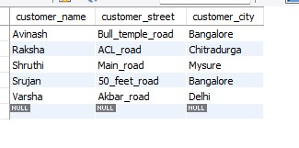

**TABLE BANKLOAN:**

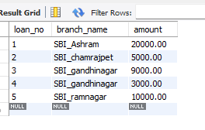

**QUERIES:**

**1.creating a View**

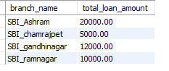

**2.display a branch name and assests from all branches in lakhs**

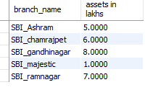

**3.Update the balance of all accounts by 5%**

**4.** **SELECT branch_name**

**FROM Branch**

**WHERE assests > ALL (**

**SELECT assests FROM Branch WHERE branch_loc = 'Bangalore'**

**);**

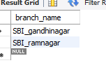

**5.** **DELETE FROM Bankaccount**

**WHERE branch_name IN (**

**SELECT branch_name FROM Branch WHERE branch_loc = 'Bombay'**

**);**

**OUTPUT:**

**No rows affected**