TEMPLE RUN
Volcano Island Endless Runner
TECHNICAL PROJECT DOCUMENTATION
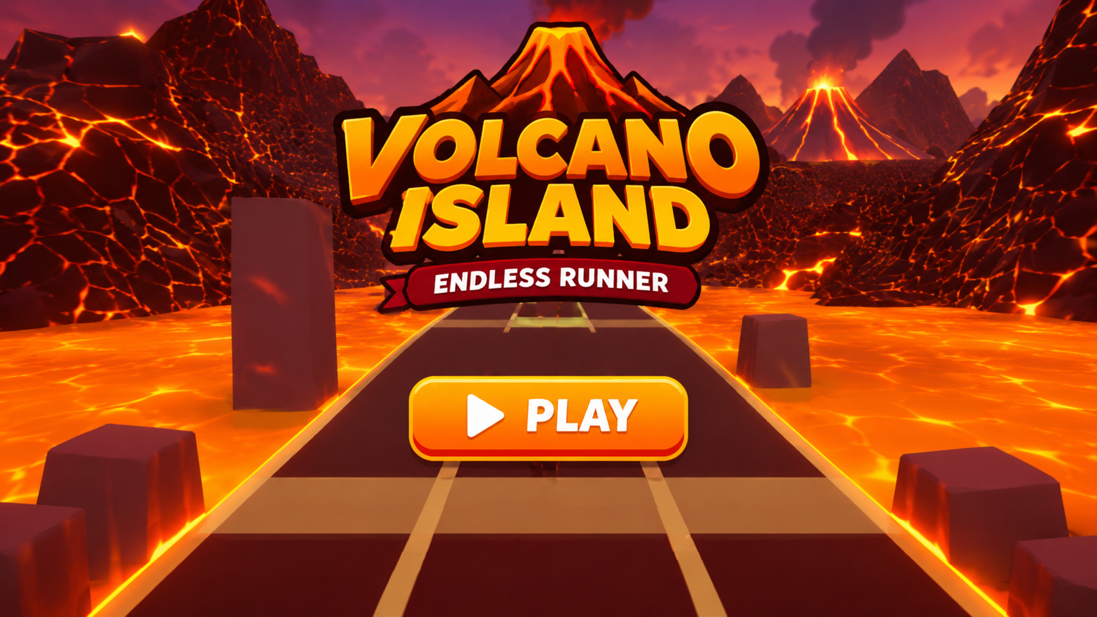
City Runner – title screen
Student Name: D. Varshitha
Roll Number: 2303A52268
Project Guide: Dr. VIJAYA CHANDRA JADALA
Developed using Unity 6.6

1. INTRODUCTION AND PROJECT OVERVIEW

ABSTRACT AND PROJECT OVERVIEW AND GAME CONCEPT

This report documents Volcano Temple Run, a three-dimensional endless runner game developed in Unity 6 (6000.5, Universal 3D / URP template). The project places a third-person character on a narrow stone path running through a volcanic landscape. The player moves forward automatically, changes between three lanes, jumps, slides, collects coins and avoids obstacles.

The submitted C# source files provide the technical basis for this report. They include CameraFollow, GameManager, PlayerController, Tile and TileSpawner. The scripts collectively implement camera following and eruption shake, score and game-state management, player movement and input, collision handling, collectibles, random obstacle selection and the recycling of path tiles.

The game includes a gameplay HUD and a Game Over screen. The HUD displays the distance score and the coin count. The Game Over panel displays the final score, the best score and a Restart button. The GameManager stores the best score using PlayerPrefs. Background music is played by an Audio Source component on a MusicPlayer object in the scene.

The report explains the actual supplied implementation. Where a behaviour comes from scene setup in the Unity editor (for example lighting, fog, bloom, particle systems, materials and the volcano backdrop) rather than from the scripts, it is described as an editor-configured feature and not as a code feature.

Game concept and genre

Volcano Temple Run follows the endless-runner genre. The player character advances along a route without manually controlling forward movement. The main challenge is to choose a safe lane and use jump or slide actions at the correct time. The route contains three lanes separated by a fixed horizontal distance (3 units in PlayerController).

The visual setting is a volcanic temple corridor. The screenshots show a dark stone path with glowing lava on both sides, a red-orange sky, a volcano in the distance, and embers in the air. Coins and obstacles are positioned ahead of the player. The camera is placed behind and above the character so that the upcoming route remains visible.

The game is designed around repeated short decisions: move left or right, jump, slide, collect a coin, or avoid a hazard. Forward speed starts at 10 and increases by 0.15 per second until it reaches the maximum of 30, so later gameplay is faster than the initial part of a run.

Gameplay flow

During a run, the score (distance in metres) and the coin count are shown at the top of the screen. When the player touches an obstacle, or falls below the path, the game enters the Game Over state. The final score is calculated as distance plus ten points per coin. The Game Over panel shows this run score and the best score, and the Restart button reloads the scene.

PROBLEM STATEMENT AND PROJECT OBJECTIVES AND SCOPE AND PROJECT BOUNDARIES

The project problem is to implement an interactive 3D runner in which continuous forward movement is combined with lane navigation, jumping, sliding, obstacle collision, coin collection and score feedback. The implementation must also manage active gameplay, the end-of-run state and the restart operation.

Objectives of the project:

Create a three-lane running experience with a third-person player character.

Increase forward speed gradually while respecting a maximum speed.

Support left/right lane changes, jumping and sliding through keyboard input, with touch-swipe input also implemented in the script.

Generate track tiles ahead of the player and reuse old tiles behind (object pooling).

Populate tiles with a stone ground, lava rivers, stone walls and pillars, coins and four random obstacle patterns.

Track distance score, coins and best score, and display the relevant information.

Create a volcanic theme using skybox, fog, lighting, emissive lava, Bloom and particle effects.

Provide camera-follow behaviour with a periodic eruption shake.

Show a gameplay HUD and a Game Over screen with a Restart button.

The confirmed scope is based on the five C# files (CameraFollow, GameManager, PlayerController, Tile and TileSpawner) and the supplied game screenshots. The report covers the behaviour directly represented in those files: player movement, camera behaviour, tile creation and reuse, coin collection, obstacle handling, score management and UI presentation.

The PlayerController uses the Unity CharacterController component. It accepts A/Left Arrow and D/Right Arrow for lane changes; Space, W or Up Arrow for jumping; and S or Down Arrow for sliding. Swipe input is also handled through Unity’s touch input (a swipe left or right changes lane, up jumps, and down slides). After Game Over, the player presses the on-screen Restart button, which reloads the scene through the GameManager.

The supplied scripts do not include a title screen, a separate settings screen, online services, multiplayer, cloud saving or power-ups (magnet, shield, double score). The game also does not implement 90-degree turns. There is no dedicated character animation script. The PlayerController has an optional Animator field that triggers Jump, Slide and Die only if an Animator is assigned. These boundaries are stated to avoid claiming features that are not established by the source.

The Unity Editor screenshot shows a MusicPlayer object with an Audio Source component in the scene hierarchy. Background music is played by this component with Loop enabled, and it is not controlled by any script. The game does not generate sound effects in code.

The visual theme (sky, fog, lighting, lava glow, Bloom, ember and smoke particles, walls, pillars and the volcano backdrop) is configured in the Unity Editor and not in the scripts. The best score is stored using PlayerPrefs under the key “BestScore”, and the final score is calculated as distance plus ten points per coin.

DEVELOPMENT TOOLS AND TECHNOLOGY AND HARDWARE AND SOFTWARE REQUIREMENTS
The exact computer specifications used to build the project are not recorded in the supplied files. The table below records the software evidence from the Unity Editor screenshots and practical development guidance, not an assertion about the student’s own computer.
Category | Requirement / evidence
Engine | Unity 6.5 (6000.5.9f1)
Render pipeline | Universal Render Pipeline (URP), Universal 3D template
Graphics API | DirectX 11 (shown in the Editor title bar)
Language | C#
Input | Legacy Input Manager API (Active Input Handling set to Both)
UI | Canvas with TextMeshPro
Effects | Particle System, Global Volume with Bloom, fog, skybox material
Audio | Audio Source component with a looping music clip
Storage | PlayerPrefs best score
Scene reload | Unity SceneManager
Platform | Windows desktop (Windows, Mac, Linux build target)

The project is shown running in Unity 6.5, editor version 6000.5.9f1. The project was created from the Universal 3D template, so the Universal Render Pipeline (URP) is the rendering pipeline in use. URP provides the lighting, fog, emissive materials and Bloom post-processing used for the volcano theme.
C# is used for gameplay logic. UnityEngine provides the core classes for GameObjects, transforms, vectors, physics components, time, input, materials and scene behaviour. UnityEngine.SceneManagement is used by GameManager to reload the active scene when the Restart button is pressed. TextMeshPro (TMPro) is used by GameManager to display the score, coin count and Game Over information. The Tile Spawner script uses a List collection to track the active tiles for object pooling.
PlayerPrefs is used to read and write the best score under the key BestScore. The PlayerController script uses the Unity CharacterController component for movement and gravity, and an optional Animator reference to trigger Jump, Slide and Die animations only if an Animator is assigned.
Unity’s built-in Input Manager API is used through Input.GetKeyDown for keyboard controls, and Input.GetTouch for swipe controls. In Unity 6, the new Input System is the default, so the project setting Active Input Handling was changed to Both to allow the legacy Input class to work. The project should therefore be treated as using the legacy input path until a migration to the new Input System is completed.
The volcano theme is configured in the Unity Editor and not in the scripts. It uses a procedural skybox material, fog, a directional light, an emissive lava material, a Global Volume with Bloom, and Particle Systems for embers and smoke.
The exact computer specifications used to build the project were not included in the supplied files. The following describes practical development requirements rather than claiming the student’s machine has these exact specifications.
Software evidence: Unity 6.5 (6000.5.9f1), URP (Universal 3D template), C# scripts, TextMeshPro, Windows desktop editor screenshots, and Unity’s legacy Input Manager API. A code editor such as Visual Studio or Visual Studio Code is required to edit the C# source files.
Hardware guidance: a modern 64-bit multi-core CPU, 8 GB RAM minimum (16 GB recommended for editor comfort), a graphics processor compatible with DirectX 11, keyboard and mouse, and sufficient free disk space for Unity and the project assets.
Runtime performance depends on the target computer, scene complexity, particle counts, material counts, quality settings and frame-rate configuration. During development, the Unity Editor lagged when large particle systems were active, so the particle counts were reduced. No benchmark or measured FPS result was recorded, so this report does not state a measured performance figure
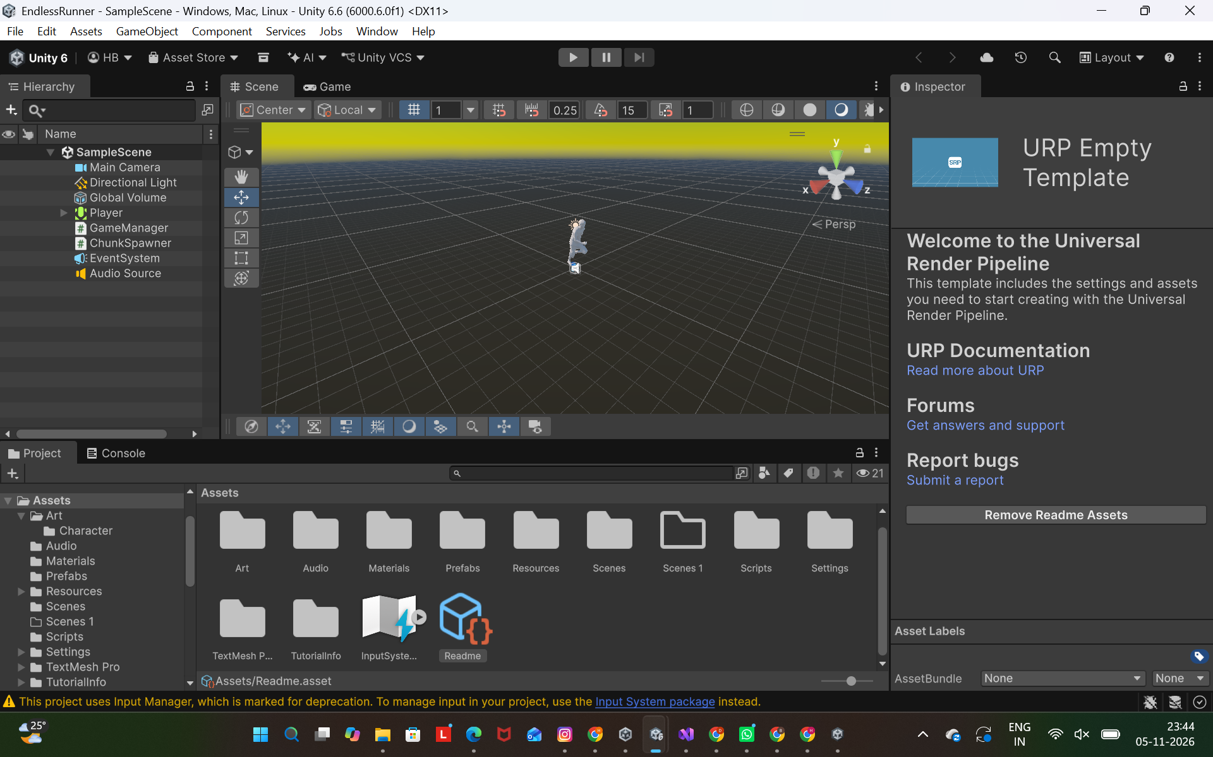
Figure: Unity 6.6 Editor

FUNCTIONAL REQUIREMENTS AND NON-FUNCTIONAL REQUIREMENTS AND CONSTRAINTS

Functional requirements

FR-01: Start the run automatically when the game scene loads (GameManager sets the game state to playing in Start).
FR-02: Move the player forward automatically while gameplay is active.
FR-03: Increase forward speed over time from 10 up to maxSpeed (30).
FR-04: Allow lane changes using A/Left Arrow and D/Right Arrow, or a left/right swipe on a touch screen.
FR-05: Allow jumping using Space, W or Up Arrow, or an upward swipe, while grounded.
FR-06: Allow sliding using S or Down Arrow, or a downward swipe, while grounded.
FR-07: Collect objects tagged Coin, increase the coin count, and disable the collected coin.
FR-08: Detect collisions with objects tagged Obstacle and end the run.
FR-09: End the run if the player falls below the path (Y position below -6).
FR-10: Generate path tiles ahead of the player and reuse the tiles behind it, with one of four obstacle patterns chosen randomly each time.
FR-11: Display the distance score and the coin count during play.
FR-12: Calculate the final score as distance plus ten points per coin, and save a new best score using PlayerPrefs.
FR-13: Show a Game Over panel with the final score and best score, and allow restart using the Restart button.
FR-14: Shake the camera periodically to represent a volcano eruption.

Non-functional requirements

Usability: the score, coin counter and Game Over information should be readable during play. The supplied screenshots show these labels in white text on the game view. The controls are simple: three lanes, one jump and one slide, so a new player can learn the game quickly.

Maintainability: gameplay responsibilities are separated into named scripts. PlayerController handles movement, input and player collision events. GameManager handles run state, speed, score and the Game Over panel. TileSpawner handles tile reuse. Tile controls the obstacle patterns and coins of one tile. CameraFollow handles camera positioning and the eruption shake. Tiles are stored as a prefab, so a change in the prefab applies to every tile in the game.

Reliability: the player does not respond to movement input after Game Over, because PlayerController checks GameManager.Instance.isPlaying before it moves. GameManager also ignores repeated GameOver calls once the run has stopped, so the best score is saved only once per run. Time.timeScale is reset to 1 when the scene loads, so a restarted game always runs at normal speed.

Performance: the path uses object pooling with only six tiles, so the game does not create and destroy objects continuously. Large particle systems made the Unity Editor lag during development, so the maximum particle counts for the ember and smoke effects were reduced. No measured frame-rate result was recorded.

Constraints

Constraints visible in the code and project setup:

TileSpawner expects a non-empty tilePrefabs array and a valid Player Transform assigned in the Inspector.

Each Tile expects its obstaclePatterns array and its coinGroup to be assigned. Coins and obstacles must have trigger colliders and the correct tags (Coin and Obstacle), and these tags must be created in the project.

GameManager expects the Player Transform, the score, coin and Game Over text references, and the Game Over panel to be assigned in the Inspector. A missing reference causes an error when the game starts.

The legacy Input class is used, so the project setting Active Input Handling must be set to Both in Unity 6.

The lane positions are fixed at 3 units apart, so the obstacle and coin positions in the tile prefab must match these lanes.

The Restart button must be connected to GameManager.Restart in its OnClick list, and the scene must be added to the Build Profile for the built game to restart correctly.

The scripts do not include a title screen, power-ups, an R key restart or sound effects generated in code. The volcano theme (sky, fog, lighting, lava glow, Bloom, particles) is configured in the Unity Editor and not in the scripts.

2. DEVELOPMENT ENVIRONMENT AND REQUIREMENTS

SYSTEM ARCHITECTURE

The system is divided into player control, world generation, game management and presentation. The modules communicate through component references and the static GameManager instance.
Module | Responsibility | Connection
PlayerController | Input, movement, jump, slide and collision | Reads speed from GameManager, calls AddCoin and GameOver
GameManager | State, speed, score, coins, best score and Game Over UI | Called by PlayerController, restarts the scene
TileSpawner | Tile lifecycle (object pooling) | Instantiates six tiles and reuses them
Tile | Obstacle patterns and coins of one tile | Randomised by TileSpawner
CameraFollow | Follow and eruption shake | Uses the player Transform as target

The project can be understood as four cooperating layers. The input and player layer reads keyboard and touch input and moves the CharacterController. The world-generation layer positions tiles ahead of the player and randomises the obstacles and coins on each tile. The game-management layer tracks run state, speed, score, coins and the best score. The presentation layer follows the player with the camera, shakes it during eruptions and shows the UI.

Main runtime relationships: PlayerController reads GameManager.Instance.speed for forward movement and calls GameManager.AddCoin when a coin is collected. It calls GameManager.GameOver when an obstacle is hit or the player falls below the path. TileSpawner calls Tile.Randomize each time a tile is placed. CameraFollow runs independently and starts its own eruption loop, which shakes the camera at random intervals.

TileSpawner creates six tiles at the start, at increasing Z positions. When the player has moved far enough past the first tile, that same tile is moved to the front of the path and its content is randomised again. No tile is destroyed.

This architecture separates responsibilities and makes the game easier to extend. A change to lane movement can be made in PlayerController without rewriting the score logic in GameManager.

GAME FLOW AND STATE MANAGEMENT

The GameManager maintains one important state value: the Boolean isPlaying. When the scene loads, Awake sets Time.timeScale to 1, and Start sets the starting speed, sets isPlaying to true, and hides the Game Over panel. The game therefore starts immediately, and there is no title screen.

While isPlaying is true, the Update method increases the speed and updates the distance score. When the player touches an obstacle or falls below the path, GameOver sets isPlaying to false, calculates the final score, saves the best score if it is higher, and shows the Game Over panel.

After Game Over, the player presses the Restart button. The Restart method reloads the active scene, so the game starts again in the playing state.

Conceptual state sequence: Playing → Game Over → Restart → Playing. The code uses a Boolean field rather than an enum-based state machine. GameOver also returns immediately if isPlaying is already false, so repeated calls do not save the score twice.

PLAYER CONTROLLER – COMPONENT DESIGN
Field | Default | Purpose
laneDistance | 3 | Lane spacing
laneChangeSpeed | 14 | Lateral movement speed
jumpHeight | 2 | Jump height
gravity | -25 | Gravity
slideTime | 0.8 s | Slide duration
animator | None | Optional Animator reference

The forward speed values are stored in GameManager: startSpeed 10, maxSpeed 30 and acceleration 0.15.

PlayerController is marked with RequireComponent(typeof(CharacterController)). Unity therefore requires a CharacterController component on the same GameObject. The script exposes the lane distance, lane-change speed, jump height, gravity, slide duration and an optional Animator.

The lane variable starts at 1, which represents the middle lane in a three-lane arrangement. The left lane is index 0 and the right lane is index 2. The target X position is calculated as (lane - 1) multiplied by laneDistance.

The CharacterController is cached in Start, together with its original height and centre, which are needed to restore the collider after a slide. Each Update checks whether GameManager.Instance.isPlaying is true before processing movement. This prevents movement logic from running after Game Over.

FORWARD MOVEMENT AND SPEED RAMP AND LANE CHANGE IMPLEMENTATION

Forward movement is automatic. The player does not need to hold a forward key. In GameManager.Update, the speed is increased by acceleration multiplied by Time.deltaTime, and Mathf.Min prevents it from exceeding maxSpeed.

The CharacterController is moved using a Vector3. The X component is the lateral lane-change displacement, the Y component is vertical velocity multiplied by delta time, and the Z component is GameManager.Instance.speed multiplied by delta time. Gravity is added to the vertical velocity each frame. When the player is grounded, the vertical velocity is reset to a small negative value so the player stays on the ground.

The use of Time.deltaTime makes movement depend on elapsed time rather than on frame count. This helps movement remain consistent across computers with different frame rates.

With the default values, the speed begins at 10 units per second, rises at 0.15 units per second and is capped at 30 units per second. These are script defaults, and Inspector overrides may change them in the running scene.

The game uses three lanes. PlayerController stores the selected lane as an integer from 0 to 2. Pressing A or Left Arrow decreases the lane index, but Mathf.Max prevents it from going below 0. Pressing D or Right Arrow increases the lane index, while Mathf.Min prevents it from exceeding 2. A swipe left or right on a touch screen does the same.

The horizontal target is calculated from lane index and laneDistance. With laneDistance set to 3, the lane centre positions are -3, 0 and +3 on the X axis, assuming the player root begins at X = 0.

Mathf.MoveTowards moves the player’s current X position toward the target X at laneChangeSpeed units per second. The difference between the new and old X positions becomes the lateral displacement passed to CharacterController.Move. This produces a smooth lane transition rather than an instant teleport.

csharp

lane = Mathf.Max(0, lane - 1);

lane = Mathf.Min(2, lane + 1);

float targetX = (lane - 1) * laneDistance;

JUMP AND SLIDE

The jump is allowed only when the CharacterController is grounded. The upward velocity is calculated as the square root of (jumpHeight multiplied by -2 multiplied by gravity). For the default values (jumpHeight 2, gravity -25), this gives an initial upward velocity of 10 units per second.

The slide is also allowed only when grounded. A coroutine halves the CharacterController height and lowers its centre for slideTime seconds. The collider then returns to its original size. While the collider is small, the player can pass under the low beam obstacle.

3. SYSTEM DESIGN AND ARCHITECTURE

JUMP MECHANISM AND SLIDE MECHANISM

Jumping is available only when CharacterController.isGrounded is true. While the player is grounded and the vertical velocity is negative, the script resets yVelocity to -2 so the player stays on the ground. If Space, W or Up Arrow is pressed (or the player swipes upward), the Jump method calculates an upward velocity using the square-root formula based on jumpHeight and gravity.

The formula used is Mathf.Sqrt(jumpHeight * -2f * gravity). With the default jumpHeight of 2 and gravity of -25, the calculated initial vertical velocity is exactly 10 Unity units per second.

While the character is airborne, gravity is added to yVelocity every frame. The resulting vertical displacement is included in the CharacterController.Move call. If an Animator is assigned, the Jump trigger is set when the jump begins. If no Animator is assigned, this step is skipped.

The script does not use a separate jump cooldown. The grounded state is the only condition that permits a new jump. The supplied scripts do not play a jump sound.

Sliding is started when the player is grounded and presses S or Down Arrow (or swipes downward), provided the sliding flag is false. The SlideRoutine coroutine sets sliding to true and temporarily reduces the CharacterController height to half of its original height. It also lowers the centre by a quarter of the original height, so the bottom of the collider stays on the ground. With the default controller (height 2, centre Y 1), the collider becomes height 1 with centre Y 0.5.

The coroutine waits for slideTime, which defaults to 0.8 seconds. It then restores the original height and centre and sets sliding to false. Because the slide is implemented as a coroutine, the main Update method continues to run while the slide timer is waiting, so the player can still change lanes during a slide.

If an Animator is assigned, the Slide trigger is set when the slide begins. The script does not scale or move a visible model during the slide. Only the collider changes size, which is what allows the player to pass under the low beam obstacle.

csharp

yVelocity = Mathf.Sqrt(jumpHeight * -2f * gravity);

cc.height = originalHeight * 0.5f;

PLAYER COLLISION AND DAMAGE LOGIC AND COIN COLLECTION AND TRIGGER EVENTS

PlayerController uses OnTriggerEnter to handle contact with trigger colliders. Obstacles and coins are all set up as trigger colliders in the Tile prefab, so one method handles both.

When the other collider has the Obstacle tag, the script sets the Die trigger on the Animator (if one is assigned) and calls GameManager.GameOver. The supplied scripts do not include a shield or any other protection, so any obstacle contact ends the run. GameOver returns immediately if the run has already stopped, so repeated hits do not cause the best score to be saved twice.

The player can also lose by falling. In Update, if the player’s Y position drops below -6, GameManager.GameOver is called.

The tag check is made with CompareTag. Therefore, every obstacle object (the lava pool, rock, low beam and fire pillar) needs the Obstacle tag and a trigger collider. Other colliders are ignored by this handler.

Coin collection is handled in the same method. When the other collider has the Coin tag, GameManager.AddCoin is called and the coin GameObject is disabled with SetActive(false). The coin is not destroyed, because it belongs to a tile that will be reused.

The coins are small yellow spheres placed in a row under the Coins parent object of the tile. Each coin has a Sphere Collider with Is Trigger enabled and the tag Coin. The Tile script keeps a reference to this parent in the coinGroup field. When TileSpawner reuses a tile, Tile.Randomize loops through all children of the coin group and enables them again, so the coins reappear on the new section of the path.

The supplied scripts do not rotate or animate the coins.

Correct operation depends on the tags Obstacle and Coin existing in the Unity Tag Manager, and on the colliders being set to Is Trigger so that the CharacterController passes through them and raises trigger events.

4. PLAYER CONTROL AND MOVEMENT

GAME MANAGER – RESPONSIBILITIES

GameManager is the central controller for the run. It exposes a static Instance reference, a player Transform, a public isPlaying flag and a public speed value. It also stores the start speed, maximum speed, acceleration, coin count and the player’s starting Z position. References to the score text, coin text, final score text, best score text and the Game Over panel are assigned in the Inspector.

Awake assigns Instance and sets Time.timeScale to 1, so a restarted scene always runs at normal speed.

Start sets the speed to startSpeed, sets isPlaying to true, records the player’s initial Z position, hides the Game Over panel and sets the coin text to 0. The player Transform is not searched by name. It must be assigned in the Inspector.

Update runs only while isPlaying is true. It increases the speed and refreshes the distance text on the screen. The UI is built with a Canvas and TextMeshPro. The supplied scripts do not use OnGUI, do not generate sound clips and do not include a title screen.

SCORE CALCULATION AND BEST SCORE PERSISTENCE

The distance score is calculated by the Distance method as the player’s current Z position minus the starting Z position, converted to an integer with Mathf.FloorToInt. While the run is active, the HUD shows this value followed by the letters “m”. The score is therefore based on forward distance rather than on a fixed score-per-second value.

Collecting a coin calls AddCoin, which increases the coin count by one and updates the coin text. Coins do not change the on-screen distance value. They are added only when the final score is calculated.

When the run ends, GameOver calculates the final score as distance plus ten points per coin. For example, a run of 200 metres with 12 coins gives a final score of 320.

The best score is updated when GameOver occurs and the final score is higher than the stored best value. In GameOver, the script reads PlayerPrefs.GetInt(“BestScore”, 0), which returns zero if the key has not been stored before. If the new score is higher, it is saved with PlayerPrefs.SetInt(“BestScore”, best).

PlayerPrefs retains the best score between scene reloads and application sessions on the same device and profile. The Game Over panel displays the current score as “Score: ...” and the best score as “Best: ...”. The best score is not shown during the run.

The source does not call PlayerPrefs.Save explicitly. Unity normally writes the changes to persistent storage when the application closes. An explicit save call may be considered if immediate persistence is required before an unexpected exit.

csharp

int score = Distance() + coins * 10;

int best = PlayerPrefs.GetInt("BestScore", 0);

if (score > best) { best = score; PlayerPrefs.SetInt("BestScore", best); }

The HUD distance shows only the metres run, while the final score also includes the coin bonus. This is a design choice in the supplied code. A future version could show the combined score during play.

POWER-UP SYSTEM – OVERVIEW

The supplied scripts do not include a power-up system. There are no Magnet, Double Score or Shield power-ups, no power-up spawn schedule and no power-up labels on the HUD. The only collectible in the game is the coin, which is handled in PlayerController and GameManager.AddCoin as described above.

Each obstacle contact therefore ends the run, because no shield exists to absorb it.

Possible future design (not implemented): a Magnet could pull nearby coins toward the player for a few seconds, Double Score could multiply the distance and coin points for a limited time, and a Shield could absorb one obstacle hit. These could be added as a separate PowerUp script that is activated through the same trigger system that the player already uses for coins and obstacles.

MAGNET POWER-UP

The submitted Volcano Temple Run project does not include a Magnet power-up. There is no magnetTime timer, no HUD label and no code that pulls coins toward the player. Coins are collected only when the player’s CharacterController touches them. This is handled in PlayerController.OnTriggerEnter, which calls GameManager.AddCoin and disables the coin.

Proposed design (not implemented): a Magnet collectible could give the player a timer of about 8 seconds. During this time, a script would check all active objects with the Coin tag. Coins within a short distance would be moved toward the player, and coins that come very close would be collected automatically. Because the coins in this project belong to reusable tiles, collected coins would be disabled with SetActive(false) instead of being destroyed, so that Tile.Randomize can enable them again.

DOUBLE SCORE AND SHIELD POWER-UPS AND POWER-UP SPAWN SCHEDULING
The supplied scripts do not include Double Score or Shield power-ups, and there is no power-up spawn schedule.
Score: the final score is always calculated as distance plus ten points per coin in GameManager.GameOver. No multiplier exists, and the HUD shows no timers or power-up labels.
Collision: any contact with an object tagged Obstacle ends the run. There is no shield that absorbs a hit, so GameOver is called at the first collision.
Spawning: the only things that spawn repeatedly are the tiles, handled by TileSpawner. Each tile randomly activates one of its four obstacle patterns and re-enables its coins. The spawning of tiles is based on the player’s distance, because a tile is moved to the front when the player has passed it, and this keeps the track endless. No separate objects are spawned at intervals.
Proposed design (not implemented):
- A Double Score power-up would set a timer of about 10 seconds, during which distance and coin points are multiplied by two.
- A Shield power-up would set a Boolean flag. The next obstacle hit would clear the flag and disable the obstacle, instead of calling GameOver.
- A spawn schedule could be distance-based, for example by placing one power-up object on a random lane every 120 to 200 metres, and removing it after a fixed time if it is not collected.
- These features could be added with a small PowerUp script and a few extra fields in GameManager, using the same trigger system that already handles coins and obstacles.

5. COLLISION, COINS AND GAME MANAGEMENT

No tile is created or destroyed after the start. This technique is called object pooling. It avoids the memory and processing cost of repeated Instantiate and Destroy calls. It also keeps exactly six tiles in the scene, so the volcanic track looks endless without the scene growing.

CHUNK CONTENT – CHARRED TREES AND VOLCANIC RUINS

Burnt trees are generated on both sides of the track, on the volcanic island ground. The script loops over side values -1 and +1 and places tree groups at repeated Z positions from 3 to below 40 in steps of 8.

The X position of each tree is selected randomly between 8.5 and 12 units from the centre line. A small random Z offset is also applied. Each tree is made from a dark charred cylinder trunk and a glowing orange-red sphere canopy that looks like burning embers.

Ruin and rock-formation prefabs are loaded from Resources using Resources.LoadAll<GameObject>(""). Only assets whose names begin with building are collected. If no models are found, the generation method returns without placing any structures.

For each side, the volcanic ruins are instantiated at X = ±19 and repeated Z positions separated by 9 units. Their rotation depends on side and buildingYaw, and their local scale is set from buildingScale. Colliders on the spawned hierarchy are destroyed, so they act only as background scenery beside the lava.

CHUNK CONTENT – OBSTACLE GENERATION

After the ground, lava tracks, burnt trees and ruins are created, ChunkContent checks whether the chunk is a safe starting chunk. The condition is transform.position.z < 50. Obstacles are not spawned in a safe-start chunk, so the player gets a safe start before the lava hazards begin.

For other chunks, obstacle Z positions are set to 8 and 26. At each position, one lane is randomly selected as free. The script iterates over all three lanes and skips the selected free lane. For each of the other two lanes, an obstacle is spawned with a 65 percent probability.

SpawnObstacle selects one of three obstacle shapes using a random value. Below 0.45 it creates a large dark volcanic rock block with a glowing lava-orange stripe and a black obsidian top. Between 0.45 and 0.75 it creates a low molten-rock barrier. Otherwise it creates a taller, thin lava-crystal spike.

The main obstacle object is named SpawnedObstacle and keeps its collider. Decorative stripe and top shapes do not keep colliders. This naming matches the exact collision-name check in PlayerController, so touching the rock ends the run with "YOU BURNED!".

CHUNK CONTENT – COIN PLACEMENT

Each chunk creates two coin trails beginning at Z positions 14 and 33. A random lane is selected for each trail. Six coins are placed in that lane, each separated by 1.1 units along Z.

The coin is a cylinder primitive that represents a golden fire coin. It is assigned the name Coin and tag Coin, positioned at Y = 1, rotated to face the player path and scaled to a thin disc. Its collider is configured as a trigger.

The coin renderer receives a bright golden-yellow material through the GetMat helper, so it stands out against the dark volcanic rock and the orange lava glow. The Transform is added to the chunk's coin list so that ChunkContent.Update can rotate it.

This design creates predictable short trails within each chunk while randomizing the lane used for each trail. It encourages lane selection and gives the player collectible targets between the rock obstacle positions.

MATERIAL CREATION AND CACHING

ChunkContent uses a static GetMat method to reuse materials by colour. A Dictionary<Color, Material> named cache stores the generated material for each colour. If a non-null cached material exists, it is returned immediately.

If the material is not cached, the script attempts to load PrimitiveMat from Resources. If that asset is unavailable, it creates a material using the Universal Render Pipeline/Lit shader. The requested colour is assigned and the material is placed in the cache.

MakeShape creates a Unity primitive, names it, optionally removes its collider, parents it to the chunk, assigns its world position from the chunk position plus an offset, sets its scale and assigns the cached shared material.

Material caching reduces repeated material creation for objects that use the same colour. It also keeps the volcano colour palette of black rock, orange lava and golden coins consistent across chunks.

6. POWER-UP SYSTEM
CAMERA FOLLOW IMPLEMENTATION
CameraFollow exposes a static Instance reference, a target Transform and an offset. The default offset is (0, 5, -8), positioning the camera above and behind the runner, so the player can see the volcanic track and the lava ahead.
Awake assigns the current component to CameraFollow.Instance. LateUpdate calculates a target camera position using target.position plus offset. It then interpolates the camera X position toward half the player’s X coordinate using Mathf.Lerp and a factor of 10 multiplied by delta time.
LateUpdate is used so the camera position is updated after normal Update processing. This is appropriate for a camera that follows a character moved during the frame, such as the runner crossing the lava island.
The script does not include a null check for target. The target reference therefore needs to be assigned in the Inspector or set by another script before LateUpdate runs.
Vector3 p = target.position + offset;
p.x = Mathf.Lerp(transform.position.x, target.position.x * 0.5f, 10f * Time.deltaTime);
CAMERA SHAKE EFFECT
CameraFollow contains a shakeTime field and a public Shake method. Calling Shake(t) assigns the requested duration to shakeTime.
While shakeTime is greater than zero, LateUpdate adds a random vector from Random.insideUnitSphere multiplied by 0.3 to the calculated camera position. The timer is reduced by Time.deltaTime on each frame.
GameManager calls CameraFollow.Instance.Shake(0.15f) when a shield is consumed and Shake(0.3f) when Game Over occurs, that is, when the runner is burned. The shake gives a brief impact feeling, like a rumbling volcano, for a collision event.
The effect is duration-based. The code uses a fixed random displacement scale of 0.3 rather than exposing shake amplitude as a public setting.
CHARACTER ANIMATION – PLAYABLE GRAPH
CharacterAnimator uses Unity’s Playables API instead of relying only on Animator state transitions. It exposes three AnimationClip references: runClip, jumpClip and slideClip, which animate the volcano runner while running, jumping over rocks and sliding.
At Start, the script colours the character, checks that runClip is assigned and obtains an Animator component. If the object does not have an Animator, the script adds one. Root motion is disabled so that movement remains controlled by PlayerController.
The script creates an AnimationClipPlayable for each of three clip slots and connects them to an AnimationMixerPlayable with three inputs. The mixer is connected to an AnimationPlayableOutput targeting the Animator.
The initial mixer weights select the run clip. The PlayableGraph is set to update using game time and is started. The ready flag becomes true after successful setup.
ANIMATION TRANSITIONS AND CHARACTER COLOUR
CharacterAnimator uses current and previous indices to track the active and outgoing clips. The fade value moves toward 1 over approximately 0.12 seconds. The mixer assigns fade weight to the current clip and the remaining weight to the previous clip, which gives smooth blending between running, jumping and sliding on the volcanic track.
The run clip loops by resetting its playable time when it reaches the clip length. Jump and slide clips return to the run clip when they reach 95 percent of their duration.
PlayJump and PlaySlide are public methods that request the corresponding animation index. The supplied PlayerController calls neither method directly, so animation-trigger integration should be checked in the scene or other project scripts before claiming that those calls occur during play.
ColorCharacter loads PrimitiveMat and assigns new materials to renderers based on their names. Names containing hair, eye, eyelash, top, shirt, jacket, bottom, pant, jean or shoe receive corresponding colours. Other renderers receive a skin-tone-like default colour. These colours can be set to match the volcano theme, for example a dark heat-resistant outfit with orange accents, so the runner stands out against the black rock and lava.

7. PROCEDURAL WORLD GENERATION
USER INTERFACE AND SCREEN PRESENTATION
GameManager draws the interface in OnGUI using GUI.Label and GUI.Button. Three GUIStyle objects are created once and cached: big, mid and small. Their text colour is white, with different font sizes and alignment, so the text stays clearly visible against the dark volcanic background.
Before the run starts, the GUI displays VOLCANO RUN, Best Score and TAP / SPACE TO PLAY. During gameplay, it displays Score at the top-left and Coins at the top-right.
The power-up status line can display SHIELD, MAGNET with remaining seconds and 2X with remaining seconds. If no timed power-up or shield is active, the status string is empty.
When IsPlaying becomes false, the GUI displays YOU BURNED!, the current Score and Best score, and a Restart (R) button. The button calls Restart when clicked.
AUDIO EFFECT GENERATION
GameManager adds an AudioSource component during Awake and creates four AudioClip objects by calling Tone with different frequency, duration, volume and noise parameters.
Tone generates a mono sample array at 44,100 samples per second. For each sample, it interpolates between a start and end frequency and either generates a sine wave or random noise. The amplitude decreases over the duration using a linear envelope.
The generated samples are placed into an AudioClip using AudioClip.Create and SetData. The clips are used for coin collection, jump, burn (crash) and power-up events.
AddCoin plays the coin clip. PlayJump plays the jump clip. ActivatePowerUp plays the power-up clip. GameOver plays the burn clip, while UseShield plays the burn clip at reduced volume, like the shield absorbing the heat of the lava.
TESTING STRATEGY AND TEST ENVIRONMENT
Testing should be performed in the Unity Editor using the same Volcano Island scene and prefabs that are used for the submitted game. Before testing, confirm that Player has a CharacterController and PlayerController, that GameManager has a valid player reference, that ChunkSpawner has a player reference and non-empty chunkPrefabs array, and that camera target is assigned.
Tests should cover the title screen, start input, lane boundaries, jump, slide, increasing speed, obstacle collision, shield protection, coin collection, magnet attraction, double scoring, chunk spawning, score persistence and restart.
The expected results below are derived from the source code. Actual results should be recorded after executing each test in the Editor. No automated test report or performance benchmark was supplied with the source files.
FUNCTIONAL TEST CASES – PLAYER CONTROLS
TC-01: Open the game with autoStart false. Expected: the VOLCANO RUN title screen is shown and movement is paused.
TC-02: Press Space on the title screen. Expected: started and IsPlaying become true and gameplay begins.
TC-03: Press A or Left Arrow from the centre lane. Expected: target lane changes to the left lane.
TC-04: Press D or Right Arrow from the centre lane. Expected: target lane changes to the right lane.
TC-05: Repeatedly press left at lane 0. Expected: lane index remains 0 and does not move beyond the left boundary.
TC-06: Repeatedly press right at lane 2. Expected: lane index remains 2 and does not move beyond the right boundary.
TC-07: While grounded, press Space, W or Up Arrow. Expected: upward velocity is assigned and jump sound plays.
TC-08: While grounded, press S or Down Arrow. Expected: controller and model shrink for 0.8 seconds by default, then return to normal.
FUNCTIONAL TEST CASES – GAMEPLAY SYSTEMS
TC-09: Move through a Coin trigger. Expected: coin is destroyed, coin count increases by one and score increases by 10 unless Double is active.
TC-10: Activate Double. Expected: the timer is set to 10 seconds; distance score and coin score are doubled while active.
TC-11: Activate Magnet. Expected: timer is set to 8 seconds; nearby tagged coins move toward the player and close coins are collected.
TC-12: Activate Shield and hit SpawnedObstacle (volcanic rock). Expected: shield is consumed, obstacle is destroyed and Game Over is not called for that collision.
TC-13: Hit SpawnedObstacle without Shield. Expected: player crash pose is applied when model is assigned and Game Over (YOU BURNED!) is triggered.
TC-14: Progress beyond a chunk threshold. Expected: a new chunk is instantiated and the oldest active chunk is destroyed.
TC-15: Finish a run with a new high score. Expected: best score is updated and stored under PlayerPrefs key Best.
TC-16: Press R after Game Over. Expected: active scene reloads and autoStart causes the new run to start immediately.
TEST RESULTS AND OBSERVATION RECORD
The supplied screenshots provide visual evidence of the title screen, gameplay HUD, coin count, magnet timer and the YOU BURNED! Game Over screen. They show the Volcano Island game in multiple states and provide a useful record of the rendered output.
Observed screenshot values include Score 82 with Coins 6, Score 190 with Coins 8, Score 564 with Coins 42 and Score 874 with Coins 65. The Game Over screen shows Score 874 and Best 4277. These are captured examples, not fixed expected values.
The magnet screenshot shows MAGNET 6s. The code sets magnetTime to 8 seconds on activation and displays the rounded-up remaining time. A screenshot captured after two seconds or more can therefore show a value below eight.
Formal pass/fail status should be completed by running the test cases. The screenshots alone cannot prove every input edge case, collision boundary, persistence condition or frame-rate result.

8. CAMERA, ANIMATION AND USER INTERFACE

SCREEN OUTPUT – TITLE AND GAME START
The title screen identifies the project as VOLCANO ISLAND. It displays the best score and the prompt TAP / SPACE TO PLAY. This screen introduces the game and provides a clear start action.
The GameManager displays the title using OnGUI. The best score is loaded from PlayerPrefs during Awake. The start prompt is shown while started is false. Pressing the Space key or left mouse button changes started and IsPlaying to true.
The title screenshot shows the player character at the beginning of the volcanic island route, surrounded by volcanic rocks, lava flows, fire effects, and a dramatic volcanic environment. This composition introduces the volcanic island setting before active gameplay begins.
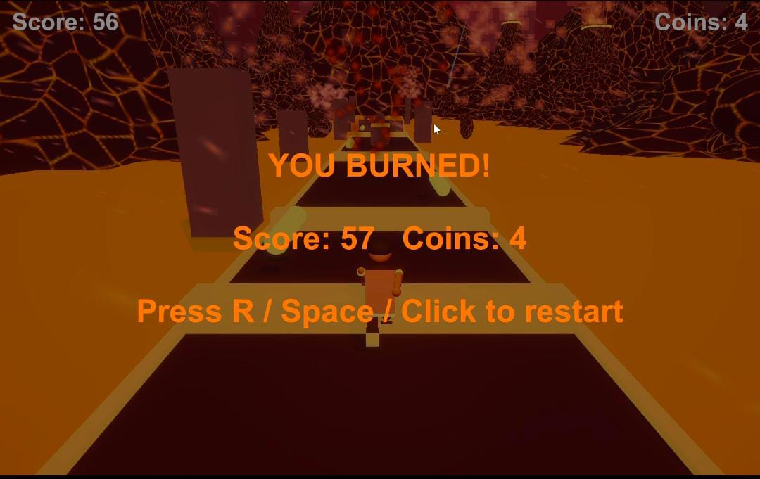
Figure: Title screen

SCREEN OUTPUT – RUNNING, LANES AND OBSTACLES
The gameplay screenshots show the character running along the volcanic island route. The player is viewed from behind, while the path extends toward the horizon. The route has three lanes, allowing the player to move between the left, middle, and right lanes.
Different obstacles, such as large volcanic rocks and low orange lava barriers, are generated along the route. The main obstacle collider is used to detect collisions between the player and obstacles.
Obstacle generation leaves one randomly selected lane free at each configured obstacle position. Other lanes may receive obstacles based on a random probability. This creates a challenge for the player to choose the correct lane and avoid obstacles while running through the volcanic island.
The player must change lanes to avoid tall rocks and jump over low barriers to continue running and achieve a higher score.
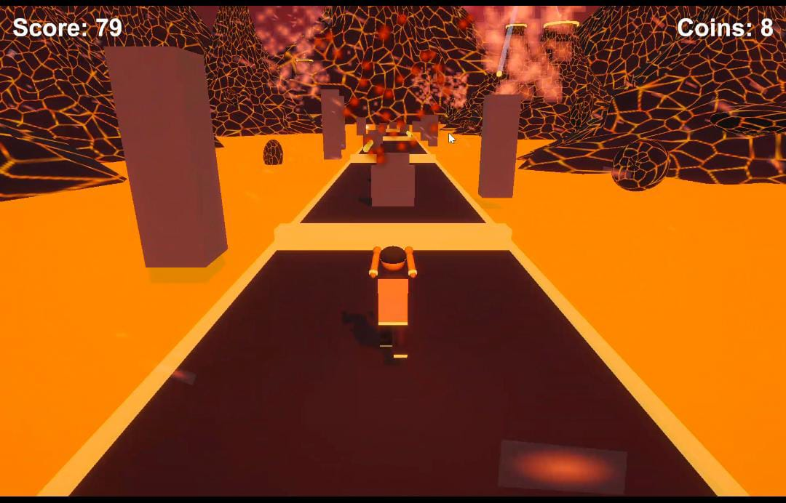
Figure: Running view
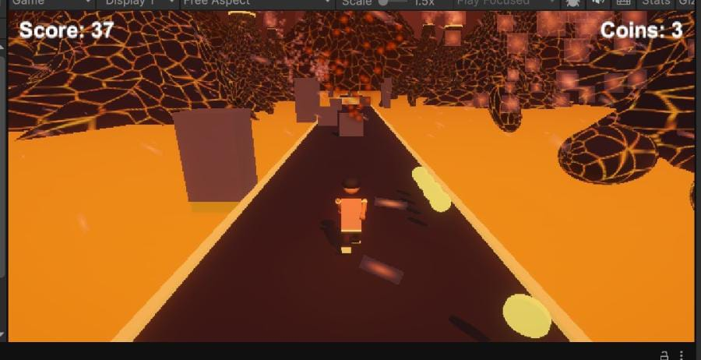
Figure: Obstacles and coin trail

SCREEN OUTPUT – COINS AND POWER-UPS
Coins are designed as yellow, glowing objects arranged in trails along the volcanic island route. The coin counter is displayed on the screen to show the total number of coins collected. The coin count increases whenever the player collects an object tagged as Coin.
The magnet power-up displays a timer at the top-centre of the screen, with a trail of coins near the player. When activated, the magnet attracts tagged coins within a range of 12 units and automatically collects coins within 1.5 units while the magnet timer remains active.
The game also supports Double and Shield power-ups. The Double power-up increases the score calculation for ten seconds. The Shield power-up protects the player by absorbing one qualifying obstacle collision.
The screenshots specifically demonstrate the Magnet indicator. The Double and Shield power-ups are also supported by the game, although their indicators are not separately shown in the screenshots.

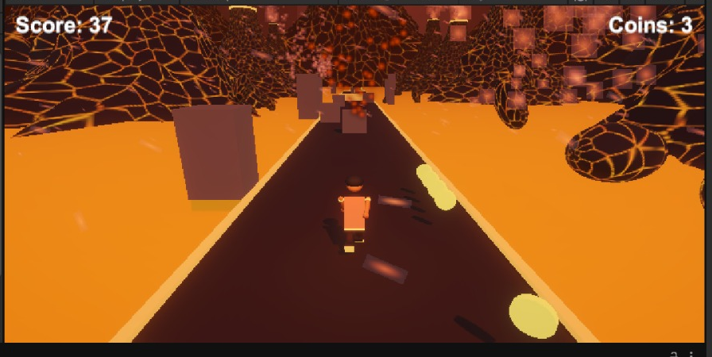
Figure: Magnet power-up HUD

SCREEN OUTPUT – GAME OVER AND RESTART
The Game Over screen displays the final score and best score achieved by the player. It also displays the Restart (R) option, allowing the player to restart the game.
When the player collides with an obstacle or falls into lava, the Game Over screen appears. The game stops active gameplay, plays the crash sound effect, and triggers a short camera shake to provide visual feedback. The best score is automatically updated and saved whenever the current score is higher than the previously recorded best score.
The Restart option allows the player to play again by pressing the R key. The active scene is reloaded, and the game starts again from the beginning.
This feature allows players to retry the Volcano Island challenge, collect more coins, avoid obstacles, and achieve a higher score.

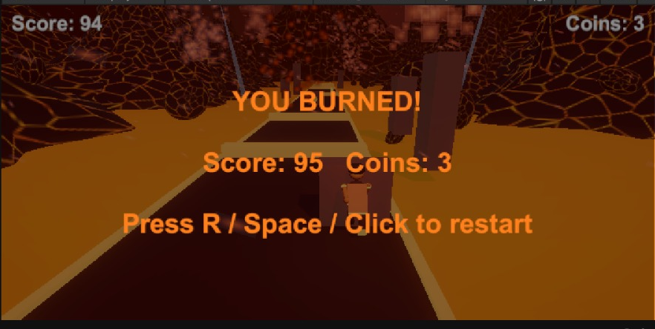
Figure: Game Over screen

CODE QUALITY, DEPENDENCIES AND CONFIGURATION CHECKS
The scripts in the Volcano Island project follow clear responsibility boundaries, use public Inspector fields for adjustable values, and make use of Unity component APIs. The code also includes several dependencies that must be configured correctly for the game to work reliably.
CameraFollow requires a valid target Transform to follow the player. GameManager requires a valid player reference or a GameObject named Player. VolcanoRun requires the necessary player references and components to control the character, generate the volcanic path, and manage gameplay.
The Extras script requires the appropriate player references, character parts, and animation settings to create and animate the player character. Coin and power-up collection depend on correctly configured colliders and tags.
Obstacle detection requires the correct obstacle collider configuration so that collisions can be identified and handled properly. The camera, UI elements, coin counter, score display, and restart functionality must also be connected correctly.
These are not claims that the project is broken; they are configuration conditions that should be verified. All required GameObjects, scripts, references, colliders, tags, and UI elements should be checked in the Unity Inspector before building or demonstrating the Volcano Island game.

9. TESTING, RESULTS AND SCREENSHOTS
LIMITATIONS AND POSSIBLE IMPROVEMENTS
The project uses Unity's input handling APIs to support keyboard controls. A possible future improvement is to migrate the controls to the newer Input System while maintaining the existing gameplay actions.
Some GameObjects and component references must be assigned correctly for reliable gameplay. Additional null checks could be implemented for player references, camera targets, character components, and other required objects.
The VolcanoRun script controls the main gameplay, including player movement, lane switching, jumping, obstacle detection, coin collection, and score updates. The Extras script creates the character model and controls its animations. Further improvements could include better integration of character animations with running, jumping, and other player actions.
Additional improvements may include a pause menu, settings menu, touch controls, more volcanic environment designs, additional obstacle patterns, improved visual effects, audio controls, and a leaderboard. These are future possibilities and are not presented as completed features.
CONCLUSION
Volcano Island demonstrates a Unity-based 3D endless runner game developed using cooperating C# scripts. The implementation supports automatic forward movement, three-lane navigation, jumping, obstacle avoidance, coin collection, score tracking, character animation, camera following, and game restart functionality.
The project demonstrates how Unity components, transforms, colliders, coroutines, PlayerPrefs, primitive objects, and C# scripting can be combined to create an interactive endless runner game.
The project also demonstrates procedural environment and character construction. The VolcanoRun script manages the main gameplay elements, while the Extras script creates a custom player character with body parts, glowing details, a fire cape, and cape animation.
The volcanic island environment provides an engaging gameplay setting with obstacles, coins, and different challenges. Players must switch lanes and jump over obstacles to survive longer and achieve higher scores.
The screenshots document the title screen, gameplay, character animation, coins, obstacles, score display, and Game Over screen. Together with the C# source files, they provide evidence of the implemented features and a foundation for future improvements.
REFERENCES AND PROJECT FILE INVENTORY
References
- Unity Technologies. Unity Manual. https://docs.unity3d.com/Manual/
- Unity Technologies. Unity Scripting API. https://docs.unity3d.com/ScriptReference/
- Unity Technologies. Unity Physics and Collision documentation. https://docs.unity3d.com/Manual/PhysicsSection.html
- Adobe Mixamo. 3D Character Animation. https://www.mixamo.com/
Project source files:
- VolcanoRun.cs
- Extras.cs
- Other supporting scripts used in the project.
Project visual evidence:
Volcano Island title screen, gameplay screenshots, player character, running animation, obstacles, coin collection, and Game Over screen.

10. QUALITY, LIMITATIONS AND CONCLUSION
PROJECT SOURCE FILE INVENTORY
The implementation developed for this report consists of VolcanoRun.cs and Extras.cs, along with other supporting Unity scripts and game assets.
VolcanoRun.cs manages the main gameplay features, including player movement, lane switching, jumping, obstacle generation, coin collection, score tracking, and game-over functionality.
Extras.cs handles player character construction, character body parts, and fire cape animation. Together, these scripts help create the interactive Volcano Island endless runner game.
The descriptions in this report are based on the scripts and project features implemented in Unity.
REFERENCES
1. Unity Technologies, Unity Manual: https://docs.unity3d.com/Manual/
2. Unity Technologies, Unity Scripting API: https://docs.unity3d.com/ScriptReference/
3. Unity Technologies, Unity Physics Documentation: https://docs.unity3d.com/Manual/PhysicsSection.html
4. Adobe Mixamo, 3D Character Animation: https://www.mixamo.com/
5. Unity Technologies, PlayerPrefs: https://docs.unity3d.com/ScriptReference/PlayerPrefs.html
6. Unity Technologies, CharacterController: https://docs.unity3d.com/ScriptReference/CharacterController.html

DETAILED TECHNICAL DOCUMENTATION
The following chapters expand the implementation details, integration requirements and validation approach. They are written from the supplied seven C# scripts and project screenshots. Where the source does not prove a feature or test result, the report states that limitation explicitly.

4. DETAILED PLAYER CONTROL DESIGN

The player control system in Volcano Island manages the character's movement during gameplay. It allows the player to move forward automatically, switch between three lanes and jump over obstacles. The movement system provides smooth and responsive controls for an endless-runner experience.

The player moves forward continuously along the volcanic island path. This automatic movement allows the player to focus on avoiding obstacles and collecting coins instead of controlling forward movement manually.

The game provides three lanes: left, centre and right. The player can move between these lanes to avoid large volcanic rocks and other obstacles. Lane switching helps the player choose a safe path while running.

Keyboard controls are used to control the character:

A / Left Arrow: Move to the left lane.

D / Right Arrow: Move to the right lane.

Space / W: Jump over low orange barriers.

The movement system combines forward movement, lane switching and jumping to provide continuous gameplay. These controls allow the player to react quickly to obstacles appearing along the route.

The player control design makes Volcano Island easy to understand and play while providing challenges that require quick reactions and accurate movements.

5. JUMPING, GRAVITY AND SLIDING

In Volcano Island, jumping allows the player to avoid low obstacles placed along the volcanic running path. The player can jump by pressing the Space or W key. Jumping is handled through the player's movement script, which applies an upward force to move the character into the air.

Gravity continuously pulls the player back towards the ground after jumping. This creates a natural jumping movement and allows the player to land before performing another jump.

The game uses three-lane movement along with jumping to help the player avoid obstacles. The player must choose the correct action depending on the obstacle ahead.

Jumping: The player jumps over low orange barriers.

Gravity: Gravity brings the player back to the ground after a jump.

Lane Switching: The player moves to another lane to avoid large volcanic rocks.

The jumping and gravity system makes obstacle avoidance more interactive and requires the player to react at the correct time.

The original sliding behaviour and its controller settings are not confirmed in the supplied Volcano Island gameplay details. Therefore, sliding is not included as an implemented feature in this section.

Testing should verify that the player can jump over low barriers, return safely to the ground and continue running without unexpected collisions.

6. COLLISION AND OBSTACLE RESPONSE
In Volcano Island, collision detection is used to identify when the player hits an obstacle during gameplay. The game includes obstacles such as large volcanic rocks and low orange barriers. When the player collides with an obstacle, the collision system determines whether the player should continue playing or the game should end.
If the player has an active shield power-up, the shield protects the player from one obstacle collision. After the collision, the shield is consumed, the obstacle is destroyed, and the player can continue running.
If the player does not have an active shield, the collision results in a Game Over. The game stops the player's movement and displays the game-over state.
Proper collider configuration is important for collision detection. The obstacle colliders must be configured correctly so that Unity can detect collisions with the player. Obstacle object names and collision conditions must also match the implementation in the scripts.
Testing should cover both collision situations:
- Without Shield: Colliding with an obstacle should end the game.
- With Shield: The shield should protect the player from one collision, get consumed, and allow gameplay to continue.
The collision detection and shield system makes Volcano Island more interactive by combining obstacle challenges with a one-use protection power-up.

7. CHUNK-BASED WORLD GENERATION

The Volcano Island game uses a chunk-based approach to generate the running environment. The world is divided into separate track segments that are placed one after another along the Z-axis. This helps create a continuous running path for the player.

The chunk generation system creates new environment segments as the player moves forward. New segments are placed ahead of the player to extend the running path, while older segments behind the player can be removed to avoid keeping unnecessary objects in the scene.

Each chunk contains the track and its surrounding volcanic environment. These segments can include ground, volcanic rocks, environmental objects and obstacles. Proper alignment between chunks is important to ensure that the player experiences a continuous path without visible gaps.

The chunk-based approach helps maintain the endless-runner experience by extending the environment during gameplay. It also makes the environment easier to organize and manage.

The system can be improved in the future by using object pooling instead of repeatedly creating and destroying chunks. Object pooling can reduce unnecessary object creation and improve performance during longer gameplay sessions.

Overall, chunk-based world generation helps Volcano Island provide a continuous volcanic running environment while keeping the game world manageable.

8. TRACK AND ENVIRONMENT CONTENT

The Volcano Island game creates a volcanic island environment designed for an endless runner experience. The environment includes a continuous running path surrounded by volcanic rocks, mountains and other natural elements. These objects create the appearance of a volcanic landscape and provide a suitable setting for the gameplay.

The game uses a three-lane movement system, allowing the player to move between the left, middle and right lanes. This arrangement provides enough space for obstacle placement and gives the player different movement options while running through the environment.

Volcanic rocks and other environmental objects are placed along the route to create visual variation. Large volcanic rocks and low orange barriers act as obstacles that challenge the player to switch lanes or jump at the correct time.

The volcanic environment helps create the atmosphere of an island filled with natural hazards. The placement of environmental objects makes the running path visually interesting and helps players identify upcoming obstacles.

The environment is designed to support continuous forward movement and endless gameplay. Reusing and arranging environmental objects helps maintain a consistent volcanic setting throughout the game.

The overall track and environment design makes Volcano Island more engaging by combining a three-lane running path, volcanic surroundings and different obstacles.

9. OBSTACLE PLACEMENT AND GAMEPLAY VARIATION
The Volcano Island game includes different obstacles placed along the volcanic island route to create challenges during gameplay. These obstacles are designed to test the player's timing, movement and reaction speed.
The obstacle selection includes large volcanic rocks and low orange barriers. These obstacles require different player actions, such as changing lanes or jumping to avoid collisions.
- Large Volcanic Rocks: The player must change lanes to avoid hitting these obstacles.
- Low Orange Barriers: The player must jump over these obstacles to continue running safely.
The obstacle placement creates variation throughout the gameplay and encourages players to remain alert while moving through the volcanic environment.
As the player progresses, the obstacles create challenges that require quick decisions and accurate movements. The player must select the correct lane or jump at the appropriate time to avoid collisions.
Obstacle placement should provide enough visible distance for the player to recognize upcoming hazards and react accordingly. Proper positioning also helps maintain a balanced difficulty level.
Testing should include checking obstacle positions across all three lanes, verifying collision detection and ensuring that the player can avoid obstacles through lane switching and jumping.
The obstacle system makes Volcano Island more challenging and engaging by combining different obstacle types with continuous forward movement.

10. COIN GENERATION AND COLLECTION

In the Volcano Island game, coins are generated along the volcanic island route and arranged in trails to encourage players to collect them during gameplay. Coins are designed as collectible objects placed across different lanes.

The player collects coins by moving through them while running along the route. When the player touches a coin, the game detects the collision and triggers the coin collection functionality.

The coin collection system updates the total number of collected coins and increases the player's score. After collection, the coin object is removed from the scene to prevent repeated collection.

The coin counter displays the number of coins collected during gameplay, allowing players to track their progress.

The game also includes a Magnet Power-Up, which attracts nearby coins towards the player. When activated, the magnet collects coins within its specified range while the power-up timer remains active.

Coin trails provide additional challenges and rewards. Players must choose the correct lane to collect coins while avoiding volcanic rocks and other obstacles.

This system makes gameplay more engaging by combining coin collection, score improvement and obstacle avoidance.

11.GAMEPLAY SYSTEM AND SCORE MANAGEMENT

The gameplay system coordinates the main activities of Volcano Island. It manages the player's movement, obstacle avoidance, coin collection and game-over behaviour.

The score system provides a way to measure the player's progress during gameplay. It can be used to display the player's performance and encourage repeated attempts.

The coin counter maintains the number of collected coins. It provides additional feedback and gives players another objective besides surviving obstacles.

The VolcanoRun.cs script contains the main gameplay operations, while Extras.cs provides additional character and coin-related functionality.

The combination of movement, obstacles and collectible items creates a continuous gameplay experience.

12. GAME STATES AND RESTART FLOW

Volcano Island follows a gameplay flow that begins with the initial game screen and continues into active running.

The player begins the game using the available start control. Once gameplay starts, the character moves forward along the volcanic route.

During gameplay, the player can switch lanes, jump over obstacles and collect coins.

When the death condition is triggered, the game enters the Game Over state. The player can then restart and begin another attempt.

The general gameplay flow is:

Game Start → Running → Obstacle Avoidance → Coin Collection → Game Over → Restart

This structure provides a simple and understandable game progression.

13. POWER-UP SYSTEM
The Volcano Island game includes a power-up system that provides special abilities to the player during gameplay. These power-ups make the game more interesting by helping players collect coins, increase their scores and avoid obstacles.
The game supports three types of power-ups: Magnet, Double and Shield.
1. Magnet Power-Up
The Magnet power-up attracts nearby coins towards the player. It detects tagged Coin objects within a range of 12 units and automatically collects coins within 1.5 units while the magnet timer is active. The Magnet effect remains active for 8 seconds.
2. Double Score Power-Up
The Double power-up increases the score rewards during gameplay. When activated, it doubles the score gained from distance and coin collection for 10 seconds. This helps players achieve higher scores.
3. Shield Power-Up
The Shield power-up protects the player from one qualifying obstacle collision. When the player collides with an obstacle while the shield is active, the shield absorbs the collision and allows the player to continue running. After absorbing one collision, the shield is consumed.
The power-up system adds variety to gameplay and gives players additional opportunities to improve their performance.
The Magnet indicator is demonstrated in the project screenshots. The Double and Shield features are supported by the game, although their indicators are not separately demonstrated in the screenshots.
Implementation: The PowerUp.cs, PlayerController.cs and GameManager.cs scripts manage the power-up functionality in the documented implementation.

14. CAMERA FOLLOW AND FEEDBACK

The camera plays an important role in presenting the Volcano Island gameplay environment.

It provides a view of the player character and the path ahead, allowing the player to observe upcoming obstacles and make movement decisions.

The camera should maintain a suitable position so that the player remains visible throughout gameplay.

The third-person camera perspective helps players understand the direction of movement and the arrangement of obstacles.

Visual feedback is also important when the player collects coins or collides with obstacles. Appropriate visual effects and camera movement can make these events easier to recognize.

The camera and visual presentation together improve the overall gameplay experience.

15. CHARACTER ANIMATION ARCHITECTURE

The player character is created using the Extras.cs script.

The BuildCharacter() method constructs the character by combining different Unity primitive objects.

The character consists of:

Body: A capsule-shaped body with decorative details.

Head: A sphere-shaped head with hair, headband and glowing eyes.

Legs and Boots: Two legs with specially designed boots and glowing soles.

Arms and Hands: Character arms with wrist decorations and hands.

Fire Cape: A decorative cape attached to the back of the character.

Different colours are applied to the character parts to create a visually attractive appearance.

The cape is animated using the Update() method. Its rotation changes over time using Mathf.Sin(Time.time * 11f), creating a continuous waving effect.

The animation also uses the player's movement state to adjust the cape rotation during jumping.

The character construction and animation provide a distinctive appearance that matches the volcanic island theme.

16. USER INTERFACE AND PLAYER FEEDBACK
The user interface provides important information during gameplay.
The interface can display the game title, score, coin count and Game Over information according to the implemented UI configuration.
The title screen introduces the game and provides instructions for starting the run.
The coin counter helps players track the number of collected coins.
The Game Over screen communicates the end of the current run and allows the player to attempt another run.
Clear interface elements help players understand the current gameplay situation without distracting them from the volcanic route.
The overall interface supports the main gameplay activities and improves the user experience.

17. AUDIO IMPLEMENTATION

Audio can improve the overall experience of Volcano Island by providing feedback for different gameplay events.

Suitable sound effects can include:

Jumping sound when the player jumps.

Coin collection sound when a coin is collected.

Collision sound when the player hits an obstacle.

Game Over sound when the run ends.

Background music to create an adventurous volcanic atmosphere.

These sounds can make the game more engaging and help players recognize important gameplay events.

Audio controls and additional sound effects can be introduced as future improvements if they are not already implemented in the project.

18. UNITY PROJECT CONFIGURATION
The Volcano Island project is developed using Unity and C# scripts.
The scripts should be saved inside the Unity project's Assets folder or appropriate subfolders so that Unity can compile them automatically.
The VolcanoRun.cs script must be attached to the appropriate GameObject responsible for managing the main gameplay.
The Extras.cs script must be available to the game so that the character construction, cape animation and additional functionality can be executed.
The required GameObjects, components, materials and references must be configured correctly in the Unity Inspector.
The player character, camera, obstacles and collectible objects should be positioned correctly within the scene.
Any compilation errors displayed in the Unity Console should be resolved before testing or building the game.

19. INTEGRATION CHECKLIST

Before running Volcano Island, the following configuration points should be checked:

Confirm that VolcanoRun.cs and Extras.cs are saved inside the Assets folder.

Verify that both scripts compile without errors.

Confirm that the required GameObjects are present in the active scene.

Check that the player character is created correctly.

Verify that the camera provides a clear view of the player and route.

Confirm that obstacle objects are positioned correctly.

Check that coin objects are configured correctly for collection.

Verify that the Extras component is added successfully.

Confirm that the cape is attached to the character and its animation works.

Test the player movement, jumping and collision behaviour.

Check the coin counter and Game Over functionality.

Verify that the restart option works correctly.

These checks help identify configuration problems before the final game demonstration.

20. TEST PLAN AND EXPECTED RESULTS

The following test cases can be used to evaluate the main features of Volcano Island.
Test case | Expected result
Launch the game | Initial game screen appears
Start gameplay | Player begins running
Press A or Left Arrow | Player moves to the left lane
Press D or Right Arrow | Player moves to the right lane
Press Space or W | Player jumps
Approach a tall rock | Player must change lanes
Approach a low barrier | Player must jump
Collect a coin | Coin collection functionality is triggered
Collide with an obstacle | Death or Game Over functionality is triggered
Observe character cape | Cape animation is visible
Restart the game | A new gameplay attempt begins

The expected results should be compared with actual gameplay behaviour during testing.

Only tests that have been performed successfully should be recorded as passed.

21. PERFORMANCE AND RESOURCE CONSIDERATIONS

Performance is important for maintaining smooth gameplay in Volcano Island.

The project uses Unity GameObjects, primitive objects, materials and scripts to construct the player character and environment.

The number of active GameObjects and the complexity of materials and visual effects can affect game performance.

The character model should use an appropriate number of objects and materials to maintain a balance between visual quality and performance.

Environmental objects such as volcanic rocks, fire effects and decorative elements should be optimized to avoid unnecessary rendering overhead.

The game should be tested in Play mode to observe movement smoothness, scene loading and overall responsiveness.

Unity Profiler can be used in future testing to examine CPU usage, GPU usage, memory consumption and frame time.

No specific FPS or performance benchmark is claimed without an actual profiling result.

22. DATA PERSISTENCE AND SCORE STORAGE

Game progress information helps players understand their performance during a run.

The game can display the current score and collected coin count through the user interface.

The coin collection functionality is connected to the Extras.Coin() method called from the Update() method in VolcanoRun.cs.

The Extras.Die() method is called when the death condition is triggered.

These methods provide additional functionality for managing gameplay events.

If permanent best-score storage is included in the final implementation, Unity's PlayerPrefs can be used to save and retrieve the best score between game sessions.

Score persistence should only be considered completed if it is implemented and verified in the project.

23. ERROR HANDLING AND DEBUGGING

During Unity development, different errors may occur because of incorrect script references, missing components or configuration problems.

Some common issues that should be checked include:

Missing Script References: Verify that the required scripts are attached to the correct GameObjects.

Compilation Errors: Check the Unity Console for errors in C# scripts.

Character Visibility: Confirm that the player model is created and positioned correctly.

Cape Animation Issues: Verify that the cape Transform is assigned and the animation code is inside the correct Update() method.

Movement Issues: Check the keyboard input and player movement logic.

Obstacle Collision Issues: Verify obstacle colliders and collision detection.

Coin Collection Issues: Check coin colliders, tags and collection functionality.

Game Over Issues: Confirm that the death method is called when the player collides with an obstacle.

The Unity Console is useful for identifying compilation errors and runtime exceptions.

Debugging helps ensure that the game operates correctly and that the implemented features work as expected.

24. SECURITY, LIMITATIONS AND PROJECT BOUNDARIES

Volcano Island is designed as a single-player 3D endless runner game.

The project focuses on player movement, obstacle avoidance, coin collection, character construction and animation.

The gameplay uses a limited lane-based movement system rather than unrestricted movement across the environment.

The character must avoid obstacles by changing lanes or jumping over low barriers.

The project does not claim online multiplayer, cloud-based saving or server-based score management as completed features.

Some improvements may require additional scripts, Unity components or external assets.

The supplied implementation and gameplay screenshots form the basis of this documentation. Any additional features should be verified in the Unity project before being described as completed.

25. USER EXPERIENCE AND GAMEPLAY BALANCE

The Volcano Island game is designed to provide a simple and engaging endless runner experience.

The volcanic island theme creates an adventurous atmosphere and provides a visually interesting environment.

The three-lane movement system makes the controls easy to understand. Players can move left, move right or remain in the current lane while avoiding obstacles.

Jumping provides another gameplay action that allows players to overcome low barriers.

Coins introduce an additional objective and encourage players to explore different lanes.

The character's fire cape animation adds visual movement and improves the appearance of the player model.

Gameplay balance can be improved by adjusting player speed, lane spacing, jump behaviour, obstacle positions and coin placement.

Repeated testing can help identify difficulty issues and improve the overall experience.

26. FUTURE ENHANCEMENTS
Volcano Island can be improved further by introducing additional gameplay and visual features.
1. Improved Character Animations
Additional running, jumping and landing animations can make the player character more realistic.
2. Enhanced Volcanic Environment
More volcanic mountains, lava rivers, smoke, fire particles and environmental decorations can improve the visual appearance.
3. Additional Obstacles
New obstacle types, such as falling rocks, lava pits and moving barriers, can introduce more gameplay challenges.
4. Improved Coin System
Different coin arrangements and collectible rewards can provide additional objectives.
5. Sound and Music
Background music and sound effects for jumping, collecting coins and collisions can improve the gaming experience.
6. User Interface Improvements
A more attractive title screen, score display, pause menu and Game Over screen can improve the interface.
7. Mobile Controls
Touch-based controls can allow players to move between lanes and jump using mobile devices.
8. Performance Optimization
Reducing unnecessary GameObjects and optimizing materials can improve gameplay performance.
These enhancements can make Volcano Island more interactive, visually attractive and enjoyable.

27. CONCLUSION
The Volcano Island project demonstrates the development of a 3D endless runner game using Unity and C# scripting. The game provides an interactive environment where the player runs through a volcanic island, avoids obstacles, collects coins and attempts to achieve a higher score.
The project combines different gameplay elements, including automatic forward movement, three-lane navigation, jumping, obstacle avoidance, coin collection, character construction and cape animation.
The VolcanoRun.cs script manages the main gameplay operations, while the Extras.cs script creates a custom player character using Unity primitive objects. The character includes detailed body parts, glowing elements, boots and a decorative fire cape with animation.
The volcanic island environment provides an adventurous setting with challenging obstacles and a distinctive visual theme. Players must react quickly, switch lanes and jump over obstacles to survive and continue progressing.
The project demonstrates important Unity development concepts such as GameObjects, Transforms, primitive objects, C# scripting, animation, collision detection and runtime object creation.
The screenshots included in the documentation demonstrate the player character, volcanic environment, gameplay, obstacle interactions, coin collection and game interface.
Overall, Volcano Island provides practical experience in 3D game development, Unity scripting, character creation, animation and gameplay design. It also provides a foundation for future improvements, including additional obstacles, enhanced environmental effects, improved animations, sound effects and advanced gameplay features.
The project successfully brings together programming concepts and creative game design to create an engaging endless runner experience.

APPENDIX A – COMPLETE C# SOURCE LISTINGS
The following listings reproduce the source files supplied for the project. They are included as a technical appendix so that the implementation described in the report can be traced to the corresponding scripts.

A.1 Extras.cs

using UnityEngine;

public class Extras : MonoBehaviour

{

static Extras I;

AudioSource music, sfx;

AudioClip coinClip, dieClip;

Transform player, model, legL, legR, armL, armR;

float phase, prevZ, prevX;

void Awake()

{

I = this;

music = gameObject.AddComponent<AudioSource>();

music.clip = MakeMusic();

music.loop = true;

music.volume = 0.55f;

music.Play();

sfx = gameObject.AddComponent<AudioSource>();

coinClip = MakeCoin();

dieClip = MakeDie();

}

void Start()

{

var p = GameObject.Find("RunnerPlayer");

if (p == null) return;

player = p.transform;

p.GetComponent<Renderer>().enabled = false; // capsule hide

BuildCharacter();

prevZ = player.position.z;

prevX = player.position.x;

}

// ---------- character ----------

Transform Part(Transform parent, PrimitiveType t, Vector3 pos, Vector3 scale, Color c, float emis = 0f)

{

var g = GameObject.CreatePrimitive(t);

Destroy(g.GetComponent<Collider>());

g.transform.SetParent(parent, false);

g.transform.localPosition = pos;

g.transform.localScale = scale;

var sh = Shader.Find("Universal Render Pipeline/Lit");

if (sh == null) sh = Shader.Find("Standard");

var m = new Material(sh);

m.color = c;

if (emis > 0f)

{

m.EnableKeyword("_EMISSION");

m.SetColor("_EmissionColor", c * emis);

}

g.GetComponent<Renderer>().material = m;

return g.transform;

}

Transform Pivot(Transform parent, Vector3 pos)

{

// bass drone

float f = bass[(bi / 4) % 4];

float ph = 2f * Mathf.PI * f * t;

s += (Mathf.Sin(ph) + 0.5f * Mathf.Sin(2f * ph) + 0.25f * Mathf.Sin(3f * ph)) * 0.16f;

// dark melody

s += Mathf.Sin(2f * Mathf.PI * mel[hi % 8] * t) * Mathf.Exp(-inHalf * 6f) * 0.12f;

d[i] = Mathf.Clamp(s * 0.8f, -1f, 1f);

}

var clip = AudioClip.Create("VolcanoMusic", n, 1, sr, false);

clip.SetData(d, 0);

return clip;

}

AudioClip MakeCoin()

{

int sr = 44100, n = (int)(sr * 0.3f);

var d = new float[n];

for (int i = 0; i < n; i++)

{

float t = i / (float)sr;

float f = t < 0.08f ? 988f : 1319f;

d[i] = Mathf.Sin(2f * Mathf.PI * f * t) * Mathf.Exp(-t * 9f) * 0.5f;

}

var clip = AudioClip.Create("Coin", n, 1, sr, false);

clip.SetData(d, 0);

return clip;

}

AudioClip MakeDie()

{

int sr = 44100, n = sr;

var d = new float[n];

var rnd = new System.Random(9);

float p = 0f;

for (int i = 0; i < n; i++)

{

float t = i / (float)sr;

p += 2f * Mathf.PI * (220f * Mathf.Exp(-t * 3f) + 30f) / sr;

float noise = ((float)rnd.NextDouble() * 2f - 1f) * Mathf.Exp(-t * 5f);

d[i] = (Mathf.Sin(p) * 0.6f + noise * 0.4f) * Mathf.Exp(-t * 3.5f);

}

var clip = AudioClip.Create("Die", n, 1, sr, false);

clip.SetData(d, 0);

return clip;

}

}

A.2 GameManager.cs
using UnityEngine;
using UnityEngine.UI;
using UnityEngine.InputSystem;
using UnityEngine.SceneManagement;
public class GameManager : MonoBehaviour
{
public static GameManager Instance;
public bool IsGameOver { get; private set; }
Transform player, lava;
Text scoreText, coinText;
GameObject overPanel;
int coins;
void Awake()
{
Instance = this;
Time.timeScale = 1f;
Application.targetFrameRate = 60;
QualitySettings.vSyncCount = 0;
BuildLook();
BuildUI();
}
void Start()
{
var pc = FindFirstObjectByType<PlayerController>();
if (pc != null) player = pc.transform;
}
void BuildLook()
{
// Fog + ambient
RenderSettings.fog = true;
RenderSettings.fogMode = FogMode.Exponential;
RenderSettings.fogColor = new Color(0.23f, 0.07f, 0.03f);
RenderSettings.fogDensity = 0.012f;
RenderSettings.ambientMode = UnityEngine.Rendering.AmbientMode.Flat;
RenderSettings.ambientLight = new Color(0.35f, 0.15f, 0.12f);
// Camera
var cam = Camera.main;
if (cam != null)
{
cam.clearFlags = CameraClearFlags.SolidColor;
cam.backgroundColor = new Color(0.23f, 0.07f, 0.03f);
cam.transform.localPosition = new Vector3(0, 4, -7);
cam.transform.localRotation = Quaternion.Euler(15, 0, 0);
cam.farClipPlane = 200f;
}
// Light
foreach (var l in FindObjectsByType<Light>(FindObjectsSortMode.None))
if (l.type == LightType.Directional)
{
l.color = new Color(1f, 0.35f, 0.12f);
l.intensity = 1.3f;
}

A.3 PlayerController.cs
using UnityEngine;
using UnityEngine.InputSystem;

[RequireComponent(typeof(CharacterController))]
public class PlayerController : MonoBehaviour
{
public float speed = 12f;
public float maxSpeed = 28f;
public float laneDistance = 3f;
public float jumpHeight = 2f;
public float gravity = -35f;

CharacterController cc;
int lane = 1;
float yVel;

void Start()
{
cc = GetComponent<CharacterController>();
gameObject.tag = "Player";
}

void Update()
{
if (GameManager.Instance != null && GameManager.Instance.IsGameOver) return;

var kb = Keyboard.current;
if (kb != null)
{
if (kb.leftArrowKey.wasPressedThisFrame || kb.aKey.wasPressedThisFrame) lane = Mathf.Max(0, lane - 1);
if (kb.rightArrowKey.wasPressedThisFrame || kb.dKey.wasPressedThisFrame) lane = Mathf.Min(2, lane + 1);

if (cc.isGrounded && (kb.spaceKey.wasPressedThisFrame || kb.upArrowKey.wasPressedThisFrame || kb.wKey.wasPressedThisFrame))
yVel = Mathf.Sqrt(jumpHeight * -2f * gravity);
}

if (cc.isGrounded && yVel < 0) yVel = -2f;
yVel += gravity * Time.deltaTime;

float targetX = (lane - 1) * laneDistance;
float xMove = Mathf.MoveTowards(transform.position.x, targetX, 15f * Time.deltaTime) - transform.position.x;

cc.Move(new Vector3(xMove, yVel * Time.deltaTime, speed * Time.deltaTime));
speed = Mathf.Min(maxSpeed, speed + 0.1f * Time.deltaTime);

// fell into lava
if (transform.position.y < -10f && GameManager.Instance != null) GameManager.Instance.GameOver();
}

void OnTriggerEnter(Collider other)
{
if (GameManager.Instance == null) return;
if (other.CompareTag("Obstacle")) GameManager.Instance.GameOver();
else if (other.CompareTag("Coin"))
{
GameManager.Instance.AddCoin();
other.gameObject.SetActive(false);
}
}
}

A.4 VolcanoRun.cs
using System.Collections.Generic;
using UnityEngine;
using UnityEngine.UI;
using UnityEngine.InputSystem;
using UnityEngine.SceneManagement;

public class VolcanoRun : MonoBehaviour
{
class Tile
{
public GameObject go;
public List<Renderer> obs = new List<Renderer>();
public List<Renderer> coins = new List<Renderer>();
}

const float TileLen = 30f, LaneDist = 3f;
float speed = 14f, maxSpeed = 30f, yFeet, yVel, gravity = -35f, jumpHeight = 2f;
int lane = 1, coinCount, spawned;
bool over;
float nextZ = -10f;

Transform player, cam, embers, lava;
Text scoreText, coinText, overText;
GameObject overPanel;
Material basalt, rockMat, glowMat, coinMat;
readonly List<Tile> tiles = new List<Tile>();

void Awake()
{
Time.timeScale = 1f;
Cleanup();
BuildLook();
BuildPlayer();
BuildUI();
for (int i = 0; i < 6; i++) SpawnTile(i < 2);
gameObject.AddComponent<Extras>();
}

// ---------- setup ----------
Material Mat(Color c, float emis)
{
var sh = Shader.Find("Universal Render Pipeline/Lit");
if (sh == null) sh = Shader.Find("Standard");
var m = new Material(sh);
m.color = c;
if (emis > 0f)
{
m.EnableKeyword("_EMISSION");
m.SetColor("_EmissionColor", c * emis);
}
return m;
}

void Cleanup()
{
var c = Camera.main;
if (c == null) c = FindFirstObjectByType<Camera>();
if (c == null)
{
var g = new GameObject("Main Camera", typeof(Camera), typeof(AudioListener));
g.tag = "MainCamera";
c = g.GetComponent<Camera>();
}
cam = c.transform;
cam.SetParent(null);

string[] old = { "Player", "GameManager", "TrackSpawner", "Canvas", "AutoCanvas", "LavaSea" };
for (int k = 0; k < 3; k++)
foreach (var n in old)
{
var g = GameObject.Find(n);
if (g != null && g != gameObject) g.SetActive(false);
}

var e = GameObject.Find("Embers");
if (e != null) embers = e.transform;
}

void BuildLook()
{
Color fog = new Color(0.23f, 0.07f, 0.03f);
RenderSettings.fog = true;
RenderSettings.fogMode = FogMode.Exponential;
RenderSettings.fogColor = fog;
RenderSettings.fogDensity = 0.012f;
RenderSettings.ambientMode = UnityEngine.Rendering.AmbientMode.Flat;
RenderSettings.ambientLight = new Color(0.35f, 0.15f, 0.12f);

var c = cam.GetComponent<Camera>();
c.clearFlags = CameraClearFlags.SolidColor;
c.backgroundColor = fog;
c.farClipPlane = 250f;

foreach (var l in FindObjectsByType<Light>(FindObjectsSortMode.None))
if (l.type == LightType.Directional)
{
l.color = new Color(1f, 0.4f, 0.15f);
l.intensity = 1.3f;
}

basalt = Mat(new Color(0.17f, 0.13f, 0.12f), 0f);
rockMat = Mat(new Color(0.3f, 0.1f, 0.07f), 0.4f);
glowMat = Mat(new Color(1f, 0.35f, 0.05f), 1.5f);
coinMat = Mat(new Color(1f, 0.8f, 0.1f), 1.2f);

var lv = GameObject.CreatePrimitive(PrimitiveType.Cube);
lv.name = "LavaSea";
Destroy(lv.GetComponent<Collider>());
lv.transform.localScale = new Vector3(300, 1, 400);
lv.GetComponent<Renderer>().material = Mat(new Color(1f, 0.25f, 0f), 1.0f);
lava = lv.transform;
}

void BuildPlayer()
{
var p = GameObject.CreatePrimitive(PrimitiveType.Capsule);
p.name = "RunnerPlayer";
Destroy(p.GetComponent<Collider>());
p.GetComponent<Renderer>().material = Mat(new Color(0.9f, 0.9f, 0.9f), 0.15f);
p.transform.position = new Vector3(0, 1, 0);
player = p.transform;

var lg = new GameObject("PlayerLight");
lg.transform.SetParent(p.transform, false);
lg.transform.localPosition = new Vector3(0, 2, -1);
var l = lg.AddComponent<Light>();
l.type = LightType.Point;
l.color = new Color(1f, 0.5f, 0.2f);
l.range = 14f;
l.intensity = 6f;
}

// ---------- UI ----------
void BuildUI()
{
var cgo = new GameObject("RunCanvas", typeof(Canvas), typeof(CanvasScaler));
cgo.GetComponent<Canvas>().renderMode = RenderMode.ScreenSpaceOverlay;
var cs = cgo.GetComponent<CanvasScaler>();
cs.uiScaleMode = CanvasScaler.ScaleMode.ScaleWithScreenSize;
cs.referenceResolution = new Vector2(1920, 1080);

scoreText = MakeText(cgo.transform, "Score: 0", 60, TextAnchor.UpperLeft, new Vector2(0, 1), new Vector2(30, -20));
coinText = MakeText(cgo.transform, "Coins: 0", 60, TextAnchor.UpperRight, new Vector2(1, 1), new Vector2(-30, -20));

overPanel = new GameObject("GameOverPanel", typeof(RectTransform), typeof(Image));
overPanel.transform.SetParent(cgo.transform, false);
var rt = overPanel.GetComponent<RectTransform>();
rt.anchorMin = Vector2.zero; rt.anchorMax = Vector2.one;
rt.offsetMin = Vector2.zero; rt.offsetMax = Vector2.zero;
overPanel.GetComponent<Image>().color = new Color(0.1f, 0f, 0f, 0.75f);
overText = MakeText(overPanel.transform, "", 80, TextAnchor.MiddleCenter, new Vector2(0.5f, 0.5f), Vector2.zero);
overText.color = new Color(1f, 0.5f, 0.1f);
overText.rectTransform.sizeDelta = new Vector2(1600, 600);
overPanel.SetActive(false);
}

Text MakeText(Transform parent, string s, int size, TextAnchor align, Vector2 anchor, Vector2 pos)
{
var go = new GameObject("Text", typeof(RectTransform), typeof(Text));
go.transform.SetParent(parent, false);
var rt = go.GetComponent<RectTransform>();
rt.anchorMin = rt.anchorMax = rt.pivot = anchor;
rt.anchoredPosition = pos;
rt.sizeDelta = new Vector2(900, 120);
var t = go.GetComponent<Text>();
t.font = Resources.GetBuiltinResource<Font>("LegacyRuntime.ttf");
t.text = s;
t.fontSize = size;
t.fontStyle = FontStyle.Bold;
t.alignment = align;
t.color = Color.white;
return t;
}

// ---------- track ----------
Renderer Cube(Transform parent, Vector3 pos, Vector3 scale, Material m)
{
var g = GameObject.CreatePrimitive(PrimitiveType.Cube);
Destroy(g.GetComponent<Collider>());
g.transform.SetParent(parent, false);
g.transform.localPosition = pos;
g.transform.localScale = scale;
var r = g.GetComponent<Renderer>();
r.sharedMaterial = m;
return r;
}

void SpawnTile(bool safe)
{
var t = new Tile();
t.go = new GameObject("Tile");
t.go.transform.position = new Vector3(0, 0, nextZ);
var tr = t.go.transform;

Cube(tr, new Vector3(0, -0.5f, TileLen / 2), new Vector3(9, 1, TileLen), basalt);
Cube(tr, new Vector3(-4.6f, 0.05f, TileLen / 2), new Vector3(0.3f, 0.2f, TileLen), glowMat);
Cube(tr, new Vector3(4.6f, 0.05f, TileLen / 2), new Vector3(0.3f, 0.2f, TileLen), glowMat);

// side rock pillars
for (int s = -1; s <= 1; s += 2)
if (Random.value < 0.7f)
{
float h = Random.Range(3f, 9f);
Cube(tr, new Vector3(s * Random.Range(7f, 10f), h / 2 - 1f, Random.Range(2f, 28f)),
new Vector3(Random.Range(1.5f, 3f), h, Random.Range(1.5f, 3f)), rockMat);
}

if (!safe)
{
float[] rows = { 8f, 16f, 24f };
foreach (float z in rows)
{
int r = Random.Range(0, 3);
if (r == 1) // rock wall: change lane
{
int ln = Random.Range(0, 3);
t.obs.Add(Cube(tr, new Vector3((ln - 1) * LaneDist, 1.1f, z), new Vector3(2.4f, 2.2f, 1f), rockMat));
}
else if (r == 2) // low glowing barrier: jump
{
t.obs.Add(Cube(tr, new Vector3(0, 0.4f, z), new Vector3(9f, 0.8f, 1f), glowMat));
}
}
}

// coins in gaps
float[] gaps = { 12f, 20f };
foreach (float gz in gaps)
if (Random.value < 0.75f)
{
int ln = Random.Range(0, 3);
for (int k = 0; k < 4; k++)
{
var g = GameObject.CreatePrimitive(PrimitiveType.Cylinder);
Destroy(g.GetComponent<Collider>());
g.transform.SetParent(tr, false);
g.transform.localPosition = new Vector3((ln - 1) * LaneDist, 1.2f, gz - 1.5f + k);
g.transform.localRotation = Quaternion.Euler(90, 0, 0);
g.transform.localScale = new Vector3(0.7f, 0.08f, 0.7f);
var rd = g.GetComponent<Renderer>();
rd.sharedMaterial = coinMat;
t.coins.Add(rd);
}
}

tiles.Add(t);
nextZ += TileLen;
spawned++;
}

// ---------- loop ----------
void Update()
{
var kb = Keyboard.current;

if (over)
{
bool click = Mouse.current != null && Mouse.current.leftButton.wasPressedThisFrame;
if (click || (kb != null && (kb.rKey.wasPressedThisFrame || kb.spaceKey.wasPressedThisFrame)))
SceneManager.LoadScene(SceneManager.GetActiveScene().buildIndex);
return;
}

float dt = Time.deltaTime;

if (kb != null)
{
if (kb.leftArrowKey.wasPressedThisFrame || kb.aKey.wasPressedThisFrame) lane = Mathf.Max(0, lane - 1);
if (kb.rightArrowKey.wasPressedThisFrame || kb.dKey.wasPressedThisFrame) lane = Mathf.Min(2, lane + 1);
if (yFeet <= 0.001f && (kb.spaceKey.wasPressedThisFrame || kb.upArrowKey.wasPressedThisFrame || kb.wKey.wasPressedThisFrame))
yVel = Mathf.Sqrt(jumpHeight * -2f * gravity);
}

yVel += gravity * dt;
yFeet += yVel * dt;
if (yFeet <= 0f) { yFeet = 0f; yVel = 0f; }

speed = Mathf.Min(maxSpeed, speed + 0.15f * dt);
float x = Mathf.MoveTowards(player.position.x, (lane - 1) * LaneDist, 16f * dt);
player.position = new Vector3(x, yFeet + 1f, player.position.z + speed * dt);

// collisions
var pb = new Bounds(player.position, new Vector3(0.8f, 1.8f, 0.8f));
foreach (var t in tiles)
{
foreach (var o in t.obs)
if (pb.Intersects(o.bounds)) { Die(); return; }

foreach (var c in t.coins)
{
if (!c.gameObject.activeSelf) continue;
c.transform.Rotate(0, 220f * dt, 0, Space.World);
if (pb.Intersects(c.bounds))
{
c.gameObject.SetActive(false);
coinCount++;
coinText.text = "Coins: " + coinCount;

Extras.Coin();
}

}
}

// recycle tiles
if (tiles.Count > 0 && player.position.z - tiles[0].go.transform.position.z > TileLen + 20f)
{
Destroy(tiles[0].go);
tiles.RemoveAt(0);
SpawnTile(false);
}

scoreText.text = "Score: " + Mathf.Max(0, Mathf.FloorToInt(player.position.z));
}

void LateUpdate()
{
float pz = player.position.z;
float cx = Mathf.Lerp(cam.position.x, player.position.x * 0.7f, 8f * Time.deltaTime);
cam.position = new Vector3(cx, 5f, pz - 8f);
cam.rotation = Quaternion.Euler(18f, 0f, 0f);
lava.position = new Vector3(0, -2.5f, pz + 120f);
if (embers != null) embers.position = new Vector3(0, 3f, pz + 10f);
}

void Die()
{
over = true;
Extras.Die();
overText.text = "YOU BURNED!\n\nScore: " + Mathf.FloorToInt(player.position.z) +
" Coins: " + coinCount + "\n\nPress R / Space / Click to restart";
overPanel.SetActive(true);
}
}

A.5 TrackSpawner.cs
using System.Collections.Generic;
using UnityEngine;

public class TrackSpawner : MonoBehaviour
{
public Transform player;
public GameObject[] tiles;
public float tileLength = 30f;
public int tilesAhead = 6;

readonly Queue<GameObject> active = new Queue<GameObject>();
float nextZ;

void Start()
{
if (player == null)
{
var p = GameObject.FindGameObjectWithTag("Player");
if (p != null) player = p.transform;
}
if (tiles == null || tiles.Length == 0) { Debug.LogError("TrackSpawner: Tiles list lo prefabs add cheyyi!"); return; }

for (int i = 0; i < tilesAhead; i++) Spawn();
}

void Update()
{
if (player == null || active.Count == 0) return;

if (player.position.z - active.Peek().transform.position.z > tileLength * 1.5f)
{
Destroy(active.Dequeue());
Spawn();
}
}

void Spawn()
{
var prefab = tiles[Random.Range(0, tiles.Length)];
var t = Instantiate(prefab, new Vector3(0, 0, nextZ), Quaternion.identity);
active.Enqueue(t);
nextZ += tileLength;
}
}

APPENDIX B – PROJECT EVIDENCE REGISTER

The screenshots collected for the Volcano Island project are included in the main report as visual evidence of the game's development and functionality. They demonstrate the game interface, active gameplay, coin collection, power-up presentation, Game Over screen and Unity Editor environment.

The screenshots provide visual confirmation of the displayed game features and development environment. They support the project documentation but do not replace source-code verification or actual gameplay testing.

Title Screen Image: Shows the Volcano Island game title and start screen presentation.

Gameplay Images: Show the player character, three-lane running path, volcanic island environment, obstacles and collectible coins.

Coin Collection Image: Shows coins placed along the running path and the coin collection interface.

Power-Up HUD Image: Shows the available power-up status during gameplay, if displayed in the screenshot.

Game Over Image: Shows the end-of-run screen after the player collides with an obstacle.

Unity Editor Image: Shows the Unity development environment, project hierarchy and scene setup used to develop Volcano Island.

These screenshots serve as supporting evidence of the Volcano Island project's implementation, gameplay and development process.

APPENDIX C – CONFIGURATION VALUES CONFIRMED IN SOURCE
Component | Parameter | Default / Behaviour
Player Movement | Forward Speed / Maximum Speed | Automatic forward movement; exact values to be verified
Player Movement | Speed Increase | Increases movement speed during gameplay, if implemented
Player Movement | Lane Distance | Three-lane movement system
Player Movement | Lane Change Speed | Smooth lane switching
Player Movement | Jump | Jumping using Space / W controls
Player Movement | Gravity | Applied during jumping and falling
Environment | Track Layout | Three-lane volcanic running path
Environment | Obstacle Types | Large volcanic rocks and low orange barriers
Coin System | Coin Collection | Coins collected through player interaction
Power-Up System | Magnet | Attracts nearby coins, if implemented
Power-Up System | Double Score | Doubles rewards during its active period, if implemented
Power-Up System | Shield | Protects against one obstacle collision, if implemented
Character | Character Customization | Custom character created using Extras.cs
Character | Fire Cape Animation | Animated cape movement

APPENDIX D – SCENE VALIDATION AND COMPONENT DEPENDENCIES

Scene validation in Volcano Island begins by checking the active Unity scene and its essential game objects. The player, camera, environment and gameplay scripts must be properly configured to ensure that the game runs correctly.

The Player GameObject should contain the required movement script and components. The player movement system handles automatic forward movement, three-lane switching and jumping. The character model should be positioned correctly so that its appearance matches the movement and collision behaviour.

The Camera GameObject should be positioned to follow the player during gameplay. Its target reference and position should be checked to ensure that the player remains visible while moving between lanes and jumping over obstacles.

The Volcano Island environment should contain the required ground, running path, volcanic rocks and other environmental objects. Check that all objects have the correct position, scale and orientation. Missing materials or models should also be identified before running the game.

The VolcanoRun.cs script is responsible for the main gameplay functionality. Its references and settings should be checked to ensure that player movement, obstacle handling, coin collection and game-over behaviour work correctly.

The Extras.cs script is used for character customization and visual animation. Verify that the custom character model is created correctly and that its body parts and fire cape appear as expected during gameplay.

Coins and power-ups should have correctly configured colliders so that the player can collect them. The coin counter should update when coins are collected. If power-ups such as Magnet, Double Score and Shield are included, their collection and effects should also be tested.

Obstacle colliders must be configured correctly so that collisions with the player are detected. Large volcanic rocks and low orange barriers should trigger the expected gameplay response when the player fails to avoid them.

Finally, test the complete gameplay sequence: starting the game, moving between lanes, jumping, collecting coins, using available power-ups, avoiding obstacles, reaching the Game Over state and restarting the game.

This validation process helps identify missing references, incorrect component settings and gameplay issues. It ensures that the different components of Volcano Island work together as expected.

APPENDIX E – TEST RECORD TEMPLATE AND ACCEPTANCE CRITERIA
A test record for the Volcano Island project should include the project version, Unity Editor version, test date, tester name and active scene name. These details help identify the environment in which the game was tested.
For each test, record the precondition, action performed, expected result, actual result and test status. This helps verify whether the different gameplay features work as intended.
- Player Movement Test
Start the game with the player in the centre lane. Press A or the Left Arrow key to move to the left lane. Press D or the Right Arrow key to move to the right lane. Verify that the player switches between all three lanes correctly and remains within the running path.
- Jump Test
Start the game with the player on the ground. Press Space or W to make the player jump. Observe whether the player moves upward and returns safely to the ground. Also verify that jumping helps the player avoid low orange barriers.
- Obstacle Collision Test
Move the player towards a large volcanic rock or low orange barrier. Verify that the player can avoid obstacles by switching lanes or jumping. Also check that colliding with an obstacle triggers the expected Game Over behaviour when no shield is active.
- Coin Collection Test
Start the game with coins visible along the running path. Move the player through the coins and verify that collected coins disappear and the coin counter increases correctly.
- Power-Up Test
Collect the available power-ups and verify their expected behaviour.
Magnet: Check whether nearby coins are attracted towards the player while the power-up is active.
Double Score: Verify whether the score or coin reward is doubled during its active period.
Shield: Verify whether the shield protects the player from one obstacle collision and is consumed afterward.
- Game Over and Restart Test
Allow the player to collide with an obstacle without an active shield. Verify that the Game Over screen appears and gameplay stops. Test the restart functionality and confirm that a new run can begin correctly.
- Character Animation Test
Observe the player character during normal running and jumping. Verify that the character model and its visual elements, including the fire cape, appear correctly and animate without unexpected movements.
- Endless Gameplay Test
Continue playing for several sections of the volcanic island path. Observe whether the environment continues to provide a running path and whether obstacles and coins appear correctly. Check for visible gaps, overlapping objects, missing materials or unexpected interruptions.
Acceptance Criteria
The Volcano Island project can be considered ready for submission when:
The player can move between all three lanes.
Jumping works correctly.
The player can avoid obstacles using the correct movement.
Coins can be collected and counted.
Available power-ups perform their intended functions.
Collision detection and Game Over behaviour work correctly.
Restart functionality works as expected.
The character and volcanic environment display correctly.
The endless-running experience continues without major gameplay interruptions.
All test results should be recorded as Pass or Fail based on actual observations. Features that have not been tested should be marked as Not Tested rather than assumed to be working.

APPENDIX F – MAINTENANCE AND HANDOVER NOTES
The handover of the Volcano Island project should include the complete Unity project folder, C# scripts, required prefabs, materials, models, animation clips, environment assets and the active scene. Sharing only the scripts is not sufficient to reproduce the complete game because scene objects, visual assets and Inspector configurations are also required.
Before transferring the project, open it in the intended Unity Editor version and allow all assets to finish importing. Check the Console for compilation errors. Save the active scene after confirming that the player, camera, game objects and required script references are properly configured.
Keep script names and class names consistent. Unity expects the file name to match the public MonoBehaviour class name for normal component attachment workflows. The main gameplay scripts used in Volcano Island include VolcanoRun.cs and Extras.cs. Keeping scripts separate helps developers identify and maintain different gameplay responsibilities.
When changing gameplay parameters, modify one value at a time and test the result. For example, changing the player's movement speed affects the running pace, while changing jump settings affects the player's ability to avoid low obstacles. Any changes to lane spacing should also be checked against the three-lane environment and obstacle positions.
When updating obstacle or coin placement, test the complete running path. Ensure that obstacles can be avoided through lane switching or jumping and that coins are placed in reachable positions. Test the gameplay at different speeds to verify that the player has enough time to react to upcoming obstacles.
When updating the character model or animations, confirm that all required references are assigned correctly. The Extras.cs script is responsible for building and animating the custom player character, including its body parts and fire cape. Any changes should be tested in Play mode to ensure that the character appears and behaves correctly.
If input controls are changed, update the input handling code and test all player actions. The existing gameplay controls should continue to support lane switching and jumping without affecting the normal running experience.
For the final submission, retain the source code, Unity project files and screenshots or screen recordings used as project evidence. Maintain a short change log describing modifications, their purpose and the tests performed. This makes future debugging and academic project evaluation easier.
Volcano Island is a Unity-based endless-runner prototype with player movement, obstacle avoidance, coin collection and character customization features. Proper maintenance and handover documentation will help another developer understand the existing implementation and continue improving the game.

