**Evaluation Only. Created with Aspose.Words. Copyright 2003-2024 Aspose Pty Ltd.**

|  |  |
| --- | --- |
|  |  |
| Download Sales Dashboard | All Business |
| Download RA Dashboard | All Business |

|  |  |
| --- | --- |
| Country | APAC |

1. Change column N in excel Action by Action2 in all regions

We need to check for the data created at local date and time by using below query:

select * from dbo.APAC_USAGE_HIST_SNAPSHOT_ALL_QTR where Country='ANZ'

order by  convert(datetime,created_at_local) desc

Note : select Country as per the region.

For reference below screenshot is attached

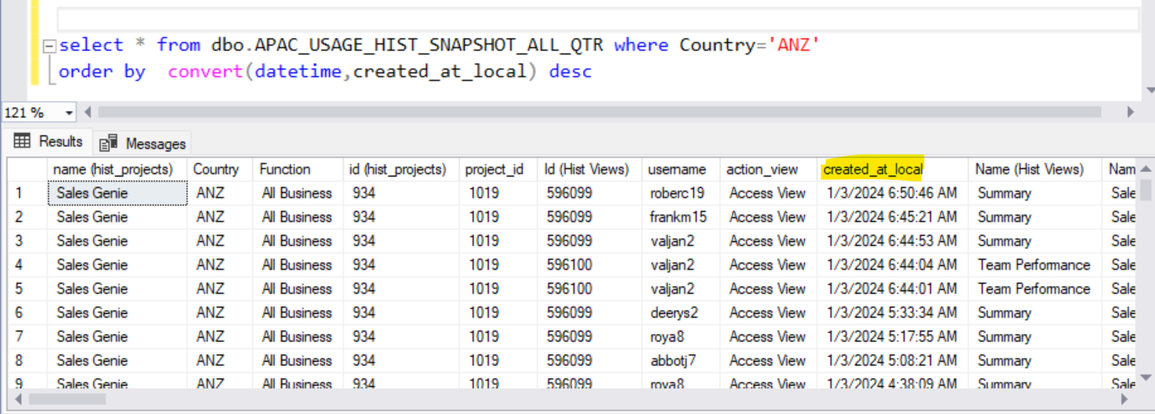

After checking for data created at local date and time then in excel sheet we need to filter the data according to created_at_local in sql.