**Evaluation Only. Created with Aspose.Words. Copyright 2003-2024 Aspose Pty Ltd.**

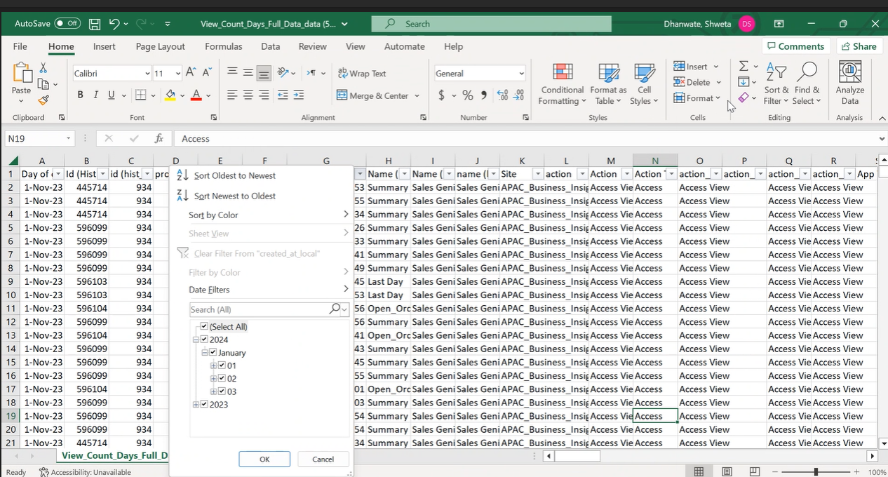

Then we need to take a filtered data in excel and copy that data in new excel sheet and save it.

After preparing the excel sheets for all regions open the remote desktop connection Go to à SSMS àCopy all excels and paste in Bang Account remote desktop. Go to SSMS à Connect to Test Environment.

Select Database ( APACBI_FIGO_SALES) à Right click àSelect Task à Import data

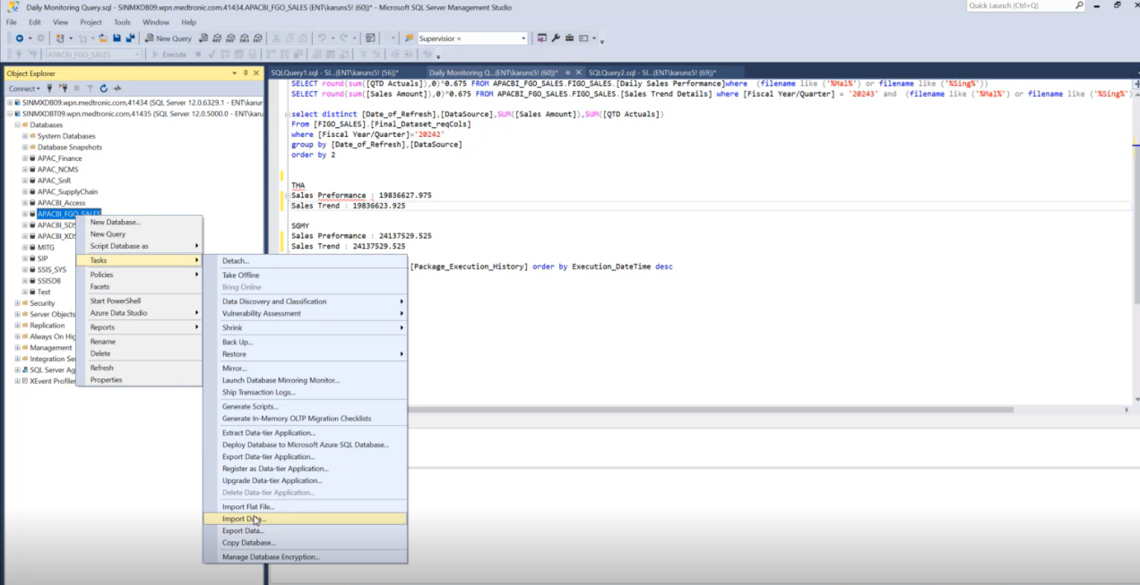

By clicking on import data, choose a data source window will appear as shown below.