**Evaluation Only. Created with Aspose.Words. Copyright 2003-2024 Aspose Pty Ltd.**

Select Data source as Micro soft excel àBrowse your excel sheet (single sheet at a time) àclick Next

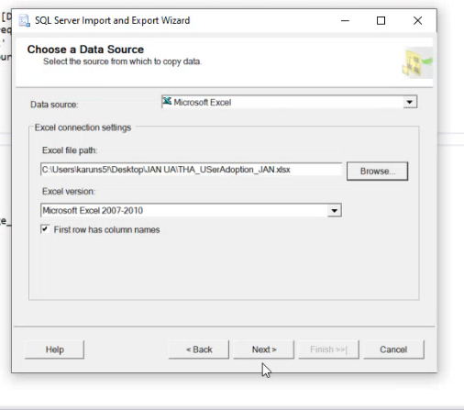

By clicking Next Choose a Destination Window will appear as shown below.

Select data base (SQL Server Native client 11.0) à Check for server name it should be Test Environment àClick Next

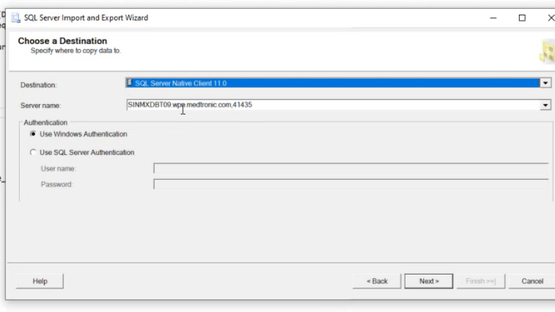

By Clicking Next Source Tables and Views Window will appear as shown below