**Evaluation Only. Created with Aspose.Words. Copyright 2003-2024 Aspose Pty Ltd.**

à Select destination as per region ()

* Japan / Korea:–[FIGO_SALES][korea_japan_usage]
* ANZ /TH/SGMY:-dbo.APAC_USAGE_HIST_SNAPSHOT_ALL_QTR
* NPI :–[FIGO_SALES][NPI_GENIE_Usage

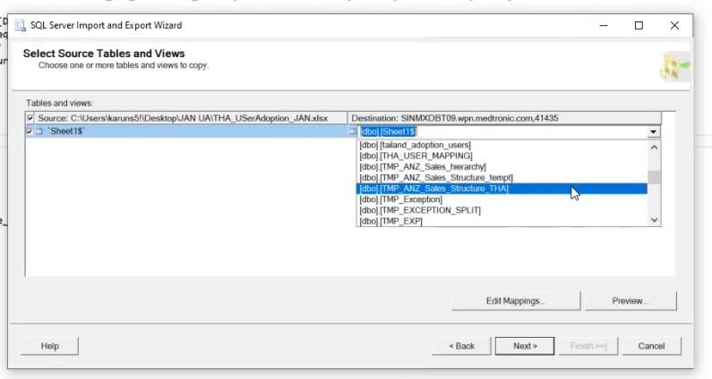

By Clicking Next à Column Mappings Window will appear as shown below. Here we need to check whether all the columns are mapped correctly à click Ok.

