**Evaluation Only. Created with Aspose.Words. Copyright 2003-2024 Aspose Pty Ltd.**

By Clicking Ok à The window will appear as shown below. This window will give the details of success rows.

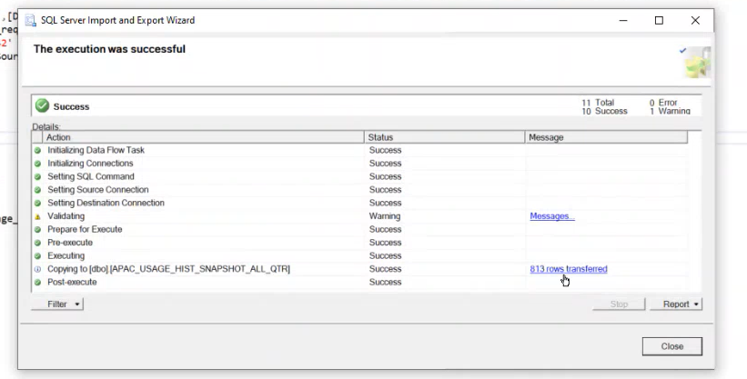

Now data is fully loaded

1) Check the users with NULL Comex IT Flag

select distinct SYSTEM_USERS_NAME, [Flag], Country from [APACBI_FGO_SALES].FIGO_SALES.Sales_Genie_User_Analytics where Flag is null and Country = ‘Japan’;

Note : select Country as per the region.

 2) Get the user details  as per the FIGO_SALES.ALL_SALES_GENIE_USERS format.

 2.1 Username & user id with below query.

select distinct  a.username, a.SALES_REP_NM from FIGO_SALES.APAC_SALES_STRUCTURES a  
join  FIGO_SALES.Sales_Genie_User_Analytics b on a.USERNAME = b.SYSTEM_USERS_NAME  
where a.USERNAME in (‘abadim3’)

 2.2 Fill in below columns as desired