
DEPARTMENT OF COMPUTER SCIENCE & ENGINEERING (AI & ML)

Heart Disease Prediction Project

A project report submitted to
MALLA REDDY UNIVERSITY
in partial fulfillment of the requirements for the award of degree of

BACHELOR OF TECHNOLGY
in
COMPUTER SCIENCE & ENGINEERING (AI & ML)

Submitted by

CH Varshith : 2111CS020620
H Varshith : 2111CS020621
D Varshitha : 2111CS020622
M Varshitha : 2111CS020623
T Varshitha : 2111CS020624
G Varun : 2111CS020625

Under the Guidance of

Sabyasachi
Asst.Professor

2023

COLLEGE CERTIFICATE

This is to certify that this is the bonafide record of the application development entitled,”HEART DISEASE PREDICTION PROJECT(HDP)” Submitted by CH Varshith(2111CS020620), H Varshith(2111CS020621), D Varshitha(2111CS020622), M Varshitha(2111CS020623), T Varshitha(2111CS020624), G Varun(2111CS020625), B. Tech II year II semester, Department of CSE (AI&ML) during the year 2022-23. The results embodied in the report have not been submitted to any other university or institute for the award of any degree or diploma.

PROJECT GUIDE HEAD OF THE DEPARTMENT

Prof. Sabyasachi Dr. Thayyaba Khatoon

CSE(AI&ML)

ACKNOWLEDGEMENT

We would like to take this opportunity to express my heartfelt gratitude to my Guide and Head of Department for their unwavering support, guidance, and encouragement throughout the development of this “Heart Disease Prediction Project”. Their expertise, valuable insights, and constructive feedback have been instrumental in shaping the project’s direction and ensuring its successful completion. Our sincere thanks to our guide, who have dedicated their time and effort to providing us with the necessary resources and knowledge to develop this project. Their constant motivation and assistance helped us overcome various challenges and ensured project’s timely completion. Additionally, We would like to thank the Head of Department for providing the necessary infrastructure and resources for the successful completion of this project. Once again, We extend our heartfelt appreciation and gratitude to all of them for their invaluable support and guidance.

CONTENTS

CHAPTER NO. | TITLE | PAGE NO.
1 | INTRODUCTION  - Abstract  1.3 Limitations of project | 6
2 | ANALYSIS  2.1Software requirement specification  2.1.1 Software requirement  2.1.2 Hardware requirement  2.2 Existing System  2.3 Proposed Systems  2.4 Modules  2.5 Architecture | 7-10
3 | - DESIGN:  3.1 DFD/ER/UML diagram(any other project diagram)  3.2 Data Set Descriptions  3.3 Methods & Algorithms  3.4 Building a Model | 11-15
4 | - DEPLOYMENT AND RESULTS  4.1 Source Code  4.2 Final Results
5 | CONCLUSION  5.1 Project conclusion  5.2 Future enhancement

1.INTRODUCTION

  - Introduction

A gym administration system project is a software application that helps gym owners and managers manage their gym operations. It can help with tasks such as membership management, scheduling classes and appointments, tracking attendance, billing and payments, and generating reports.

  - Abstract

Gyms are become the essential part of our lives, providing best exercise. Therefore, at the management end there are some necessary steps to maintain the records of every individual including trainer, trainees, and staff But maintaining the records on paper is very difficult So, it is necessary to have a computerized system that manages all these issues. Thus working on the administration system for Gym Industry are the basis of our project.

  - Limitations

  - Limited Hardware support – Since we have no information on how many users are going to access it, we may find the hardware support which is available will not be sufficient.
  - Data Security – Since this project will have some personal data of users including financial data that creates potential risks and we will need to ensure protection to secure data.
  - Maintenance & Updates – Once the system is live we will be needed to ensure that it is maintained and updated regularly to keep it running smoothly.

2.ANALYSIS

2.1 Software requirement specification
2.1.1 Software requirement
Python-
Python is an interpreted, object-oriented, high-level programming language with dynamic semantics. Its high-level built-in data structures, combined with dynamic typing and dynamic binding, make it very attractive for Rapid Application Development, as well as for use as a scripting or glue language to connect existing components together. Python is simple, easy to learn syntax emphasizes readability and therefore reduces the cost of program maintenance. Python supports modules and packages, which encourages program modularity and code reuse. The Python interpreter and the extensive standard library are available in source or binary form without charge for all major platforms, and can be freely distributed.

• Python is a popular programming language. It was created by Guido van
Rossum, and released in 1991.
It is used for-
• Web Development (Server-Side)
• Software Development
• Mathematics

MySQL-
MySQL, is required for Gym Administration System project using python because it is a popular relational database management system that can be used to store data such as member details, payment records, and gym equivalent inventory.

MySQL Connector-
MySQL Connector is required for Gym Administration system project using python because it a python driver that helps to integrate Python and MySQL. It allows the conversion between Python and MySQL datatypes.

2.1.2 Hardware requirement
The hardware requirements to run a gym administration project created using python are modest, and most modern computers should be able to handle the project’s demands without issue.

- Minimum RAM required – 4GB RAM

- Display – Monitor

- Input devices – Keyboard, Mouse

- Sufficient Storage

  - Existing System
- Existing system is a static website so you have to use file system to save record.
- Time consuming system.
- No proper system to make announcements.
- Important information can be missed while writing on page
- Inefficient and slow search.

  - Proposed System
- New proposed system allow to user to save record is database.
- Fast and easy to use
- An easy way to make a announcements.
- Full fledge information system.
- Efficient and proper availability of data.

  - Modules
- User Management
- Admin
- Membership management
- Communication and notifications management
- Package
- Trainer and equipment module

  - Architecture

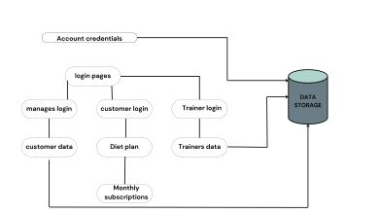

3.DESIGN
3.1 ER Diagram

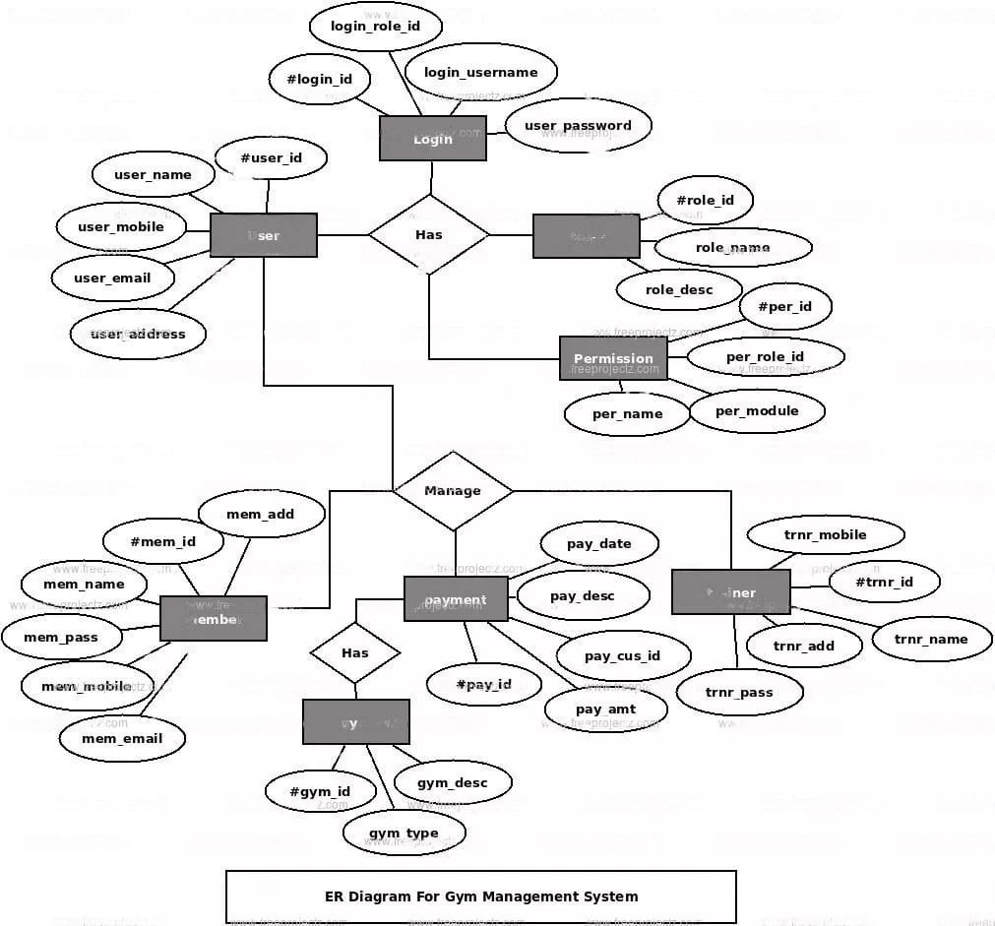

3.2 Data Set Descriptions

- Customer data: This might include information such as customer names, ages, genders, email addresses, phone numbers, and membership start and end dates.

- Package data: This might include information such as package names, prices, durations, and any additional features or services included in the package.

- Payment data: This might include information such as payment dates, amounts, payment methods, and any outstanding balances.

- Equipment data: This might include information about the gym's equipment inventory, such as equipment names, types, quantities, and maintenance schedules.

- Employee data: This might include information about gym employees, such as employee names, positions, contact information, and work schedules.

- Attendance data: This might include information about customer attendance, such as check-in and check-out times, visit dates, and any associated fees or penalties.

3.3 Model & Algorithms
There are several models and algorithms that can be used in a gym administration system. Here are some examples:

Membership Management Model: This model would include algorithms for managing member registration, tracking membership plans and payments, and handling cancellations or renewals.

Facility Management Model: This model would involve algorithms for managing gym facilities, such as tracking equipment maintenance and scheduling classes or personal training sessions.

Attendance Tracking Model: This model would include algorithms for tracking member attendance, which could be used for billing purposes, monitoring gym usage patterns, and ensuring that facilities are not overcrowded.

Personalization Model: This model would use machine learning algorithms to create personalized workout plans for each member, based on their fitness goals, health history, and other factors.

Customer Relationship Management (CRM) Model: This model would include algorithms for managing customer interactions, such as tracking inquiries and complaints, handling feedback, and improving customer satisfaction.

Predictive Maintenance Model: This model would use machine learning algorithms to predict when gym equipment may need maintenance or repair, which could help reduce downtime and improve member satisfaction.

Fraud Detection Model: This model would use algorithms to detect and prevent fraudulent activity, such as fake memberships or stolen credit card information.

Resource Optimization Model: This model would involve algorithms for optimizing the utilization of gym resources, such as equipment, staff, and facilities, to reduce costs and increase efficiency.

Marketing Model: This model would involve algorithms for targeted marketing campaigns, such as offering promotions to members who have not visited the gym in a while or sending personalized emails to members who have achieved certain fitness goals.

Performance Tracking Model: This model would include algorithms for tracking member progress over time, such as measuring weight loss, muscle gain, or cardiovascular endurance, and providing feedback to members and trainers.

3.4 Building a model

Identify the requirements: Before building the model, it is essential to understand the requirements of the gym administration system. This includes identifying the features and functionalities that the system should have, such as member registration, scheduling classes, managing staff, tracking inventory, and processing payments.

Design the data model: Once the requirements are identified, the next step is to design the data model. This involves creating a schema or blueprint of the database that will store all the relevant information. The data model should be designed in a way that allows for efficient querying and retrieval of data.

Develop the user interface: The user interface is the front-end of the gym administration system that users interact with. It should be designed to be intuitive, user-friendly, and visually appealing. The user interface should provide access to all the features and functionalities of the system.

Implement the backend: The backend is the part of the system that processes user requests and manages data storage and retrieval. This involves developing the server-side code and integrating it with the database.

Test and deploy: Once the gym administration system is built, it should be thoroughly tested to ensure that it is working as expected. Any bugs or issues should be identified and fixed before deployment. The system can then be deployed on the production server, and users can start using it.

Maintain and update: After deployment, it is important to maintain and update the system regularly. This includes fixing any bugs, adding new features, and ensuring that the system is secure and up-to-date with the latest technologies.

