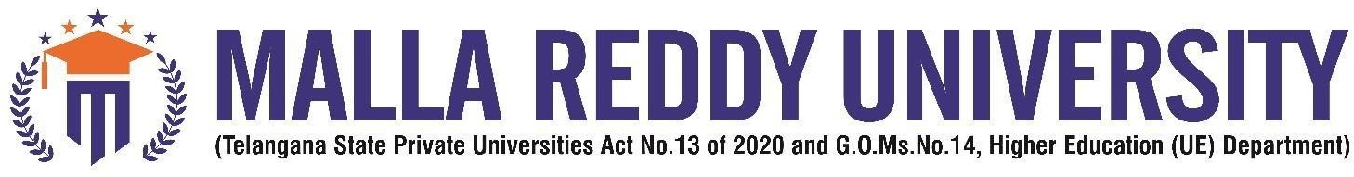

COLLEGE CERTIFICATE

This is to certify that this is the bonafide record of the application development entitled,” HEART DISEASE PREDICTION” Submitted by D Varshitha(2111CS020622),B. Tech III year I semester, Department of CSE (AI&ML) during the year 2022-23. The results embodied in the report have not been submitted to any other university or institute for the award of any degree or diploma.

PROJECT GUIDE HEAD OF THE DEPARTMENT

Prof. Dr. Komati Satish Dr. Thayyaba Khatoon

CSE(AI&ML)

EXTERNAL EXAMINER

