ASSIGNMENT-3.1

Question 1: Zero-Shot Prompting (Palindrome Number Program)
Write a zero-shot prompt (without providing any examples) to generate
a Python function that checks whether a given number is a palindrome.
Task:
• Record the AI-generated code.
• Test the code with multiple inputs.
• Identify any logical errors or missing edge-case handling.
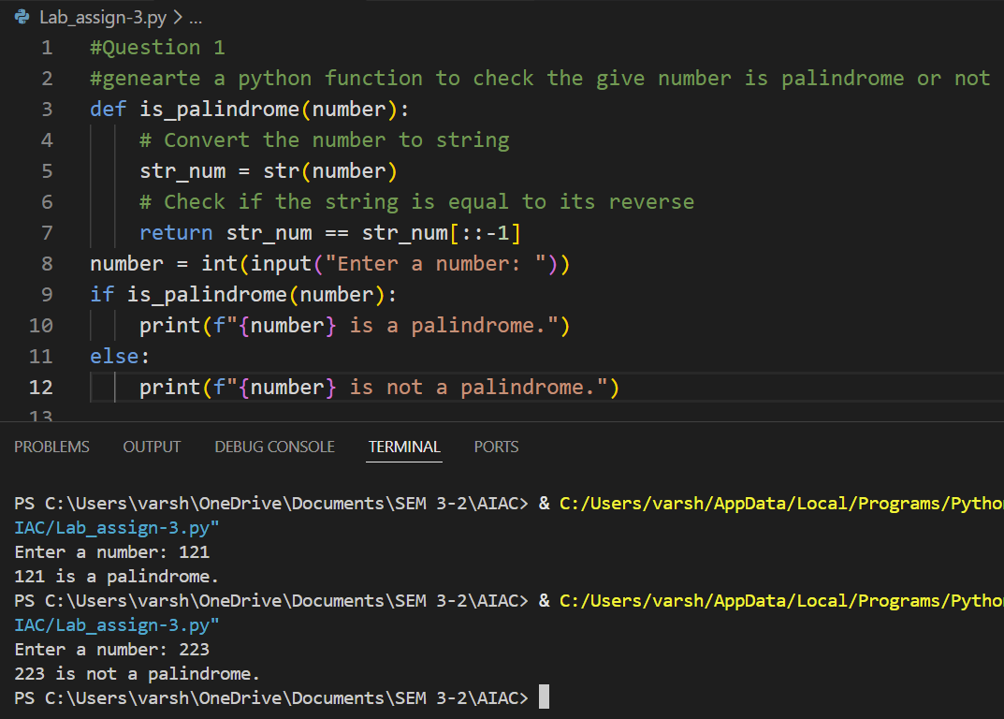
Explanation:
Zero-shot prompting relies only on instructions without examples.
It evaluates basic reasoning and may miss edge cases like negatives.
--------------------------------------------------------------------------------------------------------------------------------------
Question 2: One-Shot Prompting (Factorial Calculation)
Write a one-shot prompt by providing one input-output example and
ask the AI to generate a Python function to compute the factorial of a
given number.
Example:
Input: 5 → Output: 120
Task:
• Compare the generated code with a zero-shot solution.
• Examine improvements in clarity and correctness.
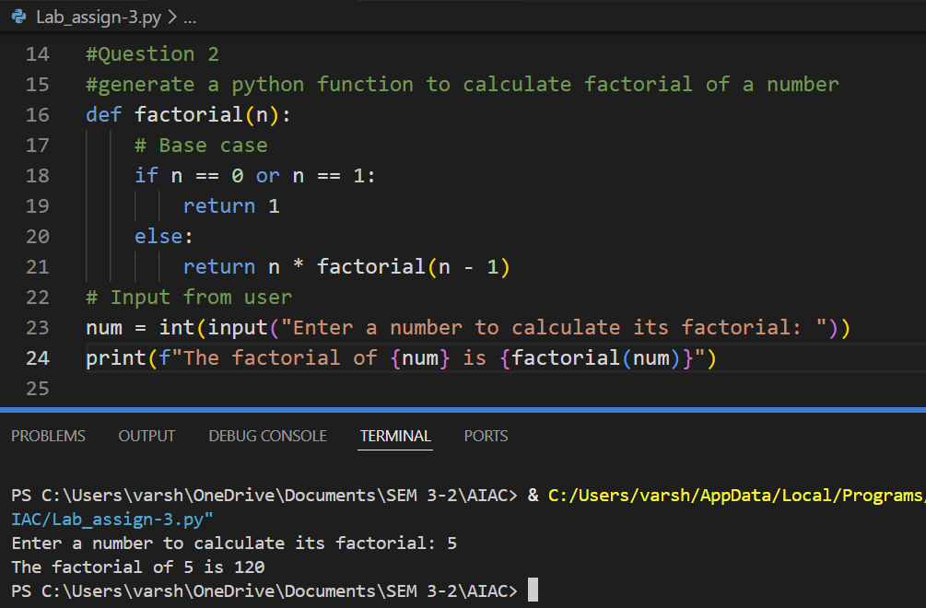
Explanation:
One example helps the AI understand expected logic.
Improves correctness and handling of base cases.
--------------------------------------------------------------------------------------------------------------------------------------
Question 3: Few-Shot Prompting (Armstrong Number Check)
Write a few-shot prompt by providing multiple input-output examples
to guide the AI in generating a Python function to check whether a
given number is an Armstrong number.
Examples:
• Input: 153 → Output: Armstrong Number
• Input: 370 → Output: Armstrong Number
• Input: 123 → Output: Not an Armstrong Number
Task:
• Analyze how multiple examples influence code structure and
accuracy.
• Test the function with boundary values and invalid inputs.
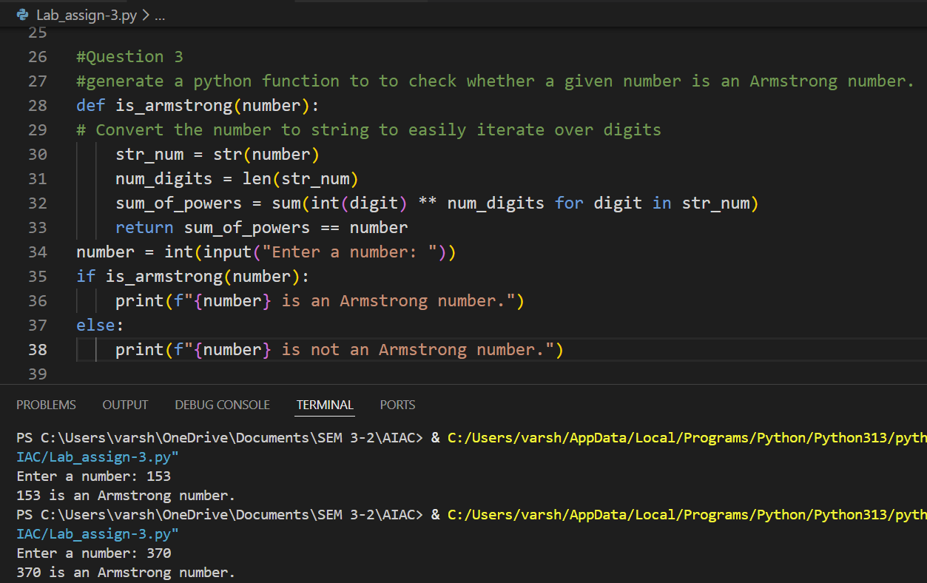
Explanation:
Few-shot prompting uses multiple examples to strongly guide the AI’s understanding of the pattern and logic.
This results in improved accuracy, clearer structure, and better handling of boundary and test cases.
--------------------------------------------------------------------------------------------------------------------------------------
Question 4: Context-Managed Prompting (Optimized Number
Classification)
Design a context-managed prompt with clear instructions and
constraints to generate an optimized Python program that classifies a
number as prime, composite, or neither.
Task:
• Ensure proper input validation.
• Optimize the logic for efficiency.
• Compare the output with earlier prompting strategies.
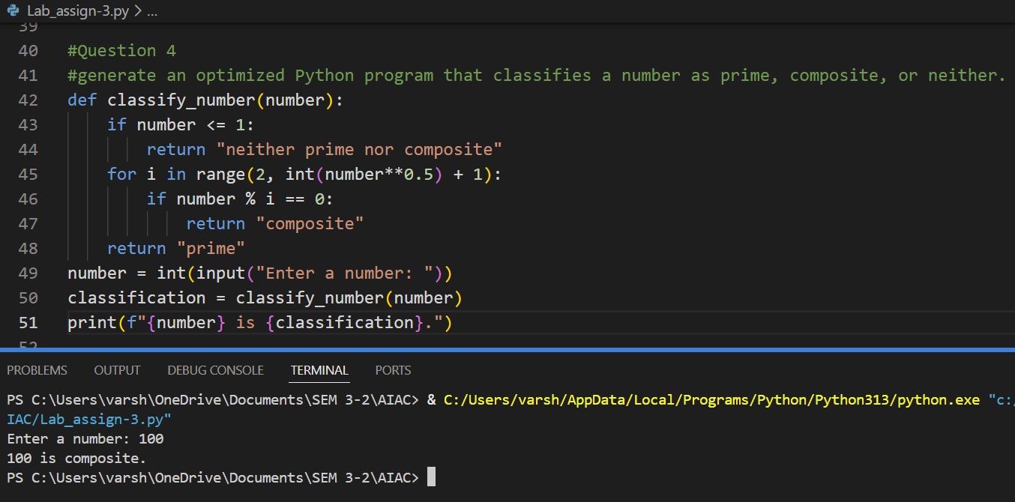
Explanation:
Context-managed prompting includes constraints like efficiency and validation, leading to optimized and robust code.
It encourages better design choices compared to basic prompting strategies.
--------------------------------------------------------------------------------------------------------------------------------------
Question 5: Zero-Shot Prompting (Perfect Number Check)
Write a zero-shot prompt (without providing any examples) to
generate a Python function that checks whether a given number is a
perfect number.
Task:
• Record the AI-generated code.
• Test the program with multiple inputs.
• Identify any missing conditions or inefficiencies in the logic.
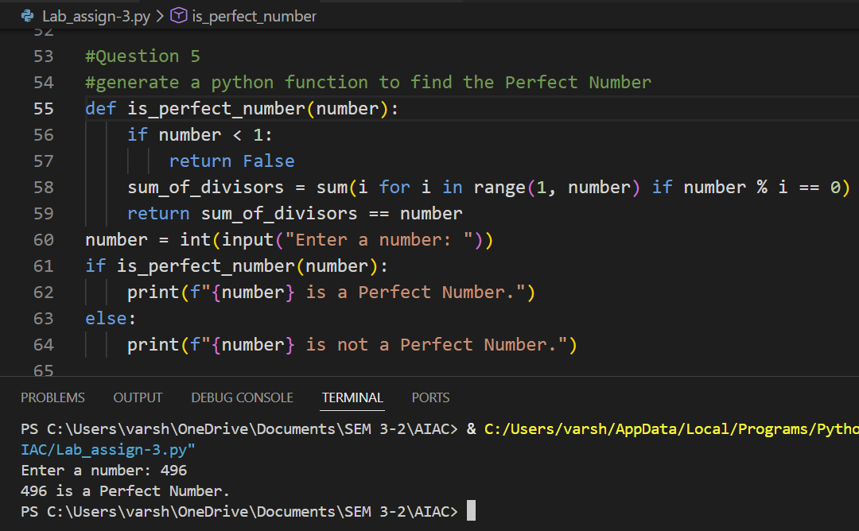
Explanation:
In zero-shot prompting, the AI generates logic without examples, which may lead to inefficiencies or missing checks.
Testing helps identify flaws such as incorrect divisor handling or performance issues.
--------------------------------------------------------------------------------------------------------------------------------------
Question 6: Few-Shot Prompting (Even or Odd Classification with
Validation)
Write a few-shot prompt by providing multiple input-output
examples to guide the AI in generating a Python program that
determines whether a given number is even or odd, including proper
input validation.
Examples:
• Input: 8 → Output: Even
• Input: 15 → Output: Odd
• Input: 0 → Output: Even
Task:
• Analyze how examples improve input handling and output
clarity.
• Test the program with negative numbers and non-integer inputs.
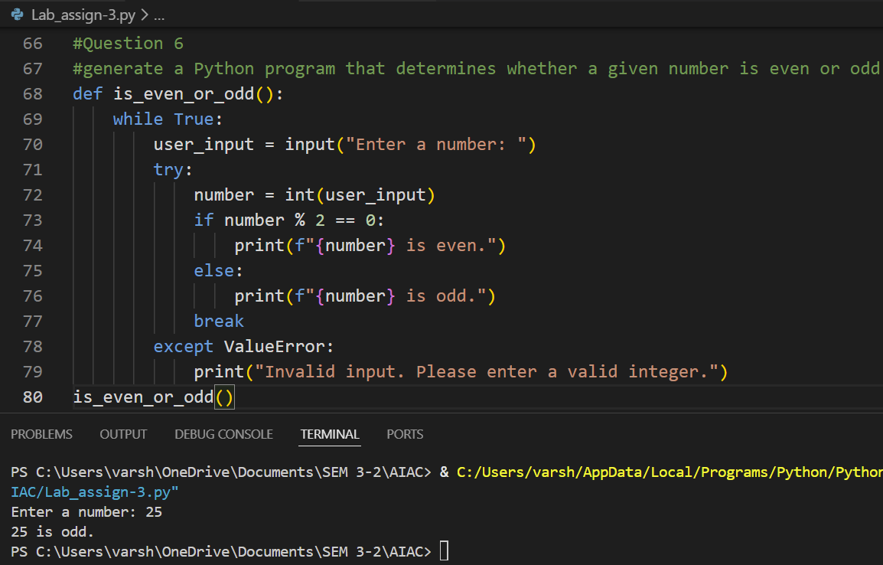
Explanation:
Providing multiple examples improves the AI’s understanding of edge cases and input validation.
This results in clearer outputs and better handling of negative and non-integer inputs.

