ASSIGMENT-6.1
Name:M Varshith Reddy
HTNO:2303A52087

Task Description #1 (AI-Based Code Completion for Loops)
Task: Use an AI code completion tool to generate a loop-based
program.
Prompt:
“Generate Python code to print all even numbers between 1 and N
using a loop.”
Expected Output:
• AI-generated loop logic.
• Identification of loop type used (for or while).
• Validation with sample inputs.
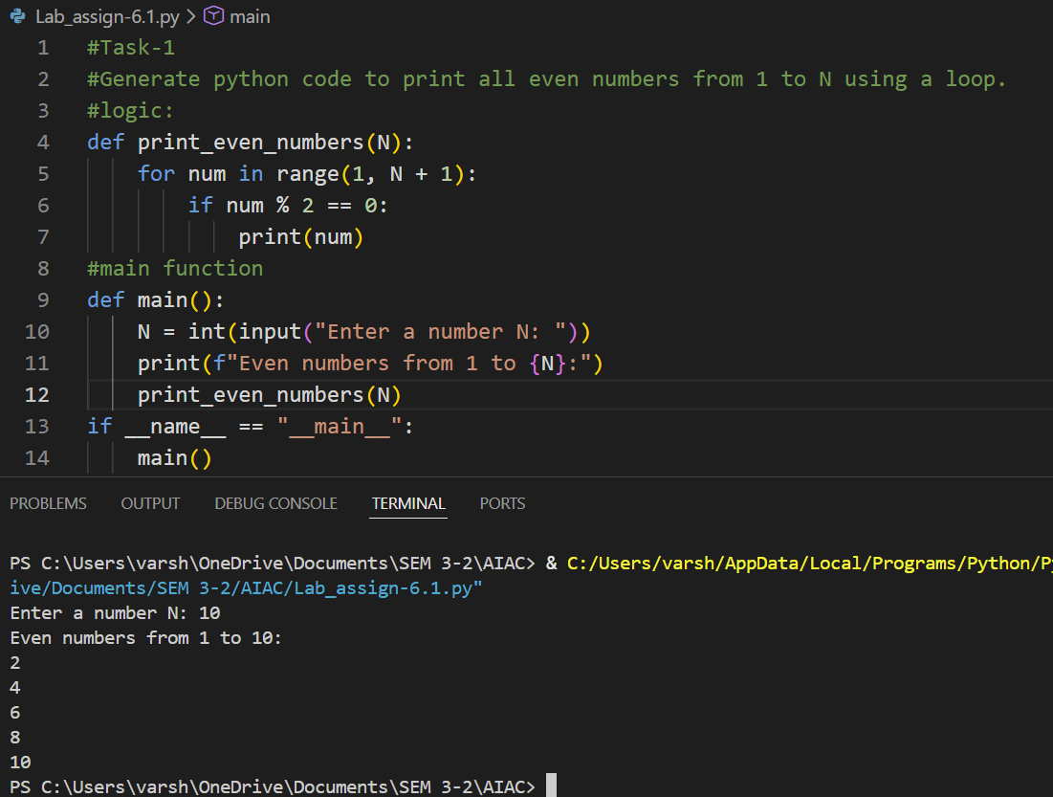
Explanation: This task uses an AI code completion tool to generate a Python program based on loops.
The AI generates loop logic (using a for or while loop) to print all even numbers between 1 and a given number N.
The loop iterates through the range and checks for even numbers.
Sample input values are used to validate that the output is correct.
--------------------------------------------------------------------------------------------------------------------------------------
Task Description #2 (AI-Based Code Completion for Loop with
Conditionals)
Task: Use an AI code completion tool to combine loops and
conditionals.
Prompt:
“Generate Python code to count how many numbers in a list are even
and odd.”
Expected Output:
• AI-generated code using loop and if condition.
• Correct count validation.
• Explanation of logic flow.
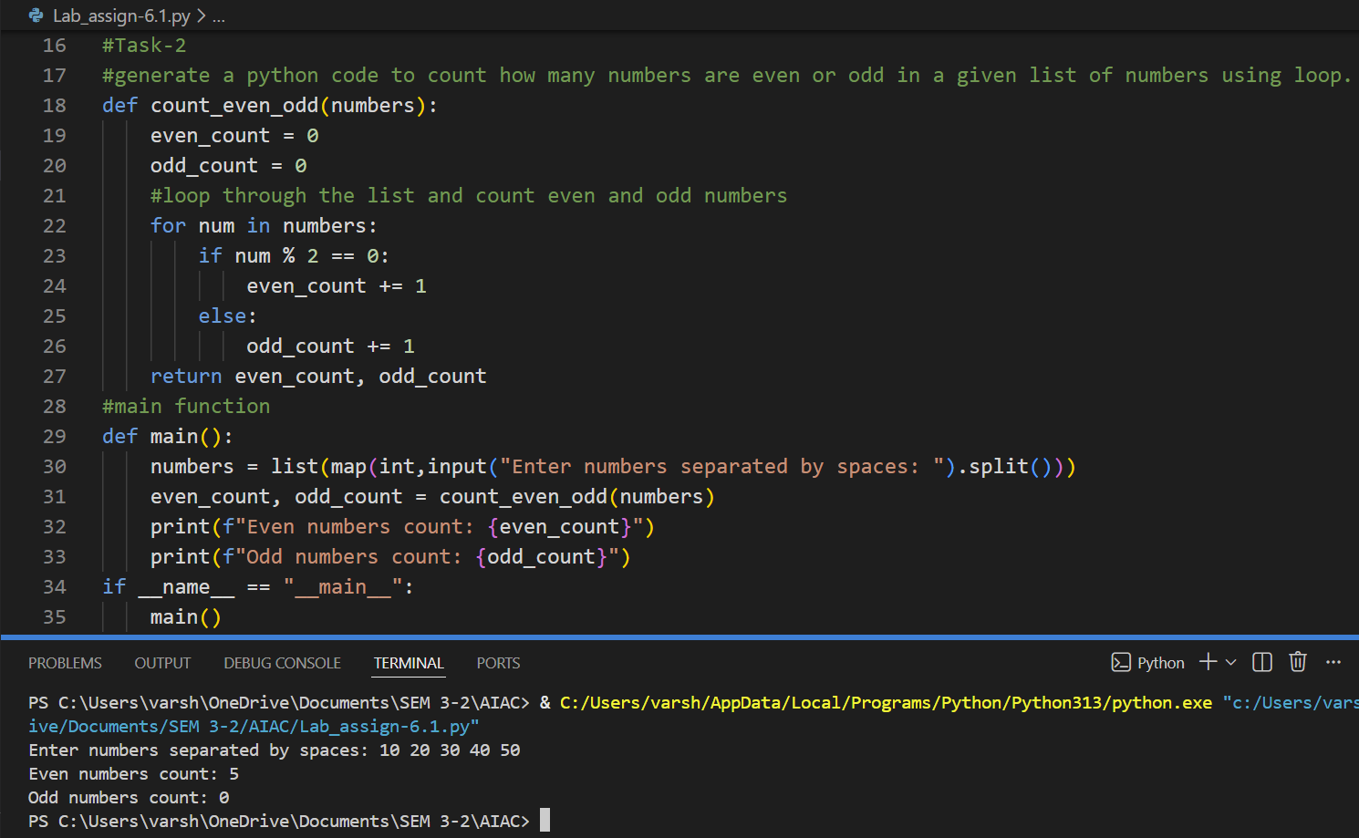
Explanation: This task uses AI to generate Python code that combines a loop with conditional statements.
The loop iterates through a list of numbers, and if-else conditions check whether each number is even or odd.
Counters are updated accordingly to keep track of totals.
Sample inputs are used to verify that the logic produces correct counts.
--------------------------------------------------------------------------------------------------------------------------------------
Task Description #3 (AI-Based Code Completion for Class
Attributes Validation)
Task: Use an AI tool to complete a Python class that validates user
input.
Prompt:
“Generate a Python class User that validates age and email using
conditional statements.”
Expected Output:
• AI-generated class with validation logic.
• Verification of condition handling.
• Test cases for valid and invalid inputs.
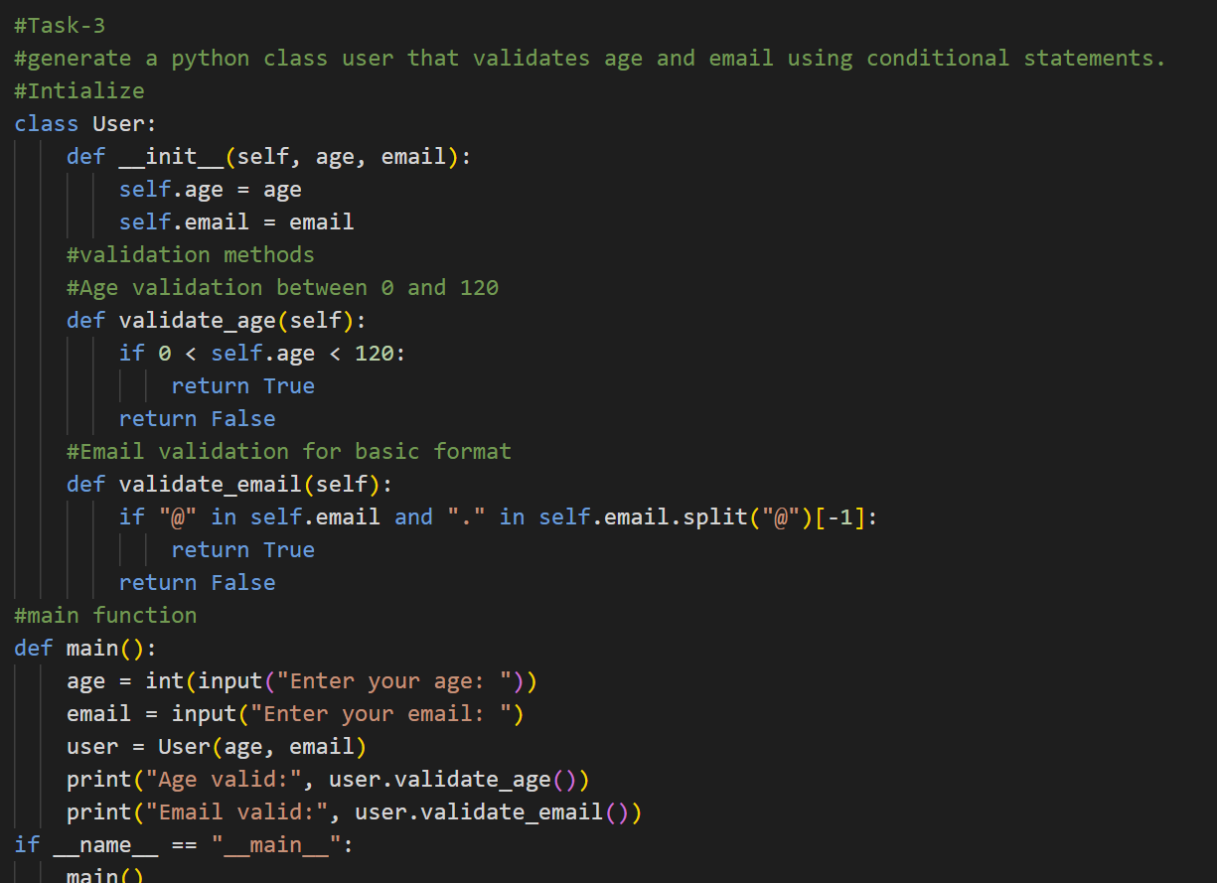
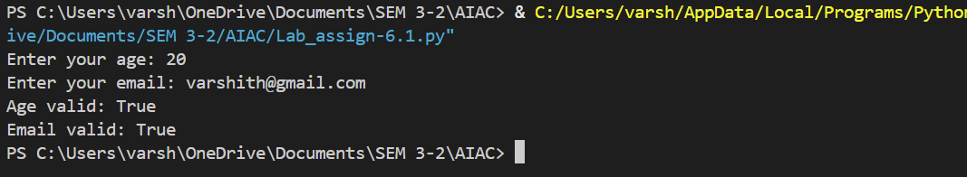
Explanation: In this task, AI generates a Python class that validates user inputs using conditional statements.
The User class checks whether the age is valid and if the email follows a proper format.
Conditions handle both valid and invalid cases gracefully.
Test cases confirm that the validation logic works correctly.
--------------------------------------------------------------------------------------------------------------------------------------
Task Description #4 (AI-Based Code Completion for Classes)
Task: Use an AI code completion tool to generate a Python class for
managing student details.
Prompt:
“Generate a Python class Student with attributes (name, roll number,
marks) and methods to calculate total and average marks.”
Expected Output:
• AI-generated class code.
• Verification of correctness and completeness of class
structure.
• Minor manual improvements (if needed) with justification.
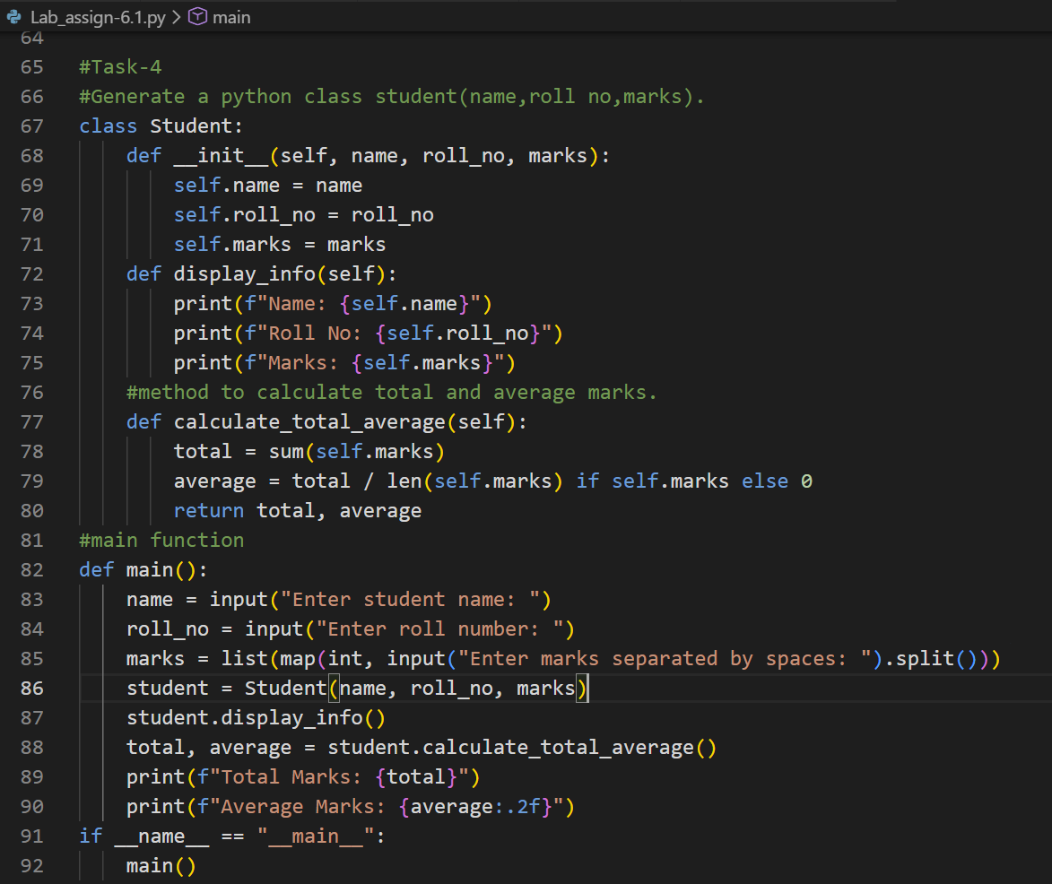
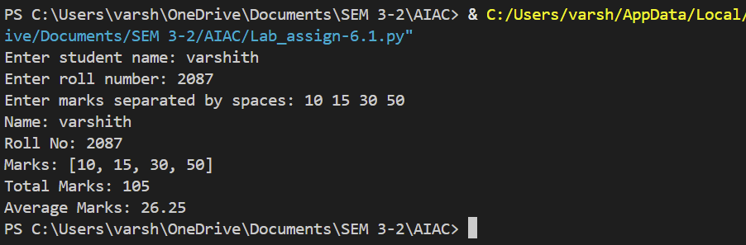
Explanation: This task involves generating a Python class to manage student details using AI assistance.
The Student class includes attributes such as name, roll number, and marks.
Methods are implemented to calculate total and average marks.
Minor improvements may be added to enhance clarity, efficiency, or error handling.

Task Description 5 (AI-Assisted Code Completion Review)
Task: Use an AI tool to generate a complete Python program using
classes, loops, and conditionals together.
Prompt:
“Generate a Python program for a simple bank account system using
class, loops, and conditional statements.”
Expected Output:
• Complete AI-generated program.
• Identification of strengths and limitations of AI suggestions.
• Reflection on how AI assisted coding productivity.

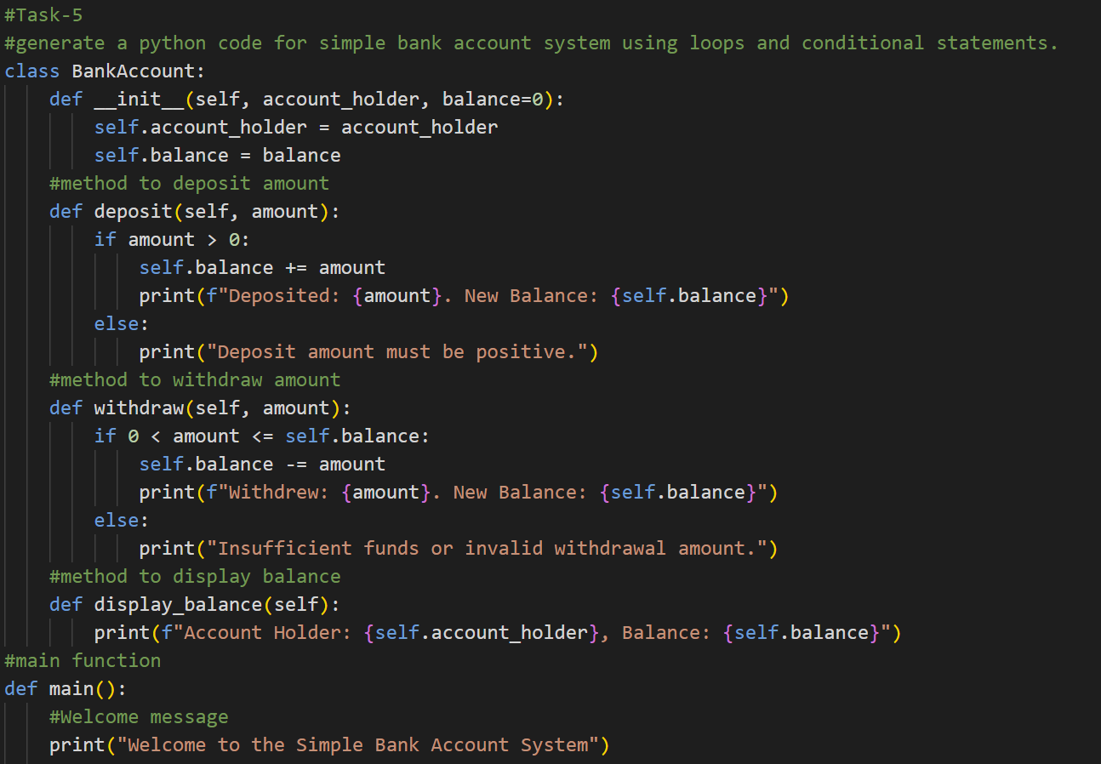
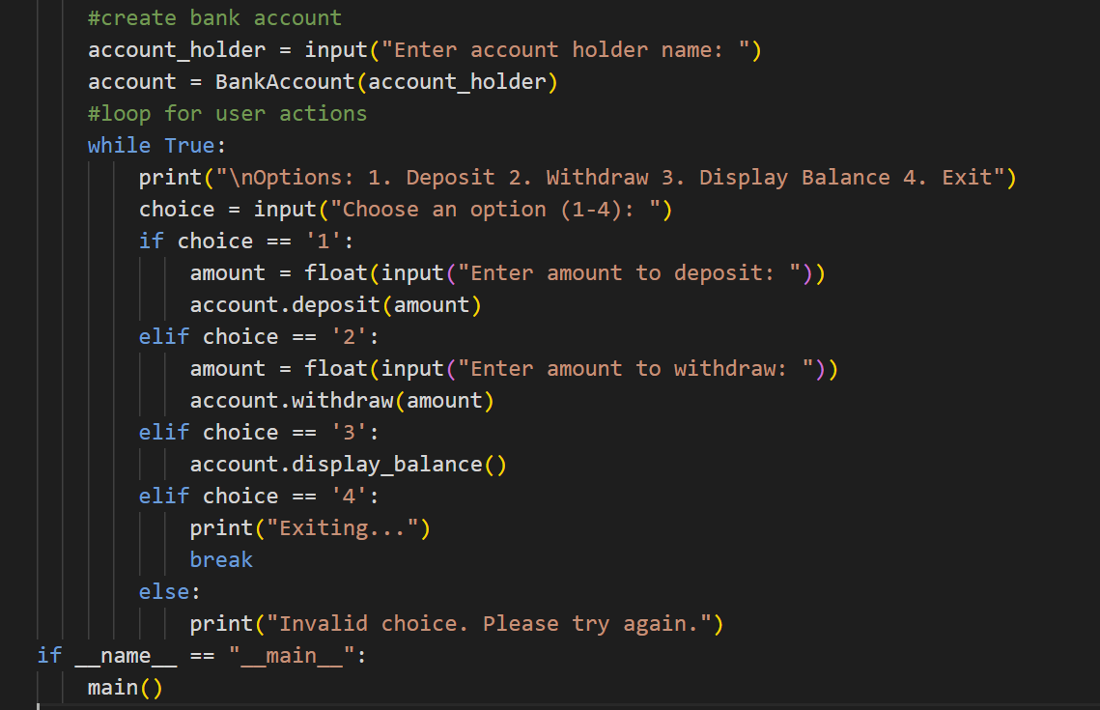
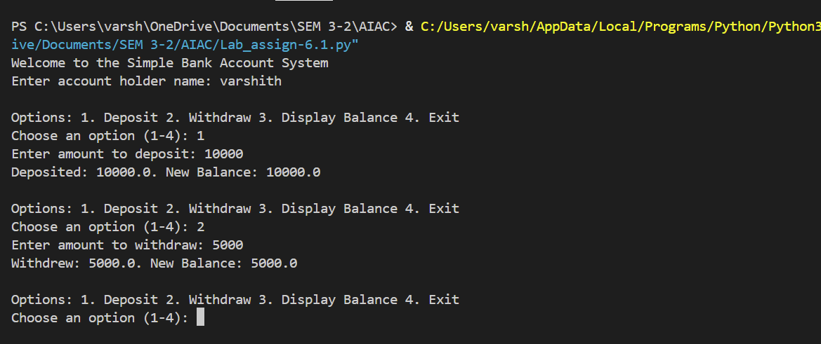
Explanation: This task uses AI to generate a complete Python program that integrates classes, loops, and conditionals.
The bank account system handles operations like deposit, withdrawal, and balance checking.
The strengths and limitations of AI-generated code are analyzed.
Finally, reflection highlights how AI improves coding speed and productivity.

