Federated Learning Based Face and Eye Blink Recognition

In this paper author has utilized OpenCv2 algorithms for user authentication by employing multi models like Face Recognition and Eye blinks pattern. To implement this project author has given following modules

1. Face Registration: here user has to enter his name and then connect to webcam to detect face and during webcam user has to press ‘q’ key from keyboard so algorithm will detect face and then trained model with detected face and given username
2. Eye blink training: in this second process user has to view on webcam and then blink eye for desired number of times to set password and once done desired blinks then press ‘q’ key from keyboard to train model with eye blinks.
3. Federated Update Model to Server: models which train locally then update to server as global models so all clients can use this updated model without sending its users details
4. Face Authentication: while authentication user has to show face in webcam and then press ‘q’ to go for authentication and once authentication successful then another webcam will open to track eye blinks and once blinks matched with trained model then application will authenticate user and terminate webcam.

Above modules you can run continuously to train all users.

SCREEN SHOTS

To run project double click on ‘runServer.bat’ file to start global model server and get below screen

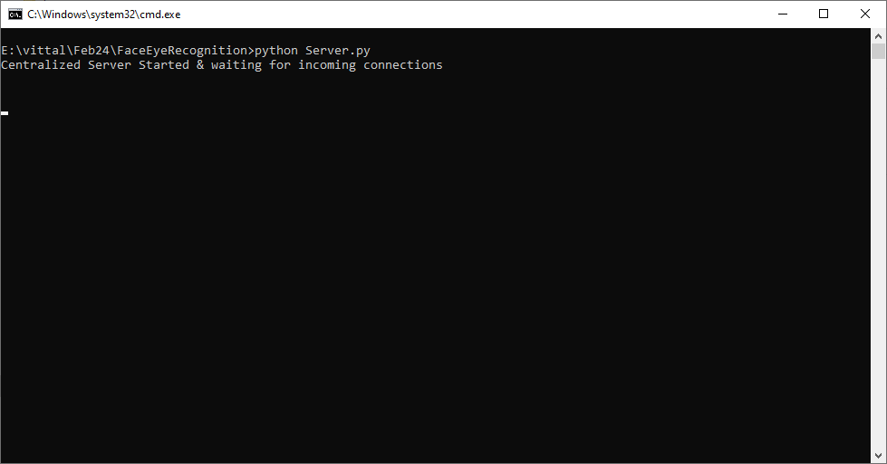

In above screen global centralized federated server started and now double click on ‘run.bat’ to start client application for training

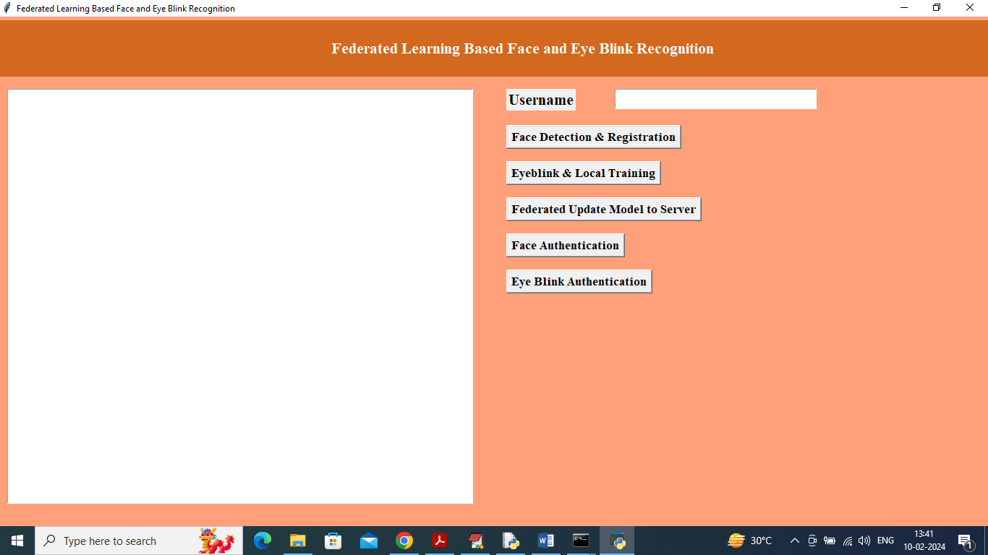

In above screen enter some username and then click on ‘Face Detection & Registration’ button to train model with given face and username.

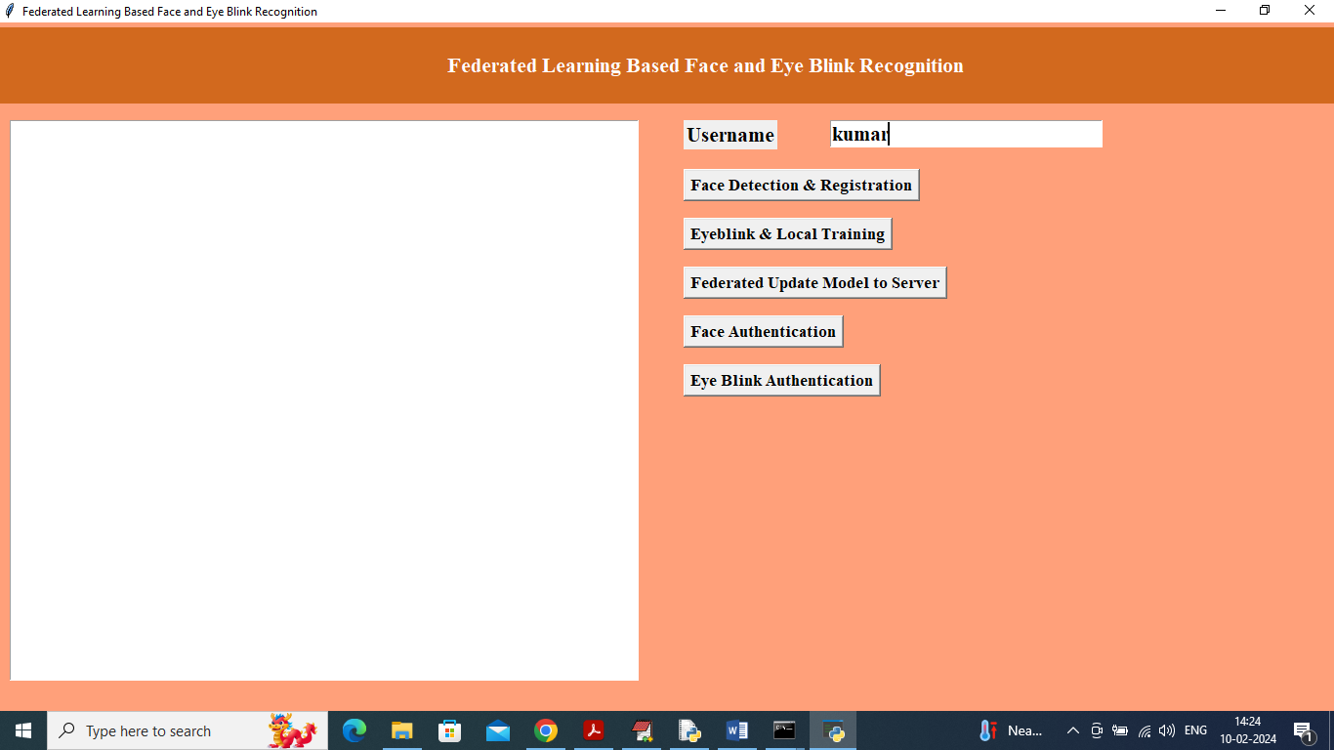

In above screen I entered username as ‘kumar’ and then press ‘face Detection’ button to get below output

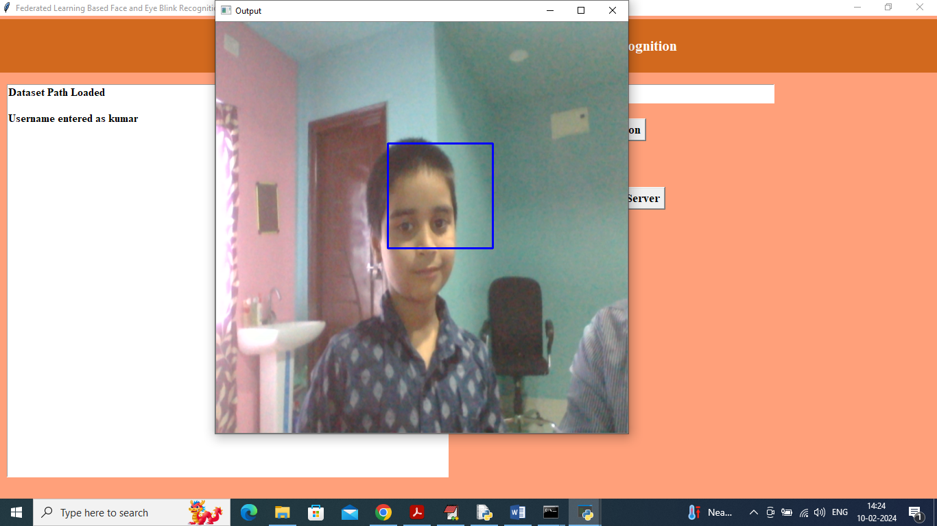

In above screen webcam started and detecting face and now press ‘q’ key to train face model with given username and get below output

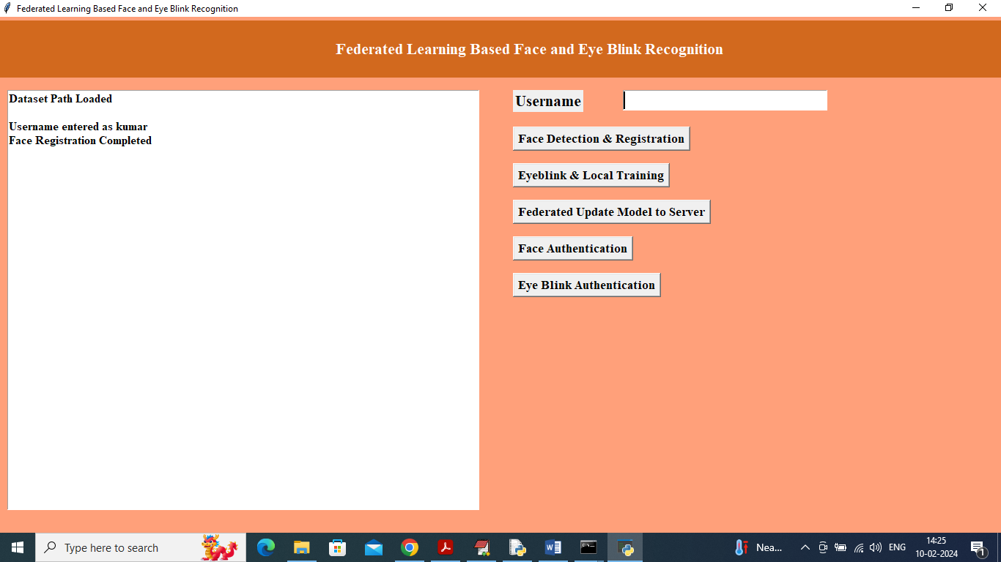

In above screen face training and registration completed and now click on ‘Eye blink and Local Training’ button to train model with eye blinks locally and get below output

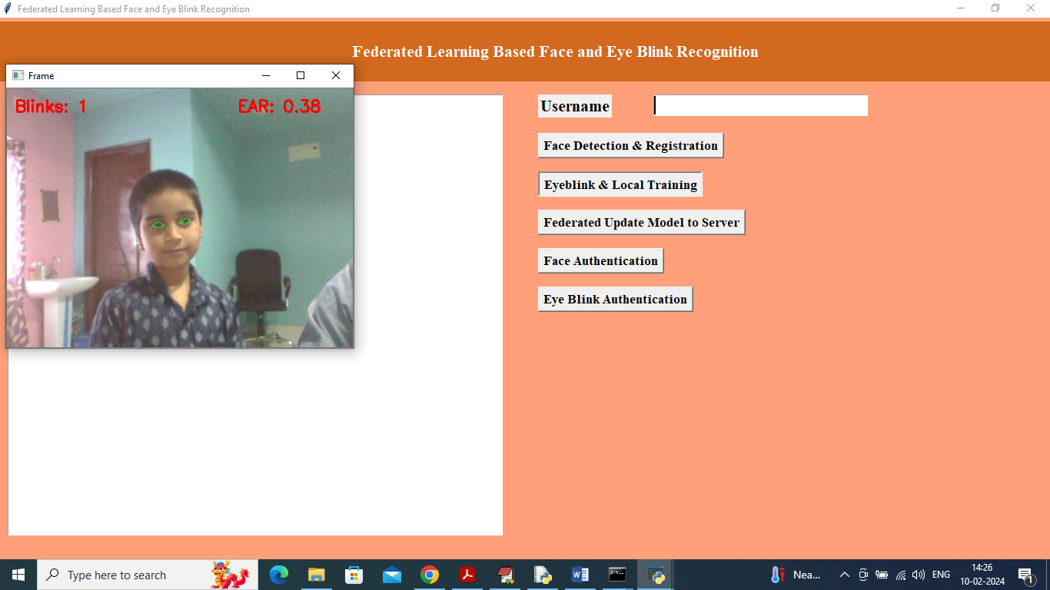

In above screen webcam started and detected eyes and now blink eyes with desired number of count and then press ‘q’ key to train model with given username and eye blink count and get below output



In above screen face and eye blink training completed with username as kumar. Now click on ‘Federated Update Model to Server’ button to update model to server and get below output

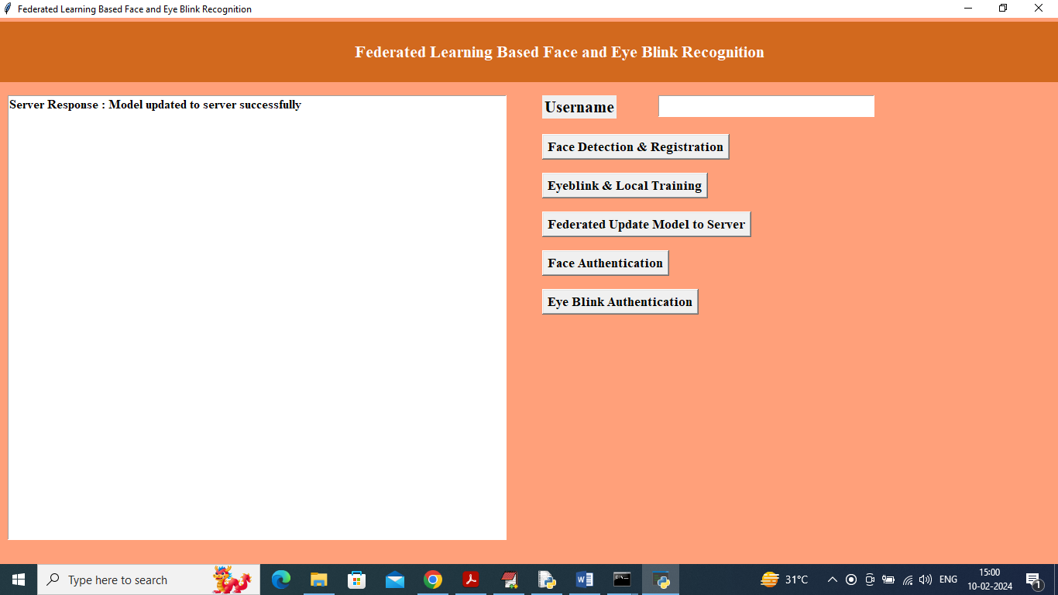

In above screen federated model learning and updating completed and now click on ‘Face Authentication’ button to start webcam and then will get below output

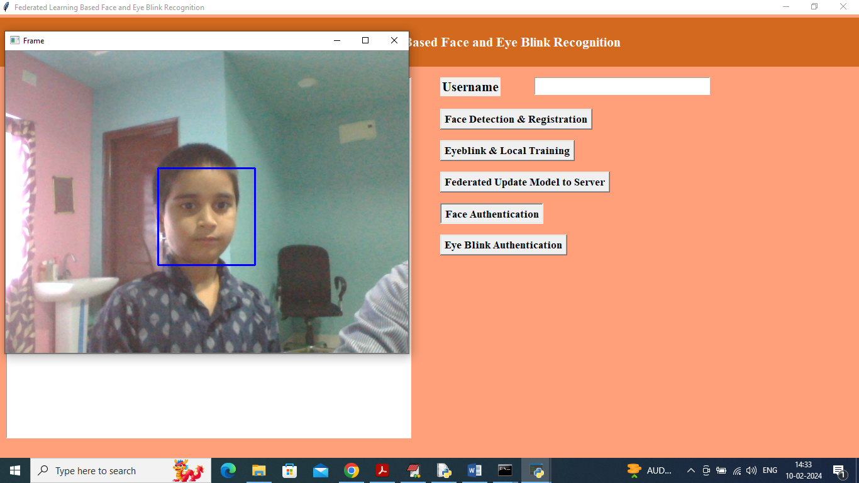

In above screen face detection for recognition started and now click ‘q’ key to authenticate face and get below output

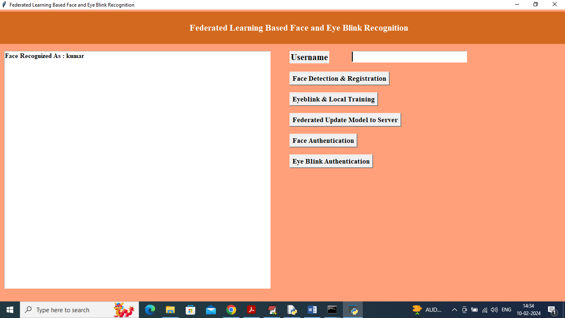

In above screen ‘Face Recognized as Kumar’ and now another webcam will started to detect eye blinks and get below output

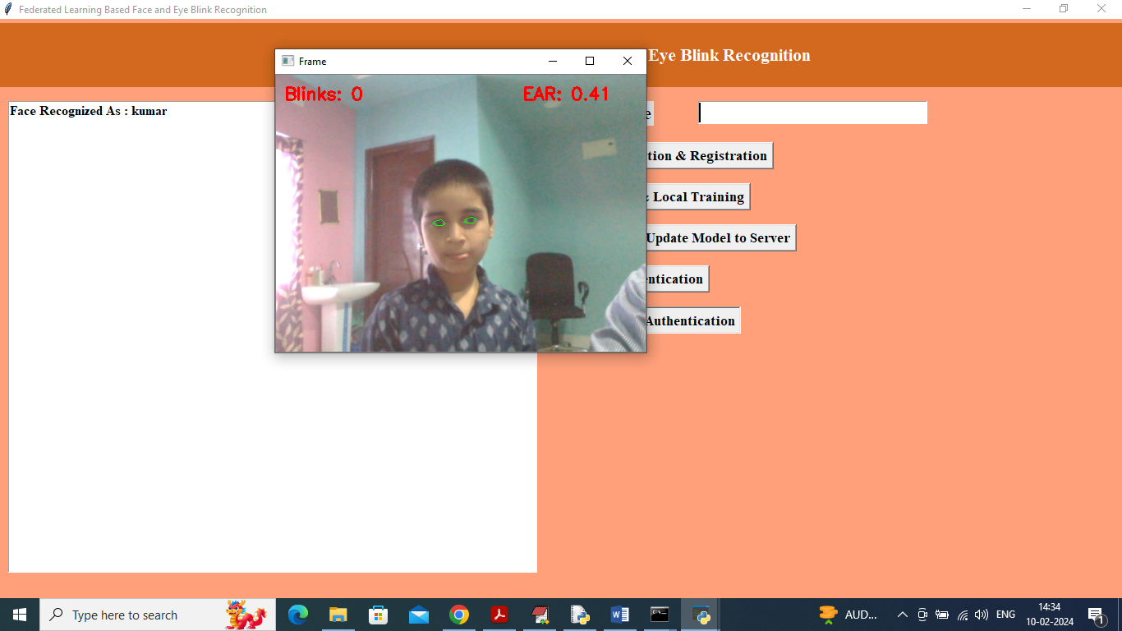

In above screen model start recognizing user by using eye blink patterns and count and once user recognized then will get below output.

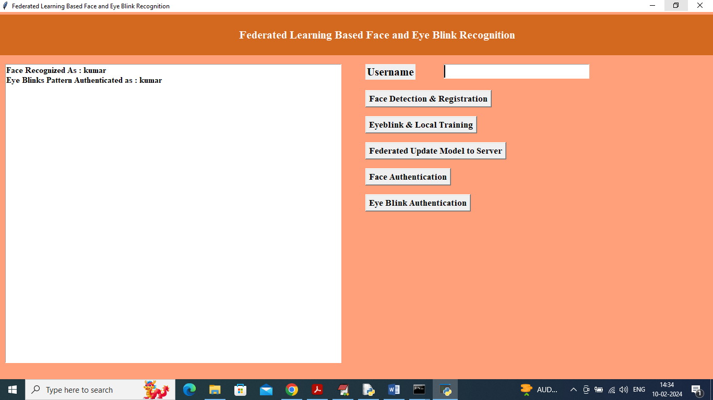

In above screen can see both face and eye blink pattern recognized as ‘kumar’.

Similarly by following above screens you can register and recognized any number of users