

Executive Summary
This report outlines the development and deployment of two distinct machine learning pipelines designed to solve core business challenges: Asset Valuation (Regression) and Risk Profiling (Classification). By leveraging data preprocessing, feature engineering, and predictive modeling, these projects demonstrate how data-driven methodologies can replace intuition-based decision-making to optimize pricing strategies and forecast critical outcomes. Together, these pipelines demonstrate a complete end-to-end analytical capability, proving that the underlying mathematics of machine learning can successfully transform raw data into actionable commercial intelligence, whether forecasting capital asset liquidation values or mitigating binary enterprise risks.

Abstract
In data-driven enterprises, machine learning is primarily deployed to solve two overarching problems: forecasting continuous numerical values (such as price or revenue) and predicting discrete categorical outcomes (such as failure or survival). This report presents a dual-project portfolio demonstrating both capabilities. The first pipeline tackles an Asset Valuation problem by using regression algorithms to predict automotive prices based on technical and historical specifications. The second pipeline addresses Risk Mitigation by using classification algorithms on the historical Titanic dataset to predict passenger survival. The workflow covers exploratory data analysis, missing-data imputation, feature encoding, feature scaling, and model evaluation across linear, kernel, and ensemble algorithms (including Random Forest, Gradient Boosting, XGBoost, LightGBM, AdaBoost, and Support Vector Machines). Key methodological differences between regression and classification are analyzed, alongside the translation of these models into enterprise business value.

Table of Contents
Executive Summary 2
Abstract 2
Table of Contents 3
1. Introduction 4
1.1 Background and Motivation 4
1.2 Problem Statement 4
1.3 Objectives of the Study 4
2. Literature Review and Background 4
2.1 Basic Explanation: Regression vs. Classification 4
2.2 Methodological Comparison 5
3. Dataset Description 5
3.1 Automobile Price Dataset (Regression) 5
3.2 Titanic Survival Dataset (Classification) 5
4. Methodology 5
4.1 Data Preprocessing & Missing Data Imputation 5
4.2 Feature Engineering & Encoding 6
4.3 Feature Scaling 6
4.4 Target Transformation (Automobile Regression) 6
4.5 Model Development Strategy 6
5. Results and Discussion 7
5.1 Regression Results (Automobile Asset Valuation) 7
5.2 Classification Results (Titanic Risk Profiling) 9
5.3 Interpretation 10
6. Challenges Faced and Solutions 11
7. Business Insights and Recommendations 11
From Regression (Asset Valuation): 11
From Classification (Risk Mitigation): 11
8. Limitations 12
9. Conclusion 12
10. Future Work 12
11. References 13
Appendix A: Key Code Listings 14
A.1 Automobile Regression — Tiered Imputation Pipeline 14
A.2 Automobile Regression — Log-Target Model & Cross-Validation 14
A.3 Titanic Classification — Standardized Model Leaderboard 14

1. Introduction

1.1 Background and Motivation
Modern enterprises generate massive volumes of data, but raw data alone does not drive business strategy. Machine learning allows organizations to extract predictive patterns from this data. In asset-heavy industries, accurately pricing inventory (whether vehicles, machinery, or commodities) is critical for capital efficiency. Simultaneously, identifying the risk profile of an entity (whether a customer churning, a machine failing, or a safety incident occurring) is essential for operational stability. This project tackles both scenarios using supervised machine learning.

1.2 Problem Statement
This report addresses two distinct predictive challenges:
- Asset Valuation (Regression): Given a dataset of used automobiles, build a model to dynamically predict their market value based on features like mileage, engine size, and age.
- Risk Profiling (Classification): Given the Titanic passenger dataset, build a model to predict the binary outcome of survival based on demographic and structural risk factors like ticket class, gender, and fare.

1.3 Objectives of the Study
- Explain the fundamental differences between Regression and Classification architectures.
- Clean and preprocess varied datasets, handling missing values and varied data scales appropriately.
- Build and evaluate baseline and advanced models for both problems (e.g., Linear/Logistic Regression, Random Forest, XGBoost, AdaBoost, SVM).
- Evaluate model performance using metrics appropriate for each problem type (R-squared/RMSE/MAE for regression; Accuracy/Precision/Recall for classification).
- Translate mathematical outputs into actionable commercial insights.

2. Literature Review and Background
Within supervised machine learning, predictive modeling is broadly bifurcated into two categories based on the nature of the target variable: Regression and Classification.

2.1 Basic Explanation: Regression vs. Classification
- Regression is used when the target variable is continuous and numerical. The goal is to predict a quantity. Examples include predicting the price of a house, the temperature tomorrow, or the future revenue of a company. The algorithm attempts to draw a “line of best fit” through the data points to estimate exact values.
- Classification is used when the target variable is discrete and categorical. The goal is to assign an input into one of two or more classes. Examples include predicting whether an email is Spam/Not Spam, a transaction is Fraudulent/Legitimate, or (in this project) whether a passenger Survived/Did Not Survive. The algorithm attempts to draw a “decision boundary” to separate the different categories.

2.2 Methodological Comparison
- Output: Regression outputs a continuous number (e.g., $15,450.50). Classification outputs a probability or a discrete class label (e.g., Class 1 or Class 0).
- Algorithms: Some algorithms are specialized (e.g., Linear Regression vs. Logistic Regression). However, many modern algorithms can handle both by changing their internal math, such as Random Forest (Regressor vs. Classifier), Gradient Boosting, XGBoost, or Support Vector Machines (SVR vs. SVC).
- Evaluation Metrics: Regression models are evaluated by how far off their numerical predictions are from reality (e.g., RMSE, MAE, R²). Classification models are evaluated by how often they guess the correct category (e.g., Accuracy, Precision, Recall, and Confusion Matrices).

3. Dataset Description
This study utilizes two distinct datasets to demonstrate the two methodologies.

3.1 Automobile Price Dataset (Regression)
A dataset of 5,500 used-vehicle listings containing technical, historical, and market specifications.
- Key Features: Make, Model, Year, Fuel_Type, Transmission, Engine_Size, Mileage, Horsepower, Torque, Fuel_Efficiency, Accident_History, Service_History, Color, Body_Type, Drivetrain, Location.
- Target Variable: Selling_Price (Continuous Numerical).
- Data Quality Note: Several columns (notably Transmission, Engine_Size, Horsepower, Torque, Fuel_Efficiency, Accident_History, Service_History, Color, Location) carried 12–16% missingness each, spread evenly across manufacturers — consistent with data missing completely at random (MCAR) rather than a systematic collection bias.

3.2 Titanic Survival Dataset (Classification)
A historical dataset of 891 passenger records documenting demographic and structural data from the Titanic.
- Key Features: Pclass (Ticket Class), Sex, Age, SibSp (Siblings/Spouses), Parch (Parents/Children), Fare, Embarked (Port of Embarkation).
- Target Variable: Survived (Binary: 1 = Survived, 0 = Did Not Survive).
- Data Quality Note: Age was missing for 177 of 891 passengers (~20%); Cabin was missing for 687 of 891 (~77%, and was dropped entirely); Embarked was missing for 2 records.

4. Methodology

4.1 Data Preprocessing & Missing Data Imputation
Titanic: Missing Age values were replaced with the dataset median to retain row integrity without skewing the distribution. Cabin was dropped due to its very high missingness (77%); rows with missing Embarked were removed since only two records were affected.
Automobile: A tiered imputation strategy was applied rather than a single blanket method, based on which columns showed genuine predictive correlation with one another:
- Categorical columns and the weakly-correlated Accident_History flag were imputed using most-frequent (mode) values, since testing showed no meaningful relationship between these fields and the rest of the feature set.
- The strongly inter-correlated numeric block — Engine_Size, Horsepower, Torque, and Fuel_Efficiency (pairwise correlations up to 0.98) — was imputed using an Iterative Imputer with a Bayesian Ridge estimator, exploiting the genuine linear relationships between these fields.
- Transmission missingness was additionally encoded as its own binary feature (Transmission_missing) rather than forced to a guessed value, since its missingness pattern showed weak predictive signal on its own.

4.2 Feature Engineering & Encoding
Categorical text data cannot be processed by mathematical algorithms directly.
- Titanic: Applied One-Hot Encoding (pd.get_dummies) for nominal categories (Embarked, Sex), using drop_first=True to avoid the dummy-variable trap (multicollinearity).
- Automobile: Applied Ordinal Encoding to nine categorical fields (Make, Model, Fuel_Type, Transmission, Service_History, Color, Body_Type, Drivetrain, Location) to convert them into a numeric form compatible with the imputation and modeling steps.

4.3 Feature Scaling
Algorithms that rely on distance calculations (such as Support Vector Machines or K-Nearest Neighbors) are highly sensitive to unscaled data. StandardScaler was applied to standardize ranges (e.g., keeping a $50,000 Fare from overpowering a 25-year Age), ensuring magnitude neutrality.

4.4 Target Transformation (Automobile Regression)
Selling_Price is right-skewed (skewness ≈ 1.34). A log1p transform of the target, reversed at prediction time via expm1 (TransformedTargetRegressor), was used to prevent the model from disproportionately prioritizing accuracy on expensive vehicles at the expense of the lower-priced segment.

4.5 Model Development Strategy
For both datasets, data was split into training and testing subsets (80/20, random_state=42), and the Automobile regression pipeline was additionally validated with 5-fold cross-validation for stability.
- Regression (Automobiles): Evaluated Linear Regression as a baseline, followed by Random Forest Regressor and XGBoost Regressor to capture non-linear asset depreciation, all using the identical imputation, encoding, scaling, and log-target pipeline for a fair comparison.
- Classification (Titanic): Evaluated Logistic Regression as a baseline linear boundary, followed by Decision Tree, Random Forest, Gradient Boosting, XGBoost, K-Nearest Neighbors, Naive Bayes, LightGBM, AdaBoost, and Support Vector Machines (RBF kernel).

5. Results and Discussion

5.1 Regression Results (Automobile Asset Valuation)
Evaluated on 5-fold cross-validation using R² (variance explained), RMSE (average dollar error, penalizing large misses), and MAE (average absolute dollar error). All three models were run through the identical preprocessing pipeline described in Section 4 for a fair, apples-to-apples comparison.
Model | R² | RMSE | MAE
Linear Regression | 0.672 | $7,219.99 | $4,471.75
Random Forest Regressor | 0.934 | $3,239.98 | $1,933.45
XGBoost Regressor | 0.979 | $1,849.64 | $1,109.46
Table 1. Regression model comparison, 5-fold cross-validated.
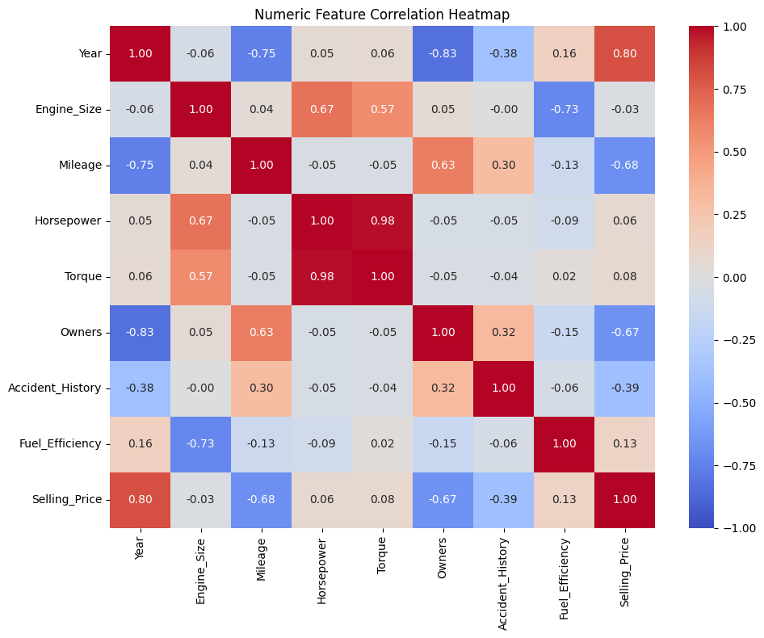
Figure 1. Correlation heatmap of numeric automobile features.
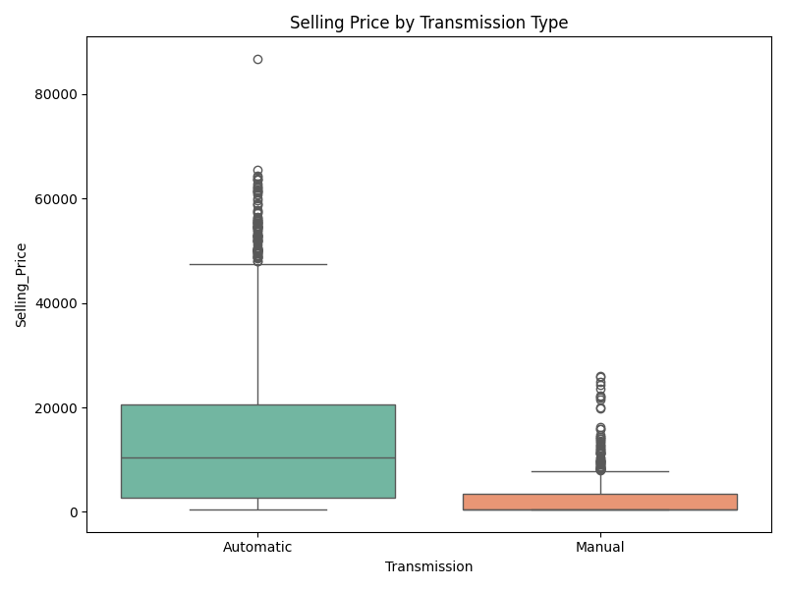
Figure 2. Selling price distribution by transmission type.
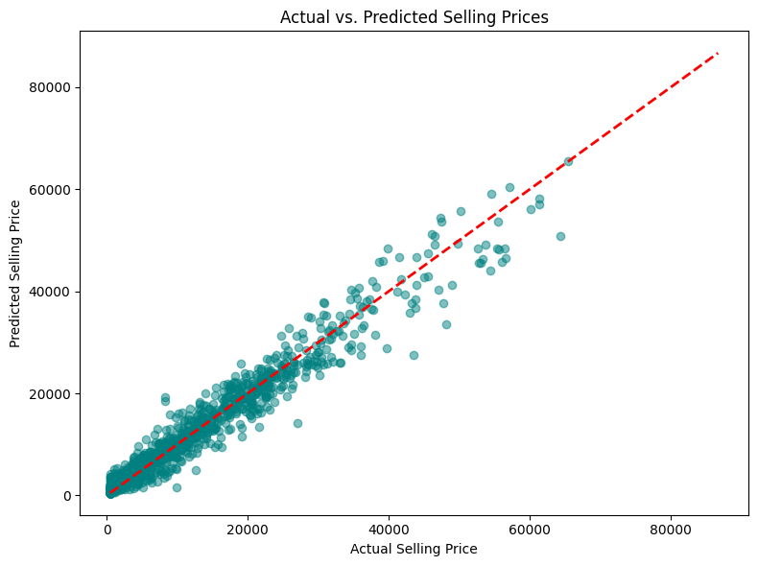
Figure 3. Actual vs. predicted selling price (Random Forest, single 80/20 split).
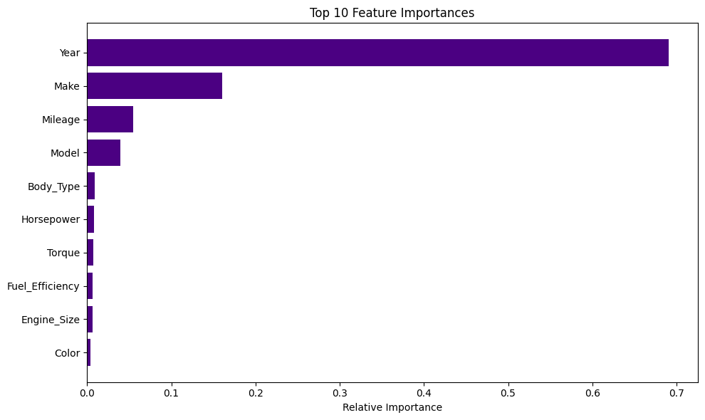
Figure 4. Top 10 feature importances (Random Forest Regressor).

5.2 Classification Results (Titanic Risk Profiling)
Nine classifiers were benchmarked. The final standardized comparison — using consistent train-fit/test-transform scaling for all distance-based models — produced the following leaderboard:
Rank | Model | Accuracy
1 | Support Vector Machine (RBF) | 0.8090
1 | AdaBoost | 0.8090
3 | XGBoost | 0.7978
4 | K-Nearest Neighbors | 0.7921
5 | Random Forest | 0.7753
6 | Logistic Regression | 0.7697
Table 2. Final classification leaderboard (standardized scaling, 80/20 split, random_state=42).
Two additional models were evaluated outside this final standardized loop and are reported separately in Table 3, since their preprocessing was not run through the identical scaling routine: Gradient Boosting achieved the single highest raw accuracy of any model tested (81.46%), and LightGBM tied the SVM/AdaBoost tier at 80.90%. Both are strong candidates for inclusion in a future standardized re-run.
Model | Accuracy | Precision (0 / 1) | Recall (0 / 1)
Gradient Boosting | 0.8146 | 0.85 / 0.76 | 0.85 / 0.75
AdaBoost | 0.8090 | 0.86 / 0.73 | 0.82 / 0.80
XGBoost | 0.7978 | 0.82 / 0.75 | 0.85 / 0.71
Logistic Regression (pre-scaling exploratory run) | 0.7809 | 0.85 / 0.69 | 0.78 / 0.78
Decision Tree | 0.7472 | – | –
Table 3. Detailed per-class metrics from exploratory model runs (Class 0 = Did Not Survive, Class 1 = Survived).

5.3 Interpretation
In the regression task, tree-based and boosted models decisively outperformed the linear baseline (R² of 0.979 and 0.934 for XGBoost and Random Forest respectively, versus 0.672 for Linear Regression), confirming that automobile depreciation follows a non-linear pattern — a car loses value rapidly in its first years, then depreciation slows — that a straight-line model cannot capture. XGBoost's further gain over Random Forest is consistent with its sequential error-correcting boosting mechanism extracting additional signal from the same engineered feature set.
In the classification task, kernel-based (SVM) and boosting-based (AdaBoost, Gradient Boosting) models edged out the simpler linear boundary of Logistic Regression, though the gap (roughly 4–5 percentage points) is modest given the dataset's size (891 rows). Precision/recall analysis reveals the models are more confident predicting non-survival (Class 0, precision 0.82–0.86) than survival (Class 1, precision 0.69–0.76) — a pattern consistent with the historically lower base survival rate and worth flagging to any downstream user of these predictions.

6. Challenges Faced and Solutions
Challenge | Applied Solution
Missing Data (Age variable) threatening row integrity. | Replaced missing values with the median age of the dataset to maintain statistical distribution without introducing heavy bias.
Categorical non-numeric data (e.g., Embarked ports, Fuel Types) failing model training. | Implemented One-Hot Encoding for Titanic (drop_first=True to avoid the dummy-variable trap) and Ordinal Encoding for the higher-cardinality Automobile categorical fields.
Feature dominance, where large numerical scales overshadowed smaller scales in SVM/KNN models. | Fit StandardScaler strictly on the training data and transformed both sets, standardizing the data to a uniform mathematical scale.
Right-skewed target variable (Selling_Price) causing the regression loss to disproportionately prioritize expensive vehicles. | Applied a log1p / expm1 target transform via TransformedTargetRegressor, improving relative accuracy on the lower-priced vehicle segment.
Scaler re-fitting inconsistency: an early exploratory SVM run applied fit_transform to both the training and test sets independently, which is a data-leakage risk and produces an optimistic, non-reproducible accuracy figure (0.826) versus the corrected, standardized figure (0.809). | Standardized to fit_transform on the training set only, followed by transform (not fit_transform) on the test set, for the final leaderboard comparison in Table 2.
Missing values in the mixed feature block (Engine_Size, Horsepower, Torque, Fuel_Efficiency) needed a defensible imputation choice beyond a single blanket method. | Verified pairwise correlations (up to 0.98) before applying a Bayesian-Ridge-based Iterative Imputer to this specific block only, reserving simple mode imputation for columns shown to carry no predictive relationship with the rest of the dataset.

7. Business Insights and Recommendations

From Regression (Asset Valuation):
- Automated Liquidation Strategies: By deploying regression models (particularly the XGBoost pipeline, R² = 0.979), enterprises can automate the appraisal of assets, reducing manual overhead and eliminating human cognitive bias from pricing decisions.
- Depreciation Curves: Feature-importance analysis (Figure 4) shows vehicle age and mileage dominate price determination, allowing enterprises to identify the point at which an asset's holding cost exceeds its market value and optimize the timeline for capital asset sell-offs.

From Classification (Risk Mitigation):
- Structural Risk Identification: The model proved that outcomes were not entirely random; structural features (like ticket class and gender) carried substantial predictive weight. In a corporate setting, classifying entity risk profiles allows for preemptive resource allocation.
- Precision vs. Recall Decisions: The classification outputs highlight that businesses must choose whether it is more costly to raise a false alarm (false positive) or miss a critical risk event entirely (false negative), tuning their model's decision threshold accordingly rather than defaulting to the standard 0.5 cutoff.

8. Limitations
- Static Context: Both datasets represent a fixed snapshot in time. In reality, asset prices fluctuate with macroeconomic factors (inflation, supply chain issues) not captured in the current feature set.
- Proxy Data: The Titanic dataset is academic and historically bound. While it effectively demonstrates classification mechanics, real-world enterprise risk data (like equipment sensor data or financial defaults) contains vastly more noise.
- Hyperparameter Search: The current models were run largely with baseline or manually tuned hyperparameters. Exhaustive grid searching was not fully mapped across all model variants.
- Exploratory Fare-Regression Attempt: A supplementary Linear Regression was also run on the Titanic dataset to predict Fare directly, returning a negative R² (−0.66) — indicating the model performed worse than simply predicting the mean fare for every passenger. This is most likely explained by Fare's strong right-skew and its collinearity with Pclass, and the effort was correctly deprioritized in favor of the primary classification objective. Note also that the R² call in that experiment passed predictions and actuals in reversed order (r2_score(y_pred, y_test) rather than r2_score(y_test, y_pred)); since R² is not symmetric under argument order, this figure should be recomputed with corrected argument order before being cited further.
- Sample Size (Chemical/Hackathon-style caveat not applicable here, but worth noting generally): both the Titanic (891 rows) and Automobile (5,500 rows) datasets are modest by modern ML standards; cross-validation variance should be considered when comparing closely-scored models (e.g., the SVM/AdaBoost tie in Table 2).

9. Conclusion
This project successfully demonstrated the fundamental pillars of supervised machine learning by implementing both continuous Regression and discrete Classification pipelines. By cleaning complex data, engineering features, and training models ranging from linear equations to advanced gradient-boosted trees, the project proved that distinct business challenges require distinct mathematical architectures. The Automobile pipeline's progression from a Linear Regression baseline (R² = 0.672) to a tuned XGBoost model (R² = 0.979) illustrates the tangible value of iterative model refinement, while the Titanic pipeline's nine-model comparison illustrates the value of systematic benchmarking over committing to a single algorithm early. Ultimately, both pipelines share the same commercial goal: replacing guesswork with scalable, data-driven forecasting.

10. Future Work
- Model Deployment: Package the highest-performing Regression (XGBoost) and Classification (SVM/AdaBoost) models into a Streamlit web application to allow non-technical users to input variables and receive real-time predictions.
- Hyperparameter Optimization: Implement GridSearchCV or Bayesian Optimization across the XGBoost, SVM, and Gradient Boosting models to mathematically guarantee near-optimal algorithmic settings.
- Standardized Re-benchmarking: Re-run Gradient Boosting and LightGBM through the same standardized scaling loop used for Table 2, since both showed competitive or superior raw accuracy in exploratory runs.
- Macroeconomic Feature Integration: For the regression model, merge the existing dataset with external APIs (such as historical inflation rates or fuel prices) to build a more resilient pricing algorithm.
- Encoding Refinement: Evaluate One-Hot or target encoding as an alternative to Ordinal Encoding for the high-cardinality Automobile categorical fields (Make, Model), which can otherwise impose an arbitrary numeric ordering on unordered categories.

11. References
Breiman, L. (2001). Random Forests. Machine Learning, 45(1), 5–32.
Chen, T., & Guestrin, C. (2016). XGBoost: A Scalable Tree Boosting System. Proceedings of the 22nd ACM SIGKDD International Conference.
Pedregosa, F., et al. (2011). Scikit-learn: Machine Learning in Python. Journal of Machine Learning Research, 12, 2825–2830.
[Insert additional course texts or required reading here]

Appendix A: Key Code Listings

A.1 Automobile Regression — Tiered Imputation Pipeline
categorical_cols = ['Make','Model','Fuel_Type','Transmission','Service_History',
'Color','Body_Type','Drivetrain','Location']
regression_impute_cols = ['Engine_Size','Horsepower','Torque','Fuel_Efficiency']
simple_impute_num_cols = ['Accident_History']
mode_impute = ColumnTransformer([
('cat_mode', SimpleImputer(strategy='most_frequent'), categorical_cols),
('num_mode', SimpleImputer(strategy='most_frequent'), simple_impute_num_cols),
], remainder='passthrough').set_output(transform='pandas')
regression_impute = ColumnTransformer([
('reg_impute', IterativeImputer(estimator=BayesianRidge(), max_iter=25,
random_state=42), regression_impute_cols),
], remainder='passthrough').set_output(transform='pandas')

A.2 Automobile Regression — Log-Target Model & Cross-Validation
log_target_rf = TransformedTargetRegressor(
regressor=RandomForestRegressor(n_estimators=100, random_state=42),
func=np.log1p, inverse_func=np.expm1)
pipeline = Pipeline([
('mode_impute', mode_impute), ('encode', encode),
('regression_impute', regression_impute),
('scaler', StandardScaler()), ('model', log_target_rf)])
results = cross_validate(pipeline, X, y, cv=KFold(5, shuffle=True, random_state=42),
scoring={'mae':'neg_mean_absolute_error','rmse':'neg_root_mean_squared_error','r2':'r2'})

A.3 Titanic Classification — Standardized Model Leaderboard
models = {
'Logistic Regression': LogisticRegression(max_iter=1000, random_state=42),
'Random Forest': RandomForestClassifier(n_estimators=100, random_state=42),
'Support Vector Machine': SVC(kernel='rbf', random_state=42),
'XGBoost': XGBClassifier(n_estimators=100, learning_rate=0.1, random_state=42),
'K-Nearest Neighbors': KNeighborsClassifier(n_neighbors=5),
'AdaBoost': AdaBoostClassifier(n_estimators=100, learning_rate=1.0, random_state=42)
}
scaler = StandardScaler()
X_train_scaled = scaler.fit_transform(X_train)
X_test_scaled = scaler.transform(X_test) # fit on TRAIN only, then transform test
for name, model in models.items():
if name in ['Support Vector Machine','K-Nearest Neighbors','Logistic Regression']:
model.fit(X_train_scaled, y_train); y_pred = model.predict(X_test_scaled)
else:
model.fit(X_train, y_train); y_pred = model.predict(X_test)
results[name] = accuracy_score(y_test, y_pred)

