**Experiment-15**

To Create a Cloning of a VM and Test it by loading the Previous Version/Cloned VM.

**Implementation**

**STEP 1:**

First install VMware workstation in your pc/laptop. Then open any one of the created VM. Then from taskbar select VM option.

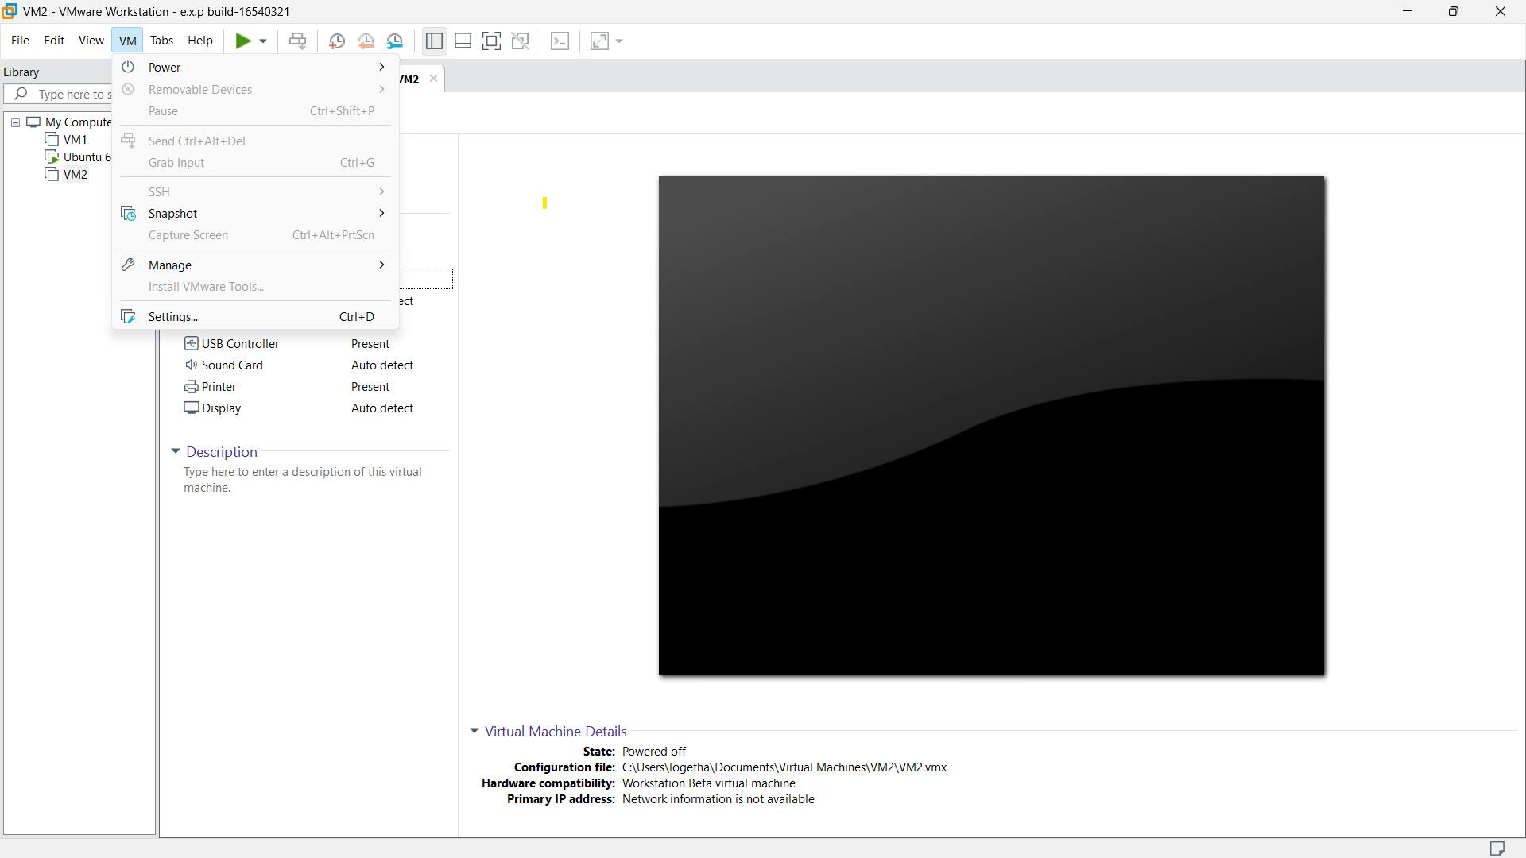

**STEP 2:**

In VM select manage option. In that click clone option.

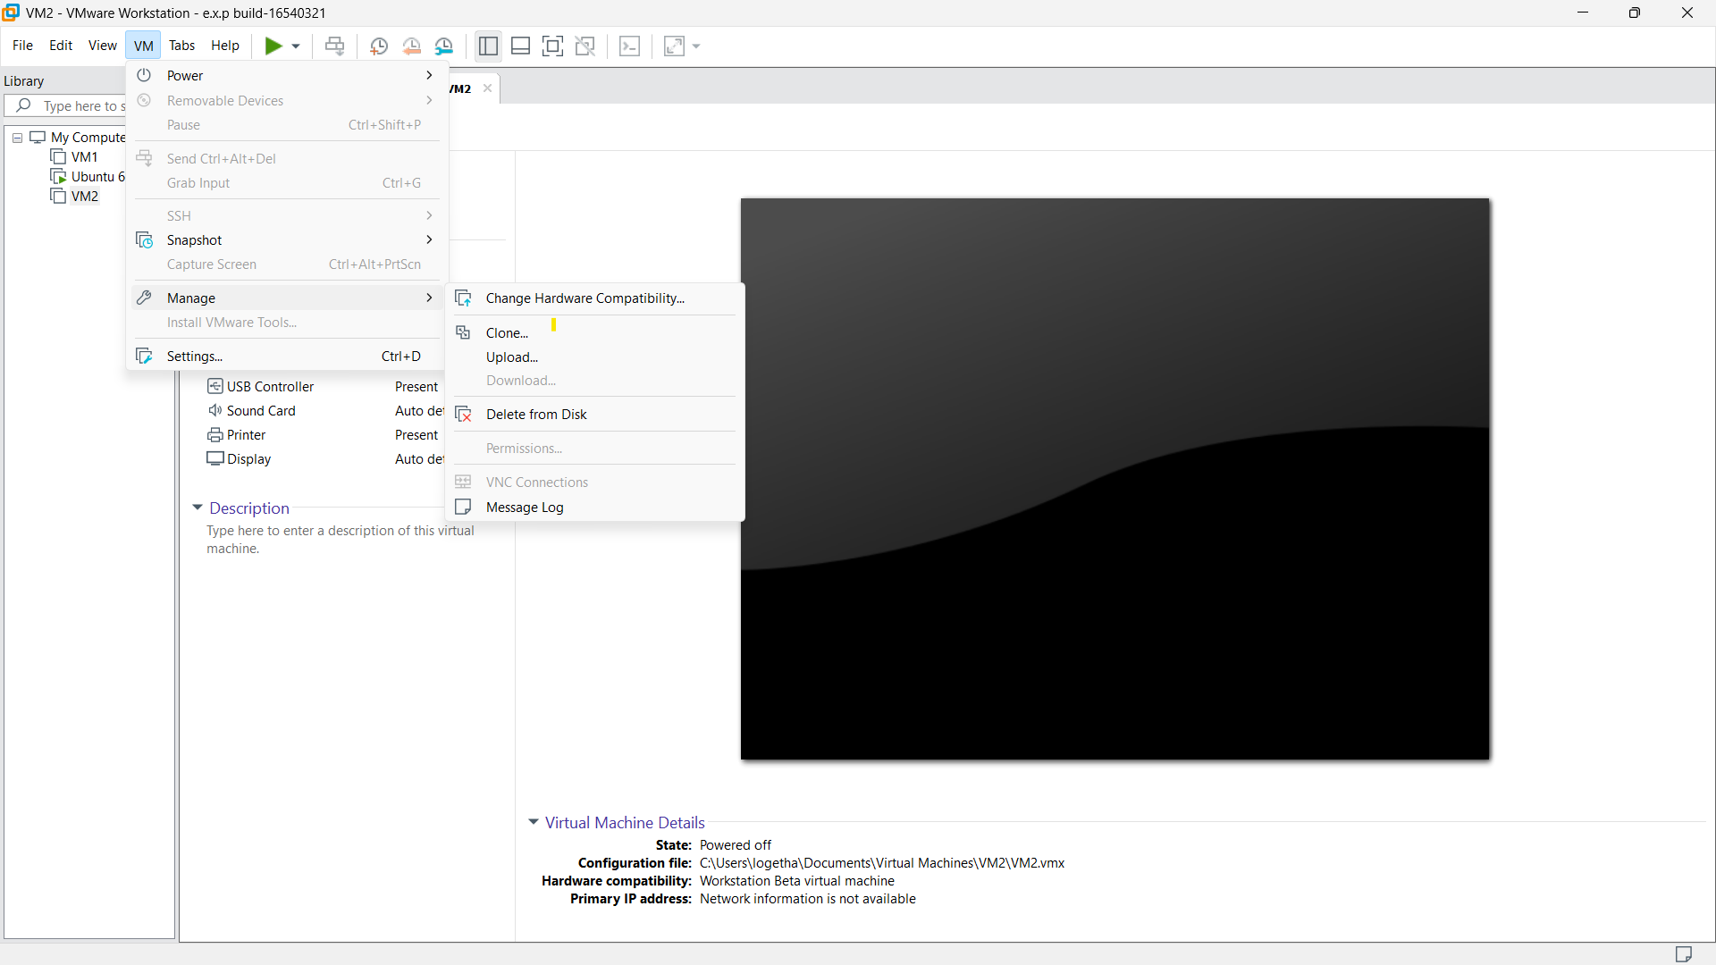

**STEP 3:**

Then a message will be displayed. In that select the first option which will be : the current state in the VM”

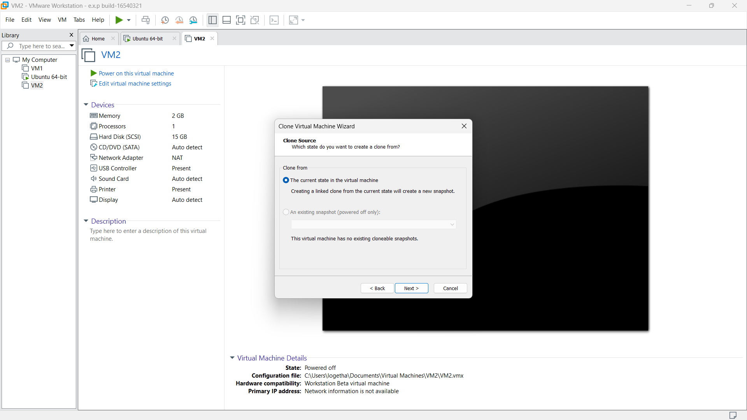

**STEP 4:**

Then select create a full clone option.

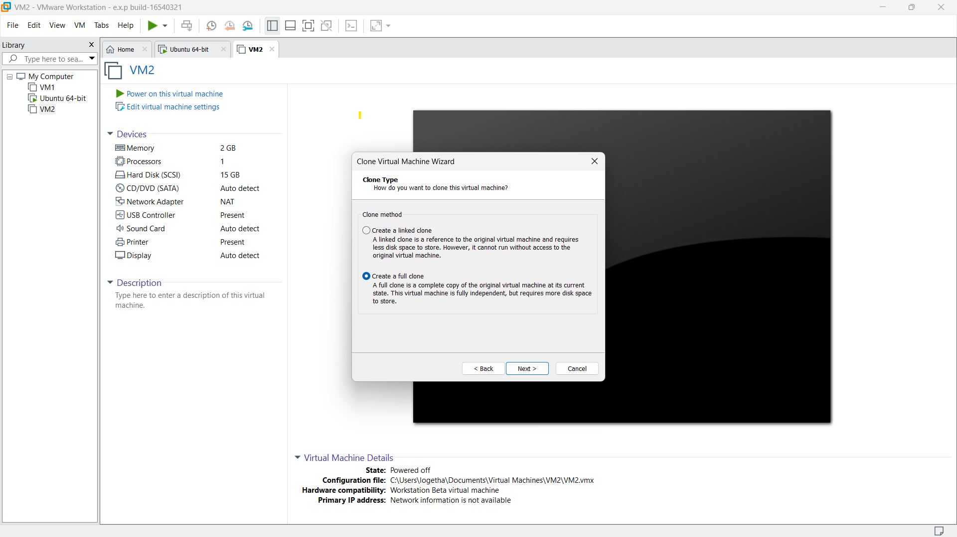

**STEP 5:**

then we need to provide the name of the new cloned VM.and then click “finish”

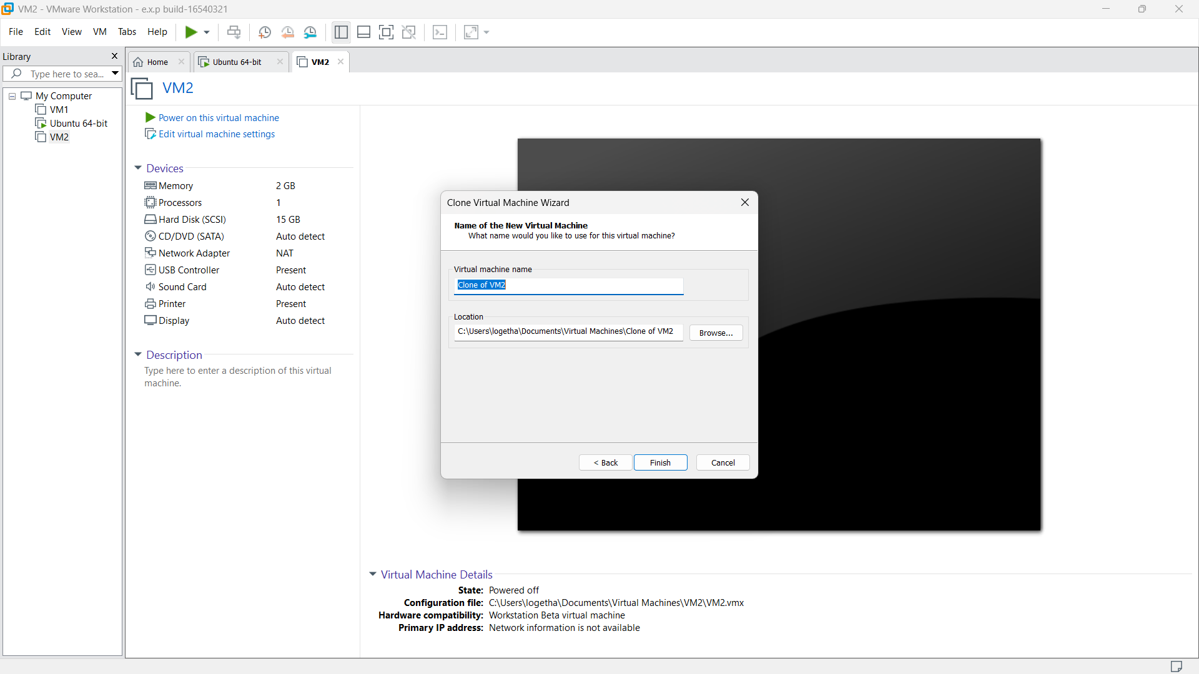

**STEP 6:**

then select close option. The new cloned of the selected VM will be created.

