GAYATHRI
23BD1A050Y

WEEk-13 : Attach an IAM Role to an EC2 Instance (S3 access without keys)
Login in to the aws account -> search for iam service in console
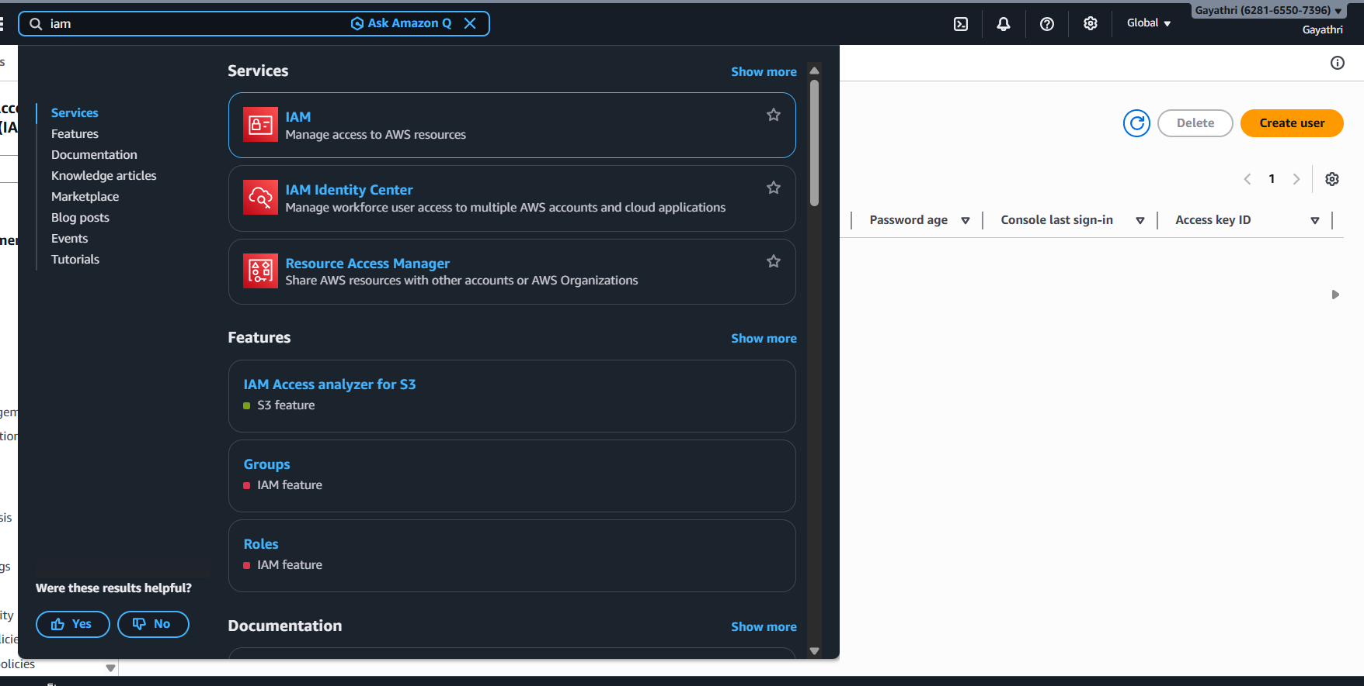

Open IAM Console → Roles → Create role
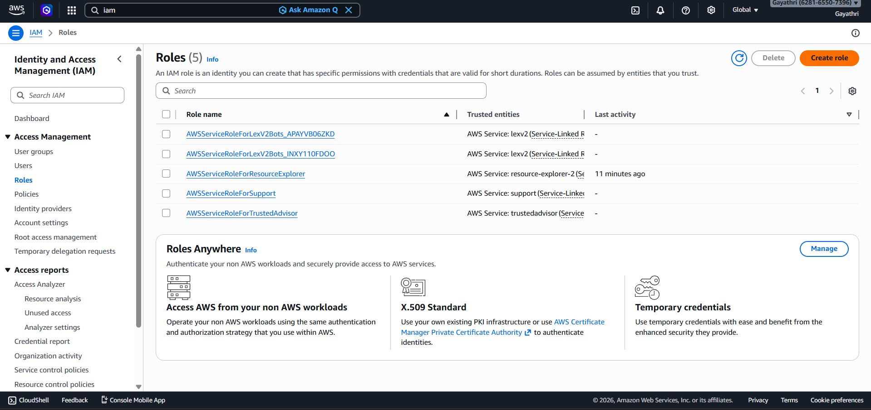
- Select AWS Service
- Use case: Choose EC2
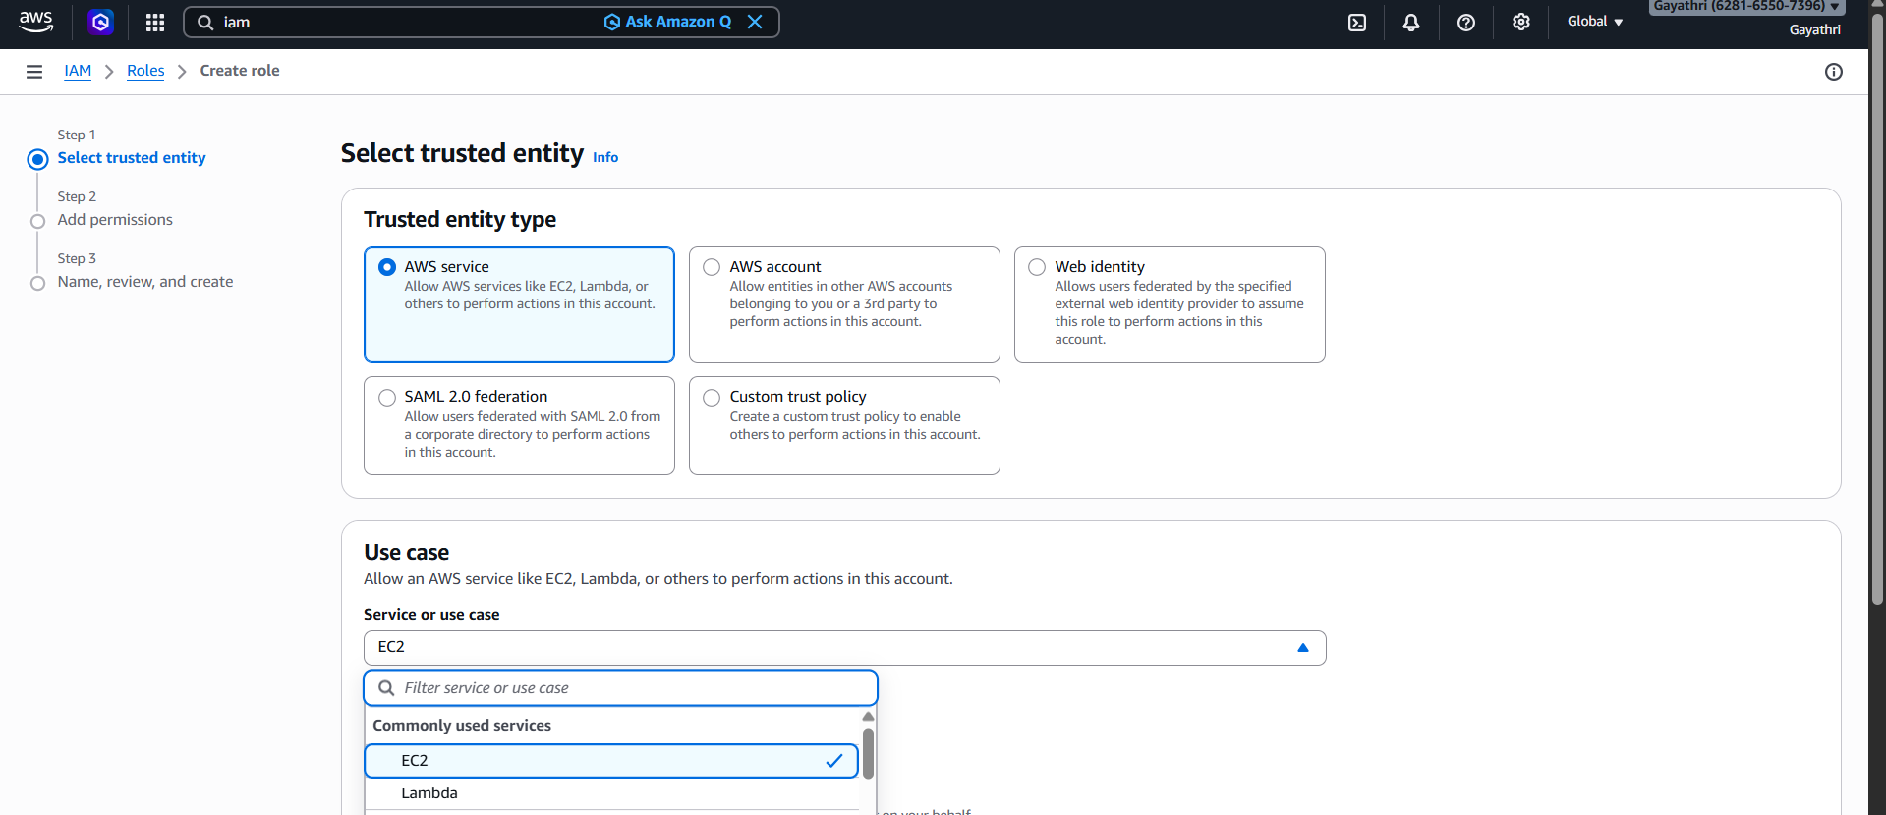

Click Next
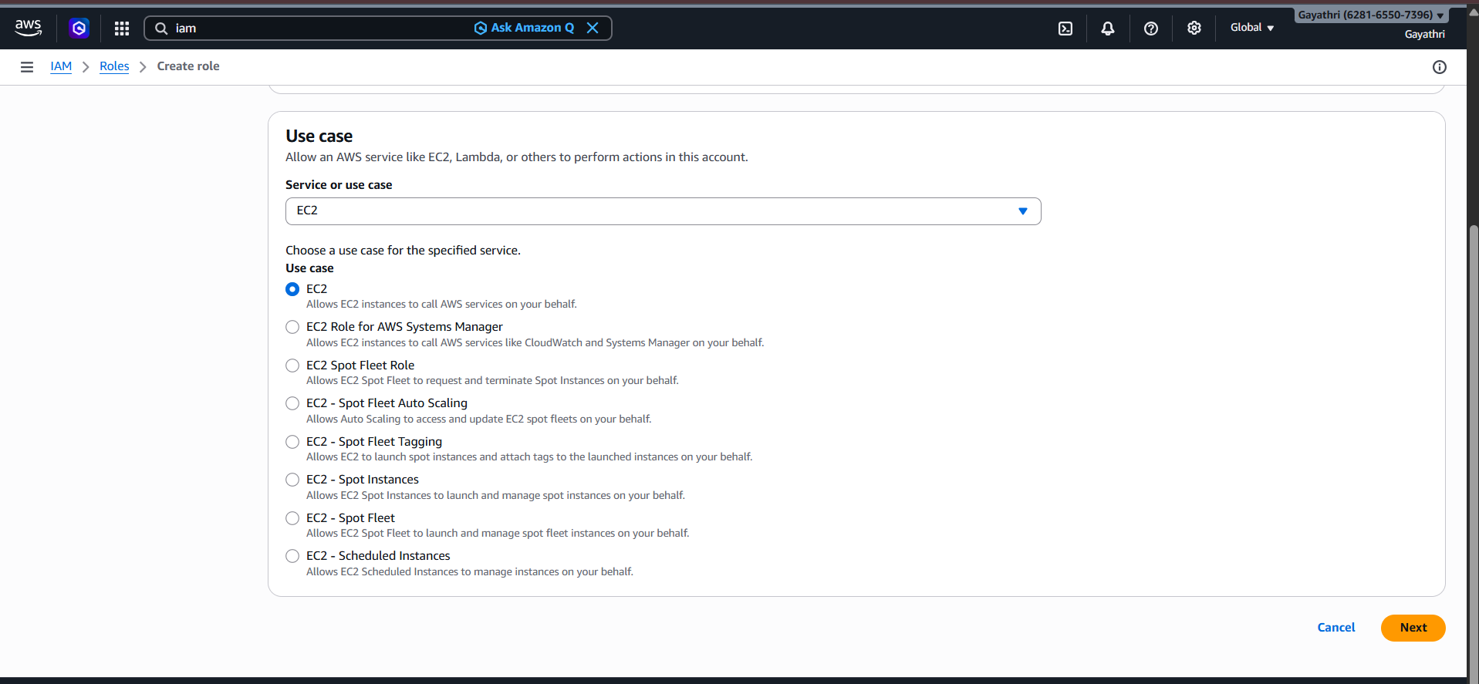
- Search policy: AmazonS3FullAccess
- Select it → Next
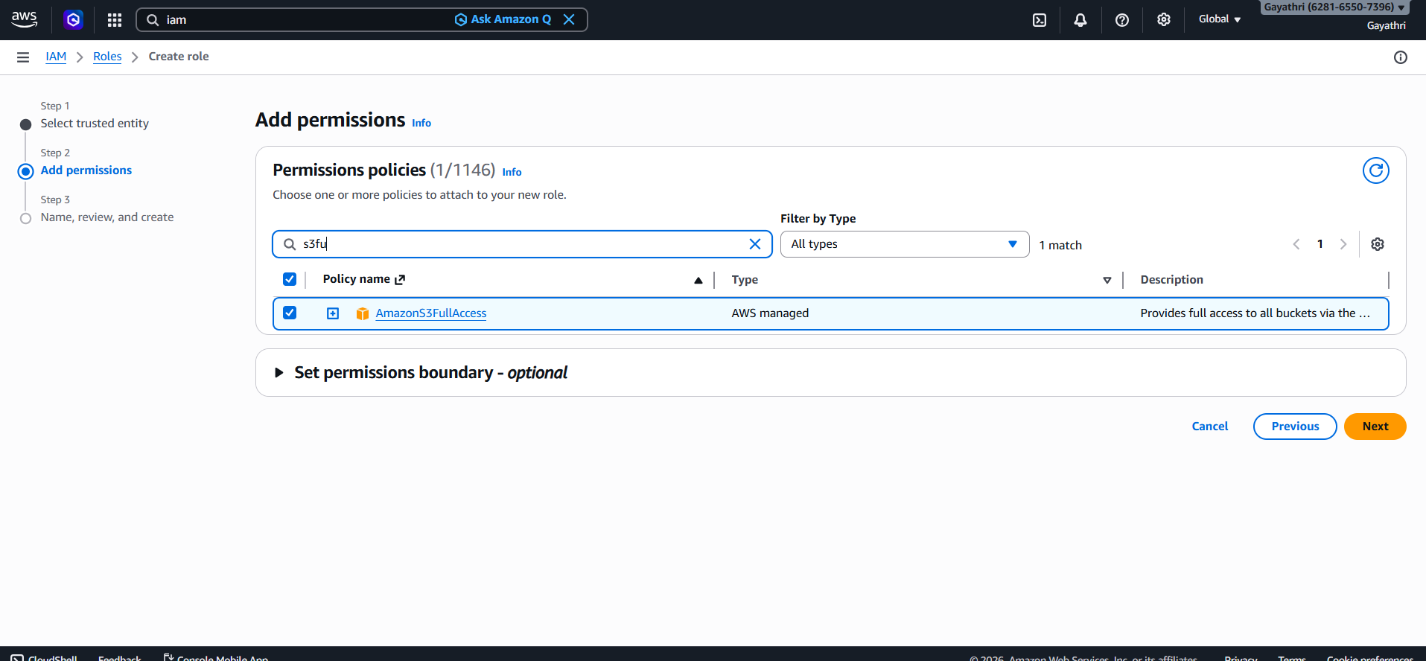

- Name: EC2-S3-Role
- Click Create role
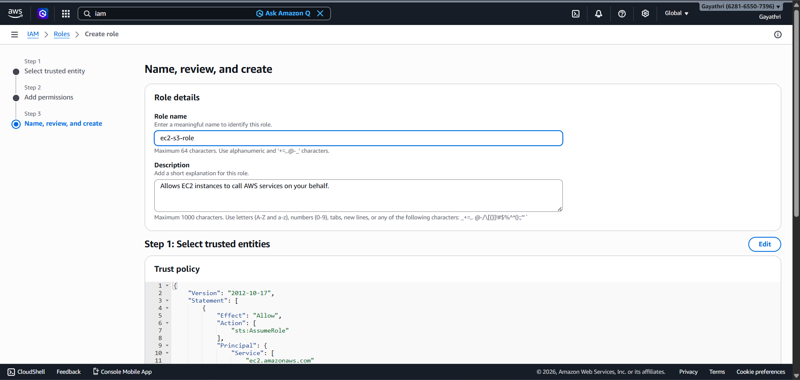

Go to EC2 Dashboard
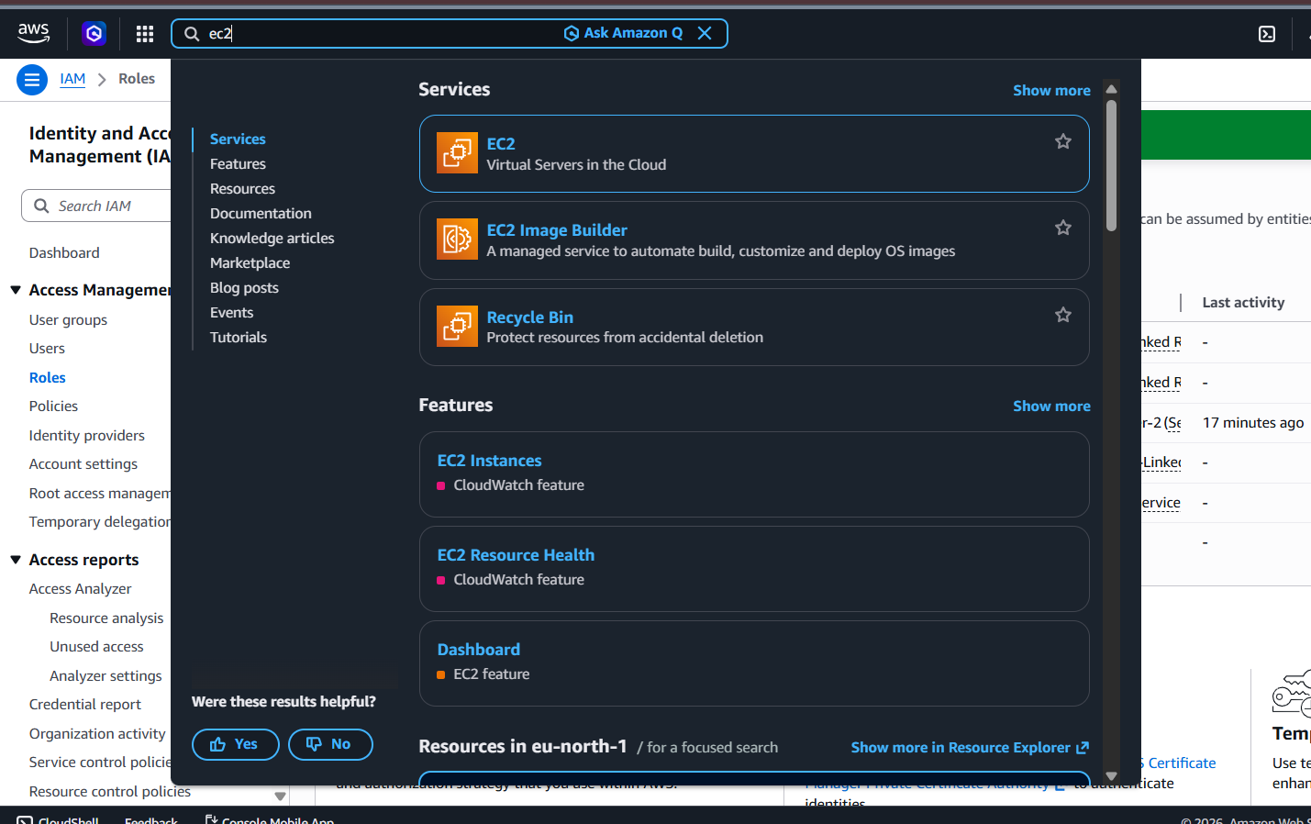
Click on launch instance
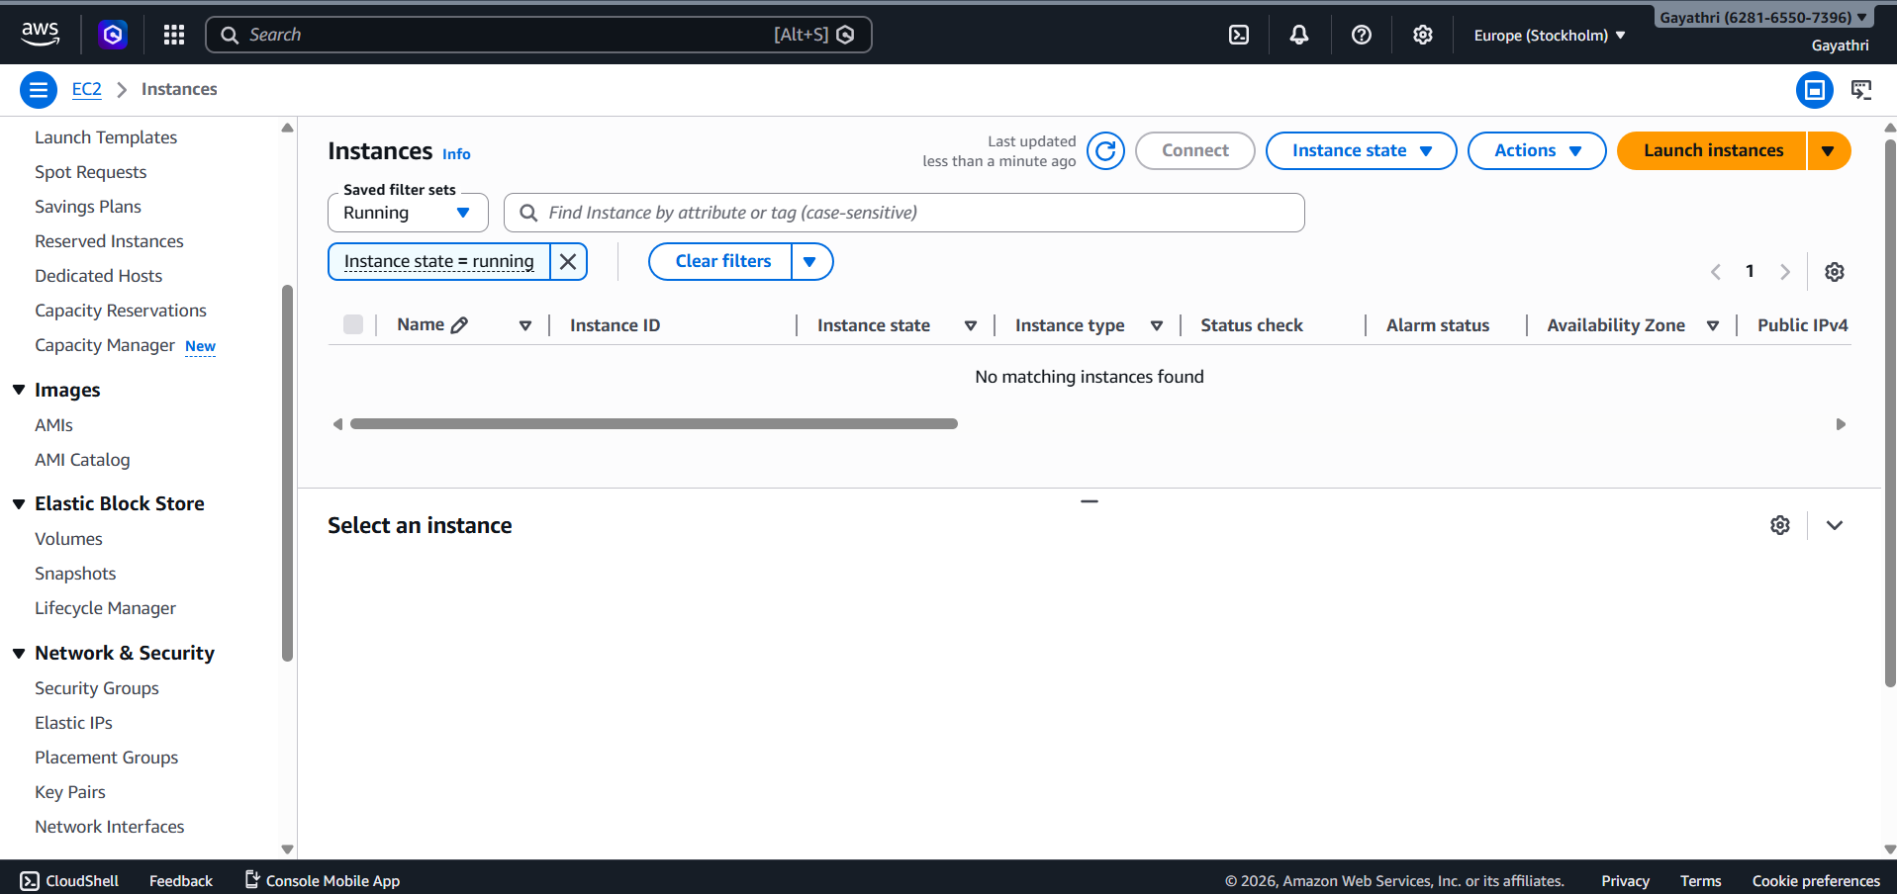
Name the instance and click on launch instance
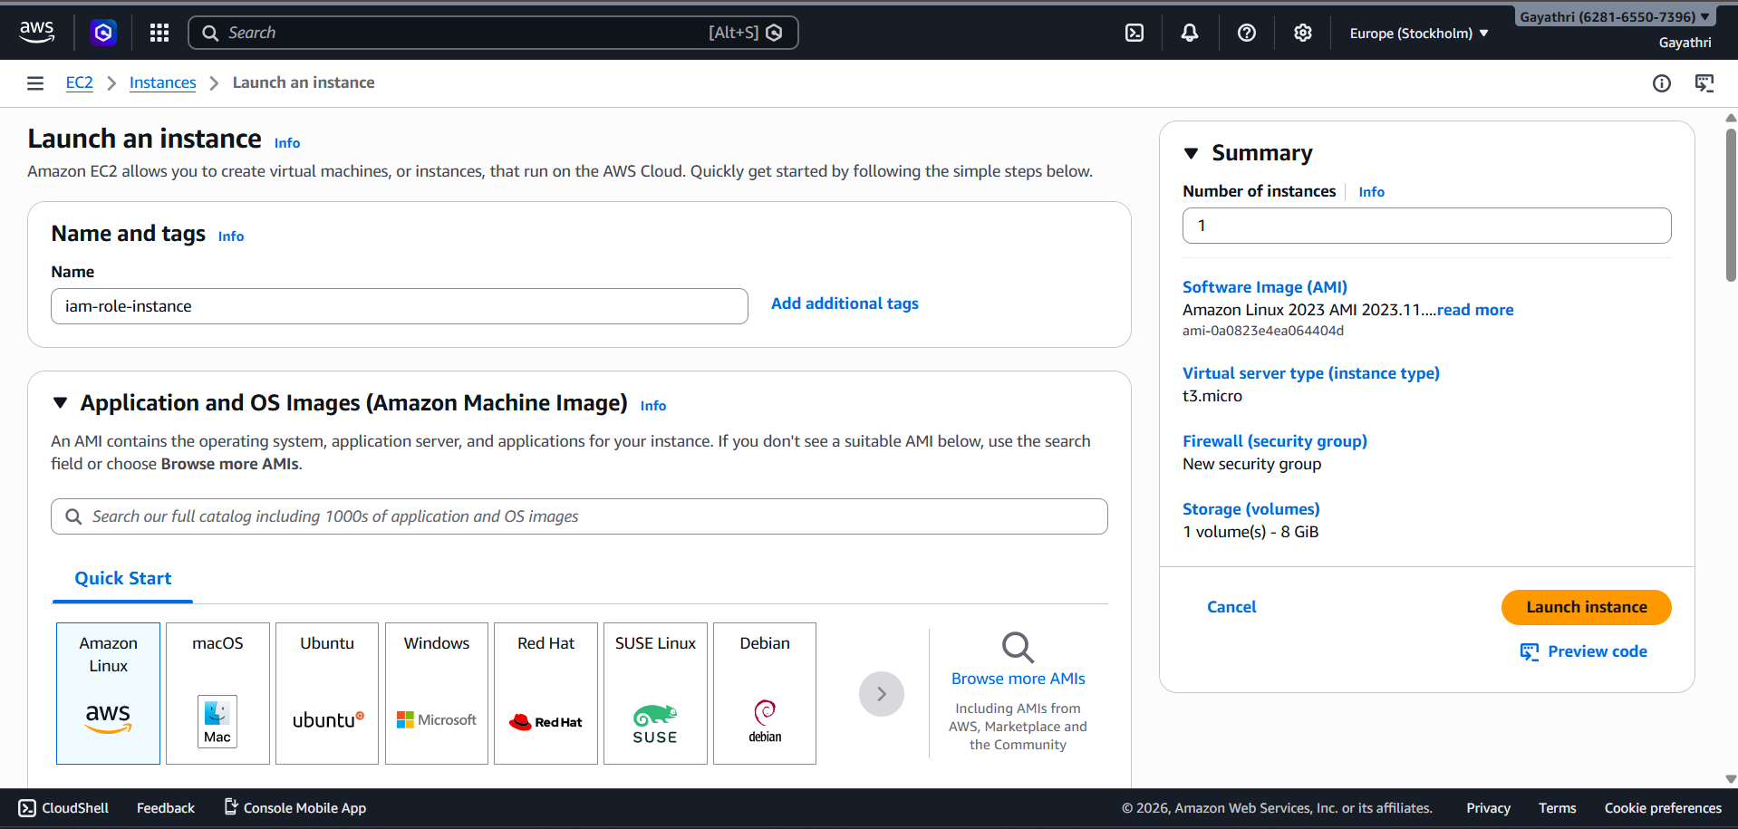

Select the running instance
Click on Actions → Security → Modify IAM role
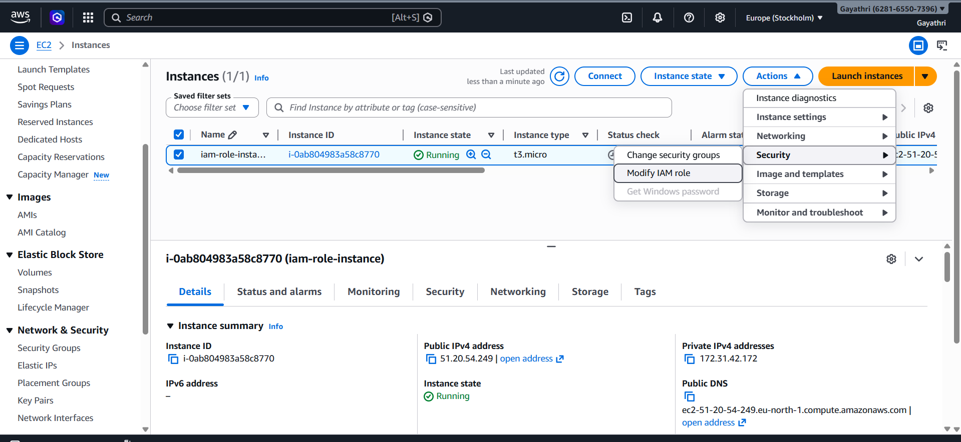

- Select EC2-S3-Role → Update
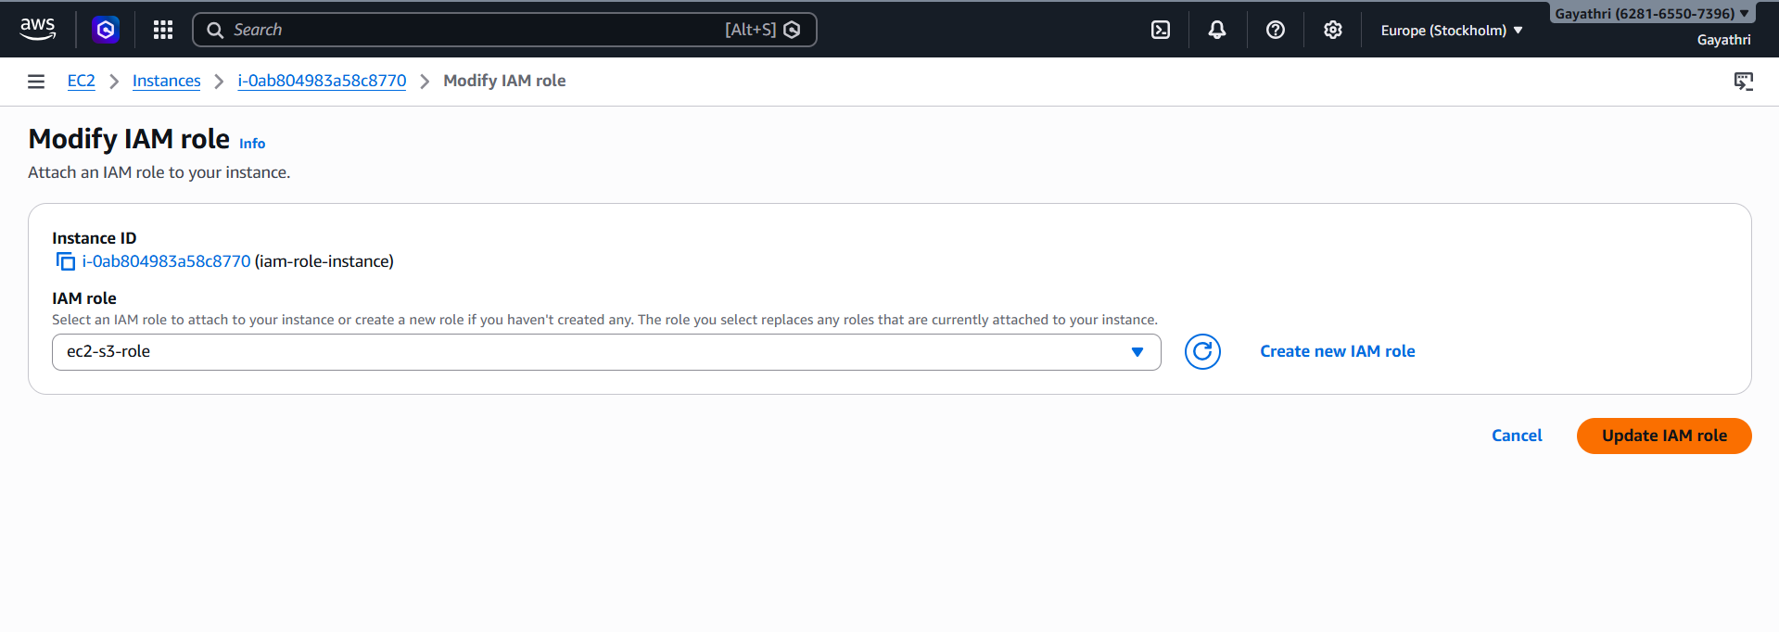

Run the instance using ssh key
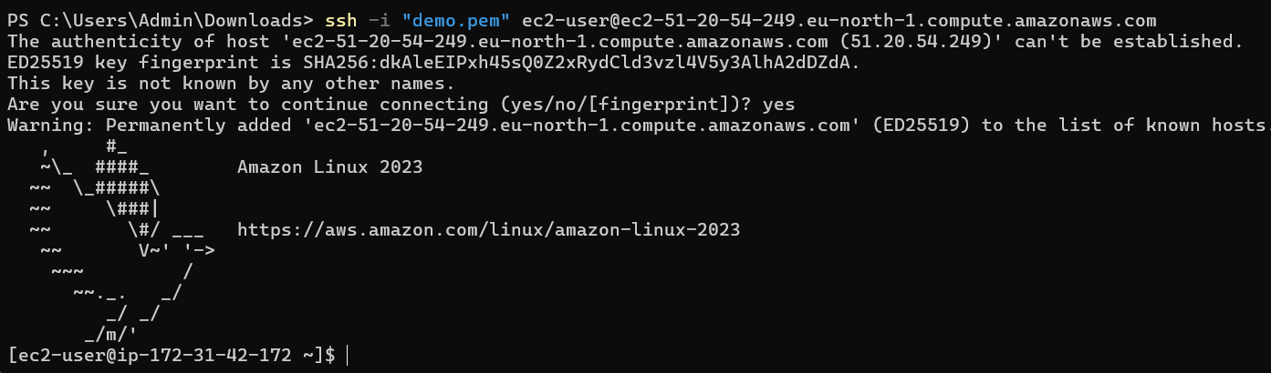
aws s3 ls
aws s3 ls Works
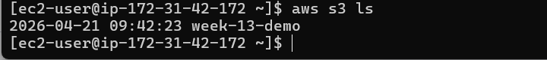
aws ec2 describe-instances Unauthorized (no EC2 permission)

SCENARIO BASED QUESTIONS

1. New developer needs EC2 + S3 access
Create an IAM User and add them to a Group (e.g., Developers) with a policy granting only required actions (least privilege).
Avoid attaching policies directly to users.

2. Temporary access for 2 days
Use IAM Role + temporary credentials via STS (Security Token Service).
Set session duration or use a role with expiration.

3. Exposed access keys on GitHub
Immediate steps:
- Deactivate/Delete keys immediately
- Rotate credentials
- Check logs in CloudTrail for misuse
- Apply least privilege
- Consider enabling MFA

4. Enable AWS CLI access
Create an IAM user and generate:
- Access Key ID
- Secret Access Key
Then configure using:
aws configure

5. 50 employees need same S3 access
Create an IAM Group (e.g., S3Users) and attach policy.
Add all users to that group → scalable and manageable.

6. Remove permissions for 20 users
Remove them from their IAM group or detach the policy from the group.
Much easier than editing each user individually.

7. HR, Developers, Admins need different access
Create separate IAM Groups:
- HR Group
- Developers Group
- Admin Group
Attach role-specific policies to each group.

8. EC2 access to S3 without keys
Use an IAM Role attached to EC2 instance (Instance Profile).
No hardcoded credentials needed.

9. Cross-account access (Account A → B)
Use IAM Role in Account B with a trust policy allowing Account A.
Account A users assume the role using STS.

10. Lambda → DynamoDB access
Create an IAM Role for Lambda with policy:
- dynamodb:GetItem
- PutItem, etc.
Attach role to Lambda function.

11. Temporary admin access
Use IAM Role with admin policy and allow user to assume it temporarily.
Optionally enforce MFA.

12. Restrict access to one S3 bucket
Create a policy with resource-level restriction:
{
"Effect": "Allow",
"Action": "s3:*",
"Resource": [
"arn:aws:s3:::my-bucket",
"arn:aws:s3:::my-bucket/*"
]
}

13. Prevent deletion of resources
Use an explicit Deny policy:
{
"Effect": "Deny",
"Action": "*:Delete*",
"Resource": "*"
}
Explicit deny always overrides allow.

14. Restrict login to office hours
Use IAM policy with condition on time:
"Condition": {
"DateGreaterThan": {"aws:CurrentTime": "2026-04-20T09:00:00Z"},
"DateLessThan": {"aws:CurrentTime": "2026-04-20T18:00:00Z"}
}

15. Restrict access by IP
Use condition:
"Condition": {
"IpAddress": {
"aws:SourceIp": "203.0.113.0/24"
}
}

16. IAM best practices
- Follow least privilege principle
- Use groups instead of individual policies
- Enable MFA
- Rotate credentials regularly
- Use roles instead of access keys when possible
- Monitor with CloudTrail
- Avoid root account usage
- Use policy conditions (time, IP, MFA)
- Regularly audit permissions

