23BA1A050Y
B GAYATHRI
WEEK – 7
AWS Lambda function to trigger whenever an object is uploaded to an S3 bucket and update a DynamoDB table

Open AWS Lambda Console: Navigate to the Lambda service by either searching for "Lambda" in the AWS Management Console
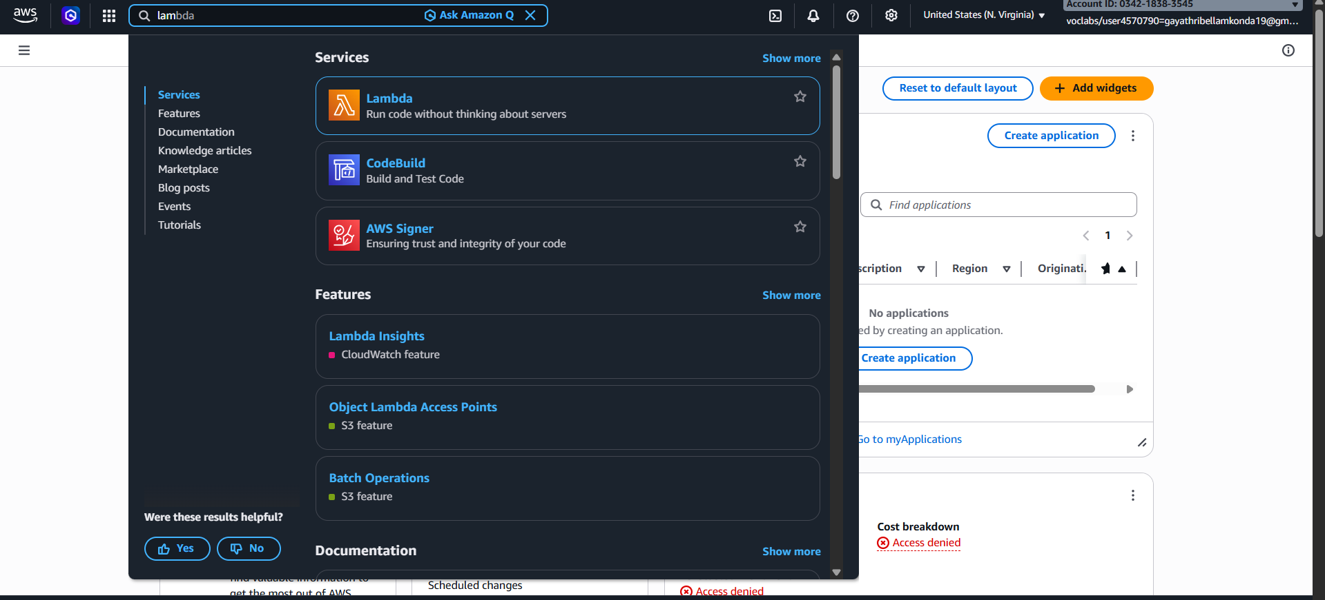
Click on the "Create function" button
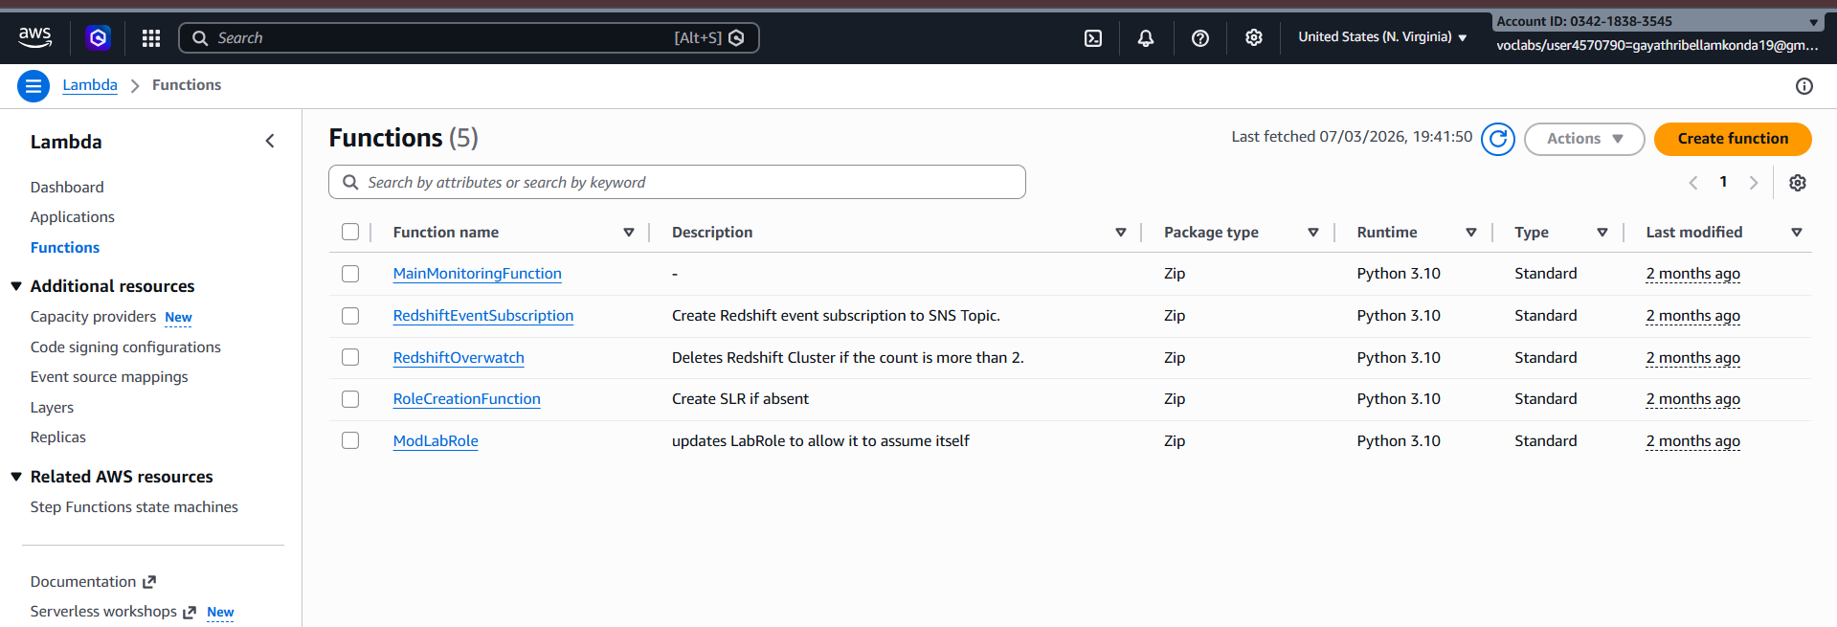

- Choose "Author from scratch".
- Enter a name for your function -> lambda-funciton
- Choose Python 3.10 as the runtime
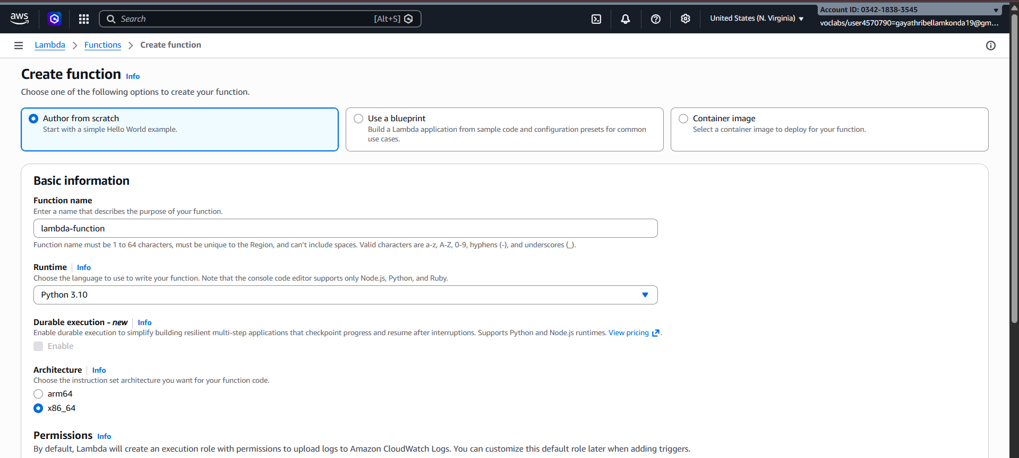
- Under "Permissionscv-> choose use another role that has permissions to access S3 and DynamoDB.
Select LabRole -> Click on create function button
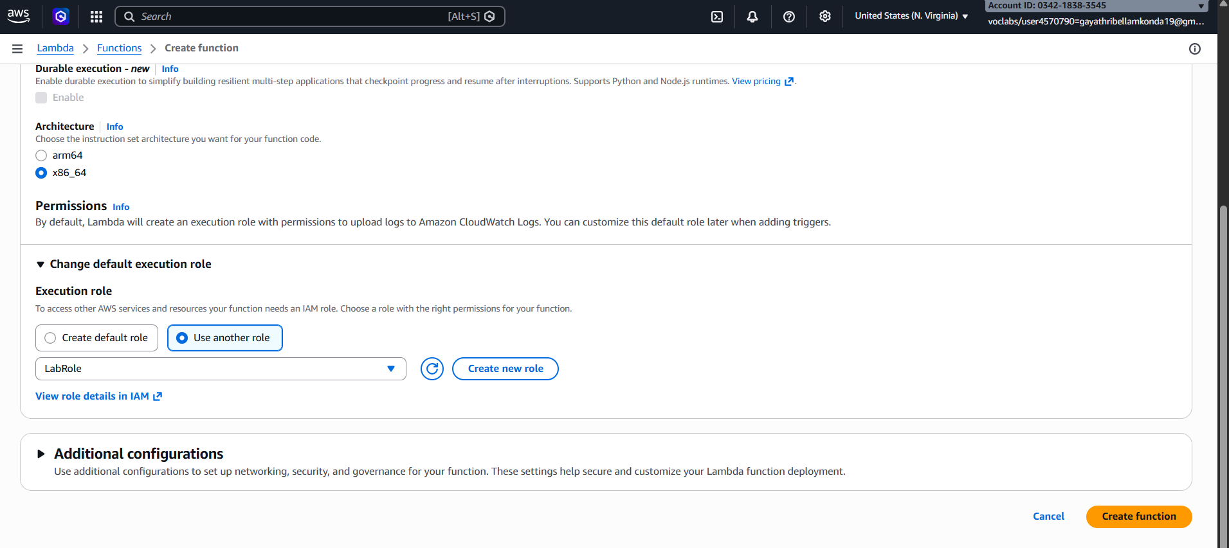

Go to S3 -> Click on create bucket
Enter the name of the bucket –> lambda-cc-lab-bucket
Keep Every thing as Default -> click on create bucket button
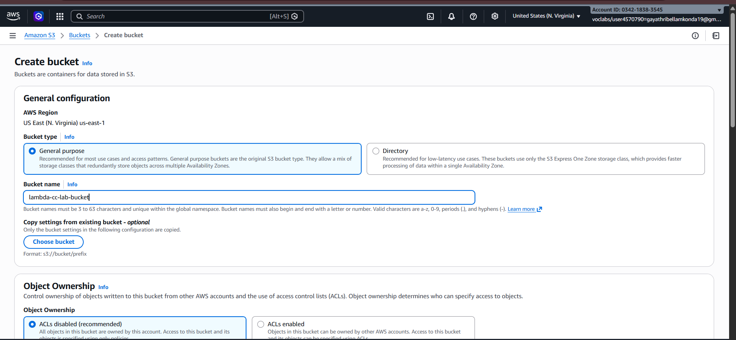
Search for DynamoDB in Aws Management Console
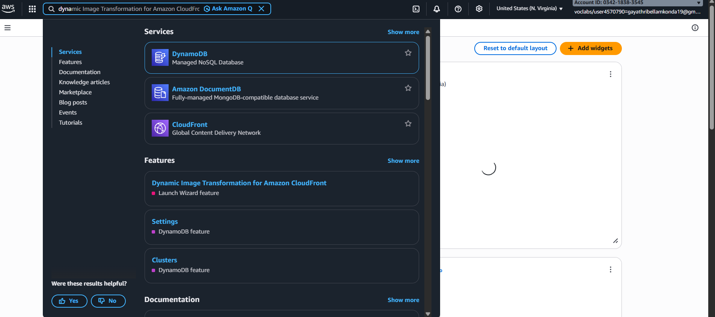

Click on Create table -> Enter the table – newtable2
Partition Key – unique -> Click on create tabel
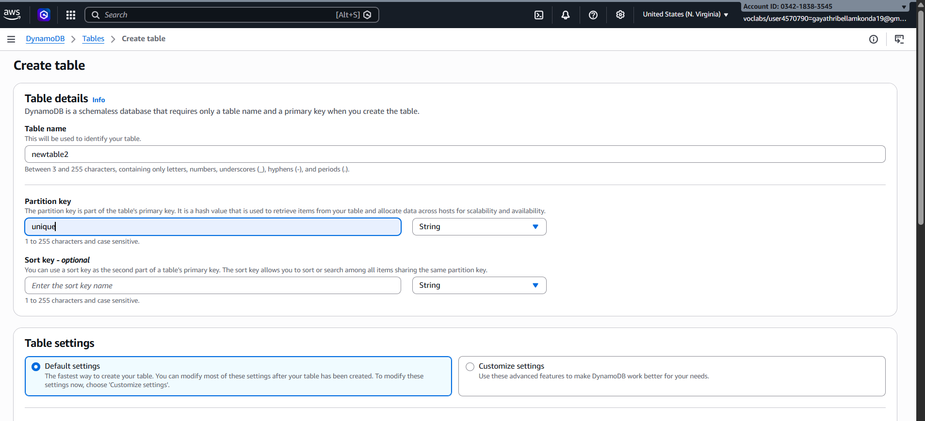
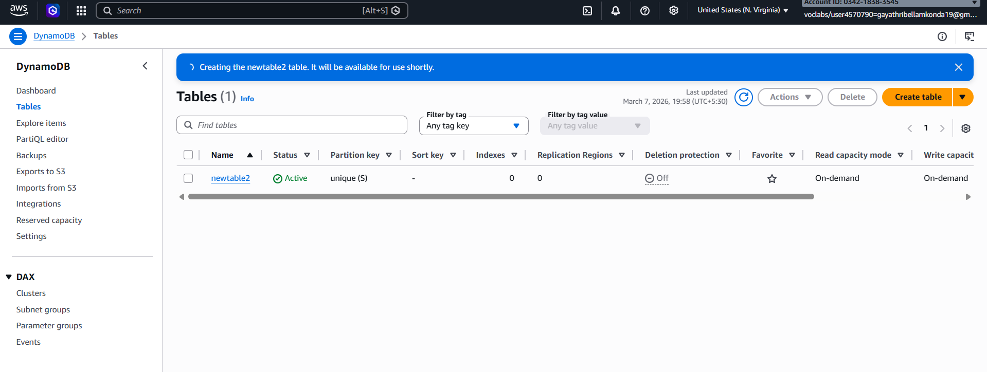

Copy the Code from the github
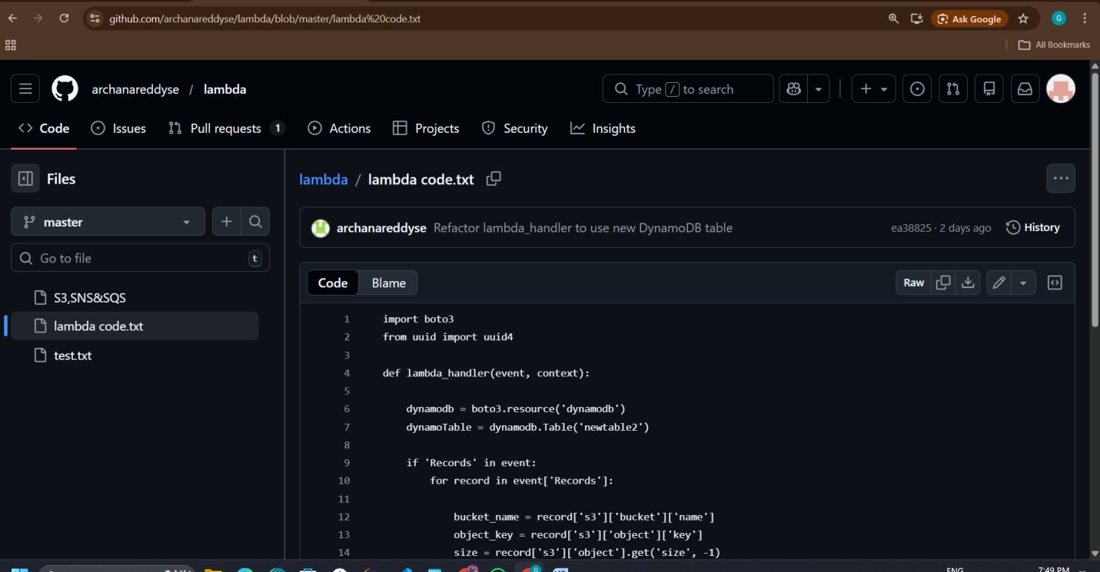
Paste the code in Code section (Make sure table names are same and they are present in same region)
Click on deploy code
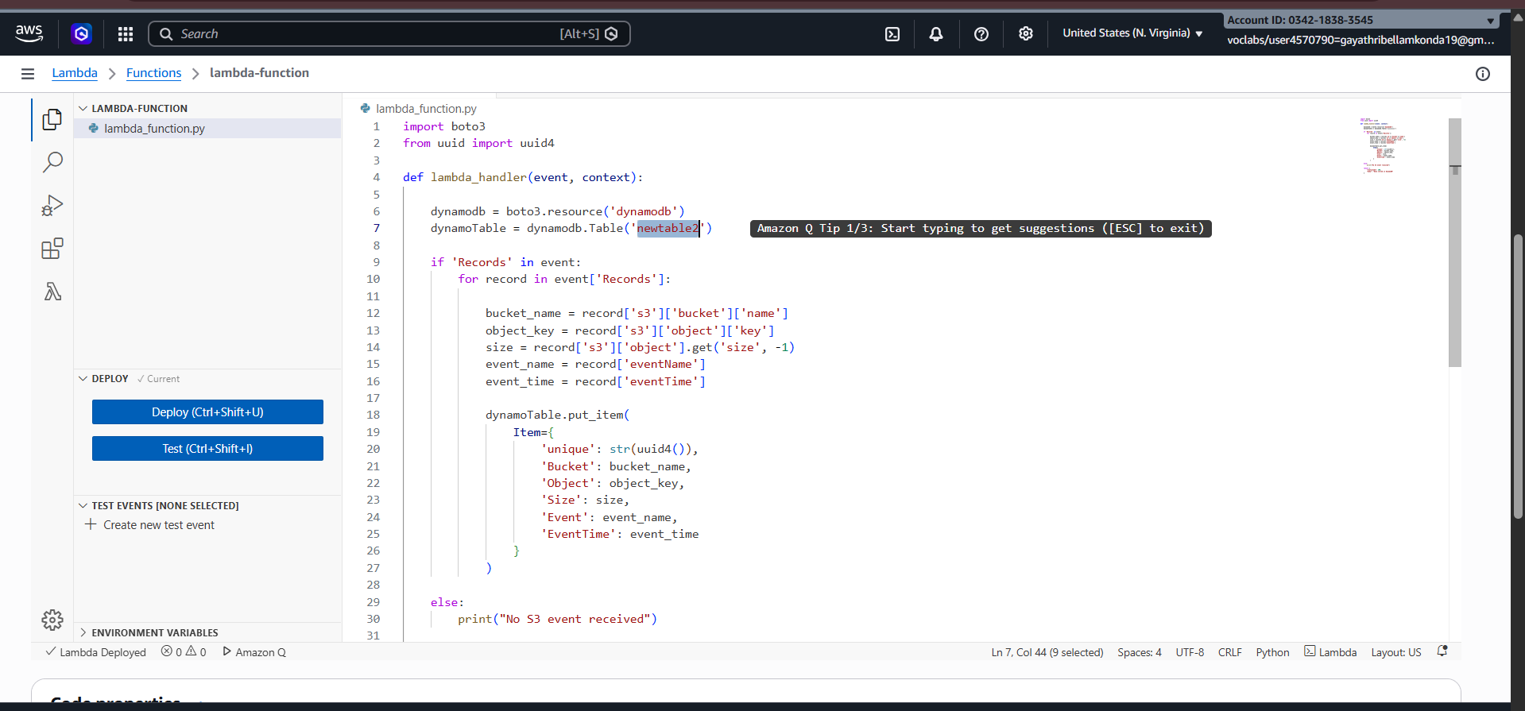

Test Your Function:
Select create new event -> select template as S3 put
Change the bucket in the code
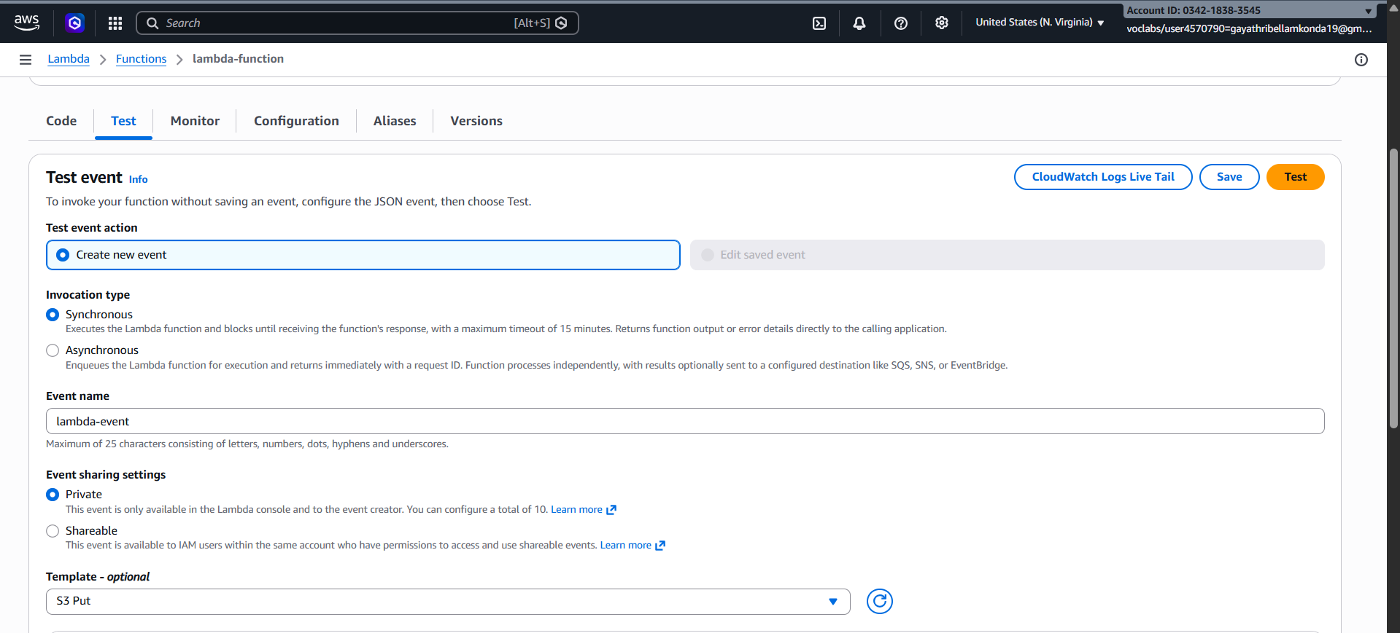
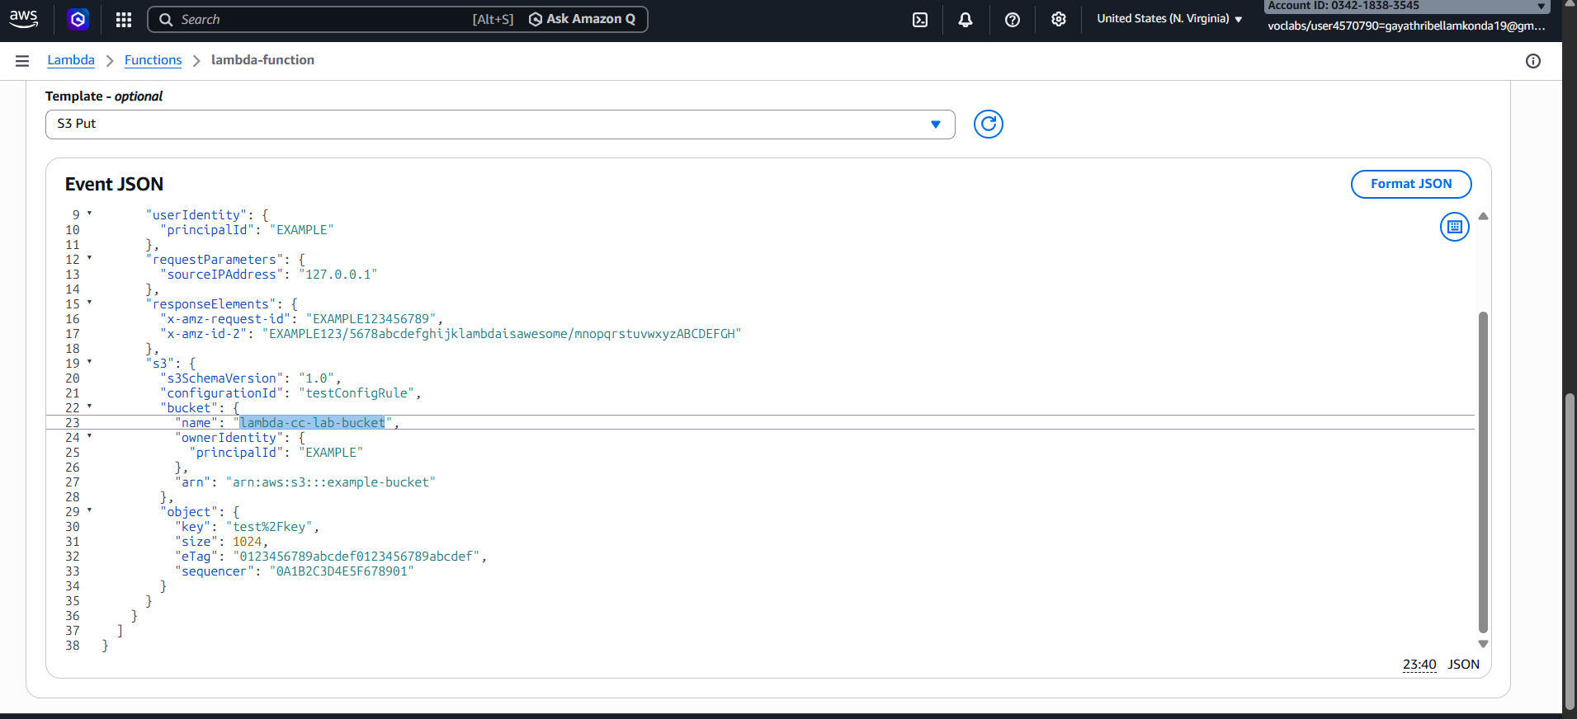

Click on save -> click on test – it will execute the code successfully
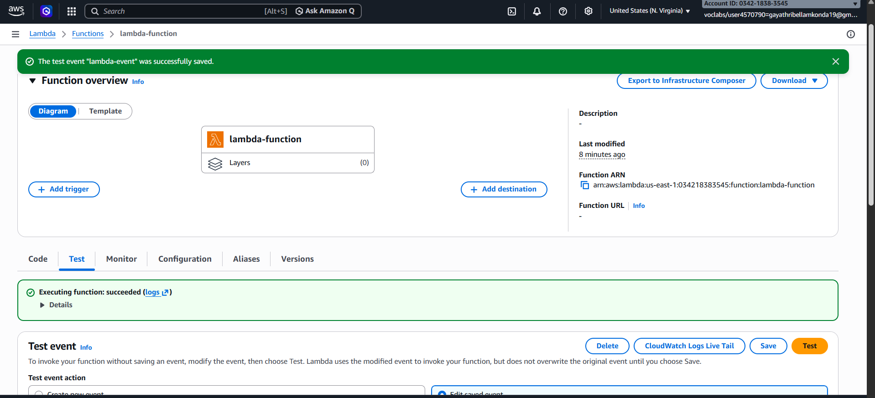
Click on Add trigger -> Select source as S3
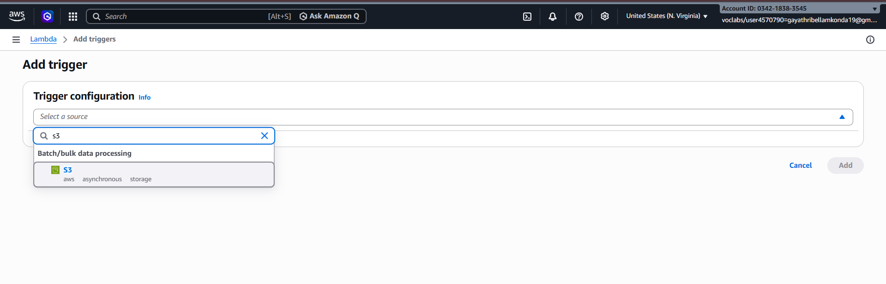

Bucket should be in same region
Select the bucket name -> select I acknowledge -> click on save button
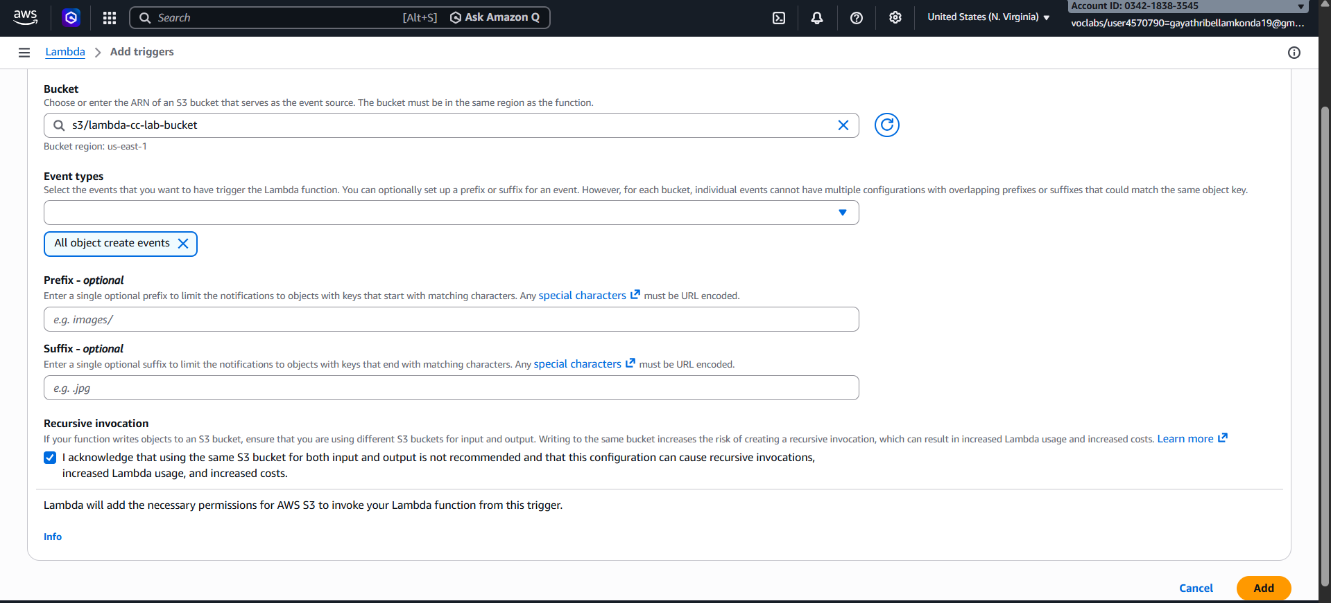
Upload any document in the bucket -> click on upload
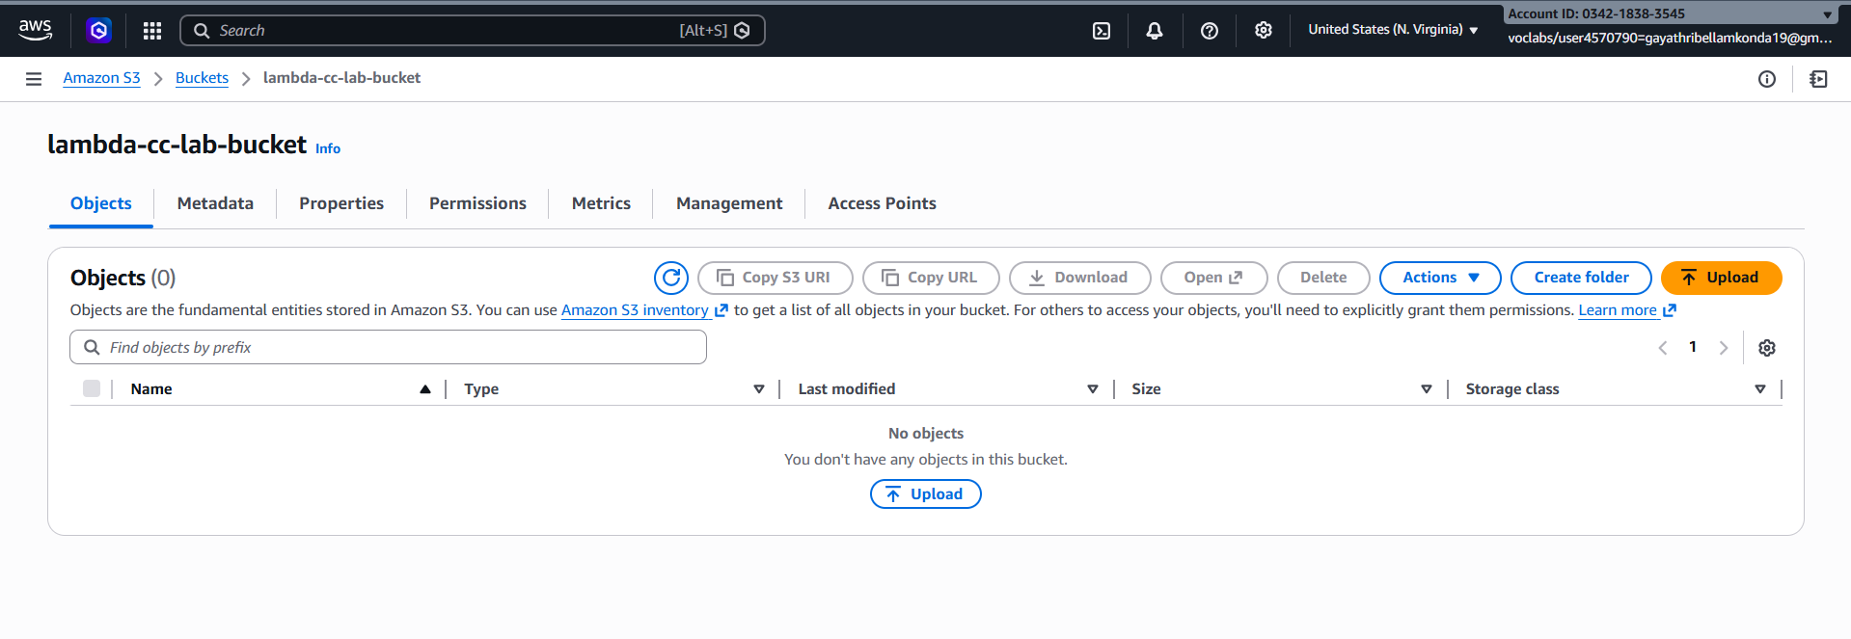
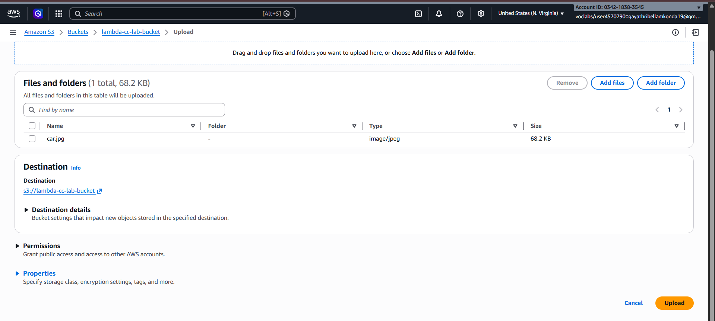
Go to DynamoDb dashboard -> Click on Explore items
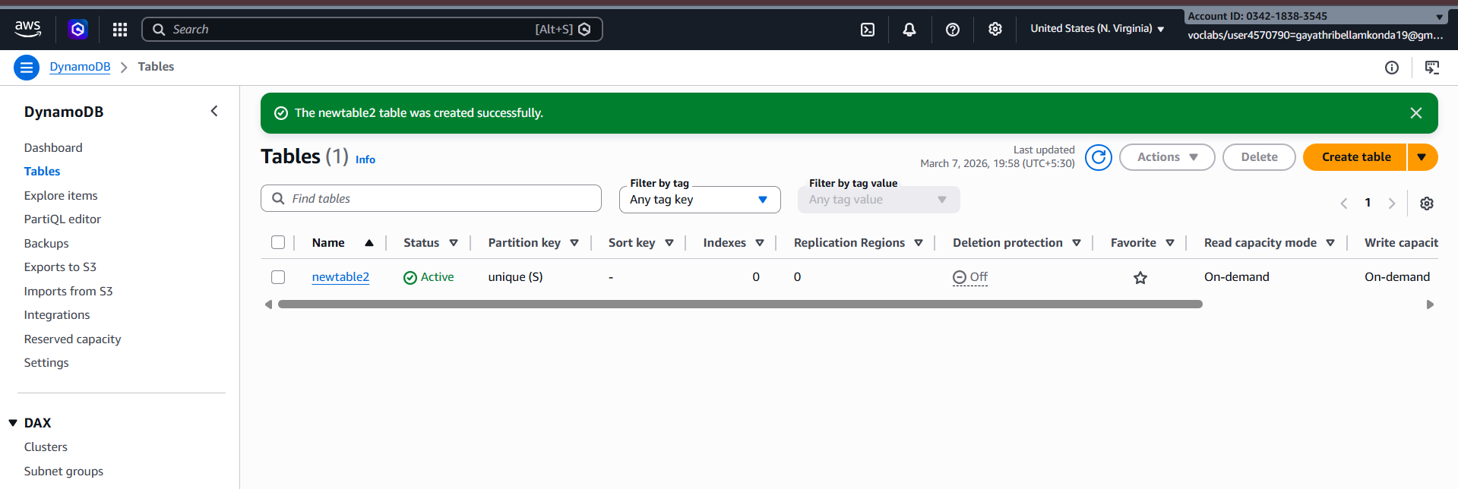

Select the table -> navigate to items returned -> uploaded objects will be visible
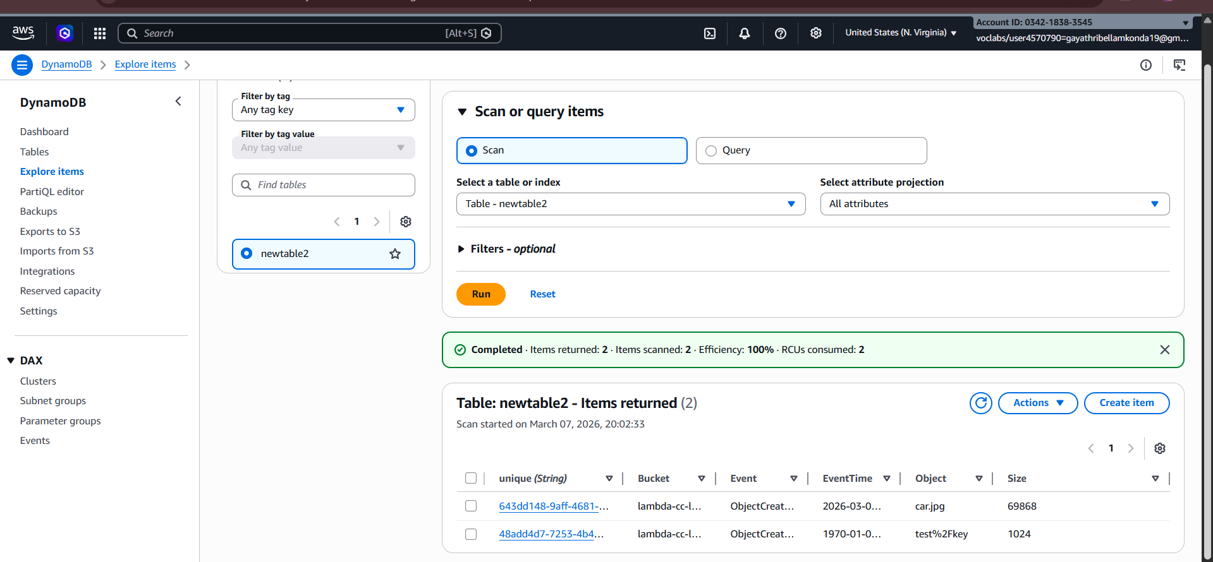
The meta data of the object will be stored in the table
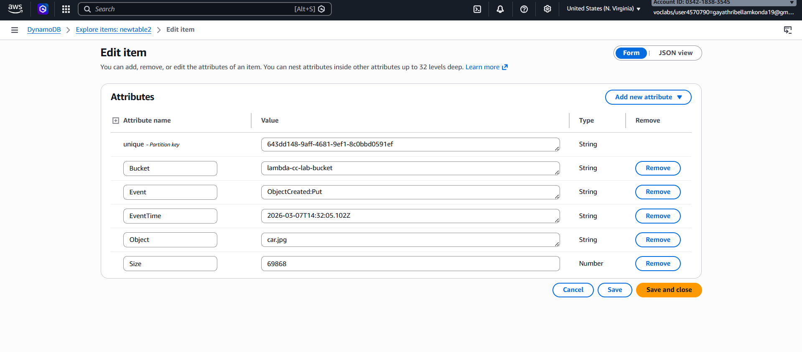

In lambda dashboard -> Go to Monitor Tab -> click on view cloudWatch logs
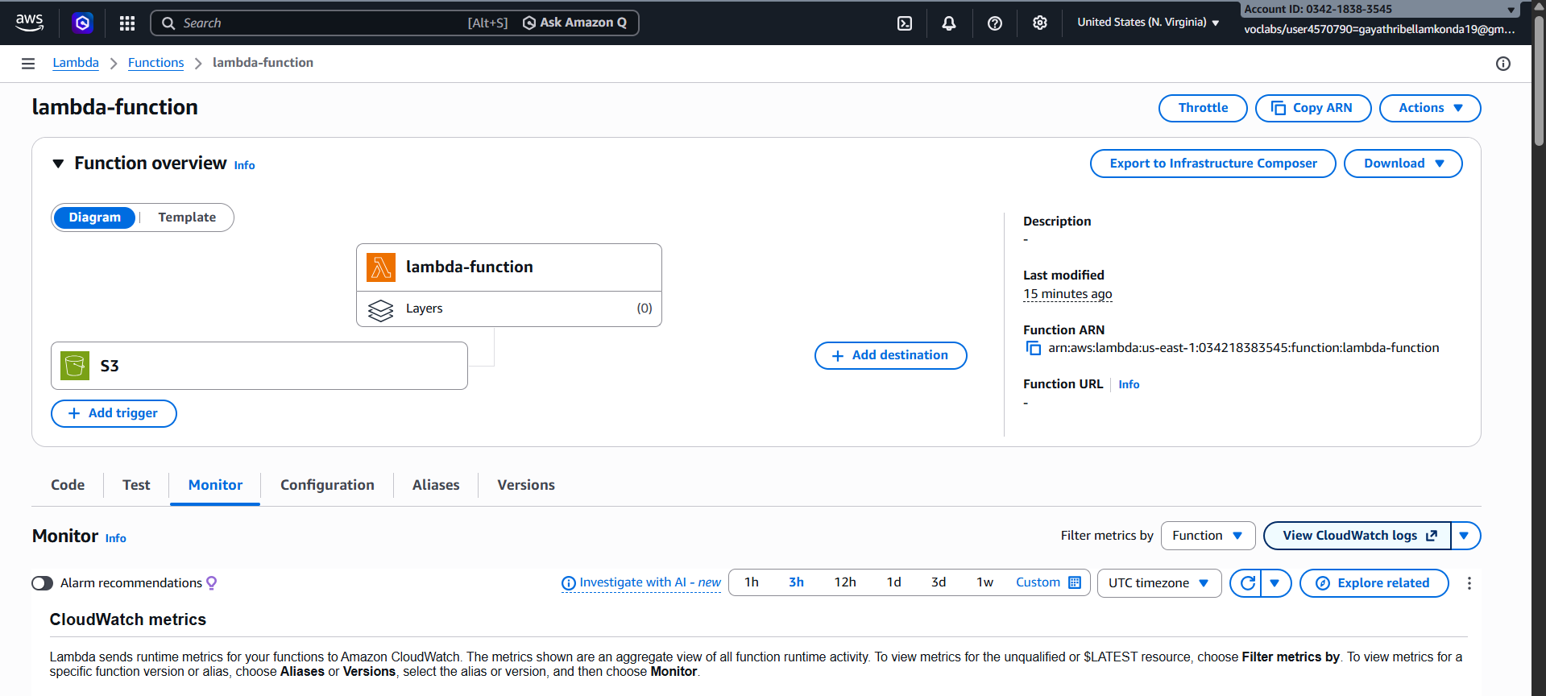
Select the log stream logs will be appeared
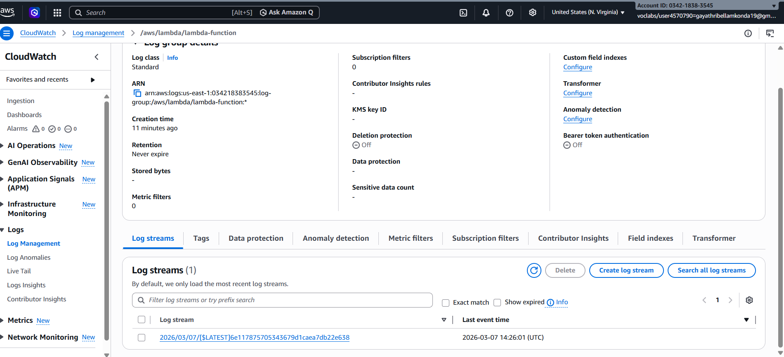
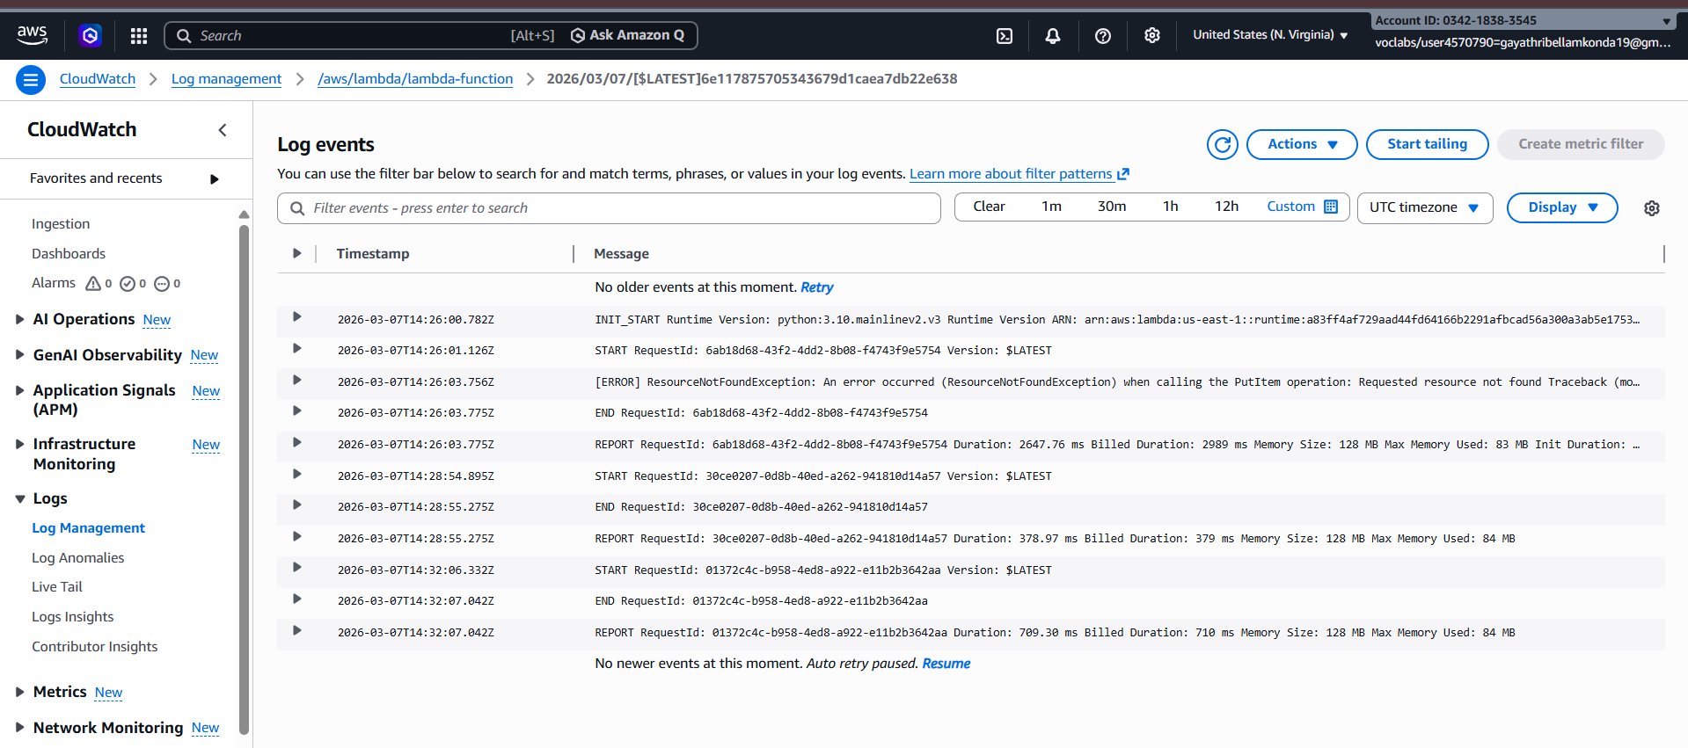

SCENARIO BASED QUESTIONS

1) Lambda function not appearing in S3 trigger list
Reason:
The Lambda function and the S3 bucket are not in the same AWS region. S3 triggers only show Lambda functions that exist in the same region.
Other possible reasons
- Missing S3 invoke permission for Lambda.
- Incorrect IAM role configuration.

2) Lambda stops after a few seconds with timeout error
Setting to check:
Check the Timeout configuration in Lambda settings.
Fix:
- Go to Configuration → General Configuration → Edit
- Increase the Timeout value (default is 3 seconds, max is 15 minutes).

3) Works for small files but fails for large files
Recommended configuration changes:
- Increase Lambda memory
- Increase Timeout
- Use S3 multipart processing
- Use AWS Step Functions or SQS for large processing tasks.
Large files take more CPU and execution time.

4) CloudWatch shows error logs but Lambda Monitoring tab shows none
Possible issue:
- Logs exist in CloudWatch Log Groups, but the Monitoring tab metrics haven't refreshed.
- Incorrect log group filtering
- The Lambda execution role might not have CloudWatch full logging permissions.

5) Developer updated code but forgot to click “Deploy”
Impact:
- The new code will not run.
- Lambda continues executing the previous deployed version.
Until Deploy is clicked, the changes remain unsaved.

6) Send failed execution details to another service
Feature:
Lambda Destinations
How it works:
- Configure On Failure Destination
- Lambda automatically sends invocation details to services like:
  - SQS
  - SNS
  - EventBridge
  - Another Lambda function
This helps with debugging and failure tracking.

7) Two teams using same Lambda affecting each other
Solution:
Use Lambda Versions and Aliases
How it helps:
- Publish different versions of Lambda
- Create aliases like:
  - dev
  - test
  - prod
Example:
- Team A uses alias → test
- Team B uses alias → prod
This isolates deployments.

8) External Python library not available in runtime
Solution:
Use Lambda Layers
Steps
- Install the library locally.
- Package it into a layer ZIP file.
- Upload the layer.
- Attach the layer to the Lambda function.
This allows custom dependencies.

9) Lambda triggered multiple times for single S3 upload
Possible causes
- Multiple S3 event notifications configured
- Both PUT and POST events enabled
- Multiple Lambda triggers attached to the bucket
- File upload via multipart upload events

10) Limit concurrent Lambda executions
Solution:
Use Reserved Concurrency
Steps:
- Go to Configuration → Concurrency
- Set Reserved concurrency limit
Example:
Reserved concurrency = 10
This ensures only 10 executions run simultaneously.

11) Lambda in VPC cannot access internet
Likely issue:
- Missing NAT Gateway configuration.
When Lambda runs inside a private subnet, it needs:
- NAT Gateway
- Proper route table configuration
Without this, internet access fails.

12) Environment variables not reading properly
Possible mistakes
- Incorrect variable name
- Case-sensitive mismatch
- Not using correct syntax in code.
Example (Python):
import os
value = os.environ['VARIABLE_NAME']

13) Failure destination enabled but no notifications received
Possible misconfiguration
- Destination service permission not granted
- Wrong destination ARN
- Destination configured for success instead of failure
Also ensure asynchronous invocation is used.

14) “Access Denied” while writing logs to CloudWatch
Missing permission:
Lambda execution role must include:
AWSLambdaBasicExecutionRole
Or these permissions:
- logs:CreateLogGroup
- logs:CreateLogStream
- logs:PutLogEvents

15) Does increasing memory improve CPU performance?
Yes, this is correct.
In Lambda:
- CPU power is proportional to memory allocation
Example:
- 128 MB → low CPU
- 1024 MB → higher CPU
So increasing memory can improve performance and reduce execution time.

16) Works in test but fails in production
Check these configuration differences
- Environment variables
- IAM roles & permissions
- VPC configuration
- Memory and timeout settings
- Dependency layers
- Different AWS resources (S3, DB, API endpoints)

17) Lambda deleted accidentally – recovery using versions
How versions help:
If versions were published:
- They remain stored internally.
- You can redeploy using previous version configuration.
Aliases help quickly redirect traffic to stable versions.

18) Detailed monitoring for invocation, duration, error rate
- CloudWatch Metrics
  - Invocations
  - Duration
  - Errors
  - Throttles

- CloudWatch Logs

- CloudWatch Alarms
  - Alert on high error rate

- AWS X-Ray
  - For request tracing and performance analysis.

