

**University Alumni Management System**

**Software Requirement Specification (SRS) Document**

**Document Control:**

| **DATE** | **VERSION** | **AUTHOR** | **BRIEF DESCRIPTION OF CHANGES** | **APPROVER SIGNATURE** |
| --- | --- | --- | --- | --- |
| 21/10/2022 | 0.1 | Group 3 | Software Requirements Documentation |  |

**Team Members:**

| **Employee ID** | **Employee Name** |
| --- | --- |
| 46274556 | Jingyanshu Ranjan Rautaray |
| 46274795 | Krishna Priyanka R |
| 46275269 | Vijitha Gangula |
| 46274555 | Supriya Ganta |
| 46274776 | Sowjanya Gummella |
| 46275328 | Krishna Sri Boggula |

**Table Of Contents**

1. Introduction

1.1 Purpose ---------------------------------------------------4

1.2 Intended audience -------------------------------------------------- 4

1.3 Intended use --------------------------------------------------- 4

1.4 Scope --------------------------------------------------- 5

1.5 Overview --------------------------------------------------- 5

2. Overall Description -------------------------------------------------- 5

2.1 Assumptions and dependency --------------------------------------------------- 6

3. System feature and requirements -------------------------------------------------- 6

3.1 Functionality -------------------------------------------------- 6

3.1.1 Alumni Module --------------------------------------------------- 6

3.1.1.1 Alumni get data function --------------------------------------------------- 6

3.1.1.2 Alumni Login function -------------------------------------------------- 6

3.1.1.3 Edit details function --------------------------------------------------- 6

3.1.1.4 Create posts function --------------------------------------------------- 6

3.1.1.5 View posts function -------------------------------------------------- 6

3.1.1.6 View profile function ---------------------------------------------------7

3.1.2 Student Module --------------------------------------------------7

3.1.2.1 Student get data function --------------------------------------------------7

3.1.2.2 Student Login function ---------------------------------------------------7

3.1.2.3 View profile function -----------------------------------------7

3.1.2.4 Edit Info function ---------------------------------------- 7

3.1.2.5 View Alumni Details function ----------------------------------------7

3.1.2.6Job post function -----------------------------------------7

3.1.3 Admin Module -----------------------------------------7

3.1.3.1 Alumni Management Existing System -----------------------------------------7

3.1.3.2 Alumni Management System Proposed --------------------------------------- 7

3.1.3.3 Edit Alumni function ----------------------------------------8

3.1.3.4Delete_Alumni_Details function ----------------------------------------8

3.2 System requirement ---------------------------------------8

3.2.1 Tools to be used --------------------------------------- 8

3.3 System feature ---------------------------------------- 8

4. Data Flow Diagram

4.1 DFD level 0 -------------------------------------- 9

4.2 DFD level 1 ------------------------------------- 9

4.3Flow Chart (level-2) ------------------------------------- 10

### 

## 

## **1.** **Introduction**

The introduction of the software requirement specification provides an overview of the entire software. The entire SRS with overview description purpose, scope, tools used and basic description. The aim of this document is to gather, analyze and give an in-depth insight into the complete **University Alumni Management System** by defining the problem statement in detail. The detailed requirements of the **University Alumni Management Systems** provided in this document.

**1.1 Purpose**

The purpose of this document is to show the requirements for the University Alumni Management System, which helps the college or university to keep track of the alumni students, by doing this it will help the students who are currently in that college or university to know about the job applications in the same field and to know about the technology which is in trend. This portal helps to connect students to alumni and help to build their career.

**1.2 Intended Audience**

This document is intended to be read by

* Admin
* Alumni
* Student

**1.3 Scope**

This project aims to create the development of a University AlumniManagement application in which administrators,students and alumni will be able to continuously communicate with each other.This provides access to the student to access alumni information and posts, which will help students in their career.

**1.4 Overview**

The system will automatically generate a list of all college students as alumni on their graduation and their account status will be transferred from the student module to the alumni management system. This single system will be able to bypass the requirement of any other Alumni Management Organization. The system can track user location as given by the user. Alumni will also be able to provide possible job opportunities. The system will also have privacy features.

**2. Overall Description**

It is a University Alumni Management portal which consists of three modules such as Admin, Student and Alumni.The Alumni can register the portal using the details like University Register number, Name, Current Designation and Department, domain he is working on and Years of Experience. After Registered on that portal, he can login using the Register no and password and post the available new job updates, technical advice and materials so that the students can know about the jobs related to their field and can easily access it.The Alumni can also modify, delete, view his present information like company name, designation, domain,address, phone number, location and email etc.,

The student can also Register in the portal by entering the Registration number, if he is registered, he can view all the details of alumni’s and the post that alumni had posted.The student can update his own details like phone number,email id in the Student Database. If he enters his department, he can view the details of alumni’s working in that only, not in any other department. If he selects the option called current job offers a list of job offers will get displayed to the student and the student can access it.

Admin can login to the portal using a password and he can add,modify,delete and view the Records in both the Alumni and Student Database.CSE, EEE, ECE, MECH, CIVIL department.

**2.1 Assumptions and Dependency**

* System should have Ubuntu Linux installed.
* ·System should have either 4GB or more RAM.
* The service is used preferably on a desktop or laptop.

**3.System Features and Requirements**

**3.1Functionality**

**3.1.1 Alumni Module:** An Alumni can first register by entering his personal and professional details, once registered the alumni can login to his page and post the job-related contents for the other users to see.

**3.1.1.1 UAM_01-> alumni_get_data () ->** It will register the new alumni using a unique university registration number. Alumni can enter the details like sign-up, login, name, address, phone number, email id, department, company, years of experience and location.

**3.1.1.2 UAM_02-> Alumni_Login () -> After** Registration is doneAlumni can enter the username and password to login to the Alumni portal.

**3.1.1.3 UAM_03-> Edit_details () ->**After entering username and password, alumni can update their details like designation, technology, company, location,years of experience.

**3.1.1.4 UAM_05-> Create_posts () ->** After login, alumni can create the Job post /Materials/Information.

**3.1.1.5 UAM_06-> view_posts () ->**Alumni can view the post for job profile, technical advice/materials.

**3.1.1.6 UAM_04->view_profile () ->**Alumni can view their profile through this function.

**3.1.2 Student Module:** A student can register into the portal. If the student already has his login credentials, then he can go into the portal and view all the information posted by alumni like job updates/technical advice/materials. Also, can view their own department alumni details. Students can also edit their information like phone number and email.

**3.1.2.1 UAM_07 -> student_get_data (): function** will register the new student into the portal by his unique university register number.

**3.1.2.2 UAM_08 -> Student_Login ():** If a student has already registered into the portal, they can login into the portal by giving their credentials like register number and password.

**3.1.2.3 UAM_09 ->view_profile ()**: After the login is successful, the student can view his/her profile.

**3.1.2.4 UAM_10 ->Edit_Info ()**: Students can also edit and update their details in the student database like phone number, email id, etc. by using the edit info func.

**3.1.2.5 UAM_11 -> View_Alumni_Details ():** Students can view the details of alumni.

**3.1.2.6 UAM_12 -> Job_posts ():**Students can also see the current job offers, a list of which will be displayed.

**3.1.3 Admin Module:** Admin can login using a password and can modify, delete, view records of Alumni database.The admin will be responsible for creating new login ID for incoming students. He can also enter a domain and see which alumni and students belong to that department.

**3.1.3.1 Alumni Management Existing system:** The existing system is built with innumerable excel sheets that are created by each user. These sheets may be collated by an alumni organization and shared with all alumni. The system is difficult to maintain on a regular basis by a small group of students.

**3.1.3.2 Alumni Management System Proposed:** The proposed system will be on-line so it can be accessed by alumni. It will enable quick and easy communication.Each user will be responsible for updating their information. Alumni will also give job opportunities to themselves using this system.

**3.1.3.3 UAM_14 ->Edit Alumni ():**Admin can login by giving the password and can edit the alumni details.

**3.1.3.4 UAM_15 ->Delete_Alumni_Details ():** Admin can login by giving the password and can delete the student details.

**3.2 System Requirements**

### **3.2.1. Tools to be used**

* CUnit
* Valgrind
* GCOV
* Splint

### **3.3 System Features**

### Supportability:The system is easy to use.

* Design Constraints: The system is built using only C language.
* Reliability & Availability**:** The system is available 24/7 that is whenever the user would like to use the system, they can use it up to its functionalities.

### Performance: The system will work on the user’s terminal**.**

**4. Data Flow Diagram**

**4.1 DFD Level 0**

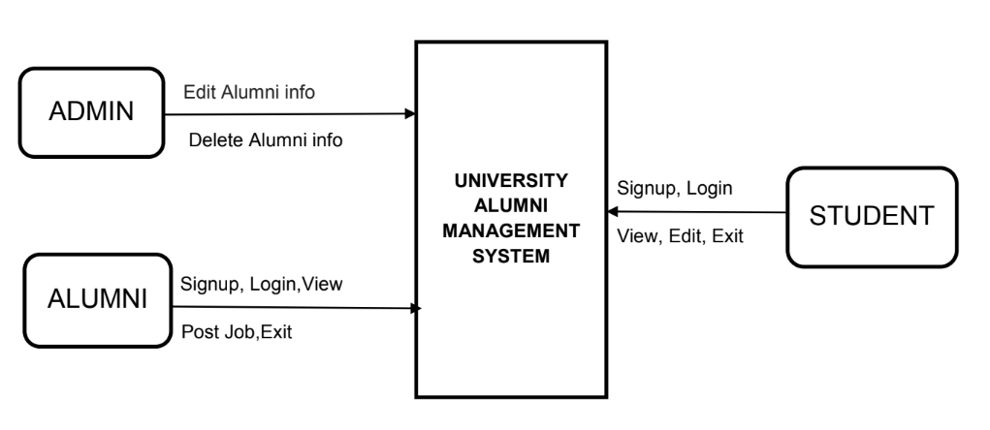

**4.2 DFD Level 1**

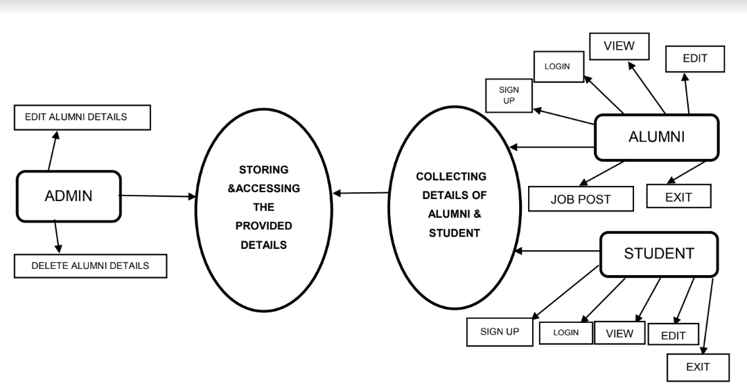

**Flow Chart of University Alumni Management system**

**4.3 DFD Level 2**

