1. **Use EXTRACT (MONTH FROM order date) for month.**

select extract (MONTH FROM order. order Date) as Month from orders o;

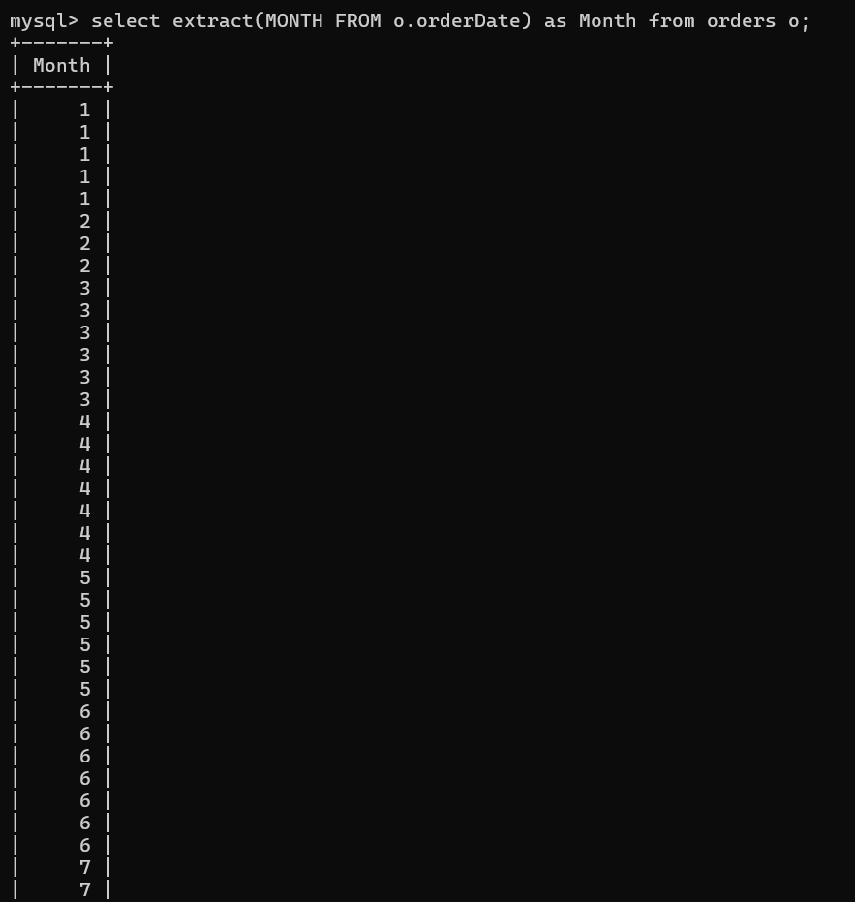

1. **GROUP BY year/month.**

select extract (YEAR FROM order. order Date) as Year, extract (MONTH FROM order. order Date) as Month from orders o group by Year, Month;

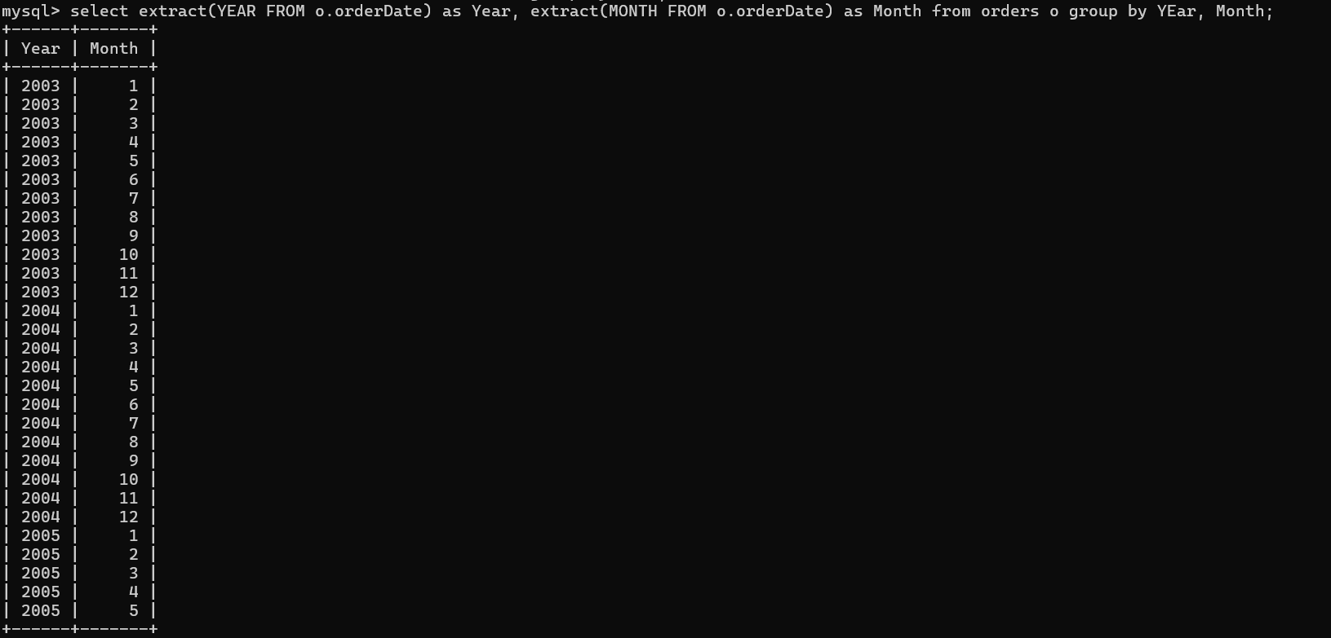

1. **Use SUM () for revenue.**

select sum (quantity Ordered*price Each) as Total Revenue from order details;

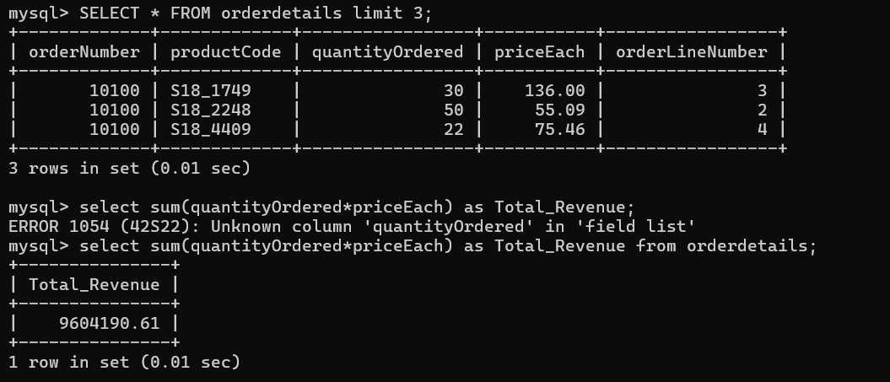

1. **COUNT (DISTINCT order_id) for volume.**

select count (distinct orderLineNumber) as Unique_Order_Lines from order details;

select count (distinct product Code) as Unique_Product_Codes from order details;

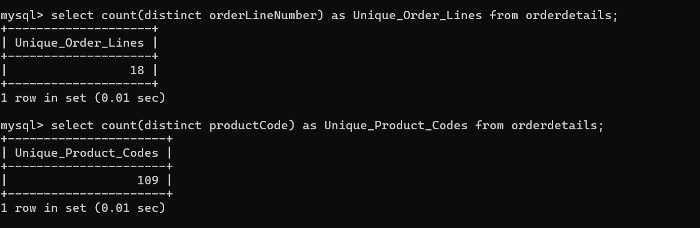

1. **Use ORDER BY for sorting.**

SELECT * FROM order details order by quantity Ordered limit 10;

SELECT * FROM order details order by quantity Ordered desc limit 10;

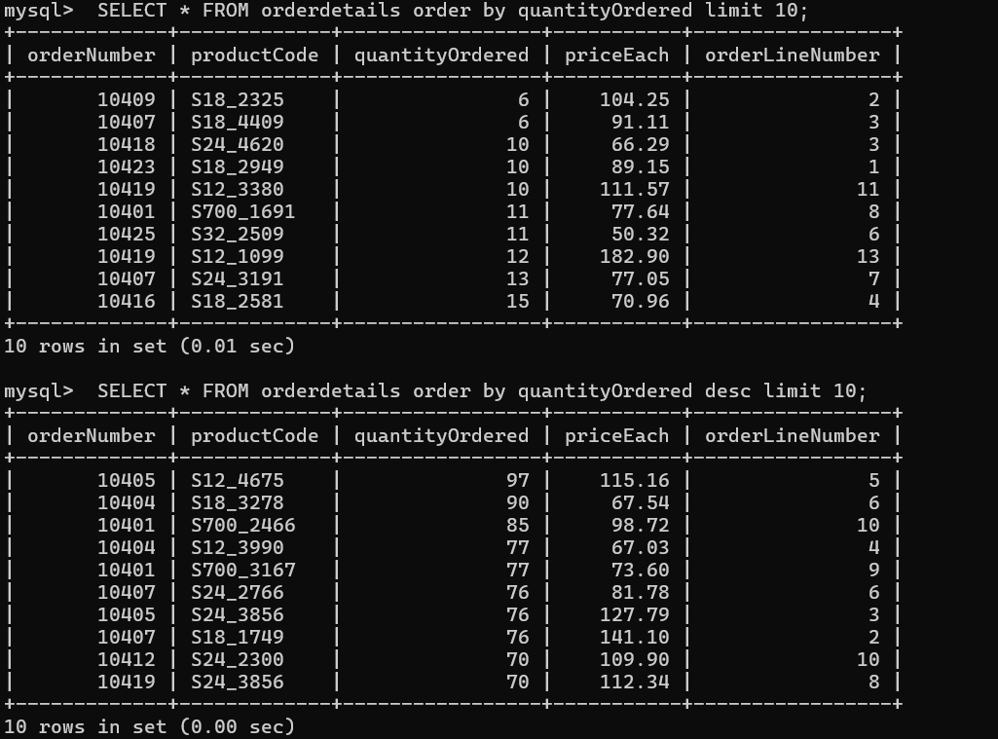

1. **Limit results for specific time periods**

SELECT * FROM orders where extract (year from orders. order Date) > 2004;

