Module 1 Assessment
1. Create a file and add executable permission to all Users(User,group and others)

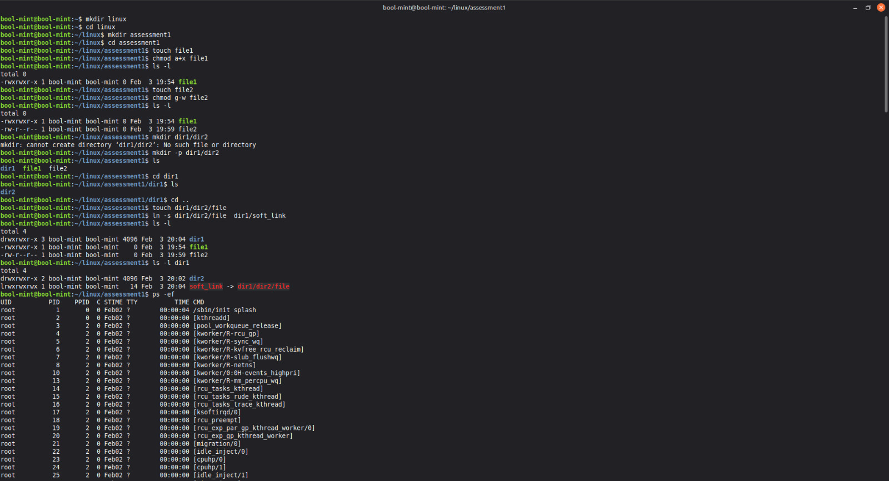

2. create a file and remove write permission for group user alone.

3. Create a file and add a softlink to the file in different directory (Eg : Create a file in dir1/dir2/file and create a softlink for file inside dir1)

4. Use ps command with options to display all active process running on the system

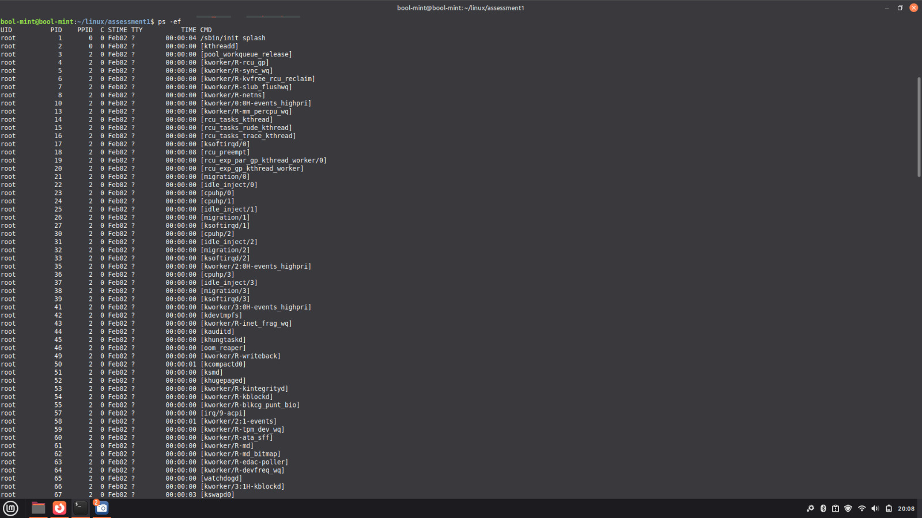

5. Create 3 files in dir1 and redirect the output of list command with sorted by timestamp of the files to a file.

