How to Run This Project

1. Extract the ZIP File
- Download the project ZIP.
- Extract the files from it to your local folder.

2. Open the Project
- Open any code editor (Python language)
- Open the folder

3. Create a Virtual Environment
- Open a terminal inside the project folder.
- Windows

- Mac / Linux:

4. Install Project Dependencies
- Run the following command:

5. Verify Project Structure
- Ensure the folder contains the following directories and file
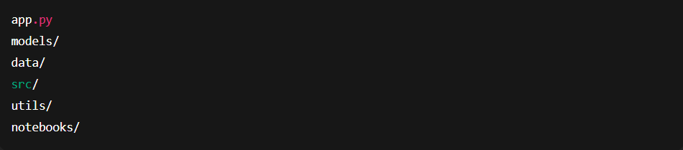

6. Run the Application

7. Application Ready
- Once the server starts, the app will automatically open or provide a local URL.

Note: The application might take a while to load as heavy models are used, please be patient and once opened the app in browser DONOT rerun or go back or close the window.

