|  |  |  |  |  |
| --- | --- | --- | --- | --- |
| November 3 2014 Version 3.0 |  |  |  | [Email]  team@zeebo.org |

Zeebo Report

Matthew Connolly  
Samuel Jacobs  
Brent Scheneman  
Michael Vartan  
Steven Le

Table of Contents

1. Similar and Prior Technologies 3

VideoRay® Pro 4 Rugged BASE ROV System

Seabotix® vLBV950

DOER® H2000

Oceaneering® Magnum PlusROV

1. Zeebo Specifications 7
2. Zeebo Required Tasks 7
3. Test and Verification 11
4. Hardware Block Diagram 12
5. Block Diagram Description 13

Battery

Power Board

Thruster Control

Sensor Suite

Pneumatic Actuators

Onboard AUV Board

External Computer

CAM1

CAM2

1. Software Block Diagram 15

Task State Machine

AUV Motion Control

1. Project Task List 17

1. AI / Control System

2. Machine Vision System

3. Motor Control

4. Sensor Suite

5. Power Distribution System

6. Pneumatic Actuators Implementation

7. Electrical System Implementation

8. Ping Sniffer

9. Navigation, Positioning, and Heading System

# Similar and Prior Technologies

## VideoRay® Pro 4 Rugged BASE ROV System

|  |  |
| --- | --- |
| Website | <http://www.videoray.com/homepage/professional-rovs/videoray-pro-4/pro-4-rugged-base.html> |
| Image | http://www.videoray.com/images/igallery/resized/801-900/Pro4_Cerakote_StandardThruster_web-811-800-600-80.jpg |
| Similarities | * "VideoRay operators worldwide have reported locating, identifying, and removing drugs, and other contraband from vessel hulls, port and harbor structures and bottoms." |
| Advantages | * Smaller Form Factor * Transportable, Deployable, Operable by single user. |
| Disadvantages | * Not delivered with a tether, user must purchase separately * Control System is not ergonomic |
| Cost | Approx. $25,000 |

## Seabotix® vLBV950

|  |  |
| --- | --- |
| Website | <http://www.seabotix.com/products/vlbv950.htm> |
| Image | http://www.seabotix.com/products/images/vlbv/vlbv300_front_lrg.jpg |
| Similarities | * Vectored Thrusters * Manipulator Arm * Intuitive Control System |
| Advantages | * SeaBotix MiniROV controls have been regarded as the most intuitive of all small ROVs. The vLBV950 is no different with the user friendly operator control unit and integrated control console. * 4x Data RS232/845 Data Channels * Safety: Isolated input power, circuit breaker, line insulation monitor, leak detector. Meets and exceeds "Code of Practice for the Safe Use of Electricity in Water" |
| Disadvantages | * Cost |
| Cost | Quote Required |

## DOER® H2000

|  |  |
| --- | --- |
| Website | <http://www.doermarine.com/?page_id=574> |
| Image | http://www.doermarine.com/wp-content/uploads/2011/03/h2000_New.jpg |
| Similarities | * DOER’s H2000 is an ultra-compact work class ROV. * Designed for multi-mission use from a variety of platforms, the H2000 can be used for underwater tasks including survey, sampling, search/recovery, NDT and inspection. * Manipulator Arm |
| Advantages | * Auto Heading * Go to heading, Depth * On-screen Overlay * Rated to 2000m * Upgradability to adapt to changing technology |
| Disadvantages | * Cost |
| Cost | Quote Required |

## Oceaneering® Magnum PlusROV

|  |  |
| --- | --- |
| Website | http://www.oceaneering.com/rovs/rov-systems/magnum-plus-rov/ |
| Image | rov-magnum-sm |
| Similarities | * Manipulator Arm * Form Factor * Mission |
| Advantages | * Fiber optics are used as the primary transmission link for all video and data signals between the vehicle and the surface control console. * This allows extremely high quality video transmission * Plug and play installation of sensors and equipment * Rated to depth of 10,000 fsw |
| Disadvantages | * Cost * None |
| Cost | Quote Required |

# Zeebo Specifications

|  |  |
| --- | --- |
| **Vehicle** |  |
| Max Length | 6 ft. [1.83m] |
| Max Width | 3 ft. [0.91m] |
| Max Height | 3 ft. [0.91m] |
| Max Weight (in AIR) | 84 lbs. [38 kg] |
| Max Depth | 50 ft. |

# Zeebo Required Tasks

“Path”

This task consists of line segments constructed from aluminum sheet snaking their way from the Gate/Control Panel, over to the Maneuvering area, past the Landing Site and Brunch. There are two segments following the Landing Site/Brunch area, one points to the Reroute power task, and one points to the Recovery area.

The “path” will be constructed of 6 inch (15 cm) wide by 4 feet (1.2 m) long sections of aluminum sheet. It will be covered with **Blaze Orange** Duck tape. The “path” is raised off the floor of the pool 1-2 feet (0.3-0.6 m) and each segment will not have a relative angle between two pieces of more than 90° (except for the segments which point between the path split). The segments are situated in such a way that if you follow a heading along the line segment you will (eventually) meet with the next task. The next path segment will be located on the “far side” of the obstacle 1-3 ft. (0.3-0.9 m). Distances between segments will vary depending on the positioning of the tasks. The order of the tasks will always be: Control Panel, Maneuver, Landing Site/Brunch, Collection/Recovery Zone, with the Reroute power task located near the center of the facility. You may complete the tasks in any order (with the Gate required to be first before starting anything else).

“Control Panel (Buoy)”

This task consists of three moored buoys. One of the buoys will be self-illuminated with high power **RED**/**GREEN**/**BLUE** LEDs (RGB buoy). This RGB buoys will be 4” in diameter and approximately 15” (38cm) long (6” [15cm] lit section). Every 5 seconds it will cycle through each of these two colors: Red and Green. On the first bump from the AUV, the buoy will stop cycling. Subsequent bumps will then toggle through the colors. The two other buoys will be 9” (23cm) diameter solid color **RED** buoy and solid color **GREEN** buoy.

To receive the most points for the RGB buoy, the AUV must set the RGB buoy to **Green**. For the solid color buoys, the most points are awarded for touching the Red then the Green buoy. These are two separate tasks and can be attempted each for points. The last two solid color buoys will be the ones that count for points for that portion of the task. The buoys are constructed so that they can take a decent blow. The mooring line will either be nylon webbing or 550 paracord to minimize the chances of the vehicle becoming entangled. You may hit the buoys from any direction.

“Maneuvering (PVC to pass over/around)”

The task consists of a 2” (5.1 cm) diameter, 6ft (1.8 m) long PVC pipe with two short vertical floating risers on each end and a longer vertical floating riser in the middle. All three risers will be tied to the horizontal section and be free to move. The vertical risers on the end will be 1ft (0.3m) long tied to the horizontal section. The longer middle riser will be 4ft (1.2m) long tied to the middle of the horizontal section. The PVC is colored using **Neon Green** and **Red** Tape.

There are two ways to score points. The first way is to pass over the horizontal section, to the left or right of the center Red riser and inside the outer Green risers. The second way is to circumnavigate around the center Red riser. The method and orientation of the circumnavigating vehicle is up to the team, as long as the vehicle completes a full 360° circuit of the Red riser. When attempting this method, the vehicle may extend past the outside Green risers. For either method, full points will be awarded for the center-line or more of the vehicle passing below the top of the Red riser.

“Landing Site (Bins)”

This task consists of a **BLACK** bin surrounded by a white border. The bins will be 1-2 feet (0.3-0.6 m) off the bottom. The four bins will be “square” array. The long side of two of the bins will be oriented with the vehicle's motion, while the long side of the other two bins will be oriented against the vehicle's motion (see Drawing 3). In each bin, there will be one Alien silhouette.

A vehicle may carry up to two markers to drop within the bins. One silhouette will be designated as the primary target (only one silhouette from each column [see Drawing 8] will be in the four bins), and one will be designated as the secondary target. The most points will be awarded for dropping one marker in the primary target, and one in the secondary target. Partial points will be awarded for dropping markers in any bin.

“Brunch (Firing torpedoes)”

This task consists of a single square **Green** board. On the board, there will be an image of a spaceship. Above the ship are four 5in (12.7cm) circular cutouts with 7in (17.8cm) **Black** borders. Below the ship are two 10in (25.4cm) circular cutout with 12in (30.5cm) **Black** border. During a run, two of the four smaller circles and one of the two larger circles will be covered.

A vehicle may carry up to two torpedoes to fire. The maximum amount of points will be awarded for firing a torpedo through each of the smaller circles. Partial points will be awarded for firing torpedoes through any cutout.

“Reroute Power (Manipulation task)”

This task consists of an array of eight **Blue** circles arranged on a 36in (91cm) **Yellow** square. There will be four **Red** power pins arranged on four of the eight **Blue** circles. A steel washer will be glued to the back of each power pin. A magnet behind each of the **Blue** circles will hold the steel washer on the power pin to the board. Due to the nature of the steel and magnets, do not expect the power pins to be centered on the **Blue** circles, see Drawing 14.

Full points will be awarded for removing a power pin from one blue circle and placing it on a different, unoccupied blue circle. Partial points for removing a power pin, and more points for replacing the pin back into its previous position. Points are additive for each **different** pin moved.

“Recovery Area (object recovery and octagon)”

This task consists of an acoustic pinger located 2 ft. (0.6 m) off the floor. Floating above the pinger, on the surface will be a single octagon representing the Recovery area. The octagon will be constructed from 1⁄2” PVC pipe and have a “diameter” of 9 ft. (2.74 m). Each side could have two octagons and two pingers placed in different locations. At the start of each run, one of the two pingers will be turned on.

Positioned directly above each pinger will be a fixture, which holds the Sample box. The top of the Sample box will be colored using Tape. Located next to the Recovery area is the 4ft (1.2m) square Collection sites with a 3” (7.6cm) border of Duck Tape. From each of the Recovery area/pingers will be a **Blaze Orange** path segment pointing to the Collection site. Within the Collection site, there will be three Mars rocks (colored **RED)** and three green cheese structures (colored **Green**). The goal is for the vehicle to capture one or more Mars rock/green cheese and delivery them to the Sample box.

In order to obtain full points for surfacing, your vehicle must surface fully inside the octagon (no portion of the sub touching the structure). In order to obtain full points for recovery, the object must be captured (maintains control) by the vehicle when it surfaces. A capture consists of constraining the object in at least 3 degrees of freedom (grabbing the object with a dangling line does not count). In order to obtain full points for the drop off, the object must be released from the vehicle and sink back down (the object must first be properly recovered in order to drop it). No part of the object can be hung up on the vehicle.

The team captain can choose to switch the active pinger, after the vehicle has recovered the object, but before the vehicle has surfaced. The vehicle can then transport the object to the second octagon and release the object.

The competition and practice side will ping at a rate of 0.5 Hz (2 seconds), and will be separated by 0.9 seconds. The pingers will be synchronized. The schedule will be:

Unit 1 (Competition) Unit 2 (Practice) Unit 1 (Competition) Unit 2 (Practice) Etc.

ping t = 0s

ping t = 0.9s

ping t = 2.0s

ping t = 2.9s

This gives the reverbs from each pinger (near) maximum time to die out. Note that for the final runs, the competitors will have the choice to keep the practice pinger on, or turn it off.

Acoustics

The pingers that we will use will be Teledyne Benthos ALP-365 pingers. They can be set from 25-40 kHz in 0.5 kHz increments.

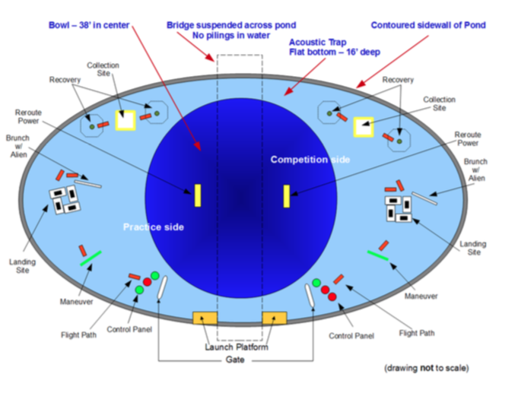

# Test and Verification

1. Recognize an orange 6” wide by 4’ long platform and maneuver along the length of it.
2. Recognize and distinguish between three 9” diameter RGB lights.
3. Zeebo must recognize and maneuver under a goal post that is 10’ wide, and 5’ tall.
4. Zeebo must recognize a 1’ by 2’ black bin and dispenses a marker into said bin.
5. Zeebo must pick up an object from 6” diameter area, and relocate it to a different 6” diameter area.
6. Locate a 9’ in diameter octagonal ring and surface through it.
7. Locate acoustical ratiometric pingers operating at 25 kHz to 40 kHz.

# Hardware Block Diagram

*Motor Control*

3

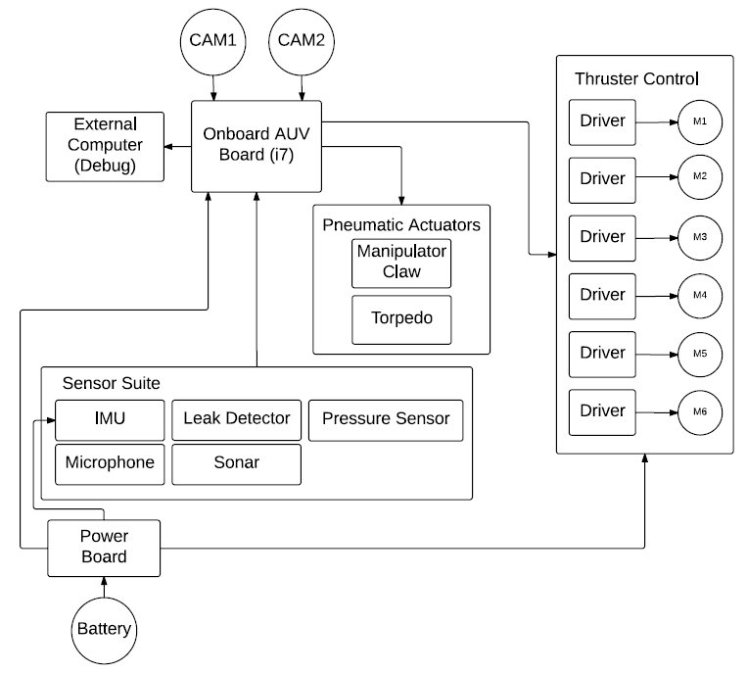

*Torpedo and Claw System*

*Image Recognition*

*Description of Purpose*

Legend:

*Navigation, Positioning and heading*

*Navigation, Positioning and heading*

9

*Ping Sniffing*

*Entire Electrical System*

6

*Power System Dist. And MGMT*

*Sensor Control and Reading*

*AI Control System*

Task #

2

1

9

8

7

5

4

# Block Diagram Description

## Battery

This is Zeebo’s onboard power source which includes a 22-volt battery.

## Power Board

This block will utilize a fabricated voltage regulator board to step down and divide voltage to the corresponding components in Zeebo. The goal of this board is to maintain functionality and to ensure electrical compatibility between current and voltage ratings.

## Thruster Control

This block will include motor drivers connected to six motor thrusters to allow full-degree movement of Zeebo utilizing pulse-width modulation interacting with the onboard AUV board.

## Sensor Suite

This block will utilizes sensors and data-logging including the Inertial Measurement Unit, leak detection sensor, pressure sensor, microphone, and sonar. The IMU will provide input to the onboard AUV board including velocity, orientation, and gravitational forces using accelerometers and gyroscopes. The leak detection and pressure sensor will be utilized in the main housing of Zeebo as double detection protocol. The pressure sensor is used to identify large pressure changes due to water leaks. The leak detection system will induce a water leak in the housing and will respond accordingly such as shutting down power to avoid underwater safety hazards.

## Pneumatic Actuators

This block will utilize actuator sensors for the manipulator claw and torpedo for the mission tasks that include dropping markers in a designated location, and firing a projective through a cutout underwater.

## Onboard AUV Board

This block holds Zeebo’s Intel i7 processor that performs manipulation tasks for the mission. This quad-core processor is the best option to reduce overall weight without sacrificing performance.

## External Computer

This block is reserved for external computers such as laptops and computers for debugging and troubleshooting purposes.

## CAM1

This block houses the front camera onboard Zeebo to determine navigation, image processing, and image recognition.

## CAM2

This block houses the downward camera onboard Zeebo to determine navigation, image processing, and image recognition.

# Software Block Diagram

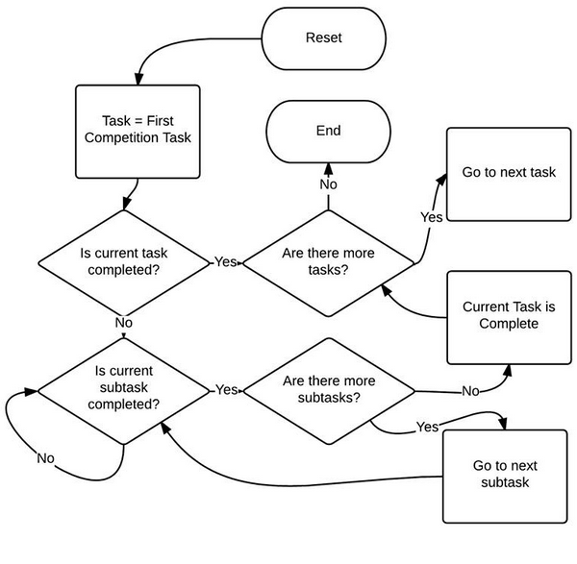

## Task State Machine

The logic behind the RoboSub mission ultimately relies on the unreleased RoboSub 2015 specs. However, the idea behind the logic in the "Task State Machine" should work for any mission Zeebo is set on. There are no user inputs in this block, as the robot is autonomous. A mission is split up into tasks and subtasks, until each subtask is a basic small action. A task to move a red square from one part of a pool to another can be broken up as follows:   
Move towards a red square/close claw on red square/move to blue circle/open claw on blue circle.  
  
Essentially, all the task state machine does is cue tasks and their related subtasks. The last task should be assigned for the mission, and would most likely be something along the lines of "Move to edge of pool/surface" for the RoboSub competition.

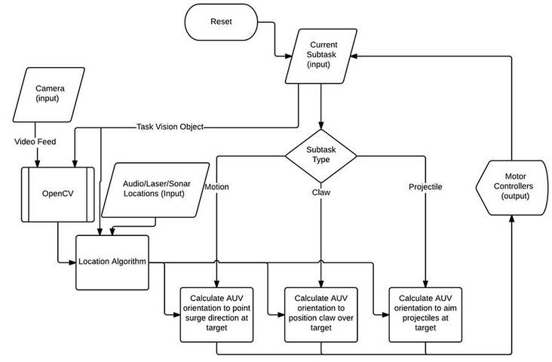

## AUV Motion Control

The AUV motion control acts only on the current subtask delegated by the task state machine. The motion control takes the following information as inputs: Current subtask, Camera. It uses the vision object from the current subtask, and the subtask type to send motor control outputs to the motor controllers.

# Project Task List

The following section outlines the tasking for the hardware design, implementation, and verification of Zeebo.

## AI / Control System

Team Members: Michael Vartan, Samuel Jacobs

Estimated Time: December 2014 to April 2015

###### *Description:*

The AI and control system is going to consist of a motherboard running an energy-efficient Intel i7 quad core processor. It is going to have a separate GPU for offloading the threads from the Machine Vision Image Recognition system.

## Machine Vision System

Team Member: Michael Vartan, Samuel Jacobs, Brent Scheneman

Estimated Time: Nov 2014 to March 2015

Description:

This task will allow image recognition fed from the cameras to the control system to determine mission task priority.

#### Includes: Camera -- Image Recognition Algorithms

Team Member: Michael Vartan

Estimated Time: Nov 2014 to March 2015

Description:

This task will utilize an algorithm to determine mission task priority based on objects of mission priority, color recognition, and object detection.

#### Includes: Ultrasonic Range Finding System

Team Members: Michael Vartan, Samuel Jacobs

Estimated Time: Nov 2014 to March 2015

Description:

This task will support in Zeebo to determine its current position, location, and distance from mission objectives.

#### Includes: Laser Range finding System

Team Members: Michael Vartan, Samuel Jacobs

Estimated Time: Nov 2014 to March 2015

Description:

This task will support in Zeebo to determining distance from objects and collision detection.

## Motor Control

Team Members: Brent Scheneman, Samuel Jacobs

Estimated Time: December 2014 to February 2015

#### Includes: Motor Control Board Layout / Fabrication

Team Member: Brent Scheneman, Steven Le

Estimated Time: January 2015 to February 2015

Description:

This task will include a custom designed circuit board with motor drivers to determine proper thruster operation and functionality.

#### Includes: Motor Electrical Implementation

Team Member: Brent Scheneman, Steven Le

Estimated Time: January 2015 to February 2015

Description:

This task will include 6 motors interconnected with the motor control board, interconnecting wires and proper insulated connections to waterproofing.

## Sensor Suite

#### Includes: IMU, Leak Detector, Pressure Sensor, Microphone, Sonar

Team Member: Brent Scheneman, Steven Le

Estimated Time: January 2015 to February 2015

Description:

This task will include the following:

1. Data-logging with the IMU
2. Leak/pressure detection in the main housing
3. Microphones utilized as arrays to determine location of sound in water.
4. Develop a sonar system to determine a position in the water to surface above it as a mission task.

## Power Distribution System

Team Member: Brent Scheneman

Estimated Time: December 2014 to February 2015

Description:

Create power management boards that monitor and distribute power throughout the system.

## Pneumatic Actuators Implementation

Team Member: Samuel Jacobs, Brent Scheneman

Estimated Time: January 2015 to February 2015

#### Includes: Manipulator Arm Power & Control System

Team Member: Brent Scheneman, Sam Jacobs

Estimated Time: January 2015 to March 2015

Description:

This task will include a pneumatic manipulator arm operating at full efficiency when the mission task is present. This is utilized in the mission tasks to drop markers underwater.

#### Includes: Torpedoes Power & Control System

Team Member: Brent Scheneman, Steven Le

Estimated Time: January 2015 to March 2015

Description:

This task will involve designing and implementing a pneumatic operated launcher system to shoot a projective (marker) through a cutout underwater.

## Electrical System Implementation

Team Member: Brent Scheneman

Estimated Time: January 2015 to March 2015

Description:

This task is to verify and ensure that the entire electrical system is protected from power surges, failures, water leakage.

## Ping Sniffer

Team Member: Brent Scheneman

Estimated Time: January 2015 to March 2015

Description:

This task will allow acoustic pingers to be sensed to navigate towards in order to complete the mission task of object recovery.

## Navigation, Positioning, and Heading System

Team Member: Brent Scheneman, Samuel Jacobs

Estimated Time: January 2015 to March 2015

Description:

This task will ensure correct movement of Zeebo underwater.