Practical-9

Demonstrate Node.js using MySQL to perform the below operations using the user-defined function: delete record, select record, select unique, drop table.

Step-1. Install Node.js
Step-2. Verify that Node.js was properly installed with the following
Command in CMD: node --version
Step-3. Verify whether NPM (Node Package Manager) is installed or not with the following command in CMD: npm --version
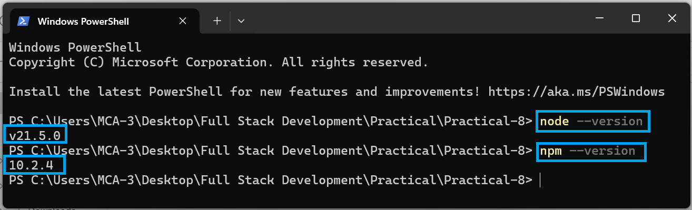

Step-4. MySQL Installation: download it from https://www.apachefriends.org/index.html
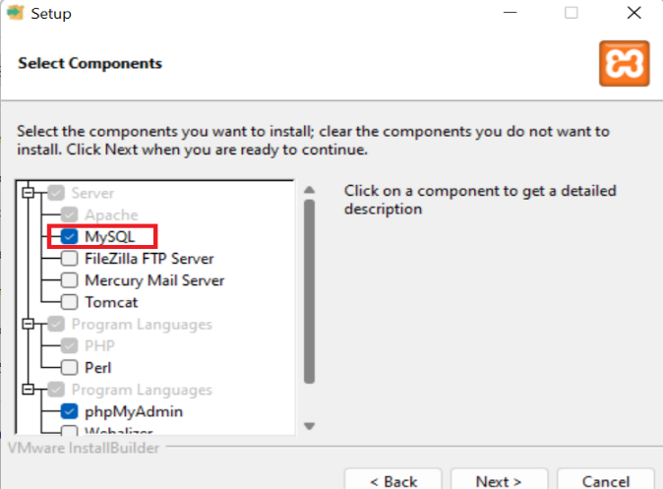 | 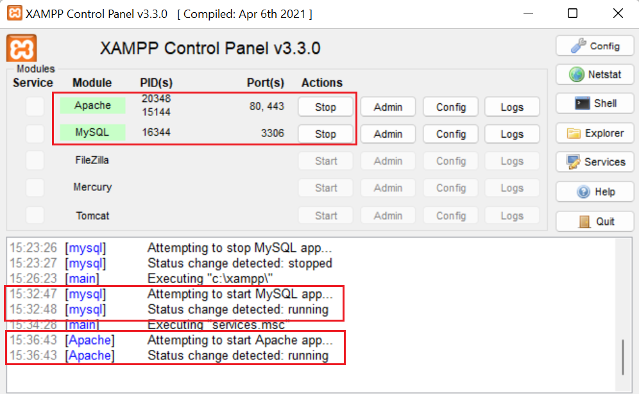
- Start XAMPP: Open the XAMPP control panel and start the Apache and MySQL services if they are not already running.
- Access phpMyAdmin: Open your web browser and go to http://localhost/phpmyadmin/. This will open phpMyAdmin, a web-based MySQL administration tool that is included with XAMPP.

Step-5. Create a new folder for your project: Open Visual Studio Code and create a new folder where you want to store your project files.

Step-6. Open Terminal in Visual Studio Code: Once you have your folder open in Visual Studio Code, open the integrated terminal. You can do this by selecting Terminal > New Terminal from the menu bar.

Step-7. Initialize a new Node.js project: In the terminal, navigate to your project folder and run the following command to initialize a new Node.js project:

npm init -y

Step-8. Install the MySQL package: Install the mysql package using npm by running the following command in the terminal:

npm install mysql

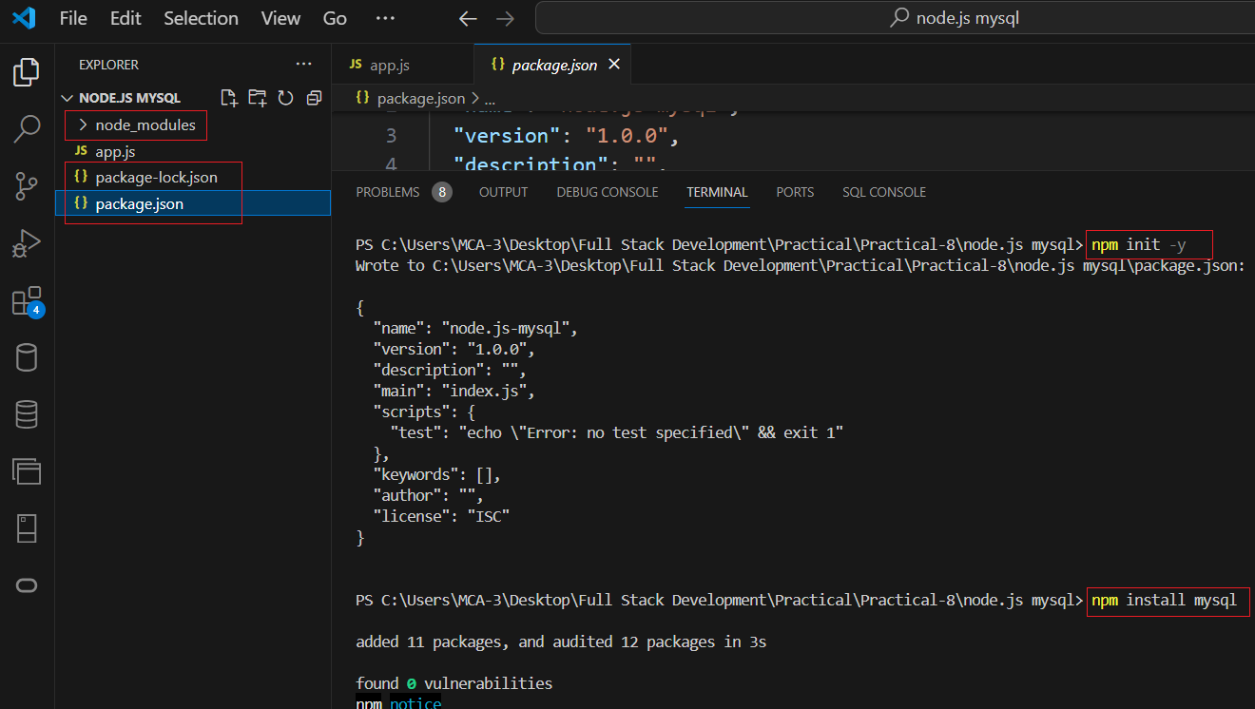

Step-9. Create a new JavaScript file: Create a new file app.js. This file will contain your Node.js code.
File name: app.js
// Import required modules
const mysql = require('mysql');

// Create a connection to the MySQL server
const connection = mysql.createConnection({
host: 'localhost', // Change to your MySQL host
user: 'root', // Change to your MySQL username
password: '', // Change to your MySQL password
database: 'my_database' // Change to your MySQL database name
});

// Connect to MySQL server
connection.connect((err) => {
if (err) {
console.error('Error connecting to MySQL server: ' + err.stack);
return;
}
console.log('Connected to MySQL server as ID ' + connection.threadId);
});

// Delete record
const deleteRecord = (id) => {
const query = `DELETE FROM my_table WHERE id = ?`;
connection.query(query, [id], (err, results) => {
if (err) {
console.error('Error deleting record: ' + err.stack);
return;
}
console.log('Record deleted successfully.');
});
};

// Select record
const selectRecord = (id) => {
const query = `SELECT * FROM my_table WHERE id = ?`;
connection.query(query, [id], (err, results) => {
if (err) {
console.error('Error selecting record: ' + err.stack);
return;
}
console.log('Selected record:', results[0]);
});
};

// Select unique records
const selectUniqueRecords = () => {
const query = `SELECT DISTINCT name FROM my_table`;
connection.query(query, (err, results) => {
if (err) {
console.error('Error selecting unique records: ' + err.stack);
return;
}
console.log('Unique records:', results);
});
};

// Drop table
const dropTable = () => {
//create my_table first under my_database first
const query = `DROP TABLE my_table1`;
connection.query(query, (err, results) => {
if (err) {
console.error('Error dropping table: ' + err.stack);
return;
}
console.log('Table dropped successfully.');
});
};

// Delete a record
deleteRecord(1);

// Select a record
selectRecord(1);

// Select unique records
selectUniqueRecords();

// Drop table
dropTable();

Step-10. Modify the MySQL connection details: Modify the MySQL connection details in the code to match your MySQL server configuration. Update the host, user, password, and database properties in the createConnection function call.
Step-11. Run the script: Save your app.js file and return to the terminal in Visual Studio Code. Run the script by executing the following command:
node app.js
Step-12. Verify the output: Check the output in the terminal to see if the script executed successfully.
