Deploying Binge Watch Online on Microsoft Azure Cloud

Project Objective
The goal of this project is to deploy an online movie watching website on Microsoft Azure cloud using Storage Account, CDN/Front Door, Virtual Machines, and GitHub Deployment, ensuring:
- Fast global content delivery
- Load balancing at DNS level
- Secure and structured cloud resource management
- Cost tracking and governance

Problem Statement
Binge Watch Online has created a static website to provide global users with entertainment content. Users have reported slow page load times because all content is served from a single server. The project addresses this by:
- Uploading static content to Azure Storage
- Configuring Azure Front Door for global delivery
- Using Azure App Service and GitHub deployment for backend code
- Setting up VM access and file sharing for team collaboration
- Managing cloud resources, costs, and billing

Step-by-Step Azure Deployment

Step 1: Upload Static Website to Azure Storage
- Create Storage Account in Azure Portal.
- Enable Static Website.
  - Index document: index.html
- Go to $web container → Upload index.html.
- Copy the Primary endpoint URL and test in browser.
index.html
<!DOCTYPE html>
<html lang="en">
<head>
<meta charset="UTF-8">
<title>Binge Watch Online</title>
<meta name="viewport" content="width=device-width, initial-scale=1.0">

<!-- Simple Styling -->
<style>
body {
margin: 0;
font-family: Arial, Helvetica, sans-serif;
background-color: #0f172a;
color: #ffffff;
}

header {
background-color: #020617;
padding: 20px;
text-align: center;
}

header h1 {
margin: 0;
color: #38bdf8;
}

nav {
display: flex;
justify-content: center;
background-color: #020617;
padding: 10px;
}

nav a {
color: #ffffff;
text-decoration: none;
margin: 0 15px;
font-weight: bold;
}

nav a:hover {
color: #38bdf8;
}

.hero {
text-align: center;
padding: 60px 20px;
background: linear-gradient(to right, #020617, #0f172a);
}

.hero h2 {
font-size: 36px;
margin-bottom: 10px;
}

.hero p {
font-size: 18px;
color: #cbd5f5;
}

.movies {
display: grid;
grid-template-columns: repeat(auto-fit, minmax(200px, 1fr));
gap: 20px;
padding: 40px;
}

.movie-card {
background-color: #020617;
border-radius: 8px;
padding: 15px;
text-align: center;
}

.movie-card img {
width: 100%;
border-radius: 8px;
}

.movie-card h3 {
margin: 10px 0 5px;
}

footer {
background-color: #020617;
text-align: center;
padding: 15px;
font-size: 14px;
color: #94a3b8;
}
</style>
</head>
<body>

<header>
<h1>Binge Watch Online</h1>
<p>Your Entertainment, Anytime, Anywhere</p>
</header>

<nav>
<a href="#">Home</a>
<a href="#">Movies</a>
<a href="#">TV Shows</a>
<a href="#">Subscription</a>
<a href="#">Contact</a>
</nav>

<section class="hero">
<h2>Stream Movies & TV Shows Worldwide</h2>
<p>Fast • Secure • Cloud Powered on Microsoft Azure</p>
</section>

<section class="movies">
<div class="movie-card">
<img src="https://via.placeholder.com/300x400?text=Movie+1" alt="Movie 1">
<h3>Action Thriller</h3>
<p>Watch Now</p>
</div>

<div class="movie-card">
<img src="https://via.placeholder.com/300x400?text=Movie+2" alt="Movie 2">
<h3>Romantic Drama</h3>
<p>Watch Now</p>
</div>

<div class="movie-card">
<img src="https://via.placeholder.com/300x400?text=Movie+3" alt="Movie 3">
<h3>Sci-Fi Adventure</h3>
<p>Watch Now</p>
</div>

<div class="movie-card">
<img src="https://via.placeholder.com/300x400?text=Movie+4" alt="Movie 4">
<h3>Comedy Show</h3>
<p>Watch Now</p>
</div>
</section>

<footer>
© 2025 Binge Watch Online | Powered by Microsoft Azure Cloud
</footer>

</body>
</html>
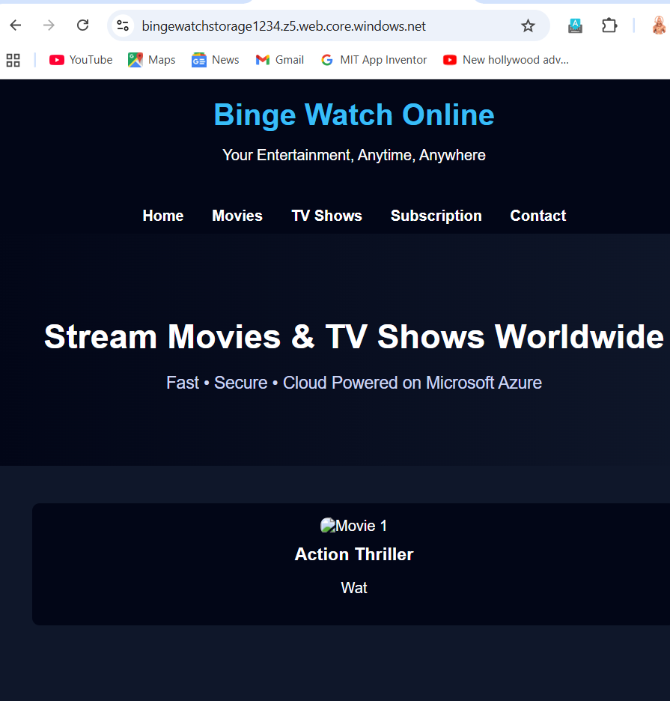

Step 2: Configure Azure Front Door (CDN)
- Create Front Door Standard.
- Add Endpoint (http://bw-endpoint-f6e9apf0fhbyf5em.a03.azurefd.net).
- Create Origin Group pointing to Storage Static Website:
  - Hostname: bingewatchstorage1234.z5.web.core.windows.net
  - HTTPS: Enabled
- Create Route:
  - Pattern: /*
  - Default root object: index.html
  - Session affinity: Disabled
  - Caching: Enabled → Query string: Ignore query string
- Save → Wait 5–10 minutes → Test Front Door URL.
If 404 occurs, check route and origin hostname.

Step 3: GitHub Deployment to Azure App Service
- Create a GitHub repository named bw-app.
- Upload your backend demo files (package.json, server.json, public/index.html) via web.
Package.json
{
"name": "bw-app",
"version": "1.0.0",
"main": "server.js",
"scripts": {
"start": "node server.js"
},
"dependencies": {
"express": "^4.18.2"
}
}
Server.json
const express = require('express');
const app = express();
const port = process.env.PORT || 3000;

// Serve static files from public folder
app.use(express.static('public'));

// Root route
app.get('/', (req, res) => {
res.sendFile(__dirname + '/public/index.html');
});

app.listen(port, () => {
console.log(`Binge Watch app listening on port ${port}`);
});
Public/index.html
<!DOCTYPE html>
<html>
<head>
<title>Binge Watch Online</title>
</head>
<body>
<h1>Welcome to Binge Watch Online!</h1>
<p>This is a demo backend app deployed via GitHub to Azure App Service.</p>
</body>
</html>
- In Azure → App Service → Deployment Center:
  - Source: GitHub
  - Repository: bw-app
  - Branch: main
https://github.com/varuganti-pavan-kumar/bw-app
- Wait for deployment → Test App Service URL.

Step 4: Azure VM and File Sharing
- Create Windows VM in same resource group.
- Mount Azure Storage or File Share.
- Verify team members can access files for collaboration.

Create the VM
- Azure Portal → Virtual Machines → + Create → Azure Virtual Machine
- Fill the basics:
  - Subscription: your subscription
  - Resource Group: BW-Prod-RG
  - VM Name: BW-Admin-VM
  - Region: west US 2
  - Image: Windows Azure x64
  - Size: Standard B1s or B2s (course project, small VM)
- Administrator account:
  - Windows → vmadmin and password: ***
- Public inbound ports:
  - Allow RDP (3389) for Windows
Click Next → Disks → Networking → Review + Create → Create

Connect VM to Storage/File Share
- Open VM → Connect → RDP
- Once inside, open File Explorer → Map Network Drive
- Fill:
  - Folder:
  - \\<storageaccountname>.file.core.windows.net\bwfileshare
  - Connect using storage account credentials (Access Key or SAS token)
- Click OK → You can now access shared files.

Step 5: Resource Governance and Cost Management
- Tag all resources:
Project: BingeWatchOnline
Environment: Dev/Test/Prod
Owner: <Your Name>
- Enable Azure Cost Management → Track usage and costs.

Set Up Cost Management
- Azure Portal → Cost Management + Billing → Budgets
- Click + Add → Budget Name: BW-Project-Budget
- Scope → BW-Prod-RG
- Budget amount → e.g., $50/month (course project, small usage)
- Alerts → Add alert at 80% and 100% of budget

Tag Resources for Governance
Apply tags to all resources (Storage, CDN, VM, App Service, Traffic Manager):
Tag Name | Example
Environment | Prod
Project | BingeWatchOnline
Owner | Pavan Kumar
Tags help cost tracking, governance, and reporting.

Verify Billing & Usage
- Azure → Cost Management → Cost Analysis
- Filter by Resource Group or Tags → Check costs for VM, App Service, Storage, CDN

Step 6: Testing
- Test storage endpoint → static website loads.
- Test Front Door endpoint → caching works.
- Test App Service URL → demo backend loads.
- Verify VM can access shared storage.

Conclusion
The project demonstrates full deployment of a globally accessible online movie website on Azure using IaaS and PaaS services. It implements:
- Static content hosting
- Global content delivery via Front Door
- CI/CD deployment through GitHub and App Service
- Resource governance and cost tracking
- VM access for team collaboration

